**Note: Please do create the tables in MySQL and insert at least 15 rows for each table for the following examples.**

1. Suppose you are given the following schema:

*employee(emp_id, name, salary)*

*flights(flight_no, from, to, distance, depart_time, arrival_time)*

*aircraft(aircraft_id, manufacturer, model, range)*

*certified(emp_id, aircraft_id)*

The *certified* relation indicates which employee(s) is/are certified to fly which aircraft. For each of the following expressions, give the equivalent SQL statements.

For example, the following SQL statement would be used to find the names of

employees who are certified to fly aircraft manufactured by ‘Boeing’:

SELECT name

FROM aircraft, certified, employee

WHERE aircraft.aircraft_id = certified.aircraft_id

AND aircraft.manufacturer = ‘Boeing’ AND employee.emp_id = certified.emp_id

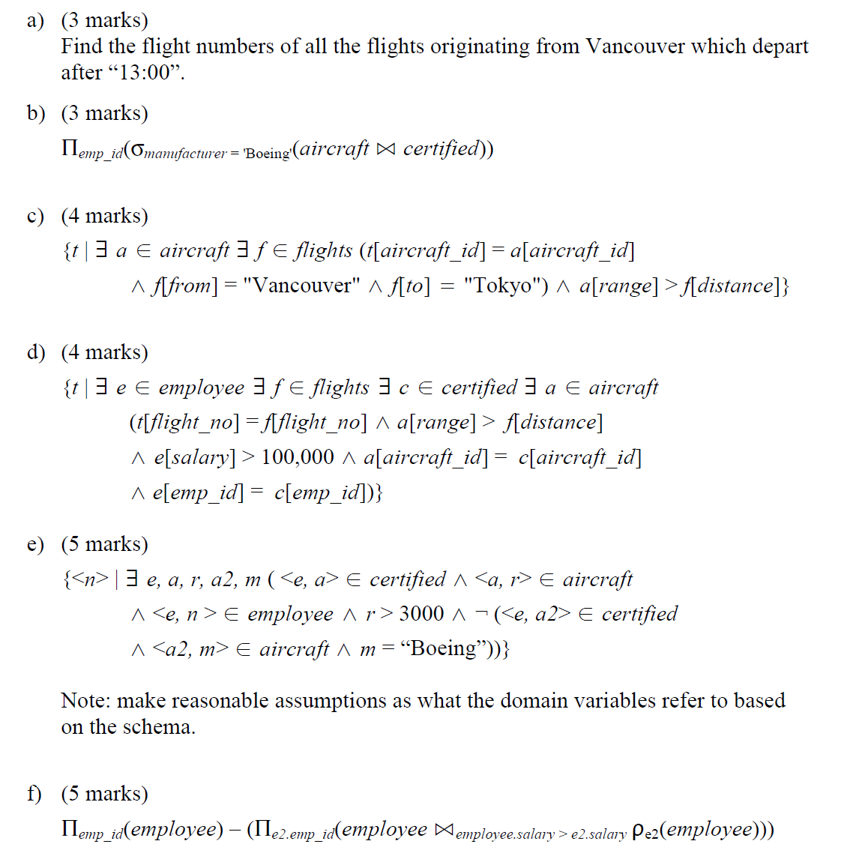

1. Suppose you are given the following schema:

*authors(author_id, last_name, first_name)*

*books(book_id, title, num_pages, author_id)*

*branches(branch_id, branch_name, address, phone_no)*

*copies(copy_id, branch_id, book_id, cost)*

*loans(loan_id, copy_id, borrower_id, due_date)*

*borrowers(borrower_id, name, member_since)*

For each of the following SQL statements give the equivalent SQL statements for the following queries:

a) For each book-branch combination, find the number of copies of the book

available at the branch. Give the branch name, book title, and count in the results.

b) Find the names of the branches that have no books available for loan.

c) Find the names of branches that hold a copy of a book written by ‘Korth’.

Please do create the tables in MySQL and insert at least 15 rows for each table.

1. For the following relation schema:

employee(employee-name, street, city)

works(employee-name, company-name, salary)

company(company-name, city)

manages(employee-name, manager-name)

Give an expression in SQL for each of the following queries:

a) Find the names, street address, and cities of residence for all employees who work for

'First Bank Corporation' and earn more than $10,000.

b) Find the names of all employees in the database who live in the same cities as the

companies for which they work.

c) Find the names of all employees in the database who live in the same cities and on the

same streets as do their managers.

d) Find the names of all employees in the database who do not work for 'First Bank

Corporation'. Assume that all people work for exactly one company.

e) Find the names of all employees in the database who earn more than every employee

of 'Small Bank Corporation'. Assume that all people work for at most one company.

f) Assume that the companies may be located in several cities. Find all companies

located in every city in which 'Small Bank Corporation' is located.

g) Find the names of all employees who earn more than the average salary of all

employees of their company. Assume that all people work for at most one company.

h) Find the name of the company that has the smallest payroll.