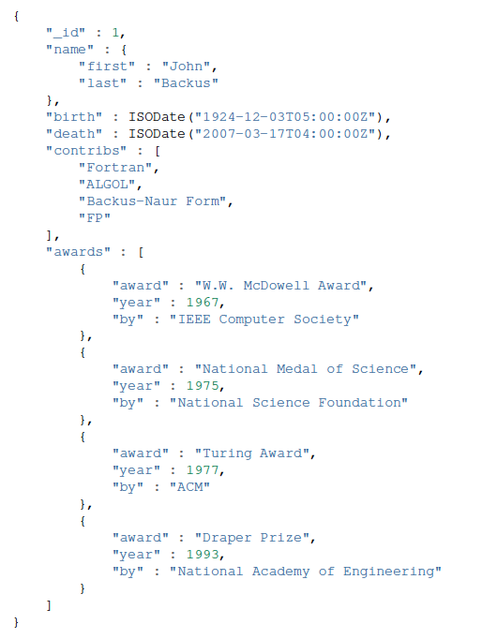

Q1: Report the documents of users where the name is “Alex Chen”.

Q2: Update the birth date of _id = 1 to 1944-11-07

Q3: Report the documents of users who got an award after year 1990

Q4: Report only the name of users who have “FP” in the contributions list

Q5: Report only one document where the number of awards is exactly 3

Q6: For user with Id = 1, delete from the awards array the award(s) in year 1977

**Queries**

1. db.collection.find({ "name.first": "Alex", "name.last": "Chen" })

2. db.collection.updateOne({ "_id": 1 },{ $set: { "birth": ISODate ("1944-11-07") } })

3. db.collection.find({ "awards.year": { $gt: 1990 } })

4. db.collection.find({ "contribs": "FP" },{ "name": 1, "_id": 0 })

5. db.collection.findOne({ $where: "this.awards.length === 3" })

6. db.collection.updateOne({ "_id": 1 },{ $pull: { "awards": { "year": 1977 } } })