domibusWebAdmin Guide

This document gives a brief overview of the features and functions of the domibusWebAdmin GUI.

To see a description of “How to install” the domibusWebAdmin please refer to the document “domibusWebAdmin – Installationguide”.

Table of contents

Login 4

Main Page 5

Monitoring panel 5

Connection panel 5

Jobs panel 5

Configuration Page 6

Monitoring panel 6

Job configuration panel 6

User configuration panel 6

Statistics 7

Reports 9

Data Tables 12

Import from PModes 12

Parties 12

Create a new party: 12

Modify a party: 13

Delete a party: 13

Actions 13

Create a new action 13

Modify an existing action 13

Delete an action 13

Services 14

Create a new service 14

Modify service 14

Delete service 14

Extra information 14

# Login

When you deployed the domibusWebAdmin on your application server it is placed at the relative path http://[your servers ip or name and port]/domibusWebAdmin. When entering the site it first wants you to login with a valid user and password.

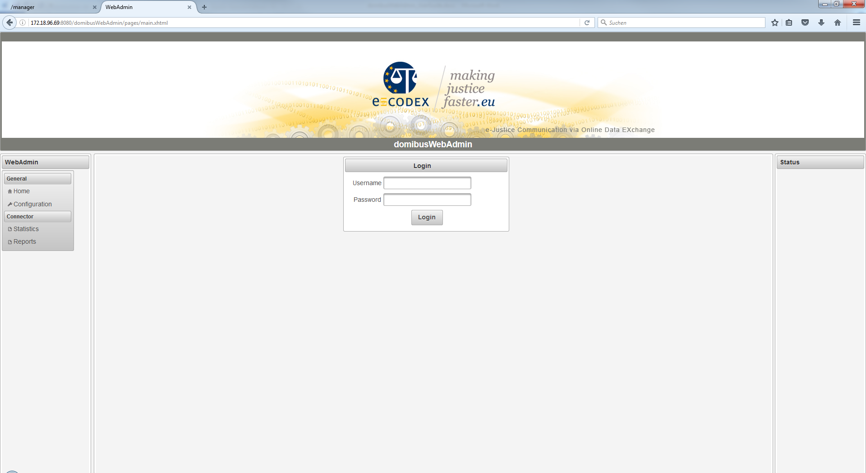

When the provided database scripts of the domibusWebAdmin were used to install the database then a first default user was created. This is “admin” with the password “admin”. Later, in the “Configuration” section of the domibusWebAdmin you can create, delete and edit users.

**!!! It is highly recommended to change the password of the “admin” user to grant restricted access to the domibusWebAdmin. !!!**

# Main Page

After login, you should find yourself on the main page, which shows the navigation menu on the left side and the summarized monitoring information in the center. The monitoring information is generally concluded with a state in the form OK (Green color), WARNING (Yellow) or ERROR (Red).

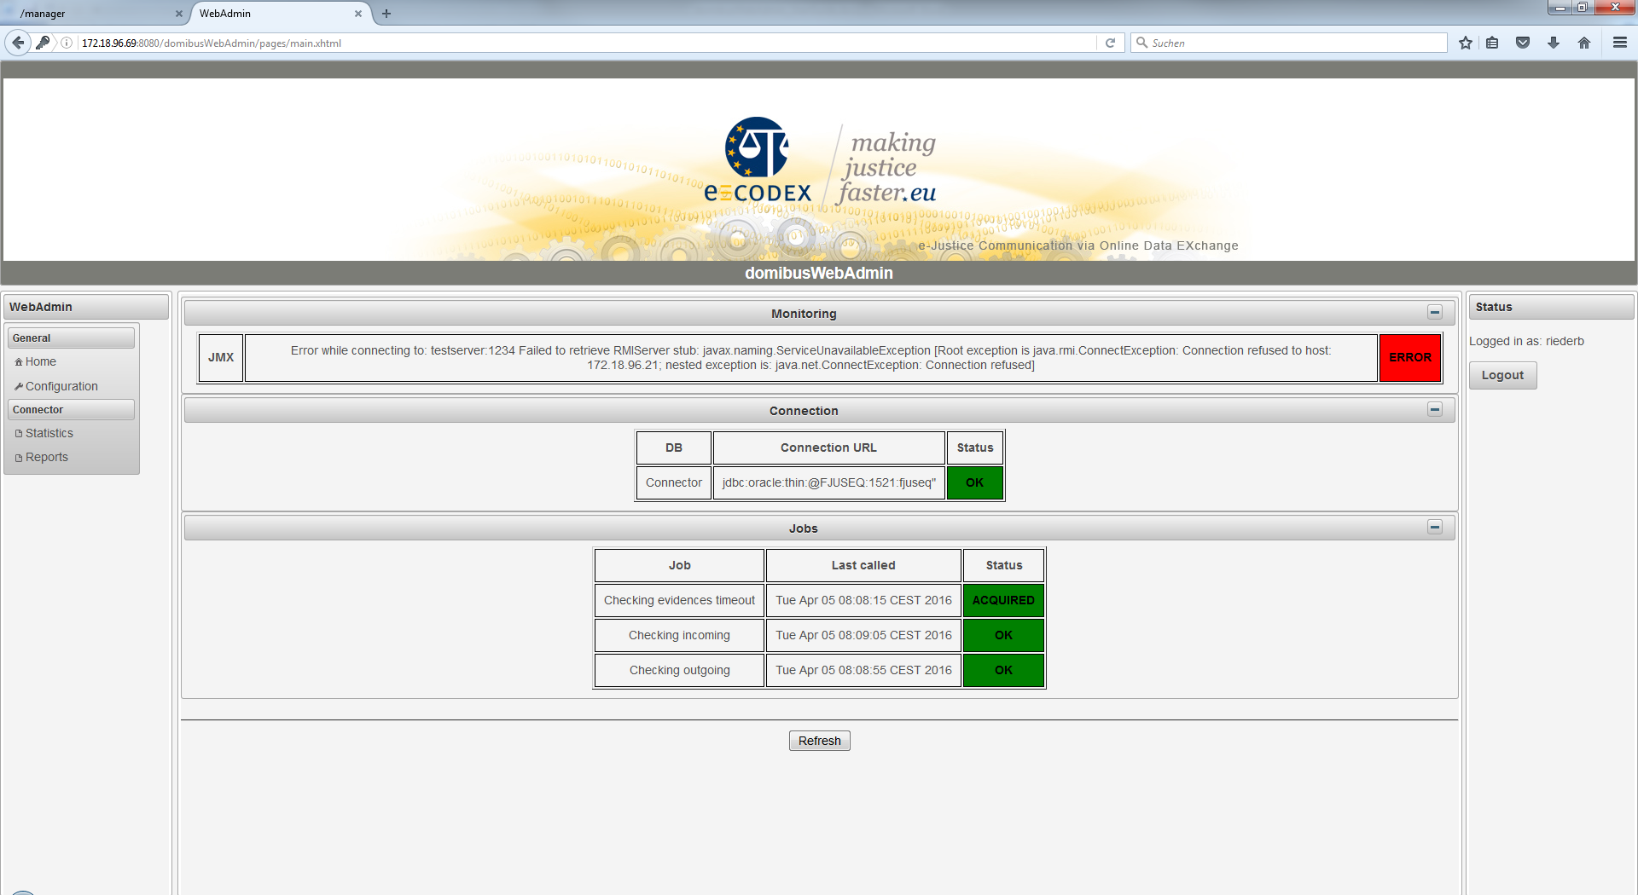

## Monitoring panel

Depending on the configured monitoring type the monitoring panel is displayed first.

The domibusConnector framework offers different interfaces to expose its monitoring information, namely JMX and REST. The monitoring panel shows the state of the selected monitoring type.

An ERROR is displayed, when the selected monitoring type is not reachable.

Note: When no monitoring interface is selected (by default monitoring type “DB”, the panel is not shown at all.

## Connection panel

This panel shows the information of the connection to the configured database.

## Jobs panel

This panel shows information about the regular running connector jobs. The following states may be displayed with the according colors:

* OK – Job is waiting for next execution GREEN
* ACQUIRED – Job is queued for execution GREEN
* PAUSED – Job is paused YELLOW
* BLOCKED – Job is prevented from execution YELLOW
* ERROR – Job failed to execute RED

# Configuration Page

The configuration page shows three panels for configuring different parts:

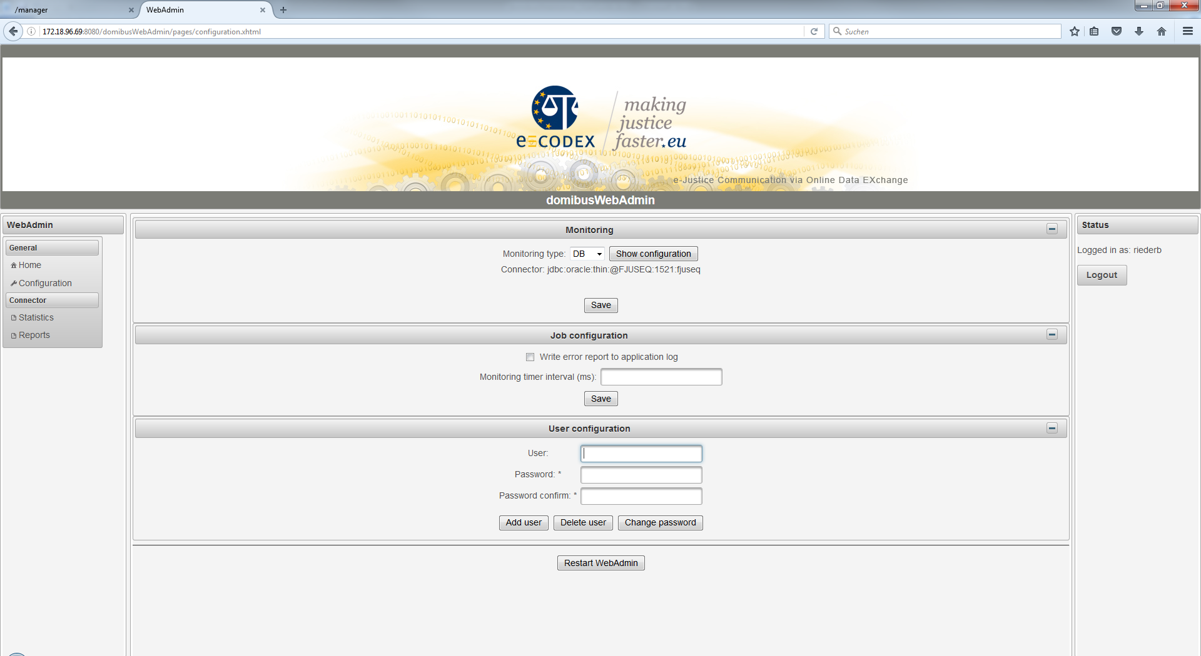

## Monitoring panel

This is the source, where the domibusWebAdmin queries its monitoring information.

Possible values are “DB”, “JMX” and “REST”.

Configuration for DB is only the information to which database the domibusWebAdmin is connected.

JMX and REST can be fully configured over the GUI.

The “Test” button tests the provided parameters and “SAVE” stores the information.

## Job configuration panel

Defines the time interval in which monitoring information is checked by the domibusWebAdmin. In case of WARNING/ERROR a report is written to the application log. This can be activated or deactivated.

## User configuration panel

This is a panel to add and delete users. Also the password for a user can be changed here. To add a user you must first enter the new User and the password. To delete a user or change its password the correct User must be entered with its correct password.

# Statistics

The statistics are shown out of the database of the connected domibusConnector database:

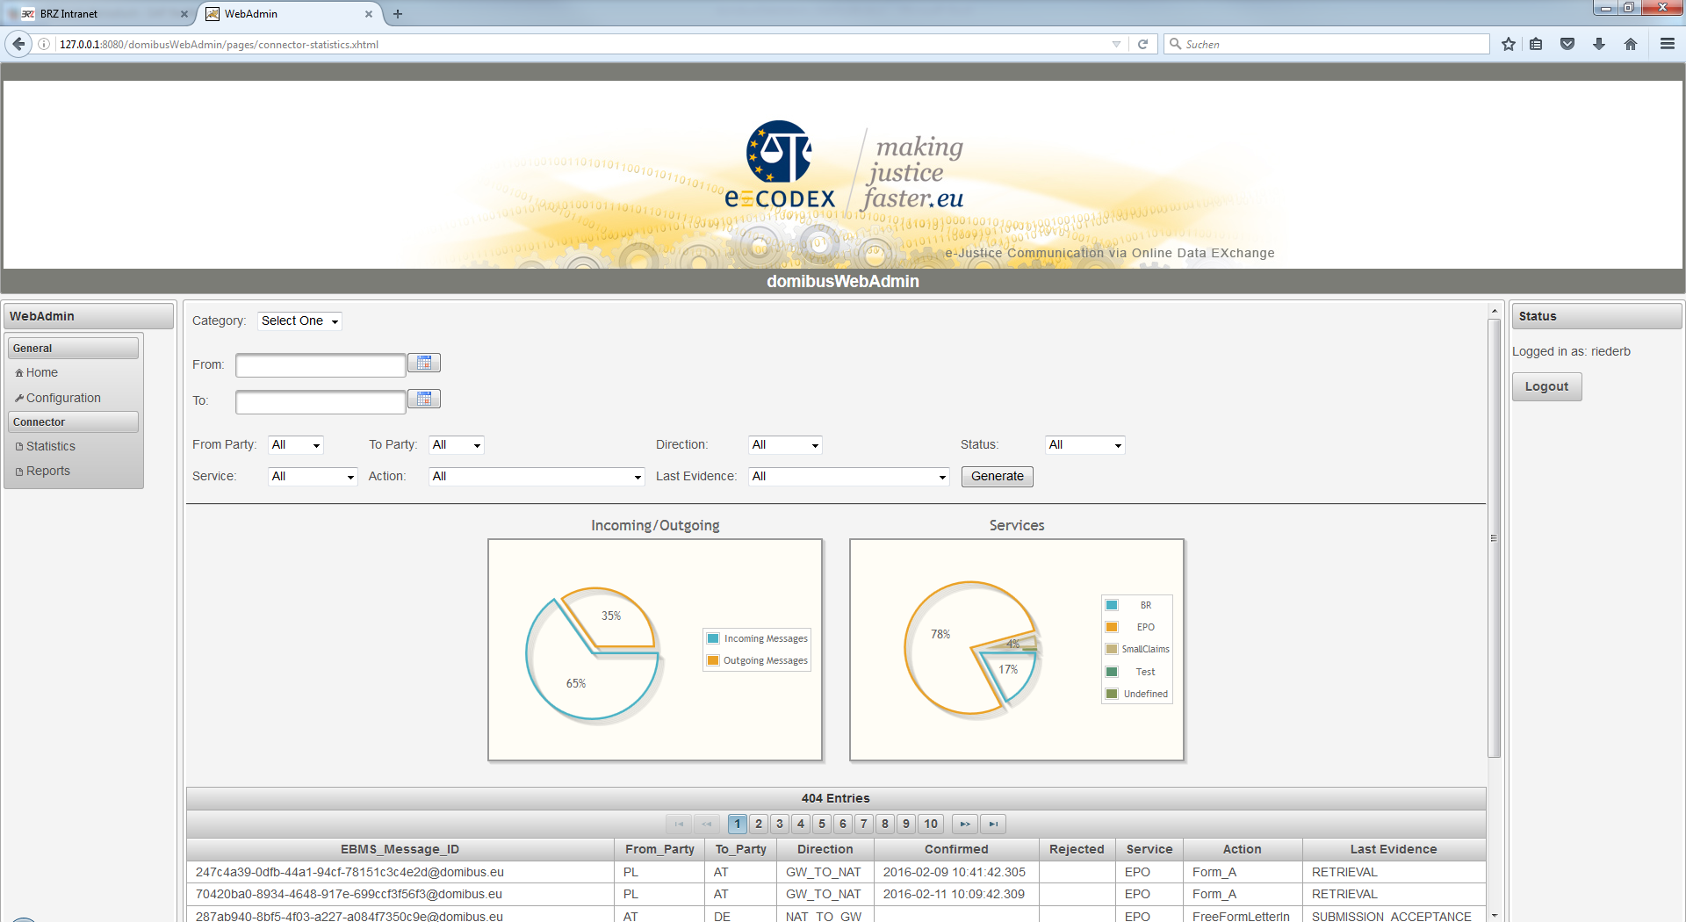

When entering the page it first shows an overall statistic as a summary and a listing.

The first box “Category” lets you choose between two options:

**Summary:**

This page shows simple diagrams for overall data. At the actual state it shows the amount of incoming/outgoing messages and the type of service.

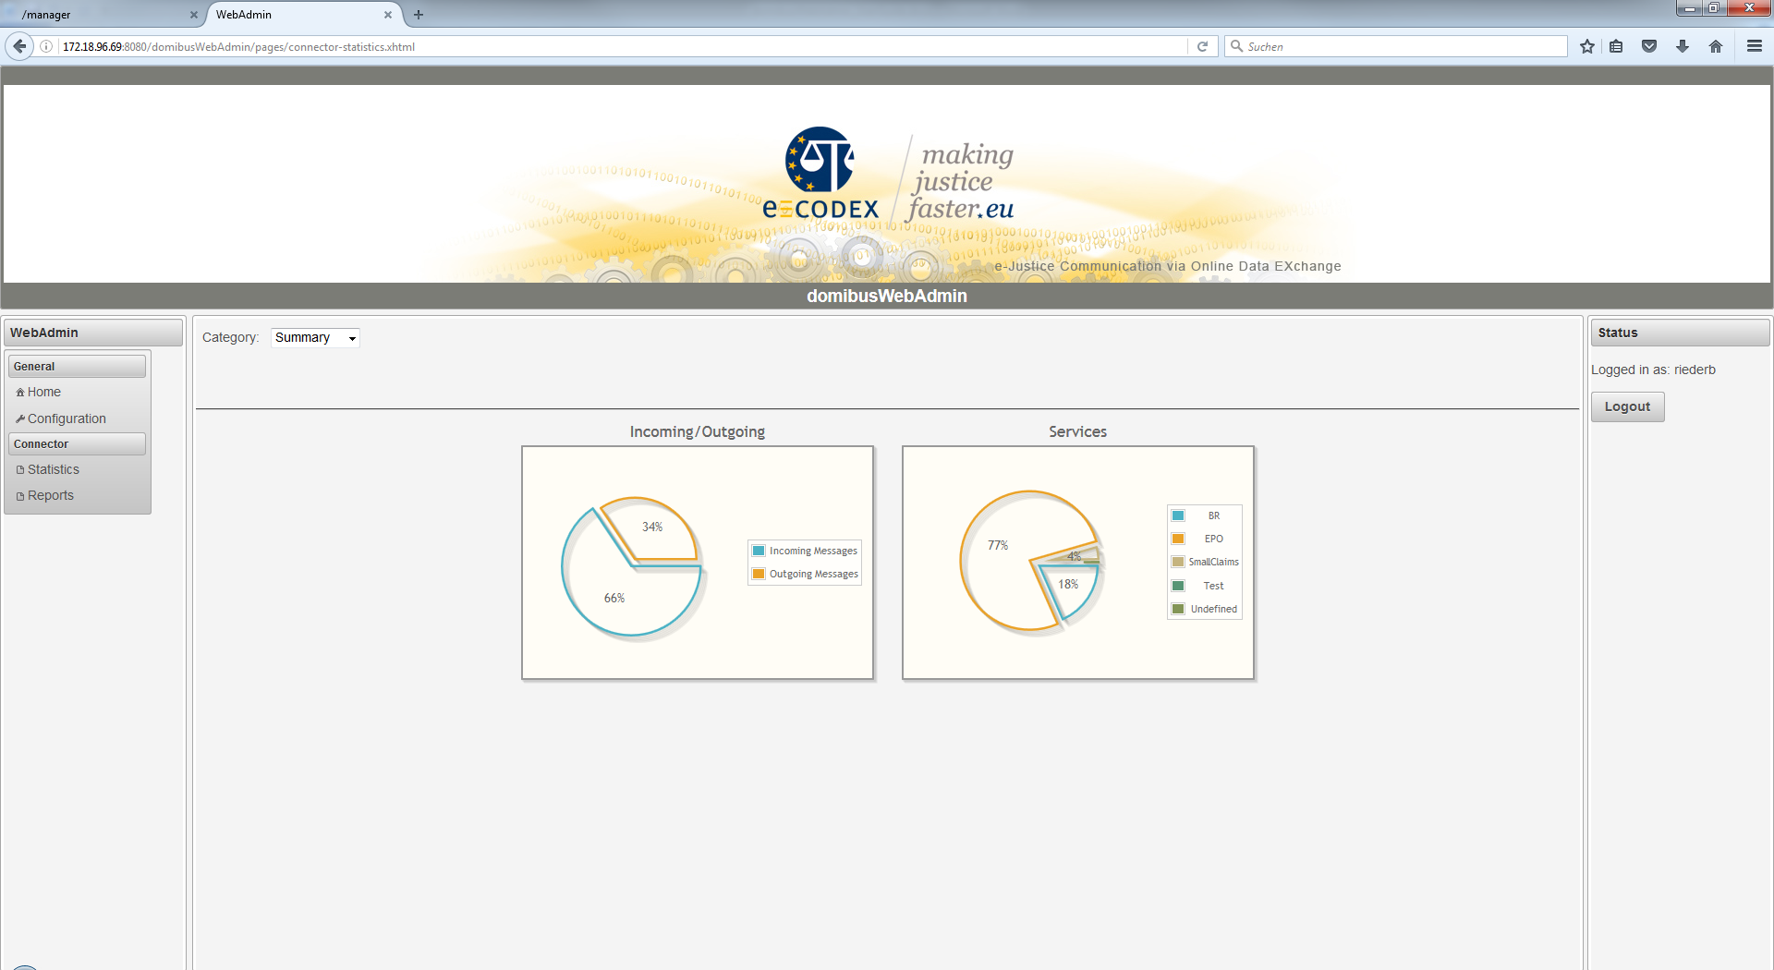

**Custom:**

Here, the connector messages can be filtered by different parameters. By hitting the generate button, the result is displayed in the table below.

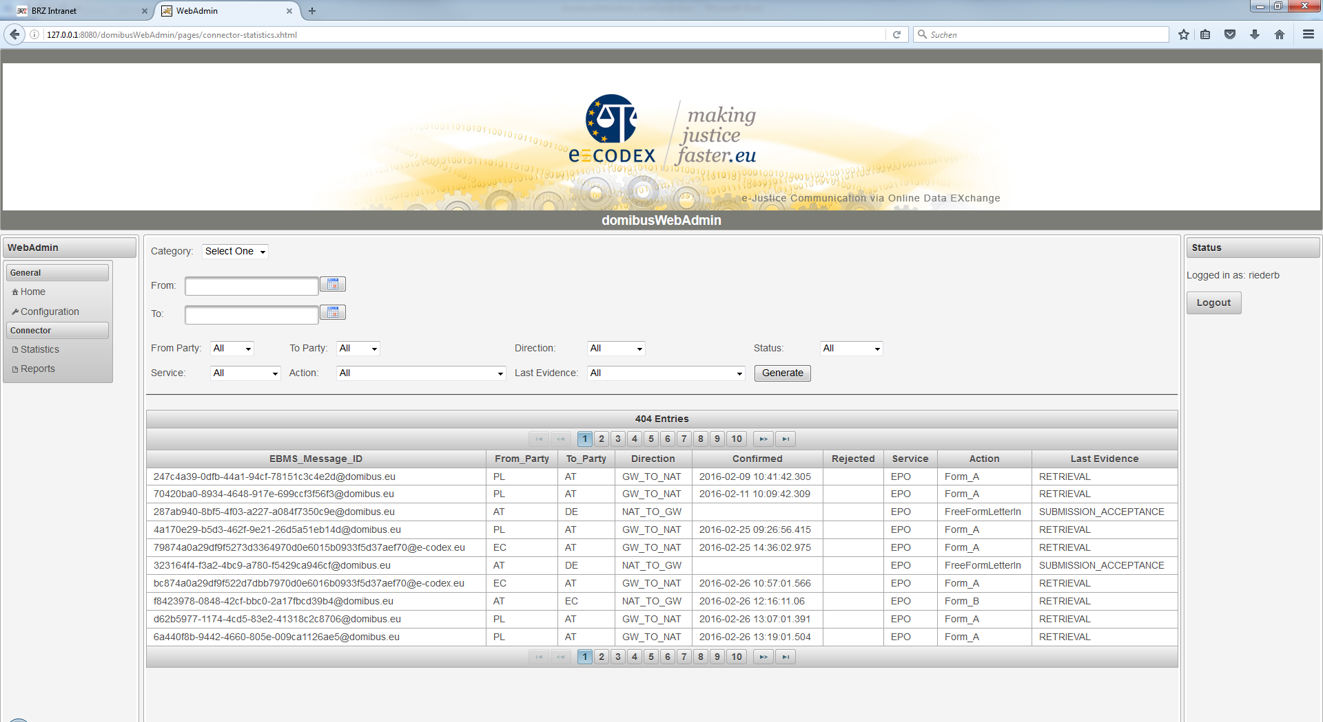

# Reports

The domibusWebAdmin can also show you reports from the connector database in a formatted way.

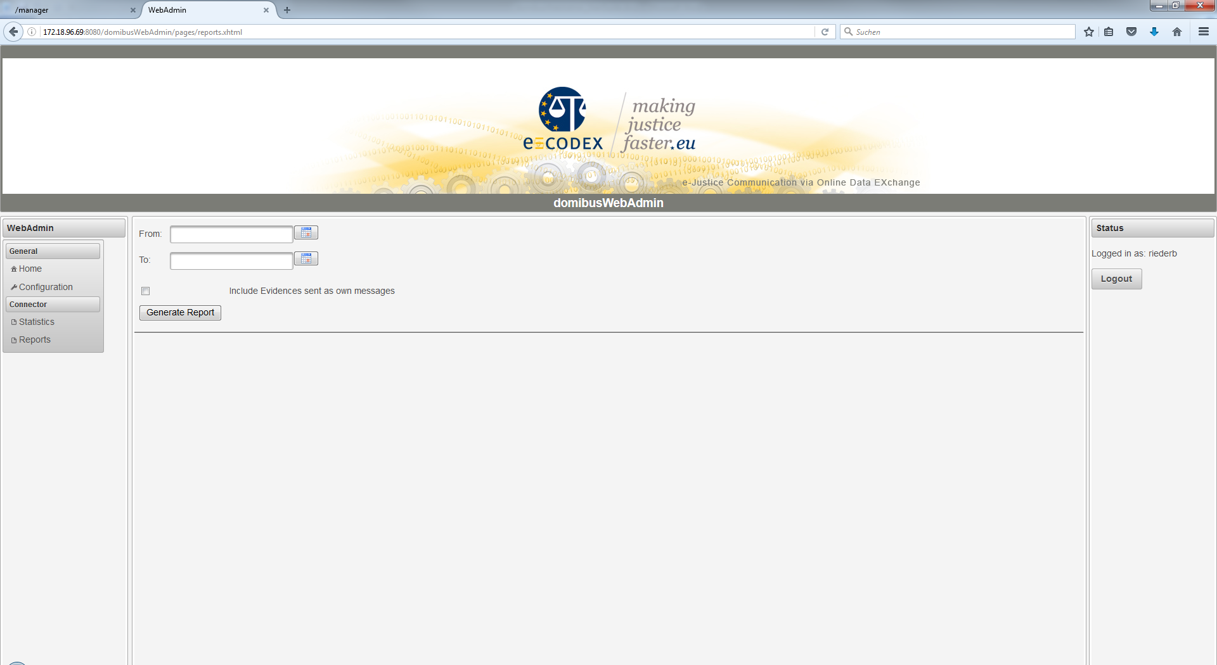

The search form just requests the time period you want the reports generated from. The best way is to use the calendar help besides the fields as the date format that has to be entered is platform dependent. If no period is entered (both fields left empty) the domibusWebAdmin generates reports from the 1st of January 2000 to the current date.

You can also choose whether to include evidences that are sent as own messages (without the first evidence that comes together with the message itself). Please note that the evidence messages are always sent the other direction as the message (as they are responses to the message).

When the reports are generated, they are displayed like this:

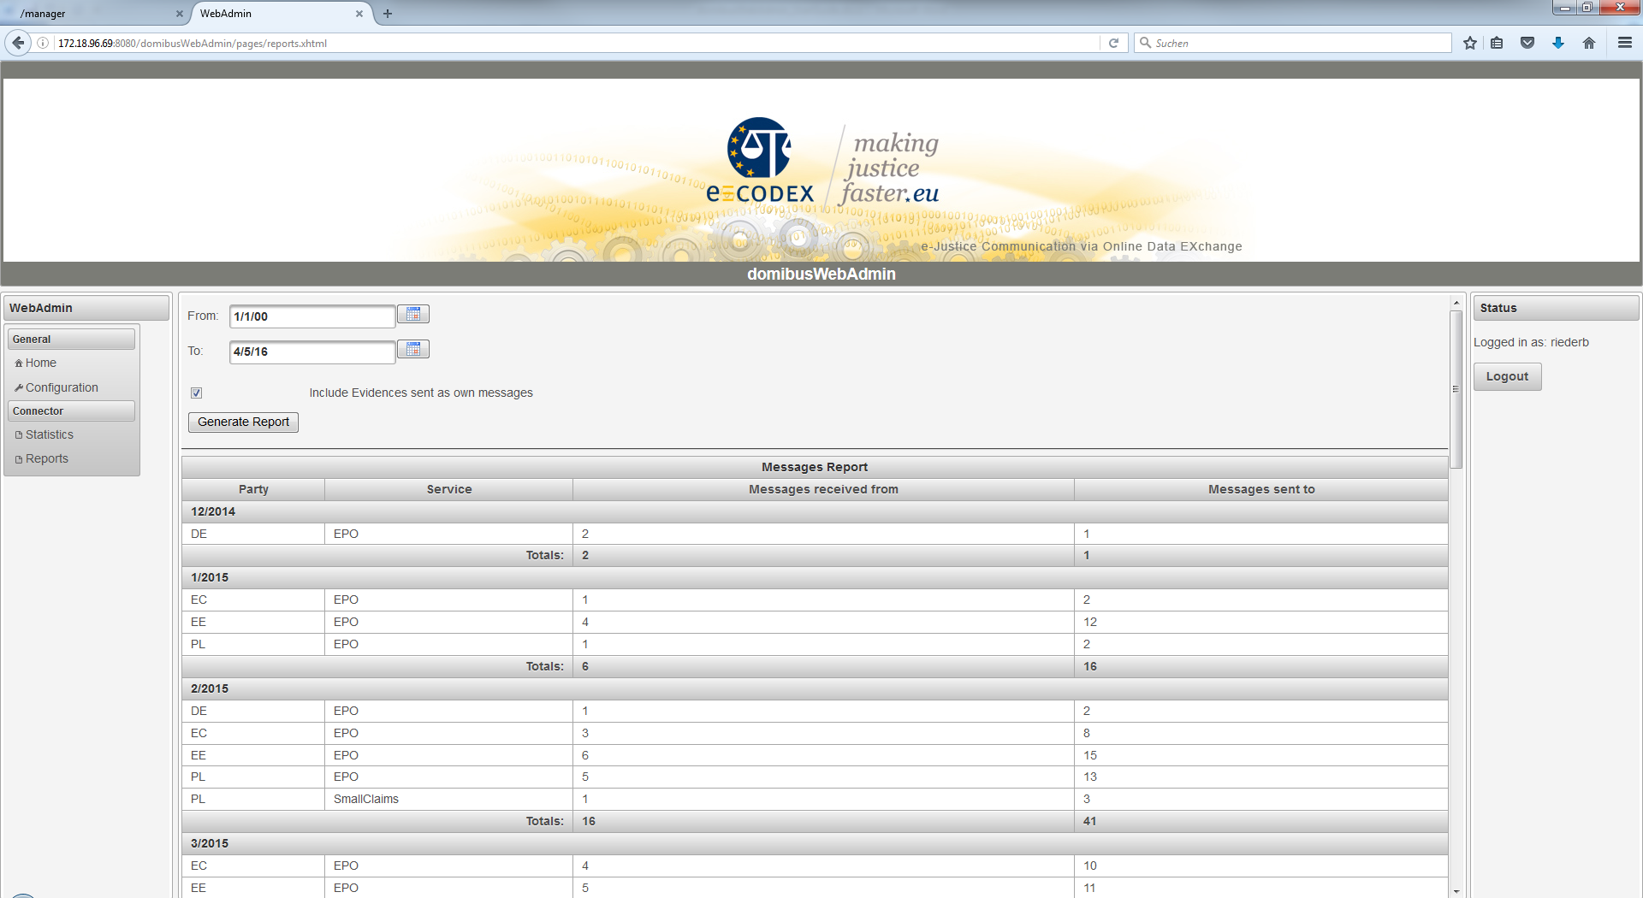

The reports show the Party to/from which the messages are sent/come from. Then the service, the amount of messages received and the amount of the messages sent per Party and Service.

The results are grouped monthly and the summarized amounts per month are also displayed.

**Export:**

The reports shown as the result can also be exported in XLS (MS Excel) format for further processing. The XLS is pre-formatted like this:

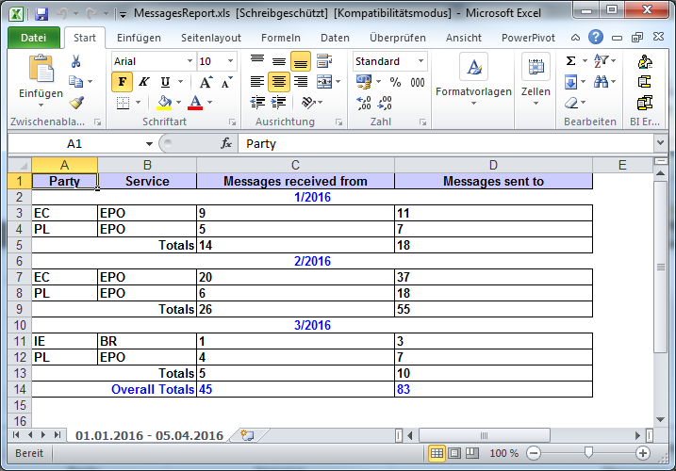

Figure 1: Screenshot of an exported report opened with Excel

In the sheet-tab the time period of the selection can be seen in case the reports need to be persisted regularly.

The data itself is formatted hardly different from the view on the page with one extension. It also shows overall totals that summarizes the amount of messages over the whole period.

# Data Tables

The domibusWebAdmin provides also an overview over configured parties, actions and services. This view is reachable over the menu entry “DataTables”.

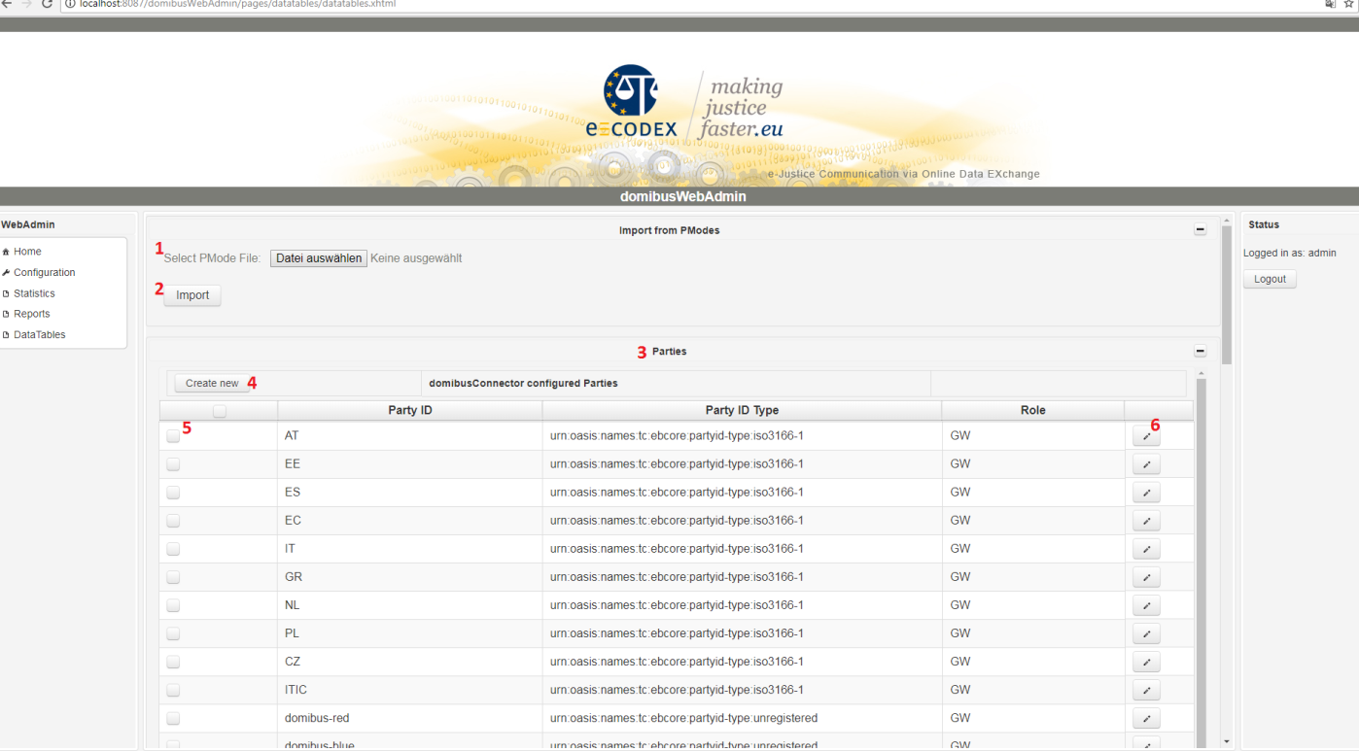

Figure 2: Screenshot of DataTables view

## Import from PModes

The „Import from PModes“ function allows you to upload a pMode-xml file. The file is used to create parties, actions and services which aren’t yet configured. So this process will only create new items. There won’t be any modifications on existing items (services, actions or parties).

Import a pmode-File:

1. select a pModeFile (see Figure 2, red number 1)
2. press the import button (see Figure 2, red number 2)

If there are any failures maybe your pmode file is corrupt.

## Parties

This table shows all which shows all configured parties. You can create new parties, modify the partyIdType of existing ones and also delete parties. Deletion is only possibly if there weren’t any messages processed according to that party.

### Create a new party:

1. Press the “Create new” button (see Figure 2, red number 4)
2. A dialog appears. Now you can type in Party ID, Party ID Type and Role of the party. Be sure that the combination of Party ID and Role is unique.
3. Press “Create” to save the new Party OR “Cancel” to abort

### Modify a party:

Each row contains a button marked with a pencil symbol. Click at the pencil symbol (see Figure 2, red number 6). You can only change the Party ID Type of the party. Press “save” to save the changes OR “Cancel” to abort the changes.

### Delete a party:

To delete a party select the party by ticking the checkbox in the first column (see Figure 2, red number 5). After selecting all parties you can start the deletion process by hitting the “Delete” button at the bottom of the table.

You can only delete parties which have not received or sent to any messages.

## Actions

This table shows all configured actions. You can create new actions, modify existing ones and also delete actions. Deletion is only possibly if there weren’t any messages processed according to that action. You can only change if the action requires a pdf.

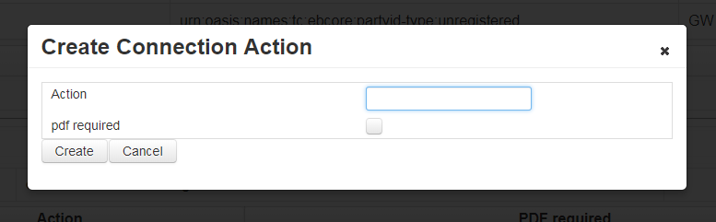

Figure 3: Create Connection Action Dialog

### Create a new action

1. Press the “Create new” button at the actions table.
2. A Dialog appears (see Figure 3: Create Connection Action Dialog). Now you can type in the action and you can use the checkbox to determine if the action requires a pdf. Be aware that the action must be unique.
3. Press “Create” to save the new action OR “Cancel” to abort

### Modify an existing action

Each action row contains a button with a pencil symbol. Press this button to open the edit dialog. You can only change if the action requires a pdf. At the edit dialog use “Save” to save the change and “Cancel” to abort the modification.

### Delete an action

To delete an action you have to select the action by ticking the checkbox in the first column. After that you can delete all marked actions by hitting the “Delete Selected” button at the end of the table.

## Services

This table shows all configured services. You can create new services, modify the service type of existing ones and also delete services. Deletion is only possibly if there weren’t any messages processed according to that service.

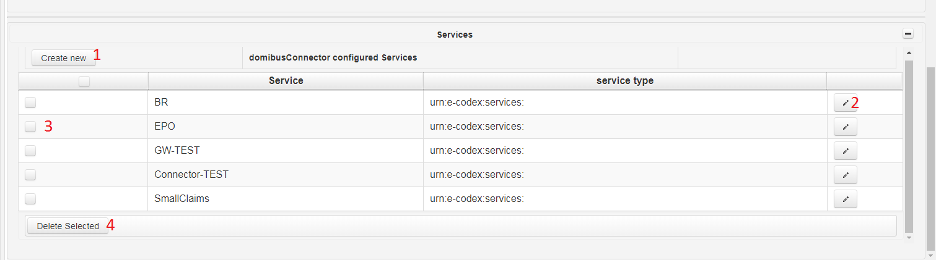

Figure 4: Screenshot of the services table only

### Create a new service

1. Press the “Create new” button at the services table
2. A Dialog appears. Now you can type in the service and the service type. Be aware the service must be unique.
3. Press “Create” to save the new service or “Cancel” to abort.

### Modify service

1. Press the button with the pencil symbol of the row you want to edit (see Figure 4: Screenshot of the services table only, red 2).
2. A dialog opens, now you can edit the service type
3. Press “Save” to save the change OR “Cancel” to abort

### Delete service

To delete a service mark it in the first row by ticking the checkbox. After that you can delete all marked services by hitting the “Delete Selected” button (see Figure 4: Screenshot of the services table only, red 4)

## Extra information

This create, modify and delete functions cannot modify an item (party, action or service) if there are any references pointing to it. This means if the connector has already processed messages using an item.

So if you really want to delete an already used service, action or party you have to do it by yourself in your database and you should know what you are doing!