domibusWebAdmin Guide

Table of contents

Login 2

Main Page 3

Monitoring panel 3

Connection panel 3

Jobs panel 3

Configuration Page 4

Monitoring panel 4

Job configuration panel 4

User configuration panel 4

Statistics 5

Reports 7

This document gives a brief overview of the features and functions of the domibusWebAdmin GUI.

To see a description of “How to install” the domibusWebAdmin please refer to the document “domibusWebAdmin – Installationguide”.

# Login

When you deployed the domibusWebAdmin on your application server it is placed at the relative path http://[your servers ip or name and port]/domibusWebAdmin. When entering the site it first wants you to login with a valid user and password.

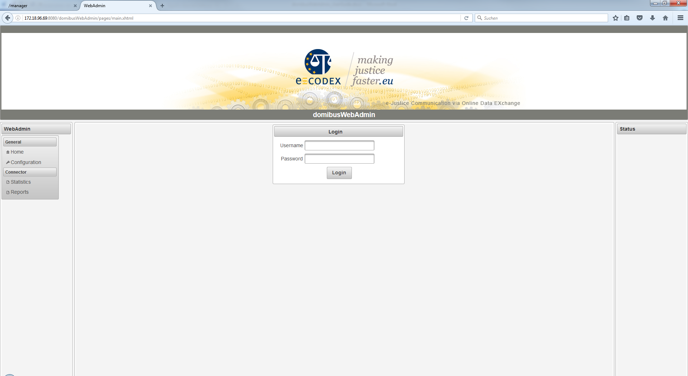

When the provided database scripts of the domibusWebAdmin were used to install the database then a first default user was created. This is “admin” with the password “admin”. Later, in the “Configuration” section of the domibusWebAdmin you can create, delete and edit users.

**!!! It is highly recommended to change the password of the “admin” user to grant restricted access to the domibusWebAdmin. !!!**

# Main Page

After login, you should find yourself on the main page, which shows the navigation menu on the left side and the summarized monitoring information in the center. The monitoring information is generally concluded with a state in the form OK (Green color), WARNING (Yellow) or ERROR (Red).

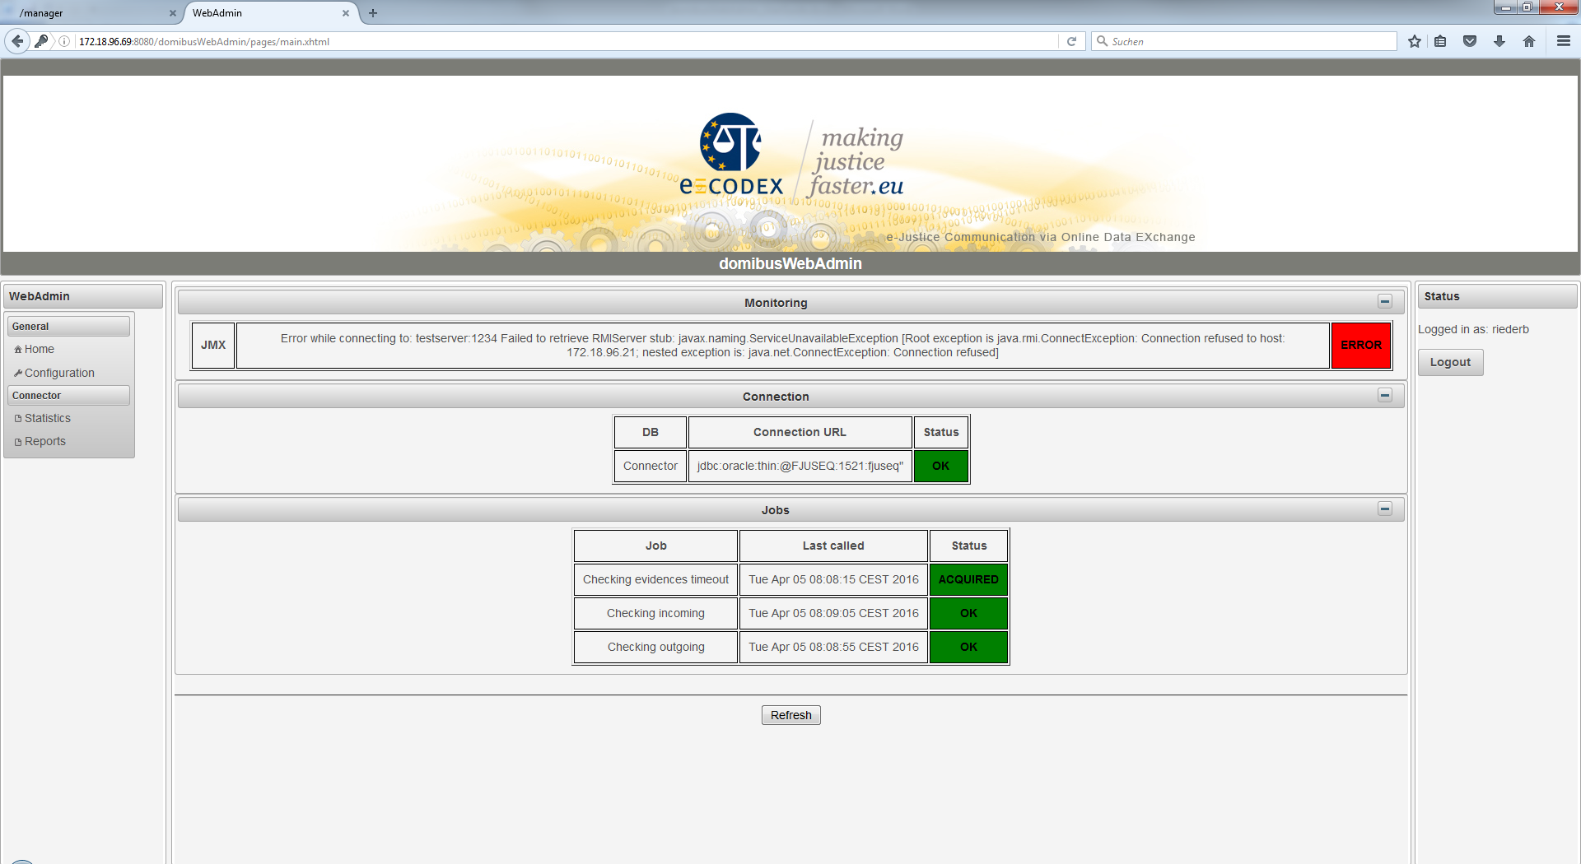

## Monitoring panel

Depending on the configured monitoring type the monitoring panel is displayed first.

The domibusConnector framework offers different interfaces to expose its monitoring information, namely JMX and REST. The monitoring panel shows the state of the selected monitoring type.

An ERROR is displayed, when the selected monitoring type is not reachable.

Note: When no monitoring interface is selected (by default monitoring type “DB”, the panel is not shown at all.

## Connection panel

This panel shows the information of the connection to the configured database.

## Jobs panel

This panel shows information about the regular running connector jobs. The following states may be displayed with the according colors:

* OK – Job is waiting for next execution GREEN
* ACQUIRED – Job is queued for execution GREEN
* PAUSED – Job is paused YELLOW
* BLOCKED – Job is prevented from execution YELLOW
* ERROR – Job failed to execute RED

# Configuration Page

The configuration page shows three panels for configuring different parts:

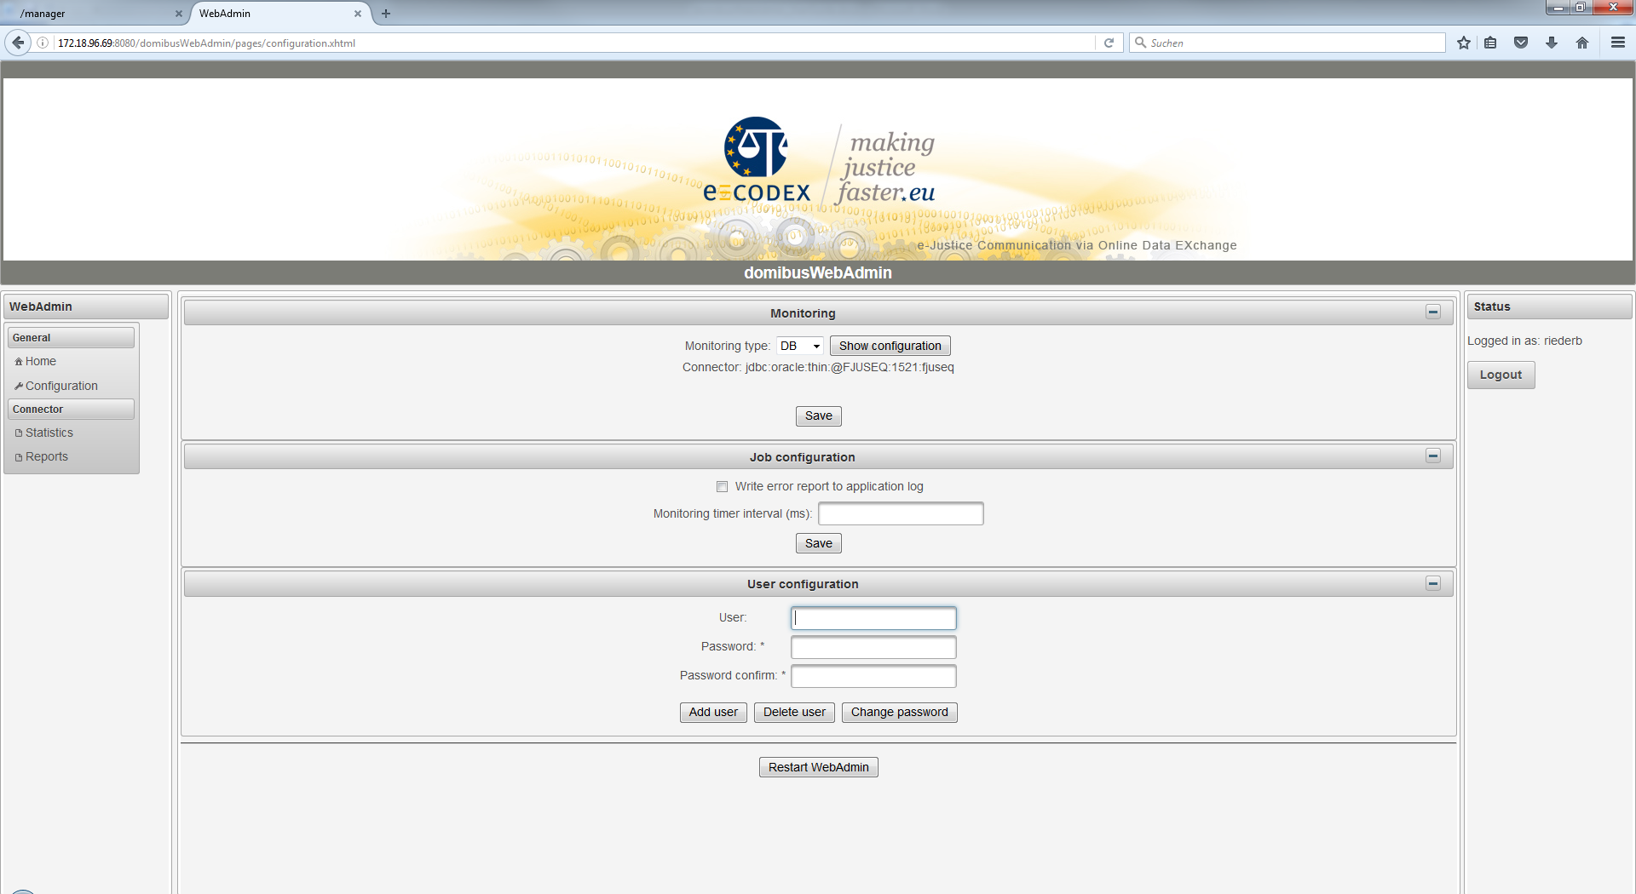

## Monitoring panel

This is the source, where the domibusWebAdmin queries its monitoring information.

Possible values are “DB”, “JMX” and “REST”.

Configuration for DB is only the information to which database the domibusWebAdmin is connected.

JMX and REST can be fully configured over the GUI.

The “Test” button tests the provided parameters and “SAVE” stores the information.

## Job configuration panel

Defines the time interval in which monitoring information is checked by the domibusWebAdmin. In case of WARNING/ERROR a report is written to the application log. This can be activated or deactivated.

## User configuration panel

This is a panel to add and delete users. Also the password for a user can be changed here. To add a user you must first enter the new User and the password. To delete a user or change its password the correct User must be entered with its correct password.

# Statistics

The statistics are shown out of the database of the connected domibusConnector database:

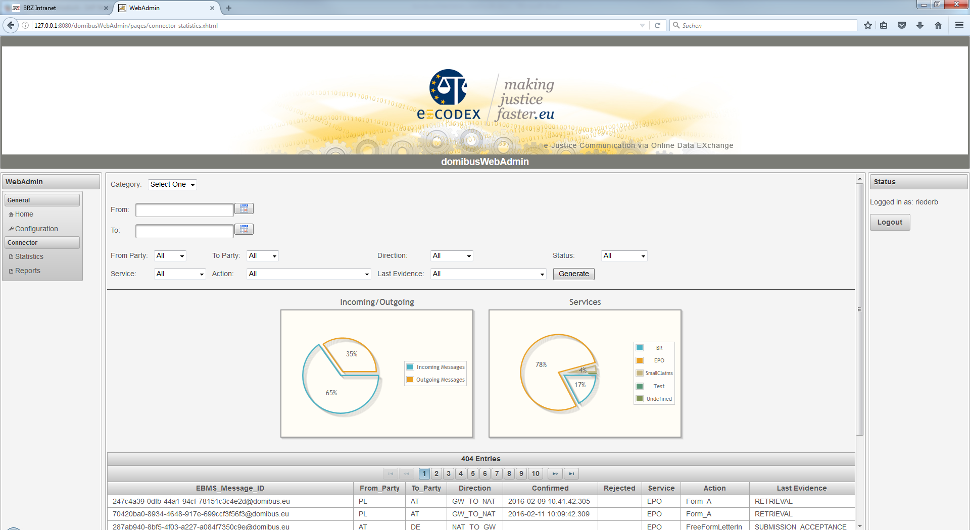

When entering the page it first shows an overall statistic as a summary and a listing.

The first box “Category” lets you choose between two options:

**Summary:**

This page shows simple diagrams for overall data. At the actual state it shows the amount of incoming/outgoing messages and the type of service.

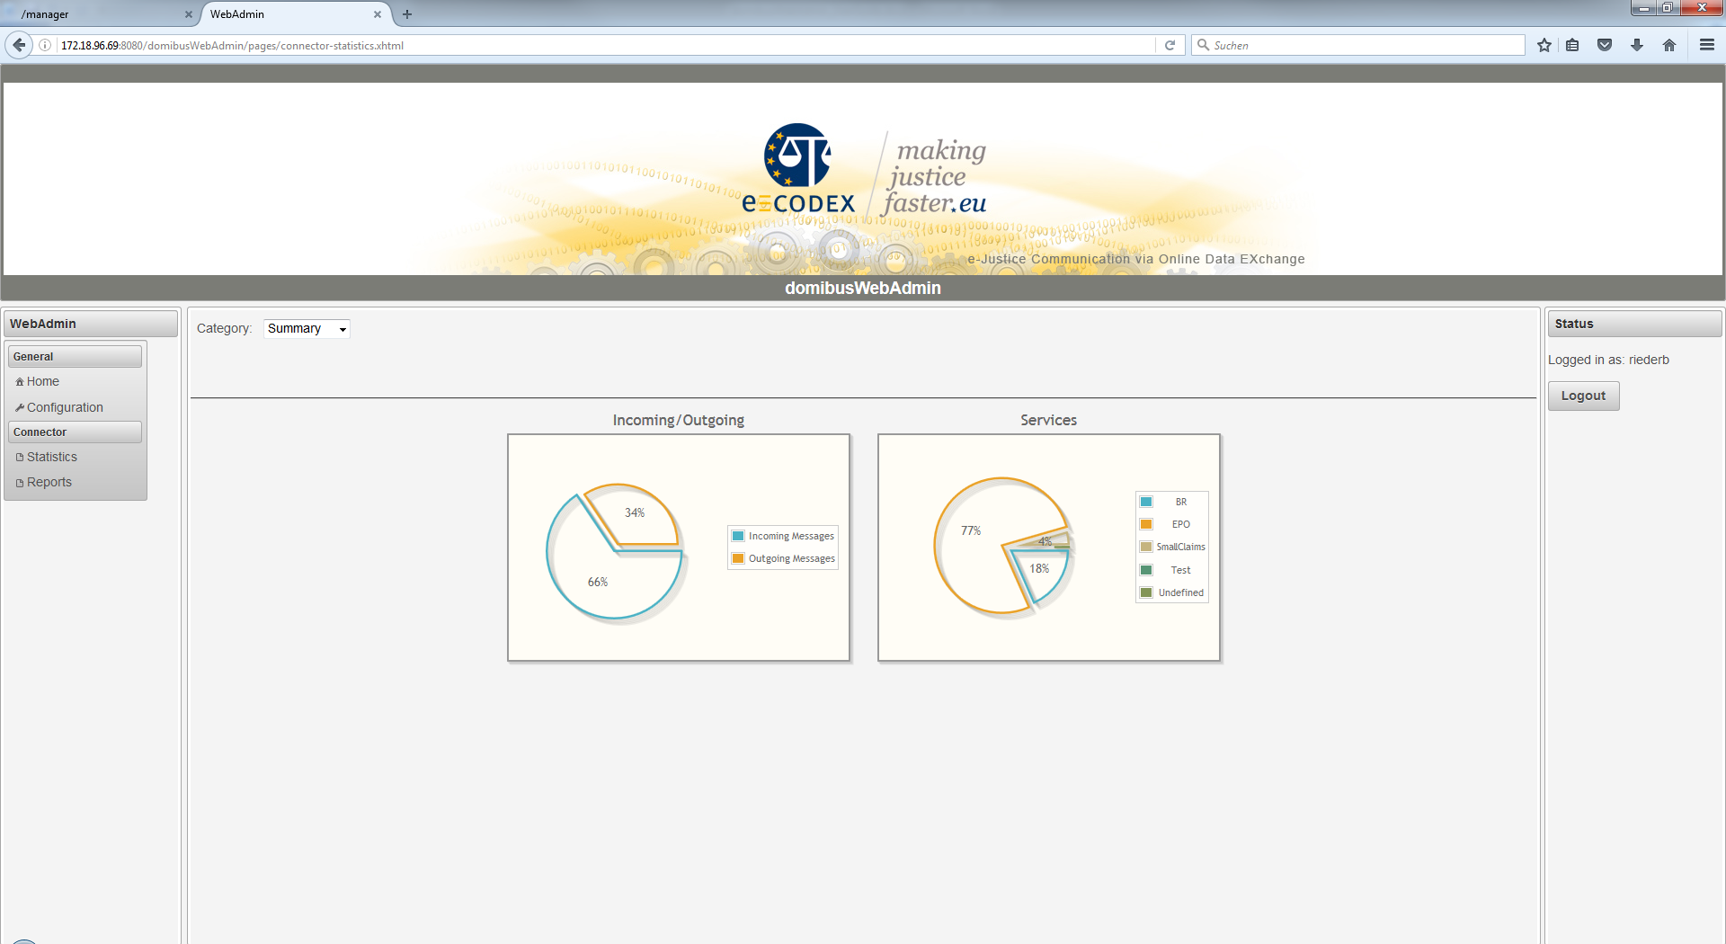

**Custom:**

Here, the connector messages can be filtered by different parameters. By hitting the generate button, the result is displayed in the table below.

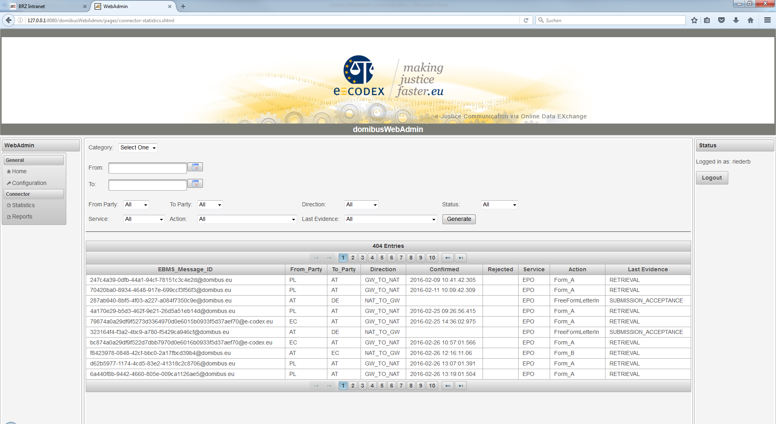

# Reports

The domibusWebAdmin can also show you reports from the connector database in a formatted way.

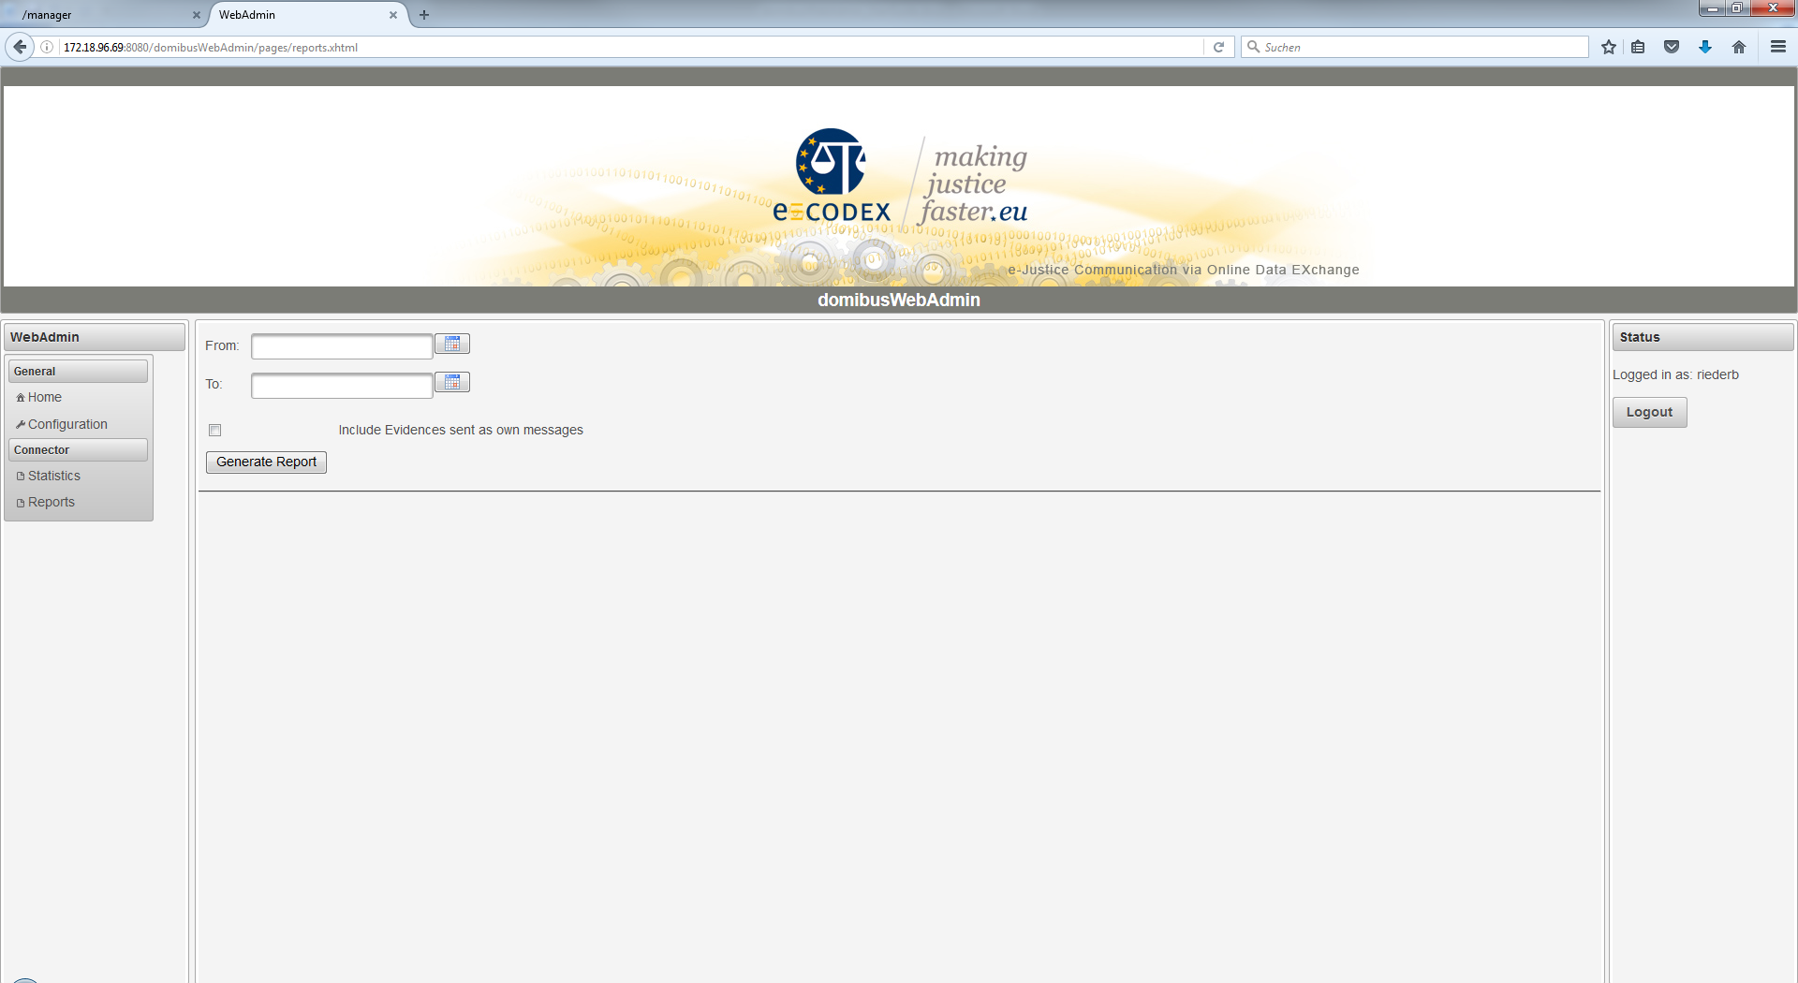

The search form just requests the time period you want the reports generated from. The best way is to use the calendar help besides the fields as the date format that has to be entered is platform dependent. If no period is entered (both fields left empty) the domibusWebAdmin generates reports from the 1st of January 2000 to the current date.

You can also choose whether to include evidences that are sent as own messages (without the first evidence that comes together with the message itself). Please note that the evidence messages are always sent the other direction as the message (as they are responses to the message).

When the reports are generated, they are displayed like this:

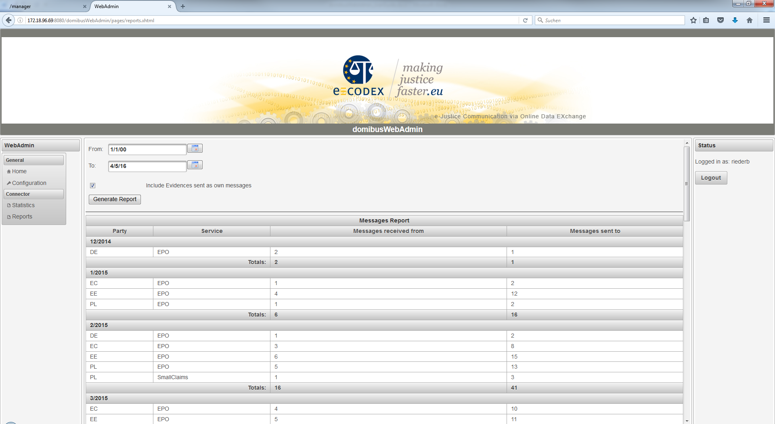

The reports show the Party to/from which the messages are sent/come from. Then the service, the amount of messages received and the amount of the messages sent per Party and Service.

The results are grouped monthly and the summarized amounts per month are also displayed.

**Export:**

The reports shown as the result can also be exported in XLS (MS Excel) format for further processing. The XLS is pre-formatted like this:

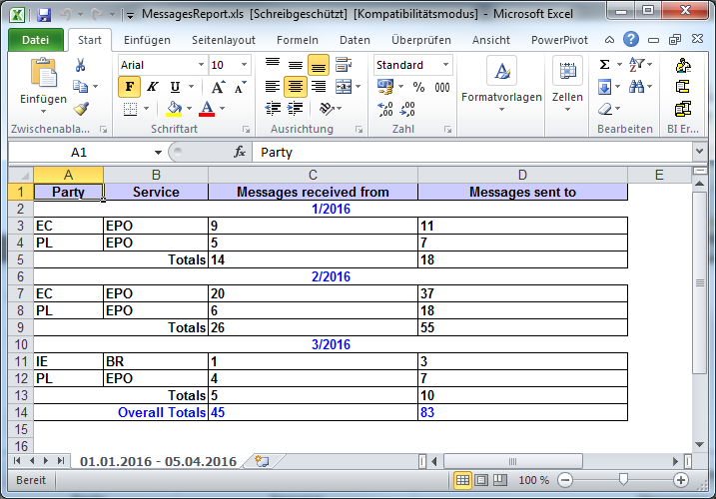

In the sheet-tab the time period of the selection can be seen in case the reports need to be persisted regularly.

The data itself is formatted hardly different from the view on the page with one extension. It also shows overall totals that summarizes the amount of messages over the whole period.