Linux Programming Practice Lab

Edith Susanna Andrews

17MIS1048

1. **Script 1**

apt-get install sl

sl

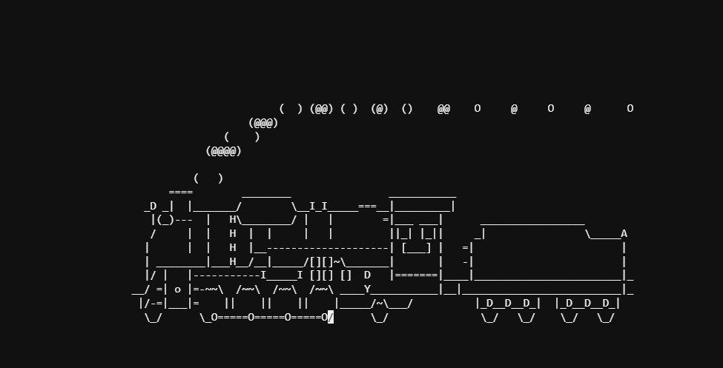

1. **Script 2**

rev

factor

yes

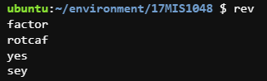

1. **Write a C program to implement Simple reader – writer algorithm using shared memory segment with semaphore**

/* A readers/writers program using a shared buffer and semaphores */

#include <sys/types.h>

#include <unistd.h>

#include <stdio.h>

#include <sys/mman.h>

#include <sys/sem.h>

#include <stdlib.h>

#define BUF_SIZE 5 /* logical size of buffer */

#define SHARED_MEM_SIZE (BUF_SIZE+2)*sizeof(int) /* size of shared memory */

#define run_length 10 /* number of iterations in test run */

#define buf_used 0 /* semaphore array index to check buffer elts used */

#define buf_space 1 /* semaphore array index to check buffer elts empty */

int sem_init(void)

{ /* procedure to create and initialize semaphores and return semaphore id,

assuming two semaphores defined in the given array of semaphores */

int semid;

/* create new semaphore set of 2 semaphores */

if ((semid = semget (IPC_PRIVATE, 2, IPC_CREAT | 0600)) < 0)

{ perror ("error in creating semaphore");/* 0600 = read/alter by user */

exit (1);

}

/* initialization of semaphores */

/* BUF_SIZE free spaces in empty buffer */

if (semctl (semid, buf_space, SETVAL, BUF_SIZE) < 0)

{ perror ("error in initializing first semaphore");

exit (1);

}

/* 0 items in empty buffer */

if (semctl (semid, buf_used, SETVAL, 0) < 0)

{ perror ("error in initializing second semaphore");

exit (1);

}

return semid;

}

void P(int semid, int index)

{/* procedure to perform a P or wait operation on a semaphore of given index */

struct sembuf sops[1]; /* only one semaphore operation to be executed */

sops[0].sem_num = index;/* define operation on semaphore with given index */

sops[0].sem_op = -1; /* subtract 1 to value for P operation */

sops[0].sem_flg = 0; /* type "man semop" in shell window for details */

if (semop (semid, sops, 1) == -1)

{ perror ("error in semaphore operation");

exit (1);

}

}

void V(int semid, int index)

{/* procedure to perform a V or signal operation on semaphore of given index */

struct sembuf sops[1]; /* define operation on semaphore with given index */

sops[0].sem_num = index;/* define operation on semaphore with given index */

sops[0].sem_op = 1; /* add 1 to value for V operation */

sops[0].sem_flg = 0; /* type "man semop" in shell window for details */

if (semop (semid, sops, 1) == -1)

{ perror ("error in semaphore operation");

exit (1);

}

}

int main (void)

{ pid_t pid; /* variable to record process id of child */

/* shared memory elements */

caddr_t shared_memory; /* shared memory base address */

int *in; /* pointer to logical 'in' address for writer */

int *out; /* pointer to logical 'out' address for reader */

int *buffer; /* logical base address for buffer */

/* semaphore elements */

int semid; /* identifier for a semaphore set */

/* local variables */

int i_child, j_child; /* index variables */

int value; /* value read by child */

/* set up shared memory segment */

shared_memory=mmap(0, SHARED_MEM_SIZE, PROT_READ | PROT_WRITE,

MAP_ANONYMOUS | MAP_SHARED, -1, 0);

if (shared_memory == (caddr_t) -1)

{ perror ("error in mmap while allocating shared memory\n");

exit (1);

}

/* set up pointers to appropriate places in shared memory segment */

buffer = (int*) shared_memory; /* logical buffer starts at shared segment */

in = (int*) shared_memory + BUF_SIZE*sizeof(int);

out = (int*) shared_memory + (BUF_SIZE+1)*sizeof(int);

*in = *out = 0; /* initial starting points */

/* create and initialize semaphore */

semid = sem_init();

if (-1 == (pid = fork())) /* check for error in spawning child process */

{ perror ("error in fork");

exit (1);

}

if (0 == pid)

{ /* processing for child == reader */

printf ("The reader process begins.\n");

for (i_child = 0; i_child < run_length; i_child++)

{ P(semid, buf_used); /* wait semaphore for something used */

value = buffer[*out];

*out = (*out + 1) % BUF_SIZE;

printf ("Reader's report: item %2d == %2d\n", i_child, value);

V(semid, buf_space); /* signal semaphore for space available */

if ((i_child % 3) == 1)

sleep(1); /* take time to process every third element */

}

printf ("Reader done.\n");

}

else

{ /* processing for parent == writer */

printf ("The writer process begins.\n");

for (j_child = 0; j_child < run_length; j_child++)

{ P(semid, buf_space);/* wait semaphore for space available */

buffer[*in] = j_child*j_child; /* put data in buffer */

*in = (*in + 1) % BUF_SIZE;

printf ("Writer's report: item %2d put in buffer\n", j_child);

V(semid, buf_used); /* signal semaphore for something used */

if ((j_child % 4) == 0)

sleep(1); /* take time to generate every fourth element */

}

wait (pid);

printf ("Writer done.\n");

/* Remove the semaphore from the system and destroy the set of

semaphores and data structure associated with it. */

if (semctl (semid, 0, IPC_RMID) < 0)

{ perror ("error in removing semaphore from the system");

exit (1);

}

}

exit (0);

}

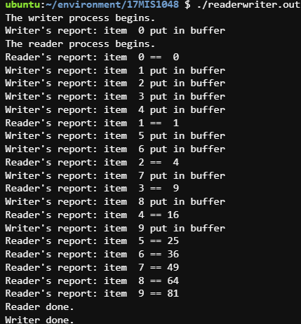

1. **Write a bash shell script to monitor the health of your system. Let the details be stored and archived in any folder of your choice.**

#!/bin/bash

echo -e "

Hostname : `hostname`

Kernel Version : `uname -r`

Uptime : `uptime | sed 's/.*up \([^,]*\), .*/\1/'`

Last Reboot Time : `who -b | awk '{print $3,$4}'`

`vmstat`

`iostat`

`cat /proc/meminfo`

"



 