Class Matching Points Grid

Includes:
stdio.h
math.h
vector
MatchingPoints.h

Methods:
MatchingPointsGrid(MatchingPointsList *, double res_x, double res_y);
void createNewGrid(double res_x, double res_y);
int getNearestPoint(double X, double Y);
void getPointsClose(double X, double Y, double dist);
vector <int> selected_points;

Methods description:

Genaral notes:
Matrices are images ranging from 0.0 to 1.0.

MatchingPointsGrid
Create fast structure for interpolating grid. This structure is described at the end of this document.
Grid is created based on Matching Points XYZ bounding box function.
User must define x and y grid resolution.

createNewGrid
Create new grid based on new x and y resolutions.

GetPointsClose
Create a list of points that is within the circle centered in X,Y and having the radius = dist.
The resulting list may be manipulated direcly from the object. E.g.:
MatchingPointGrid mpg(myList, 1.0, 1.0);
mpg.getPointsClose(10.0, 20.0, 5.0);
int size = mpg.selected_points.size();
for (int i=0; i<size; i++)
printf(“Selected index: %d\n”,mpg.selected_points.at(i);

Fast structure:

In order to provide a faster access to a “cloud of points” data, we developed an appropriate structure.
First, we compute the 3D bounding box values (X_{i}, Y_{i}, Z_{i}, X_{f}, Y_{f}, Zf), where “i” means the initial values of the box and “f” the final values.
Based on Xs and Ys bounding box values and a given X and Y spatial resolution (res_x and res_y), we create a grid.
Each cell of the grid contains a set of points ids, which coordinates X and Y falls within that cell spatial limits, according to the following equations:
col = round((X - Xi)/res_x)
row = round((Y – Yi)/res_y)
Figure 1 shows the structure:

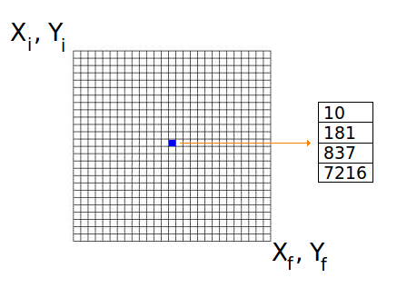Figure 1. Fast Structure

This structure allows the grid interpolation with the analysis of much fewer set of points and faster than some traditional tree structures.
For a given X,Y coordinate, it calculates the grid col,row, as seen above. It takes in account 1 pixel in each direction, as seen in figure 2, in order to encompass all useful points. In that case, if a radius R is given, it will be considered R+1.

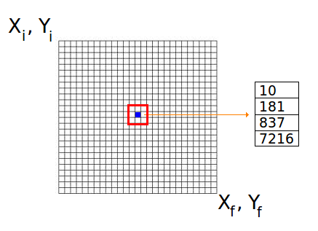Figure 2. Minimum area considered.

