

**Community Tools Against Corruption**

**Solution Architecture**

#### image Documentation licensed under the Creative Commons Attribution-ShareAlike 3.0 License: <http://creativecommons.org/licenses/by-sa/3.0/> Introduction

Anti-corruption Platform built on the open source software content and open standards. For implementing, managing and using the platform there is no need for obtaining any additional commercial content or tools. Anti-corruption Platform implemented by using open source operating systems. Any browser (including browsers of mobile devices) can be used. The platform will be mobile friendly, and compatible with all mobile devices.

#### Technical solution

**Soft Tehnica’s Approach:**

The Soft Engineering Company undertakes to provide the services described in this offer, limiting itself to its own resources, without concluding subcontracts with other companies and organizations. Next, please find all the necessary information about the technology, the technical solution and all the details necessary for the successful implementation of a project.

**Solution architecture:**

For system architecture, we use the existing platform (Drupal 8) to develop the website "Anti-corruption Platform " so that the web page responds optimally to the requirements.

Modules will developed with Drupal CMS. The IT platform includes modules for platform management: Backup, Audit, Control, Security, and so on. The platform run on the server with OS from the UNIX family, Apache web server and MySQL Database. It will be possible to access the site from the internet.

#### Development Technologies - Drupal CMS Platform (Framework)

**General Description:**

Drupal is an open source content management (CMS) platform developed in PHP language and distributed under the GNU General Public License. It uses at least 2.1% of all global websites, from personal blogs, to online stores, government websites, presentation sites, and even social networks. The standard installation of Drupal, known as Drupal Core, contains the essential features of a content management system. These include:

• Managing user accounts,

• managing content types (articles, pages, other types) and creating content;

• Classification of content using nomenclatures;

• Menus management;

• RSS feeds,

• Customizable graphics themes.

There are over 21,000 free Drupal-enabled modules available to modify and extend the core capabilities of CMS and add new features or customize the Drupal platform functionality and its look.

With these modules and modular design, Drupal is the most versatile open source content management system. Drupal is also described as a web platform on which to create various web applications known as Drupal distributions. Although Drupal offers a sophisticated programming interface for developers or programmers, Drupal is very accessible to those without programming knowledge who want to use the basic installation of Drupal and manage their own site.

Drupal runs on any platform that supports both a PHP server (including Apache, IIS, Lighttpd, Hiawatha, Cherokee or Nginx) and a database (such as MySQL, MongoDB, MariaDB, PostgreSQL, SQLite or even Microsoft SQL Server).

**Drupal Benefits for Web Development:**

The main advantages offered by the Drupal platform are:

**• Easy to use -** the administration interface makes it easy to carry out daily tasks with a host of facilities for website builders and content publishers.

**• Flexible -** Users with assigned rights can define their own content structure and add custom fields to content modules, users, vacancies, comments, entities, and more. Data for these fields can be stored in SQL, NoSQL databases, or remote storage can be used. In addition, one of the modules already available for Drupal can be used at any time.

**• Scalable -** The site built with Drupal will be fast, prompt and will be able to withstand increased traffic due to enhanced JavaScript, CSS optimizations, better caching and more.

**• Expandable -** thanks to the effort of the entire community, over 21,000 Drupal modules are available or under development, including Views, Pathauto and WYSIWYG, at least one being launched every day.

**• Open source -** Thousands of people are working together to continuously improve Drupal platforms, modules, themes, and distributions. Much of the modules, the themes are free, which helps to significantly reduce the costs of web developers. It is therefore very likely that a difficult problem has already been solved.

**• Personalization** **(layout and structure), chord and structure -** With regard to features, operation, layout and design, Drupal is highly customizable, offering lots of choices for developers and designers to meet customer requirements. The platform allows you to accurately control what appears on the screen with Render API generating functionality and some really advanced alter hooks. The new RDF module provides semantic web markup.

**• Image and file management -** Adding images for content is a default feature. The platform allows you to generate different styles of images for thumbnails, previews, sliders, and other image styles. Files can be handled privately or as public files.

**• Automatic Code Testing -** Drupal has an automated testing framework with over 30,000 embedded tests allowing continuous integrated testing of all Drupal core modifications and modules created by community members. So for each update, the platform guarantees no bugs.

**• Good Database Support -** Drupal has a database layer that improves out-of-the-box support for SQLite, MySQL / MariaDB and PostgreSQL. Also, modules created by community members can be installed to use MS SQL Server, Oracle and others.

**• Creating distribution profiles -** Drupal uses the concept of installation profiles to create distributions or even Drupal content. A new API and portable configurations allow the code to include multiple settings.

**• Enterprise class solution -** In terms of scalability, flexibility, reliability, maneuverability, security, interoperability, and availability of resources, Drupal is a Enterprise class solution. The platform can easily be integrated with other applications such as SAP, phpBB, etc.

**• Increased security** - Building platforms in Drupal allows compliance with best-in-class application security practices with measures that prevent vulnerabilities included in OWASP TOP 10. This involves security measures for the server side and platform side.

**• Extended API support -** Drupal provides extensive API support for integration with Facebook, Twitter, Google Apps, Google Analytics, YouTube, etc. Whenever custom custom modules can be created by using a well-documented API.

**• It's SEO-Friendly -** Because SEO plays a vital role in the online marketing strategies of any company, Drupal allows the creation of SEO-friendly web sites with great flexibility to display content in a way used by search engines.

**• Mobile responsive -** The growth and spread of smart devices opens the gates for the new marketing platform for companies. For smart device users "you can also see the Drupal site as well as desktop users. Small businesses can rely on this feature in order to generate more tracks.

**Soft Technica has implemented the following types of projects based on Drupal technology:**

* Corporate and promotional sites to facilitate marketing efforts in setting up digital presence;
* Smart Solutions for SMEs (Drupal for Business) to accelerate working processes: collaborative systems (Drupal intranet platforms, Project Management Tools), ERP, study planning systems and corporate training (LMS), Digital Asset Management (DAM), event management applications.
* Drupal-based SaaS based content for start-ups and technology enterprises: complex software that helps businesses deliver qualitative on-demand services to their customers.
* Community solutions: Platforms for NGO-type organizations, including platforms for crowdfunding campaigns.
* The Soft Software team constantly improves its expertise and is a technology leader within the Drupal community being involved in creating and maintaining Drupal modules and supporting the Drupal Association.

#### Drupal Structure

**Drupal has a modular structure on five main levels:**

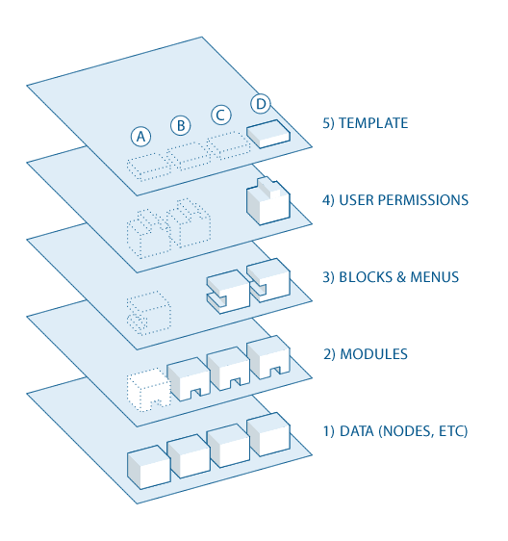

**Data Level**

At the bottom of the system is the concept of nodes, which are configurable data structures and which retain the content on the platform. Before they display information on the site, they must be entered into the system.

**Module level**

The next level is the module. Modules are functional plug - ins that are either part of the Drupal core or are developed by contributors, members of the Drupal community. The modules are based on Drupal's basic functionality, allowing custom data elements (fields) to be grouped on programmable nodes, and display customized content based on user-defined filters.

**Level of blocks and menus**

On the next level are blocks and drops. Blocks provide a way to display information from a module or can be created to display customized content. They can be placed in different places (regions) of the layout (theme) aspect. Blocks can be configured to exit in different ways, as well as display only on defined pages, or just for certain users. Menus are navigators in Drupal. They define the content that is displayed for each defined address (relative URL). Menus are a basic element of Drupal, which provides links to all pages created in Drupal.

**Permissions**

Another level gives it user permissions. This level checks the configured settings to determine which types of users have view or change access. Permissions are defined for different roles. Users are assigned to these roles in order to grant them defined permissions.

**Presentation**

The top level is the theme of the site. This is mainly composed of XHTML and CSS, with some Twig variables mixed together so that the generated Drupal content can be displayed in the appropriate locations. Also included with each theme is a set of functions that can be used to overwrite standard functions in modules to provide full control over the mode. Templates can also be assigned to user-based execution.

This bottom-up directional stream controls the way Drupal works.

#### Architectural decisions

The technical software proposal is based on a separate modular architecture on functional levels, which implies the existence of several components that will fulfill a complex functionality in the application. At each level of the application, the modules will respond to various functionalities. The flow of data within the platform will be organized so that the separation of the business level database level and the presentation level is clear.

Separating the application into modules will allow for more efficient division of permissions and granulate functionality so that the administrator can create roles and permissions as accurately as possible.

**In the following diagram, we will link the main functional modules of the platform:**

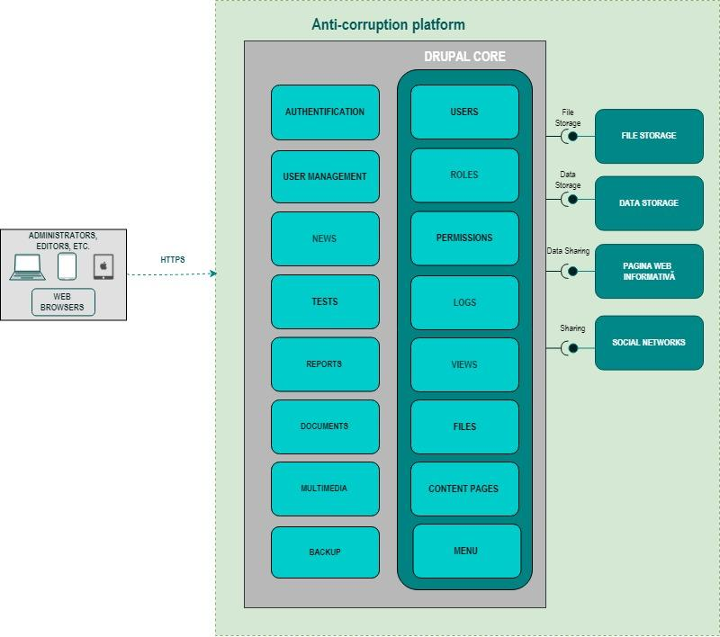

#### Anti-corruption Platform Modules

* The Anti-corruption Platform functional modules required by the the Contracting Authority and its Partner will include both standard modules such as Backup, Audit, Control, Security, and additional developed modules.
* The modules that will run in the Anti-corruption Platform background:
* Content Management System (CMS)
* News&Research
* User Management
* Media
* Tests
* Reports
  + 1. CMS Module:
* The CMS module is used to manage the content of the public site. Within this module, the Administrator will define pages, blocks, links, and other public data structures.
* For this purpose, the Spring MVC platform is used - a system used to organize and facilitate the creation of web content. This system facilitates both visual and logistic administration of portal content. The CMS module is used to publish content on the Internet through which content management, storage, and accessing information is performed. This module allows a better organization and indexing of content (text, images, audio or video clips) in a flexible way, as required by the Contracting Authority and its Partner.
* In addition to the CMS Module operating facilities, they allow any authorized user (CMS Administrator) to add information to the portal through forms. They are based on templates that act as a platform for adding / modifying content for each page of the portal, depending on the type of information to be entered / introduced. Modules will allow publishers to publish content quickly and easily without necessarily having specialized technical training. A variety of content can be published using this system: from simple to complex pages with special design and presentation with dynamic information.

**Homepage – Main Page**

* Main landing page for Anti-corruption Platform information center;
* Links to the pages of the platform – Learn, Test, Be Involved.
* Block with 1)Top Institutions – Number of reports per institution, 2)Top Problems – Number of reports per problem, and 3)Total number of Reports:
* Top Institutions that are reported – link to the Report Page, Filtered by the Targeted Institution
* Top Problems that are reported – link to the Report Page Filtered by the Targeted Problem
* Number of Reports – cumulative number of reports, being incremented as soon as a new corruption case is reported
* Block with last anticorruption problems reported (the title of the block is the name of the problem), with short quotes from each report, including date of the report and targeted institution
* Block with video “Meet CPR Platform” – short video about the project;
* Newsfeed, news and research archive about advocacy activities;
* Report Template – including Code of Conduct (Popup feature)
* Contacts of CPR;
* CPR newsletter subscribe box
* Project- and platform-related information with logos of partners (eGA and CPR) and funding institutions (OSI and MFA of Estonia);
* The links to social media of CPR (FB, twitter etc);
* Privacy Policy (PopUp), Sitemap, About the Project (PopUp)

The homepage should be concise and not overloaded with information. It should guide the user to the main modules.

**LEARN page**

* After pressing the button “LEARN” on the homepage the user is directed to the LEARN page with general descriptive texts about different categories of corruption. Different categories of corruption are displayed after opening the LEARN page. Every category has a descriptive text (text area incl. opportunity for multimedia). The descriptive texts are meant for advancing the user’s knowledge on the essence of concrete category of corruption and its legal consequences. Initial list of categories (up to 10 categories)
* “Do you recognize corruption?” block with the link to the Test Page
* Block with Report and Be Involved Links
* Privacy Policy (PopUp), Sitemap, About the Project (PopUp)

**BE INVOLVED page**

* After pressing the **button “BE INVOLVED”** on the homepage and on other pages the user is directed to the **BE INVOLVED page,** where the introductory text about the aim of the community, the opportunities to contribute to anti-corruption activities is displayed (events, actions, information letters). **The page should also enable to upload videos.** The note on the usage of personal data protection should be displayed.

The registration template should contain the following fields:

* Name (mandatory)
* Email (mandatory)
* Phone (optional)
* link to FB account (optional)

Platform will gather following data about involved persons:

* Name (mandatory)
* e-mail (mandatory)
* phone
* link to FB account
* Date of involvement
* Date of leaving
* Reason of leaving
* After registration, the user should receive the e-mail confirmation. The **unsubscription from the list should be available.**
* News & Research Block
* Do you recognize corruption block with the link to the Test Page
* Block with Report and Be Involved Links
* Privacy Policy (PopUp), Sitemap, About the Project (PopUp)

**News Page & Research Page**

News & Research page is used to add, edit, and manage news articles. This page is divided into numerous tabs that reasonably separate the options into various logical sections:

* **Categories** - lets you add and delete News categories.
* **Field Definitions** - allows for the creation of Field Definitions for the News.
* **Options** - contains settings for submitting and viewing News articles.

**Newsletter Module:**

* Newsletter module will manage signup newsletter for your site, you can display a SIGN UP FOR newsletter form in your site where user can add their email in the form to sign up for newsletter. In the back-end, you can create email and send to the subscribers.
* Features:
* Multiple newsletters lists configurable on existing terms
* Plain text or HTML out of the box.
* Multiple schedules Each newsletter can have more than one schedule, e.g. Daily, Monthly, Weekly, manually or even custom, eg after 10 new posts for this term.
* Centralized administration and configuration on a single page.
* Users can customize the terms in the list they subscribe to.
* Custom template per list.
  + 1. User Management Module:
* The User Management Module allows users to register, login, and leave the application (auto log).
* The User Management Module provides support for user roles, which can be configured with granular permissions, which allows each role to do only what the administrator allows. Each user has one or more roles. By default, there are three roles: anonymous (a non-authenticated user), logged in (a logged-in and authorized user), as well as an administrator (a logged-in user who has assigned site administrator permissions).
* Registered users must authenticate themselves by providing username and password, alternatively an OpenID authentication.
* The visitor accessing the system has a unique session ID that is stored in the cookie. To ensure the security of cookies does not contain personal information, it acts as a key to retrieve the information stored on the server.
* The User Management Module allows:
  + Manage groups
  + Manage permissions
  + Run update scripts
  + View the user page
  + User administration
  + Creating new users
  + Set up user, mail, and picture registration
  + Select a theme
  + Consult the help option in the user profile
    1. TEST Module - H5P:
* TEST Module will be implemented by using Drupal module HP5 (<https://www.drupal.org/project/h5p>) ……
* After pressing the **button “TEST”** on the homepage or on other pages the user is directed to the TEST page with a questionnaire that has to enable the user to advance his or her knowledge on different aspects of corruption. It has to provide the respondent with the possibility to select one answer from two options as a response to a question or dilemma concerning corruption. Depending on the concrete answer, the user is given an explanation, whether the chosen pattern of behavior is recommended or not and what is the reason. The TEST page starts with the explanation of the purpose of the questionnaire (textual, up to 1000 symbols). The press button **“START”** is visible; this leads to the first question. The question, the answer and the explanation are text areas, but should also include possibility to add pictures, videos, hyperlinks.
* When all questions are answered following information is displayed: the text, which thanks the user for taking the test; was it useful for the user (Yes/No answer), the possibility to share the test on social media:
  + an invitation to join community (button leading to the BE INVOLVED page);
  + to report (button leading to the REPORT page) and
  + to learn more about the corruption (button leading to the LEARN page).
* The user should also have the opportunity to share his or her TEST result on social media.
* The user should have the opportunity to share the TEST subpage (the Mockup “cpr-test-design-00”) on social media after completing the test.
* Platform has to include tools for administrators to generate and edit any piece of content. The administrator should configure the questions, the answers and explanations.
* **The administrator should be able to see the statistics of the answers to the questions** (in order to analyse the results, for instance, which question gathered most correct or wrong answers).
* Statistics contain the following fields:

- Range number of concrete user (generated by platform)

- Date

- Number of correct answers per user

- All answers of all questions of user

* Total number of users All statistics should be archived. It has to be possible to start gathering statistics from scratch (for example after changing of questions). The platform should include the tool for downloading statistics in CSV and XML format for processing data with external tools.

**H5P - Create and Share Rich Content and Applications**

With this module, you will be able to create interactive videos, question sets, drag and drop questions, multichoice questions, boardgames, presentations, flashcards and more using Drupal.

All the content is HTML5, meaning it will work great on smartphones, tablets and other mobile devices. With H5P, you create and edit HTML5 content directly in your web browser just like you edit any other Drupal content.

In addition to being an authoring tool for rich content, H5P also enables your site to import and export H5P files. H5P files are package files for HTML5 content and applications. They work much the same way as Flash files work. You can easily upload them to your Drupal site and publish rich Internet content and applications. Whenever you upload a new type of content as an H5P file, your editor will learn how to create and edit this type of content so that you're able to create more content of the same type, using the H5P editor. This makes H5P a very powerful authoring tool.

In Drupal 8, H5P is implemented as a field, i.e. not a content type like in Drupal 7.

1. Install the H5P module as you would install any other Drupal module.
2. Enable the **H5P** and **H5P Editor** modules
3. Add an H5P field to a content type (admin/structure/types/manage/your-conten-type/fields)
4. Go to **Manage form display**, and choose **H5P Editor** as widget for the H5P field

**Administration of H5P libraries**

An H5P administration interface is available at /admin/content/H5P. This page lists all installed H5P libraries, and provides the functionality to:

* Add H5Ps containing libraries only (no content)
* Delete unused H5P libraries
* List all nodes using a specific library

The process of creating new content and new libraries for H5P is documented on [http://h5p.org](http://h5p.org/).

* + 1. Reports Module:

After pressing, the **button “REPORT”** on the homepage the user is redirected to the **REPORT page.** The REPORT page aims at providing the user with the opportunity to report corruption-prone situations and procedures. The explanatory text about the conditions of reporting should be clearly visible on the REPORT page. In addition, the good code of conduct should be displayed (text area in PopUp feature).

**The reporting template appears on the REPORT page with a text “Do you know a corruption case?”**

The **user selects answers from the dropdown menus** of the template that are predefined and inserts the required text into the blank fields. The template should not overburden the user, but at the same time should provide enough information for statistics.

The template for the user contains the following fields:

* Title (mandatory for the user)
* Institution (mandatory for the Content Administrator)
* User is inserting the name of the institution or choose suggestion from the list. If the institution is not suggested, the new one can be typed by the user. The new institutions are added to the list of existing institutions. If the institution indicated has subdivisions, following fields appear additionally:
* - the field for indicating a subdivision (with a dropdown menu)
* - the field for indicating the type of procedure (with a dropdown menu)
* Type of problem with a dropdown menu, with the option to add other problems ((mandatory for the Content Administrator)
* Description of the report (1000 symbols) (mandatory information for adding by the user)
* Upload a file - photo, pdf, videos, audios, links (optional for the user).
* Users can report anonymously, but can also insert his or her name (optional) and leave his or her contact details after submission of the report (optional, see details below). After submitting the report (pressing the button “SUBMIT”), the text thanking the user for the input and further instructions on what happens with report are displayed (text area).
* In addition, on the same page the user is asked, whether he or she wishes to leave contact details (name and e-mail) in order for administrators of the platform to be able to contact the user in case of additional questions. The fields for inserting the name and the e-mail are displayed below the question, afterwards clicking the SUBMIT button.
* The user that provided the e-mail as a further contact regarding the report gets an automatic notification, when the report has been approved by the moderator and is publicly available on the platform. The link to the report on the platform is provided in the notification text.
* Also, the second button asking whether the user is interested in the news regarding corruption. The link is provided that leads to the BE ENGAGED page (Join Our Community Button).
* Users’ reports are publicly displayed on the REPORT page only after moderation by the Content Administrators.
* The REPORT page also displays the statistics on the submitted reports: per institution and per problem Platform should include tools for archiving reports. The database of reports is created.
* **Statistics (Administration Feature)** for every report should include the following data:
* Range number of concrete user (generated by platform)
* Date
* Name (if exists) or anonymous
* E-mail (if exists)
* IP address
* Institution
* Subdivision (if exists)
* Type of problem (if exists)
* Title of the report
* Text of the report
* Text after editing by administrators
* Reports Page
* Filter Reports by: Institution, Problems, Period
* List of the Reports with expansion feature, reported by users
* Block with Report, Learn, Be Involved
* Platform has to include tools for administrators to generate and edit any piece of content. All reports should be archived. It has to be possible to start gathering REPORT statistics from scratch (for example, after changing of structure of report).
* The platform should include the tool for downloading REPORT statistics in CSV and XML format for processing data with external tools.
  + 1. Administration module
* Platform includes the environment for administrators. This environment and tools will open for them after login.
* The role of the administrator is to manage the information provision on the platform, to configure all modules (incl. to manage and edit reports), detect abuses, block spammers, analyse and display statistics. More detailed description of administration tasks is provided above per each functionality.
  + 1. User groups. Authentication and authorization
* Platform should support 3 types of users:
* Anonymous users may use platform without procedure of login
* Content Administrators of the platform
* Administrators of platform are involved users whom is granted the right for administration of the platform.
  + 1. Internationalization (Multilingualism) module
* Platform will support multilingualism. The list of supported languages will be specified in the configuration of platform. For every supported language will be provided corresponding language file, which translates all interface elements.
* The initial supported languages are: RO, EN, RU. The initial content of the platform will be in RO. The Customer will provide translations.

## User stories

|  |  |  |
| --- | --- | --- |
| Type of user | Possibilities | User stories / possibilities |
| Unauthenticated User | • Navigate through the website • Search site information • Signup for newsletter | **User story Looking for information, Navigate**  As a random site visitor, I wannt to navigate through the site, read about CPR, discover events/ books/read blog/watch videos, see photos.  In addition, I want to tap a key word in the search bar so I can get the information I am looking for. |
| **User story Subscribe to the newsletter**  As a site visitor I want to subscribe to the newsletter, so I can receive in my inbox news about CPR's activity.  As subscribed user I want to be able to unsubscribe in a comfortable way. |
| **User Story Learn**  **As a site visitor I want to learn about different corruption types.** |
| **User story Take the test**  As a site visitor, I want to take the test and try my knowledge of corruption matters, get suggestions. For this, I will answer questions, see the results and correct answers.  After competing the test, I want to share the Test page with others on my social media accounts. |
| **User story Report a corruption case**  As a site visitor, I want to have the possibility to report corruption cases I know. For this, I want to have the possibility to report the situation in written form, to upload a picture, video, voice registration and to leave my contacts or to be anonymous. |
| **User story Get involved**  As a site visitor, I would like to not only navigate through the platform, take test, report corruption cases, but also to become part of the community joining it. For this, I will complete a special form leaving my contacts to the platform administrator. |
| Content Administrator | • Own profile management • Content creation/management • Event creation/management • Content creation/management • Can create categories and tags • Content Administrator do not have access to change your site settings or add new users • Can upload files • Users with the Content Administrator role have full control on the content sections of the website. They can add, edit, publish, and delete any posts on a site. An Content Administrator can moderate, edit, and delete comments as well. • They can edit and publish content by themselves. | **User story Content management**  As an Content Administrator, I want to manage the content (news, articles, tests, etc.) on the website so I can:  - add new content - edit current content - turn on / off content - remove content  **User story Manage content**  As an Content Administrator, I want to write and add content (text, images, videos, etc.) on the website, so people can read them.   Also, I want to modify, delete every content posted on the website.  **User Story Moderate Corruption Cases Reports**  - Add Institution to the Report  -Add Problem to the Report  -Moderate Quotes of the Report  -Moderate Reports, Edit, Delete, Approve |
| Platform Administrator | • News and articles redaction/publication • Newsletter creation/emission • Home/Front page content management • Static pages management • User management • Content creation/management • Get reports  • He is the most powerful user role. Users with the administrator role can add new posts, edit any posts by any users on the site, and even delete those posts. • Most importantly an administrator user can add new users to the site, change information about existing users including their passwords as well as delete any user • This role is basically reserved for site owners and gives you the full control the site. | **User story Users management**  As the Administrator of the website, I want to: - Add a new user manually - Activate / deactivate accounts - Repeat email confirmation - Edit details about the users - Remove users (or disable access) from the system - Assign roles within the system |
|
|
|
|
| **User story Pages administration**  As the Administrator, I want to manage all the pages on the website, so I will decide what content and where will be displayed. |
|
|
|
|
|
|
|
| **User story Reports**   As Administrator, I want to receive reports from the system, so I can see how many visitors and which kind of visotors were on Anticorruption platform, for what information were they looking for, in what period of time, did they take the test or reported about corruption cases. |
|
|
| Every user, every role |  | **User story. Change language**  As a user, I want to change the language on the website to English, Russian, Romanian so I can understant the content. |