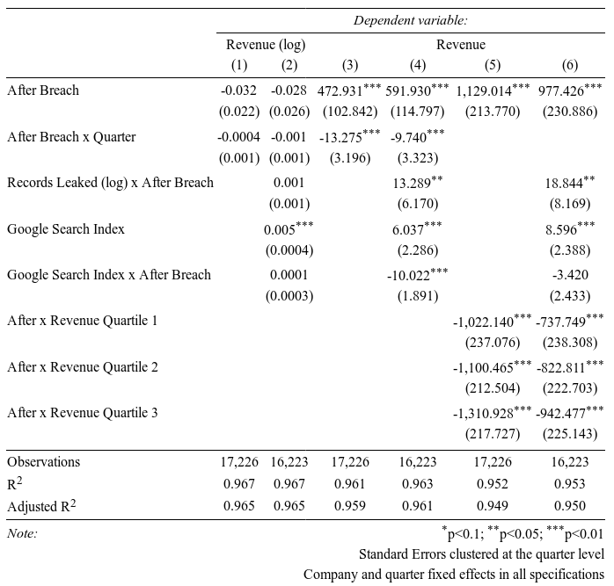
First I give some results for Revenue using my difference in difference specification. In all of the tables the first line is the difference in difference estimator and the second line is a differential time trend after the breach.

In the specifications for log revenue ((1) and (2)), there is a negative point estimate but it is not significant, nor is the differential time trend. With the same specification on raw revenue ((3) and (4)) we see a significantly positive coefficient which is very surprising. This implies that data breaches actually lead to more sales! However, the time trend is negative suggesting that these effects fade over time. Finally, when including dummies for the quartile of a firm’s revenue in it’s first period in the data set ((5) and (6)), we see that this positive effect on revenue is driven by the top quartile of firms, for the rest the net effect is close to zero or slightly negative (add the interaction with the first term). The controls included suggest that larger breaches in terms of number of records leaked result in larger gains in revenue. This is somewhat intuitive, because it is in the same direction as the average effect of a breach. Google searches do not have a clear differential effect on revenues. This is likely because in fact (surprisingly) Google searches do not increase significantly after a data breach. This is shown in the third table.
Now the same specification is shown with profit as the outcome. Specifications (1) and (2) include a company specific time trend, while the rest do not. (Note that I have considered including time trends for the revenue specifications as well, but excluded those here for the sake of brevity).
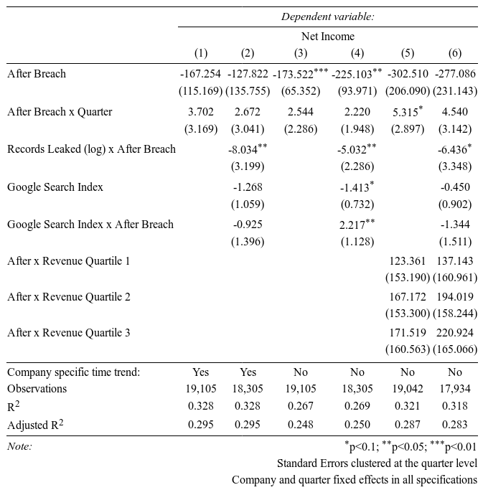
We can see that without time trends there are significantly negative coefficients (data breaches cause loss of profit), and similar point estimates in other specifications. In the other specifications the coefficients are not significant because the company specific time trends and “quantile regression” take away a lot of power. Overall, there seems to be evidence that data breaches cause lost profits. Since the differential slope is insignificant in all specifications, it appears these losses are persistent. Unfortunately the quantile regression is not as interesting here, because the standard errors are very large, so it is hard to say if there is any differential effect depending on firm size. Specifications (2) and (4) suggest that larger breaches result in larger losses in profit, but again Google searches do not have any clear effect.

Considering that revenue appears to go up, and profits appear to go down, basic knowledge of accounting would dictate that expenses must being going up. I went back to COMPUSTAT and downloaded the full list of quarterly outcomes in order to test if this is the case. In the following table I show a variety of variables as outcomes in the same difference in difference specification in order to determine what else might be affected by data breaches, as these may be useful controls in the specifications for revenue and profit.
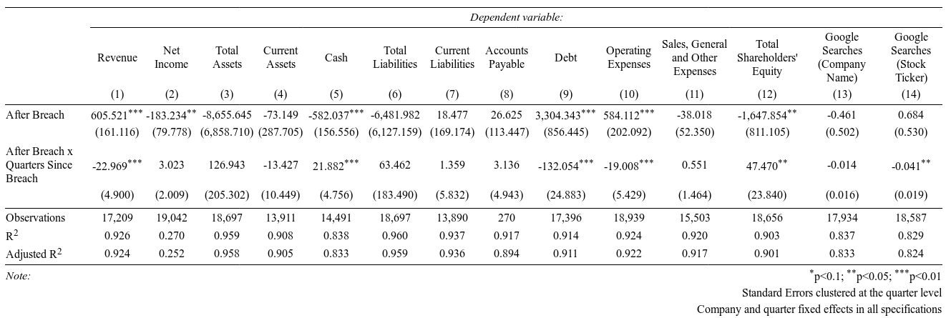
Data breaches seem to have no effect on a number of elements that we might expect to see an effect on such as sales expenses (advertising), Google searches, and current liabilities. However, it does seem to have a substantial differential effect on other variables, in particular, cash on hand, debt, operating expenses, and shareholder equity. These suggest a number of potential mechanisms for the effects on revenue and profit. I will consider them one at a time.

Loss of cash is intuitive; firms who do not expect the data breach to happen will be forced to pay out of pocket for surprise expenses which will deplete their cash reserves. The differential time trend here is positive as expected suggesting that these cash reserves recover over time. Increase in debt is also intuitive. If the breach causes a large amount of costs on the firms, then they may be forced to borrow to cover expenses. Again, as expected the time trend suggests that debt levels recover over time. Operating expenses are effectively total business related expenses. As expected these increase because of the data breach, and again recover over time. Unfortunately, this is a very broad measure, so it does not help to explain what costs in particular increase as a result of the data breach. I hypothesize that, for example, legal expenses are significant, however, the data-set does not appear to have data that is that granular. Nonetheless, this conclusion is at least consistent with the “revenue – expenses = profit” hypothesis. Finally, we note that shareholder’s equity decreases as a result of the breach, and then recovers over time. This is also an intuitive result, and it will be interesting to compare this to the results of the stock market study, which I have not yet been able to complete.

In summation, the preceding analysis suggests that data breaches lead to increases in revenue, particularly for large firms, but also proportionally larger increases in expenses that result in a net reduction of profits. These effects tend not to persist, and in nearly all regards firms appear to recover from the data breaches over time.

