Stock Market Event Study
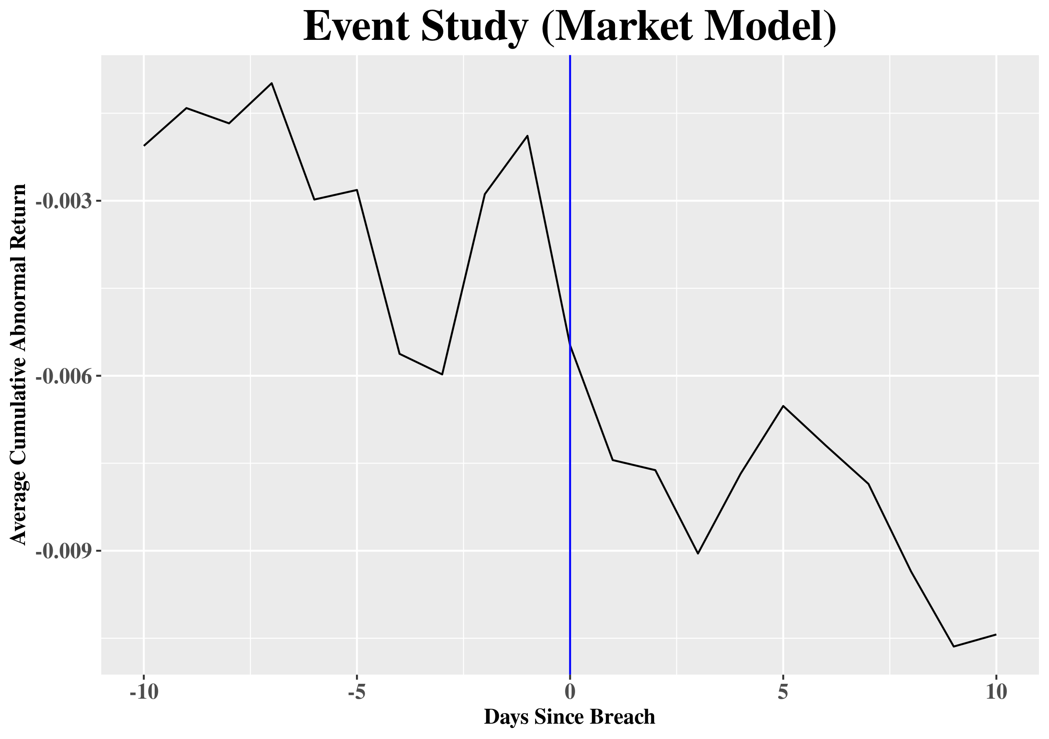
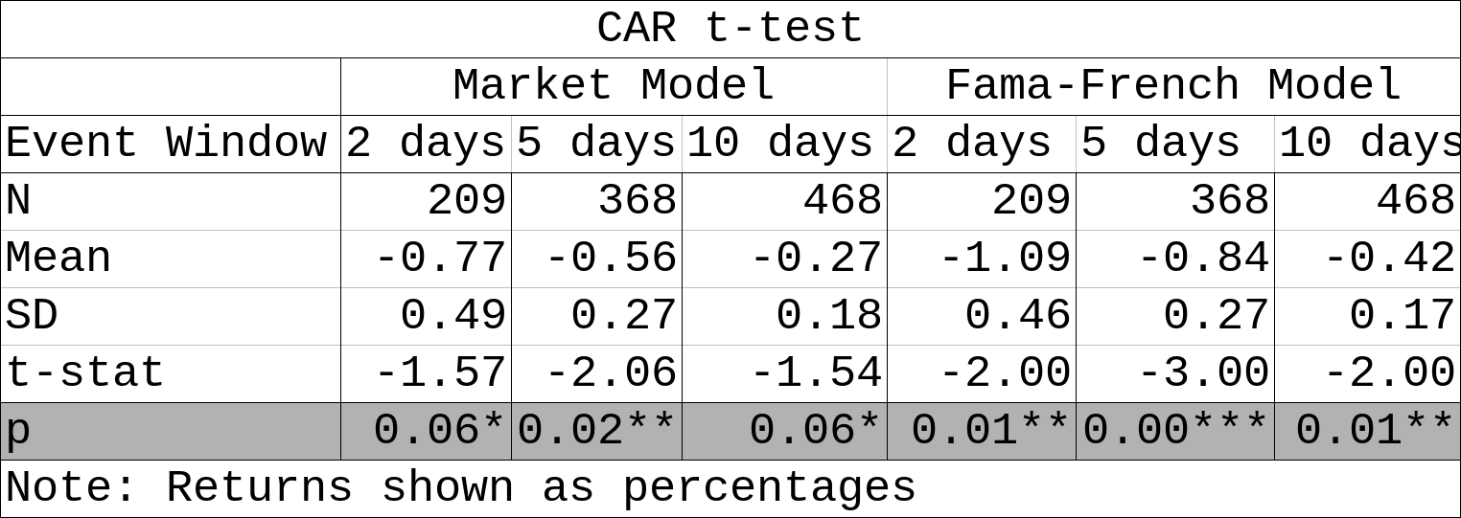
- Stock prices decrease significantly after data breaches, robust to many specifications.

- Stock market seems to react more strongly than firm specific variables – but this does not mean it is disproportionate.
Market Impact
What is privacy worth to consumers?
information? What other
of Data Breaches
Do they punish firms for exposing their
costs do firms face?

By: Emmet Hall-Hoffarth
Advisors: Erik Snowberg & Marit Rehavi
Firm Event Study (Profits)
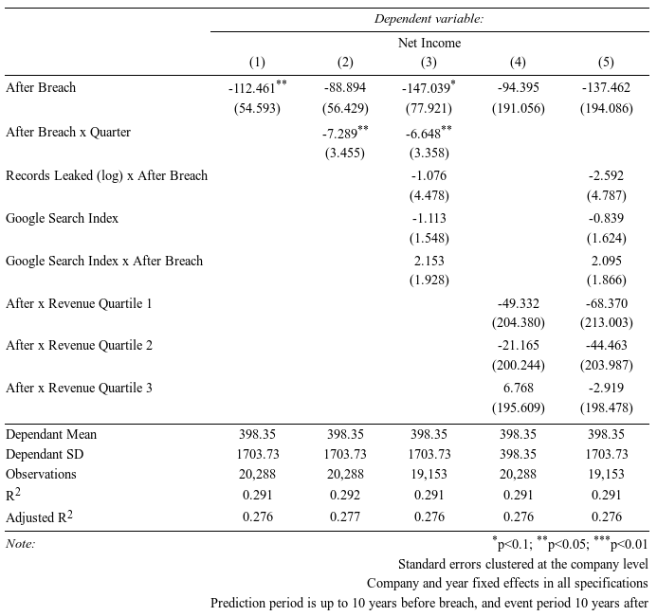

Firm Event Study (Revenues)
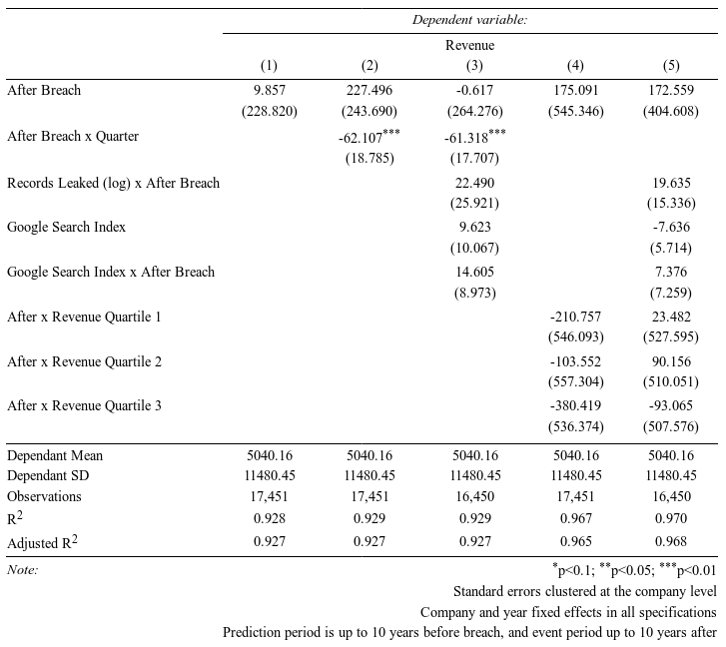
Mean Residual Profit (FE removed)
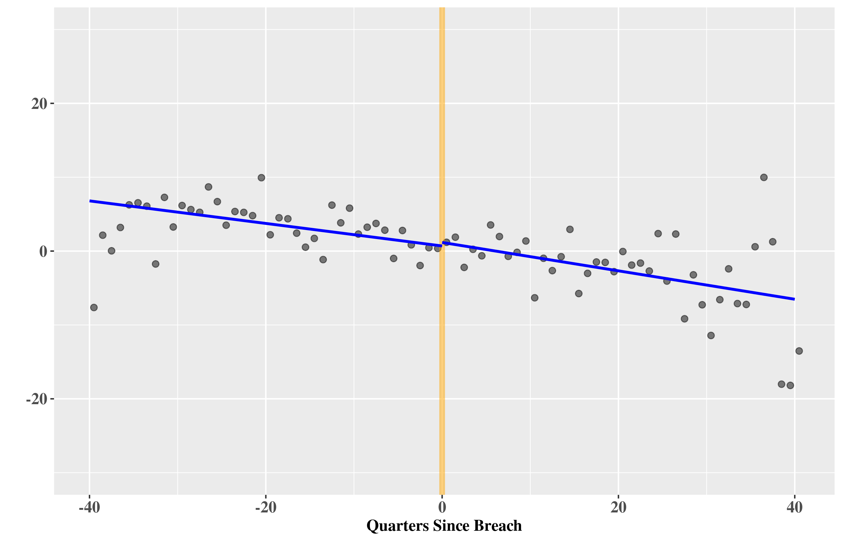
Mean Residual Revenue (FE removed)
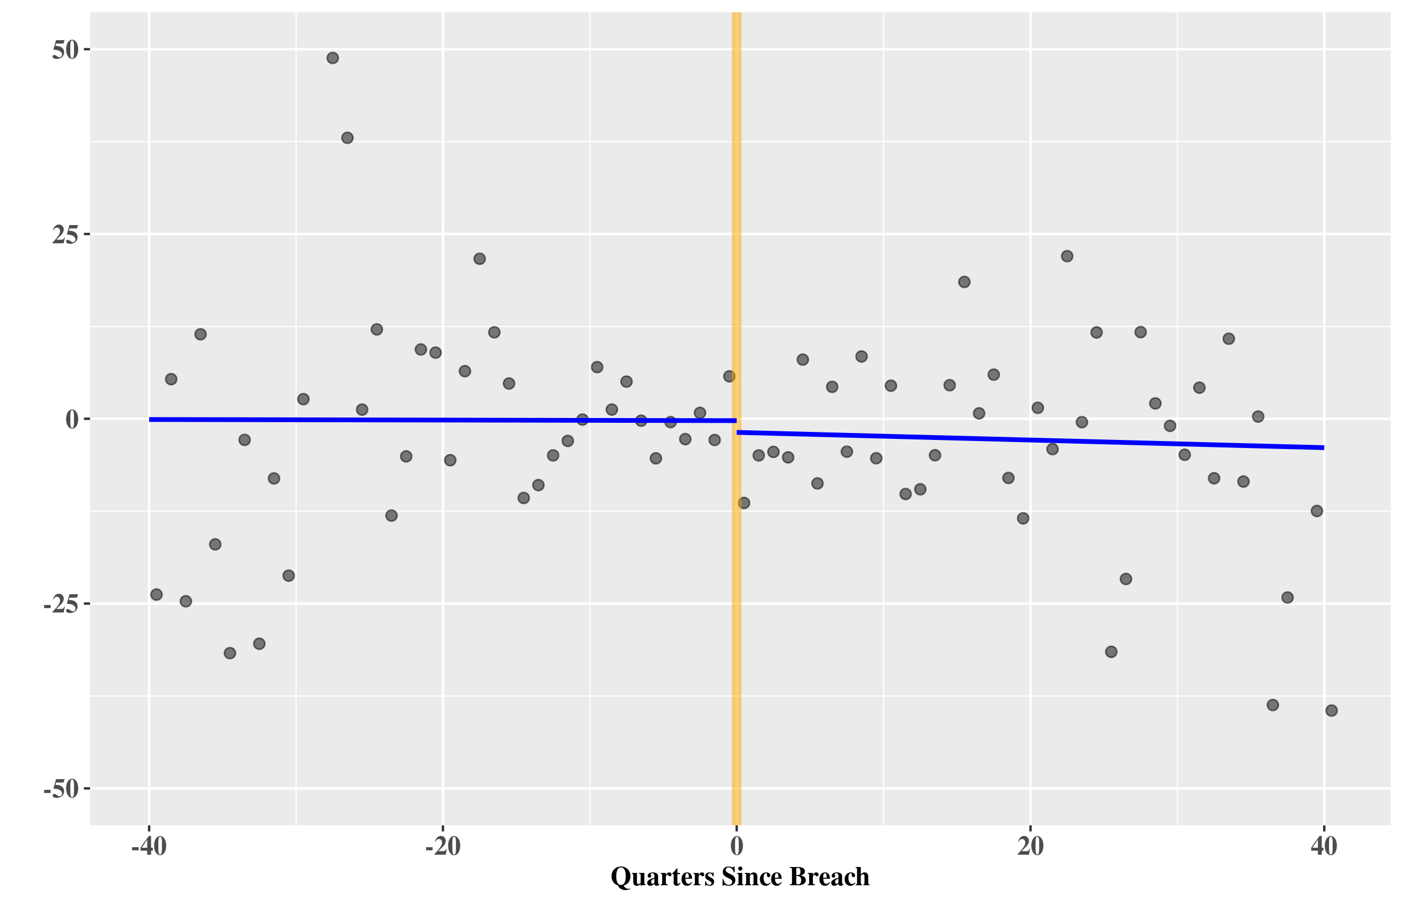
Firm Event Study (Other Outcomes)
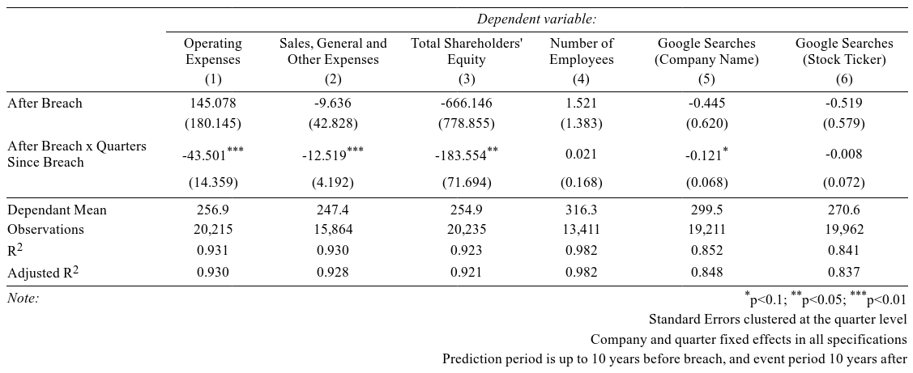
- Expenses are expect to rise because profits fall but revenues do not.
  - In fact expenses fall over time alongside revenues, suggesting that the firms are shrinking in size as a result of the data breach

- Google searches do not seem to be affected by data breaches.
Firm Event Study (Type of Data Loss)

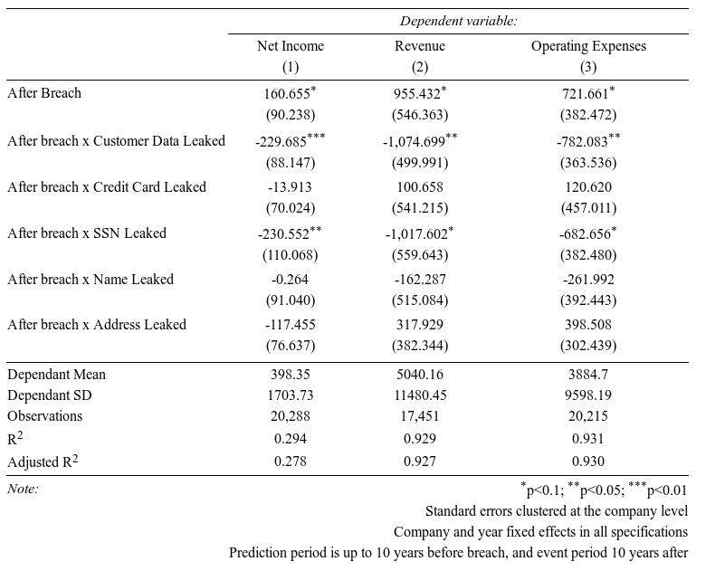
- Overall we do not observe significant consumer punishment. However, when it is “Consumer Data” (as apposed to for example employee data) that is lost there are stronger negative effects.

  - However, the net effect (subtract row 2 from row 1) is close to zero.

- No evidence that consumers respond to loss of their credit card, name or address.

- Consumer response (lost revenues) is strongest to the loss of social security numbers.

  - This is reasonable considering that consumers likely only give this information to institutions they believe are trustworthy.

Summary Statistics
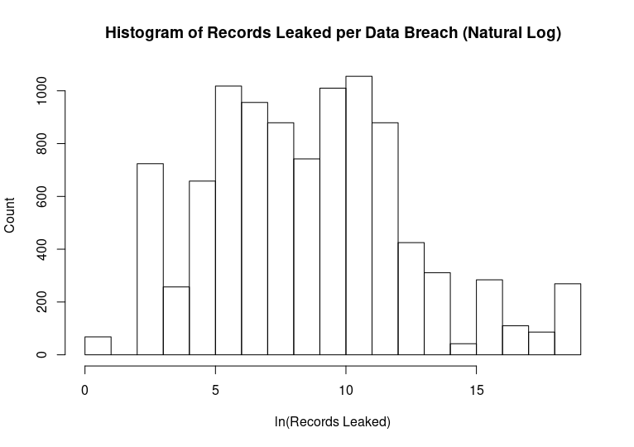
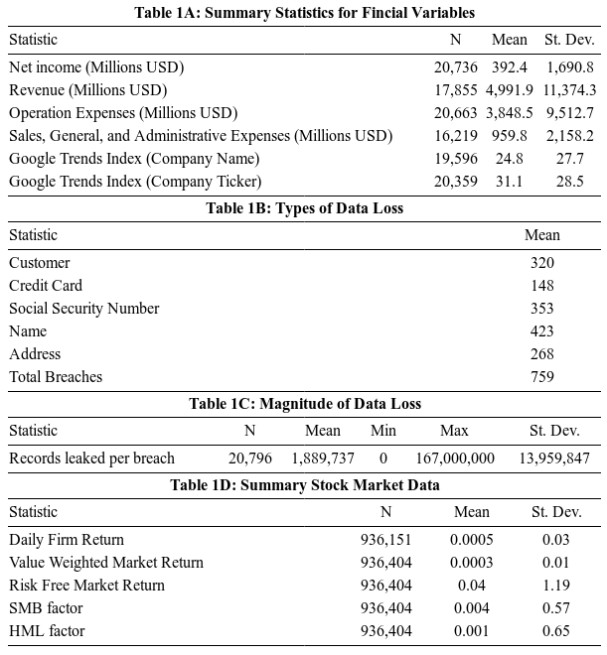
Key Take-Aways

- Firms suffer from lost profits as a result of data breaches, but not at the hands of consumers.

- Effect is not large, average discontinuous drop in profits after a breach are 6.5% of a sd.

- Firms’ revenues react weakly, if at all, although there may be more negative effects for smaller businesses.

- Lost profits recover over time (After x Quarter). However, convergence rate is such that they will not obtain previous levels in any reasonable time frame.

- The size of the data breach does not seem to matter (2).

- Consumers react more when it is indeed “consumer data” that was lost, and social security numbers are particularly sensitive (3).

- The stock market reacts strongly to data breaches.
Methodology

- “Firm Event Study” has this functional form:

Where:is the outcome for firm i in quarter q, is a dummy that indicates whether a firm has had a data breach after quarter q, and Q is the current quarter.andare firm and year fixed effects.

- “Stock Market Event Study” uses standard finance models (Market and Fama-French) to predict returns after the breach.

- These predicted returns are summed over the event period to calculate Cumulative Abnormal Return (CAR), for which a t-stat can be computed.

- Event study the key identifying assumptions:
  - A) The event actually took place when it was recorded.
    - Verified by testing for no effect on placebo event dates.

  - B) No other events happen simultaneously.
    - This is more difficult to confirm. Firms may choose strategically when to admit a data breach.
Motivation

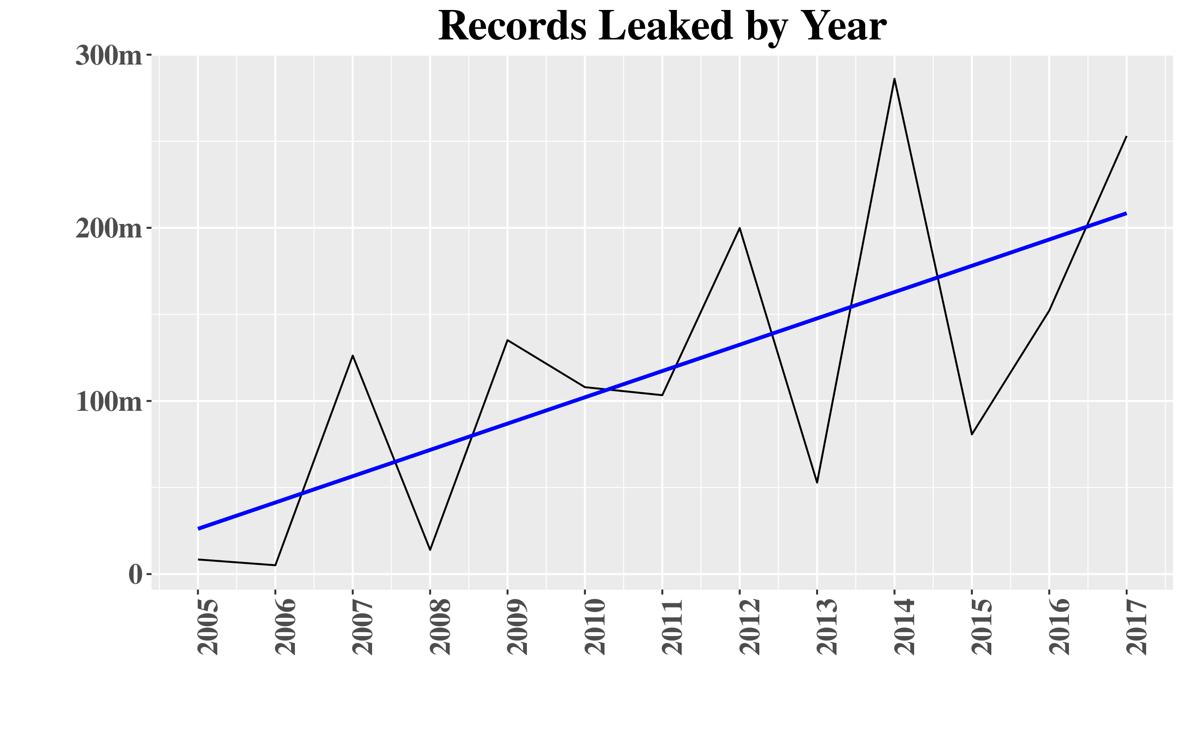
- The frequency and severity of data breaches has been increasing at an alarming rate.

- While much concern is expressed in the media and by privacy experts, little is known about the true costs of data breaches.

- Do consumers “punish” firms for leaking their information by boycotting, resulting in reduced sales?

- If not consumer reaction, what other costs do firms face?

- Are stock market reactions in line with actual business effects?
Data

- Data were combined from a number of sources for this paper:

  - Privacy Rights Clearinghouse: Registry of all publicly announced data breaches. Firms in the United States are legally mandated to publicly announce data breaches.

  - COMPUSTAT: Data on firms’ income, revenue and other financial information for the “Firm Event Study.”

  - CRSP: Data on daily stock returns for the “Stock Market Event Study.”

  - Kenneth French: Data for model factors for the “Stock Market Event Study.”

  - Google Trends: Data on Google Searches of companies was collected using an (unofficial) API for Google Trends.
Stock Market Event Study
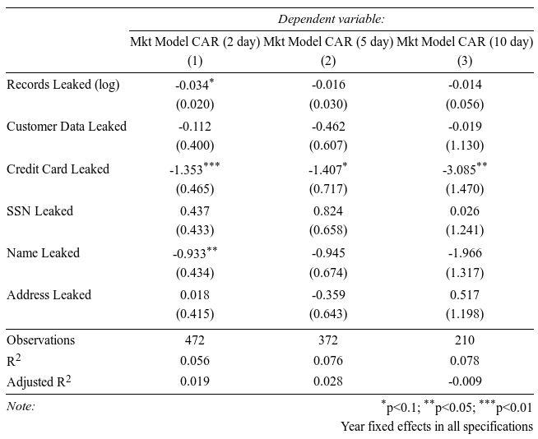

- Regress CARs on characteristics of breach to determine what is associated with response.

- Results are correlations only.

- As in Firm Event Study number of records leaked not a strong predictor.

- Surprisingly, stock market seems responsive to credit card leaks but not social security number leaks, but reverse / confounding causality possible.

