Specifications:
- There are 2 tasks to be solved in 12 hours in this take home exam.
- You will implement your solutions in the1.cpp file.
- You are free to add other functions to the1.cpp
- Do not change the first line of the1.cpp, which is #include "the1.h"
- Do not change the arguments and return value of the functions crossMergeSort() and sillySort() in the file the1.cpp
- Do not include any other library or write include anywhere in your the1.cpp file (not even in comments).
- You are given a test.cpp file to test your work on Odtuclass or your locale. You can and you are encouraged to modify this file to add different test cases.
- If you want to test your work and see your outputs you can compile your work on your locale as:
>g++ test.cpp the1.cpp -Wall -std=c++11 -o test
> ./test

- You can test your the1.cpp on virtual lab environment. If you click run, your function will be compiled and executed with test.cpp. If you click evaluate, you will get a feedback for your current work and your work will be temporarly graded for limited number of inputs.
- The grade you see in lab is not your final grade, your code will be reevaluated with different inputs after the exam.
The system has the following limits:
- a maximum execution time of 1 minute (your functions should return in less than 1 seconds for the largest inputs)
- a 256 MB maximum memory limit
- a stack size of 64 MB for function calls (ie. recursive solutions)
- Each task has a complexity constraint explained in respective sections.
- Solutions with longer running times will not be graded.
- If you are sure that your solution works in the expected complexity constrains but your evaluation fails due to limits in the lab environment, the constant factors may be the problem.
- If you solution is correct, the time and memory limits may be adjusted to accept your solution after the lab. Please send an email if that is the case for you.
int sillySort(int* arr, long &comparison, long & swap, int size);
int crossMergeSort(int *arr, long &comparison, int size);
In this exam, you are asked to complete the function definitions to sort the given array $arr$ with ascending order.
- sillySort() should count the number of $comparison$ and $swap$ executed during sorting proccess (Comparisons are only between the values to be sorted only, not your auxiliary comparisons) and return the number of calls of sillySort() (which is 1 in minimum).
- crossMergeSort() should count the number of $comparison$ executed during sorting proccess (Comparisons are only between the values to be sorted only, not your auxiliary comparisons) and return the number of calls of crossMergeSort() (which is 1 in minimum).
Silly sorting algortihm (sillySort()) is as follows:
- assume the input array A[1..N] is divided into 4 quarters as q1=A[1..N/4], q2=A[N/4+1..N/2], q3=A[N/2+1..3N/4], q4=A[3N/4+1..N]
- do 6 recursive calls as follows when N>=4 otherwise sort the list with N<4 elements directly.
- sillysort: q1 and q2 (sillysort A[1..N/2] )
- sillysort: q2 and q3 (sillysort A[N/4+1..3N/4] )
- sillysort: q3 and q4 (sillysort A[N/2+1..N] )
- sillysort: q1 and q2
- sillysort: q2 and q3
- sillysort: q1 and q2
- when the input size N<=2 no recursion. (do nothing for N=0 or 1 and just apply swap when N =2)
- to make things simpler we will only use N as a power of 2 on our tests (although not necessary with non-rec termination conditions).
- It is an in-place algorithm, so no merging is needed. Nothing else is needed after the recursive calls.
- count the swap between any 2 elements of the array A, such as swapping A[i] and A[j].
- count the comparison between any 2 elements of the array A, such as A[i]>A[j]
- return the total number of calls to sillySort()

Cross merge sort (crossMergeSort()) is a variation of k-way merge sort, where k is 4 and the partitions are merged in a different order:
- Assume the input array has N elements which is a power of 2. If the input array A[1..N] has more than or equal to 4 elements it is divied into 4 quarters as q1=A[1..N/4], q2=A[N/4+1..N/2], q3=A[N/2+1..3N/4], q4=A[3N/4+1..N]
- do 4 recursive calls as follows:
- cross merge sort q1
- cross merge sort q2
- cross merge sort q3
- cross merge sort q4
Then,
- merge q1 and q3 into h1
- merge q2 and q4 into h2
- merge h1 and h2 into resulting array

- If the input array has exactly 2 elements, just compare these elements and swap if necessary.
- If the input array has exactly 1 element, do nothing.

- You can use the following pseudocode as a base for merge function:
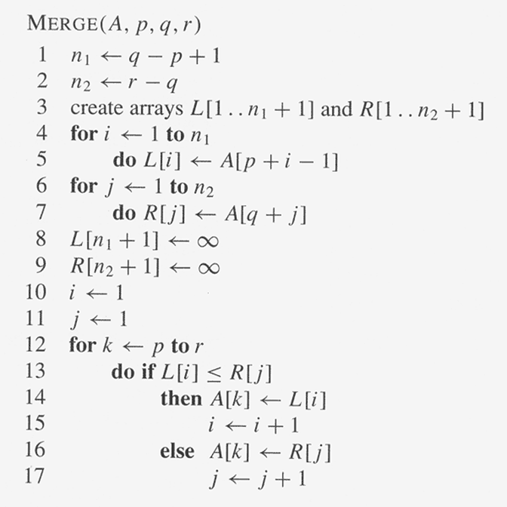
- Note that the pseudocode reads sequential data, but in our approach will merge data that are seperated from each other. Thus, the function needs modification.
- In case of equality, pick the element from leftside array(i.e. choose from q1, q2, and h1).
- Hint: when merging 2 arrays with length n, there can be minimum n comparisons and maximum 2n-1 comparisons.
- count the comparison between any 2 elements of the array A, such as A[i]>A[j]
- return the total number of calls to crossMergeSort()
Constraints:
- Maximum array size is 2^11 for sillySort() and 2^16 for crossMergeSort().
Evaluation:
- After your exam, black box evaluation will be carried out. You will get full points if you fill the $arr$ variable as stated and return the number of comparisons, function calls and swaps correctly for the cases that will be tested. sillySort() and crossMergeSort() are 50 points each.
Example IO:
1)
initial array = {-1, -3} size=2
sorted array = {-3, 1}
for crossMergeSort; num_of_calls=1, comparison=1
for sillySort; num_of_calls=1, comparison=1, swap=1
2)
initial array = {1, 2, 3, 4} size=4
sorted array = {1, 2, 3, 4}
for crossMergeSort; num_of_calls=5, comparison=5
for sillySort; num_of_calls=7, comparison=6, swap=0
3)
initial array = {7, 7, 7, 7} size=4
sorted array = {7, 7, 7, 7}
for crossMergeSort; num_of_calls=5, comparison=4
for sillySort; num_of_calls=7, comparison=6, swap=0
4)
initial array = {0, -5, 2, 6, 4, 18, 22, -14} size=8
sorted array = {-14, -5, 0, 2, 4, 6, 18, 22}
for crossMergeSort; num_of_calls=5, comparison=16
for sillySort; num_of_calls=43, comparison=36, swap=9

