PROBLEM DEFINITION
In this exam, you will help farmers having a rectangular shaped field (Width x Length) who want to partition this field according to some fixed configuration considering the type of the plant. The aim here is to reduce the area which does not belong any partition. For example, let our farmers have a field of (7 x 10) and the smallest area needed for a group of plant might be (6 x 5) and (1 x 9) for another group. They can use the same group more than once. However, the width and the length is fixed for a group of plant considering the watering and optimal case for sunlight etc. In other words, an area for a plant is not open to rotation.
What is the minimum area wasted by not planting anything? An optimal solution can be seen as:
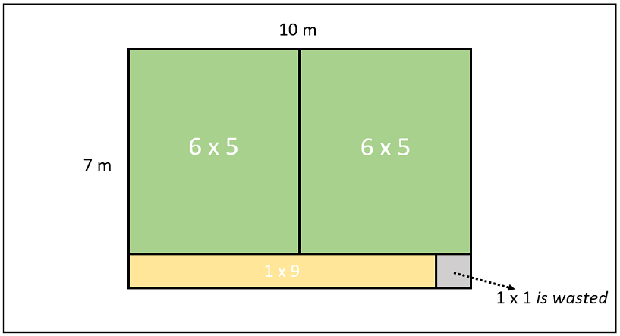
In general case, the solution can be found searching through possible cuts for partitions both vertically and horizontally. Here is the guide for computation:
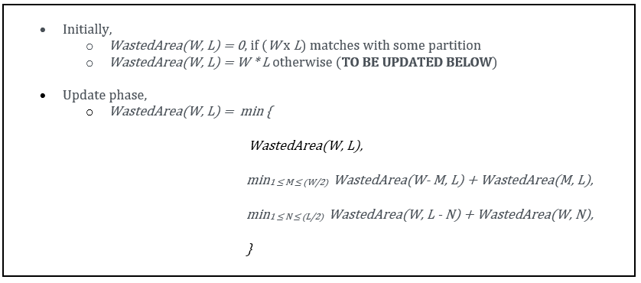
Notice that in the search of possible cuts, we go through the half of the edges since the results are symmetrical in our case. This will not be applied in bottom-up solution. That is, we will construct the solution for all of the edges in bottom-up approach.
You will solve this problem for 3 different methods as in the previous exam:
- Recursive method,
- Memoization method,
- Bottom-up method.
Specifications:
- There are 3 tasks to be solved in 12 hours in this take home exam. All of the methods will return the wasted area according to the given field and partitions.
- Partitions will be given in a 2D Boolean array where if a partition of M x N exists then, partitions[M][N] is true, false otherwise. The size of the array is (W+1) x (L+1), including the redundant initialization for 0th row and 0th column for the sake of simplicity.
- Recursive and Memoization method will compute the number of calls during the computation where the Bottom-up method will count the number of iterations while searching possible cuts (separately for vertical and horizontal cases).
- You will implement your solutions in the5.cpp file.
- You are free to add other functions to the5.cpp
- Do not change the first line of the5.cpp, which is #include "the5.h"
- <iostream>, <climits> , <cmath> , <cstdlib> are included in "the5.h" for your convenience.
- Here is the full content of "the5.h" file:
#ifndef _THE_5_H_
#define _THE_5_H_
#include <iostream>
#include <climits>
#include <cmath>
#include <cstdlib>
int recursiveMethod(int W, int L, bool** partitions, int* numberOfCalls);
int memoizationMethod(int W, int L, bool** partitions, int* numberOfCalls);
int bottomUpMethod(int W, int L, bool** partitions, int* numberOfIterations);
#endif

- Do not change the arguments and return value of the functions recursiveMethod, memoizationMethod, bottomUpMethod in the file the5.cpp
- Do not include any other library or write include anywhere in your the5.cpp file (not even in comments).
- You are given test.cpp file to test your work on Odtuclass or your locale. You can and you are encouraged to modify this file to add different test cases.
- If you want to test your work and see your outputs you can compile your work on your locale as:
>g++ test.cpp the5.cpp -Wall -std=c++11 -o test
> ./test

- You can test your the5.cpp on virtual lab environment. If you click run, your function will be compiled and executed with test.cpp. If you click evaluate, you will get a feedback for your current work and your work will be temporarily graded for limited number of inputs.
- The grade you see in lab is not your final grade, your code will be reevaluated with completely different inputs after the exam.
The system has the following limits:
- a maximum execution time of 32 seconds (your functions should return in less than 1 seconds for the largest inputs)
- a 192 MB maximum memory limit
- an execution file size of 1M.
- Solutions with longer running times will not be graded.
- If you are sure that your solution works in the expected complexity constrains but your evaluation fails due to limits in the lab environment, the constant factors may be the problem.
Constraints:
- 1 ≤ W ≤ 600, 1 ≤ L ≤ 600
- 1 ≤ Number of partitions ≤ 200
- 1 ≤ M (width of a partition) ≤ W
- 1 ≤ N (length of a partition) ≤ L
- Since recursive method generates huge number of calls, it will be tested small inputs only.

Evaluation:
- After your exam, black box evaluation will be carried out. You will get full points if you fill the return value as the wasted area and the number of calls/iterations are correct according to the given method.
Example IO:
Given field of 7 x 10 and partitions as (6 x 5) and (1 x 9):
1) Recursive Method:
  - set number of calls = 7491377
  - return 1
2) Memoization Method:
  - set number of calls = 574
  - return 1
3) Bottom-Up Method:
  - set number of iterations = 644
  - return 1
TEST EVALUATION:
Due to the limitation of our programming environment, larger inputs can not be stored. Therefore, we create them when needed. The test evaluation has 2 phases for each method. The first phase has the same inputs given here to check if your codes work fully correct on small inputs. If your code works perfectly on at least one of the first 2 tasks, it will also be tested on the second phase for the task(s) that works correct. The second phase on the other hand, creates and sorts larger arrays that are on boundaries. (Note that the tests give 50 pts for each phase. However, the real inputs will be like the ones on the second phase which means if your code works only on phase 1, it is possible for your real grade to be 0 afterwards).

