**Syllabification**

The file “**Input_file.txt**” contains the orthographic and phonetic forms of words in French.

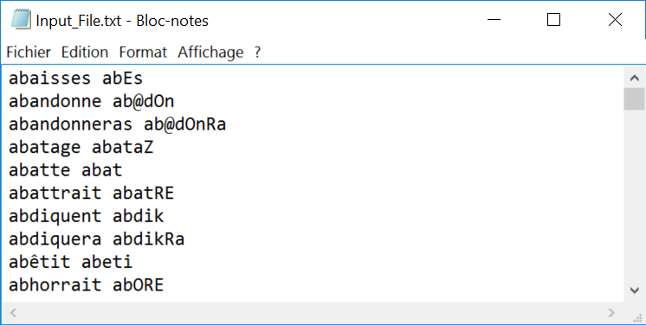

**Orthographic coding:** the following characters used:

Consonants: “**p t k b d g f s c v z g j m n r l h ç x w q**”;

Vowels : “**a e i o u y é è ê î ô â ê ë ï à ù** û»

**Phonetic coding:** the following signs used:

stop consonants: /**p t k b d g/**

fricatives: /**f s S v z Z/**

liquids: /**R l/**

nasals: /**m n N G/**

semi-vowels: /**w j 8/**

oral vowels: **/ a e i u o y E 9 2 O * /**

nasal vowels: **/ @ 1 5 /**

Create the following forms for every word:

‘C’’V’ representation of the orthographic forms (ex: “bouteille” 🡪 “**CVVCVVCCV**”)

‘C’’V’ representation of the phonetic forms (ex: “butEj” 🡪 “**CVCVC**”)

Syllabic representation of the phonetic forms (ex: “butEj” 🡪 “**bu-tEj**”)

‘C’’V’ representation of the syllabic (phonetic) forms (ex: “bu-tEj” “**CV-CVC**”)

The syllabic structure defined in phonology is the following (see the figure hereafter): every syllable has a **nucleus** that contains a **vowel** (obligatory in French) **followed** by one or several optional consonants in **coda** position. The **nucleus** can be **preceded** by one or several consonants in **onset** position.

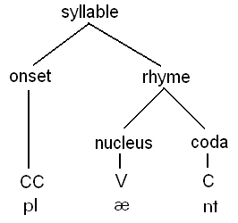

For the syllabic segmentation in French, apply the following rules:

* **1 consonant between 2 vowels** 🡪 consonant in onset position of the second syllable;
* **2 adjacent vowels** 🡪 2 syllables;
* **2 consonants between two vowels:** 
  + the first consonant is **different** **from liquids and semi-vowels** and the **second is a liquid or a semivowel** 🡪 the whole consonant cluster in **onset position** of the next syllable ***(note: never separate a consonant from a semivowel or a liquid).***
  + **2 liquids** 🡪 syllabic boundary between the two liquids;
  + the **first consonant is a liquid** and a **second is not a liquid neither a semi-vowel** 🡪 syllabic boundary between the two consonants.
  + **the first consonant is a semi-vowel** and the **second any consonant** 🡪 syllabic boundary between the semi-vowel and the second consonant.
  + **the two adjacent consonants are neither liquids** **nor semi-vowel** 🡪 syllabic boundary between the two consonants.
* **3 consonants between 2 vowels:** 
  + the first is not a **liquid** nor a **semi-vowel**, the second is **a liquid** and the **third a semi-vowel** 🡪 the whole consonant cluster in **onset** position.
  + **3 consonants** (or more): they are neither **liquids nor semi-vowels** 🡪 syllabic boundary between the two first or two last consonants.

Your output file should have the following form:

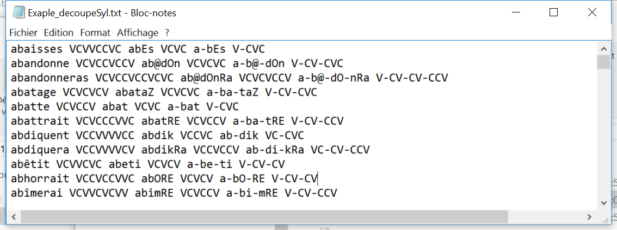

What are the 15 most frequent syllabic structures in French expressed with:

* ‘C’ and ‘V’ forms,
* macro-classe forms (fricativeV, ficativeU, stopV, stopU, nasal, liquid, Semi-Vow, vowel – you can use shorter labels)
* by consonants and vowels