**Quick start guide for Stock Synthesis Interface (SSI; GUI) version 3.30.15**

1. Download [the SSI](https://vlab.ncep.noaa.gov/web/stock-synthesis/document-library/-/document_library/0LmuycloZeIt/view_file/9416166) from the [Stock Synthesis vlab site](https://vlab.ncep.noaa.gov/web/stock-synthesis). To download, click on the Download button circled in red in the below screenshot.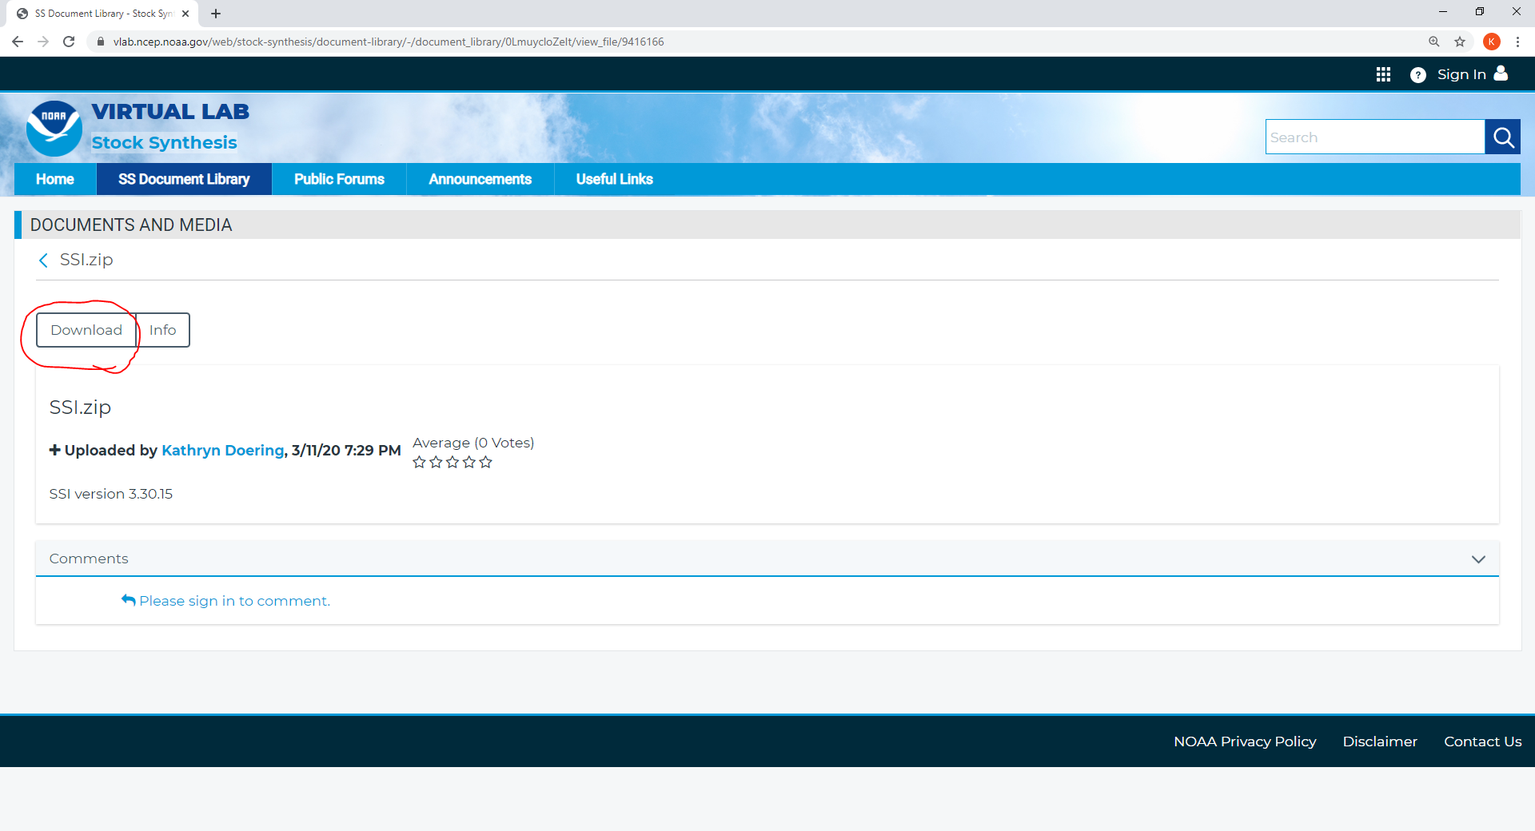
2. Unzip the downloaded file called SSI.zip. The contents (shown in screenshot below) include SSI.exe (circled in red), which is the SSI, a folder called “default”, which contains the default SS model files, and several other files.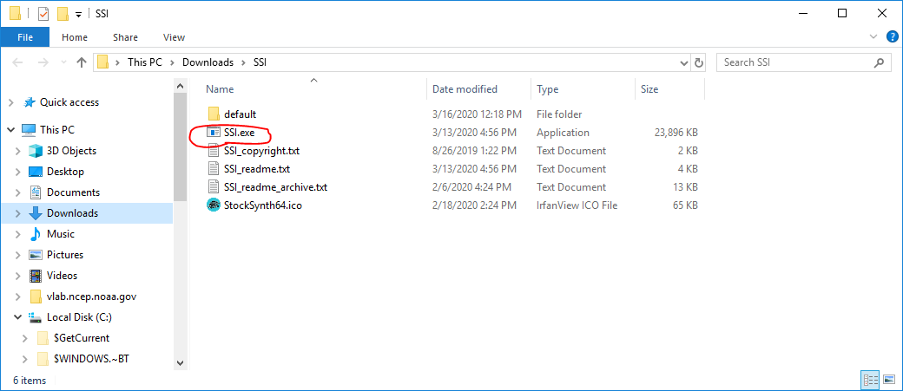
3. Click on SSI.exe to open SSI.
4. Note that a default model (the Stock Synthesis example model called Simple) is loaded, so you can use this model right away in the SSI. The path and names of model files are shown circled in red in the below screenshot. Note the path to a weight at age file is also shown, but it is not used for this particular model.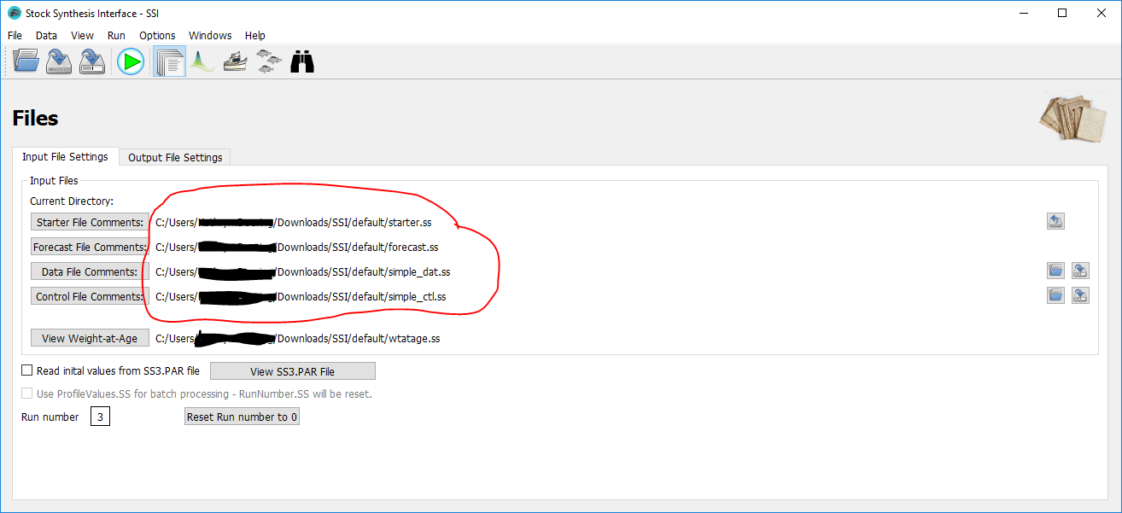
5. Model contents can be viewed and edited by using the 4 buttons circled in red in the below screenshot.

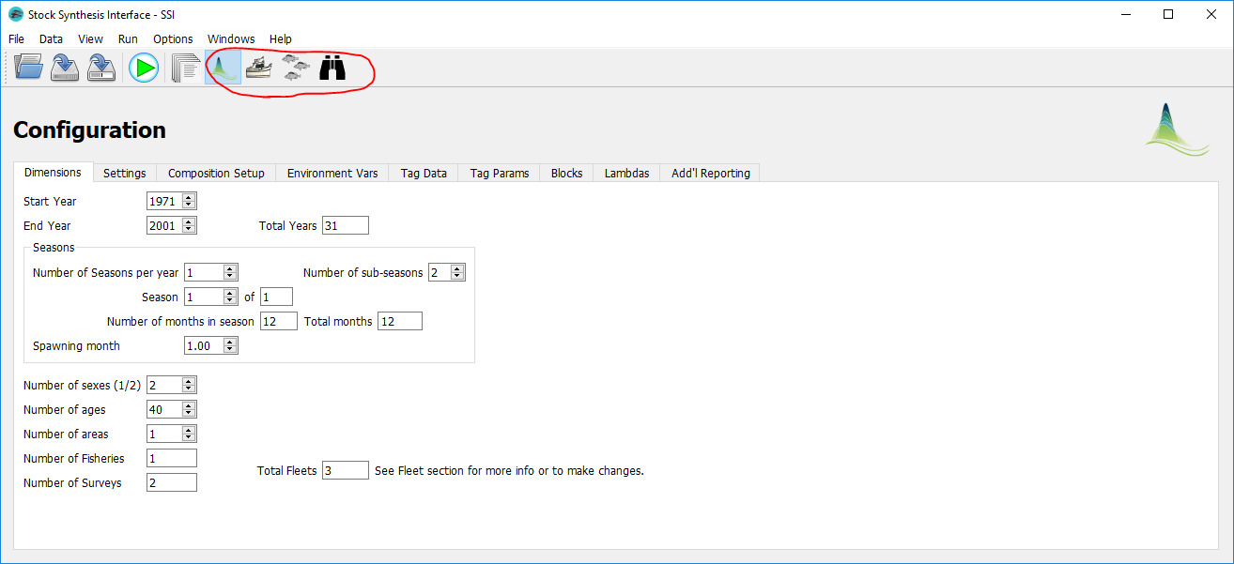

1. Before using SSI to run the model, SSI needs to know where the SS executable is. If SS executable isn’t yet present on the computer, you can download one of the latest executables from the [Latest SS executables folder](https://vlab.ncep.noaa.gov/web/stock-synthesis/document-library/-/document_library/0LmuycloZeIt/view/5042555) on vlab. Once an SS executable has been downloaded, in the SSI, click on options, then the ”Locate SS executable” selection from the dropdown menu (selection shown circled in red in the below screenshot). Navigate to and select the SS executable (usually named ss.exe, but can have any name) to use for running the model. 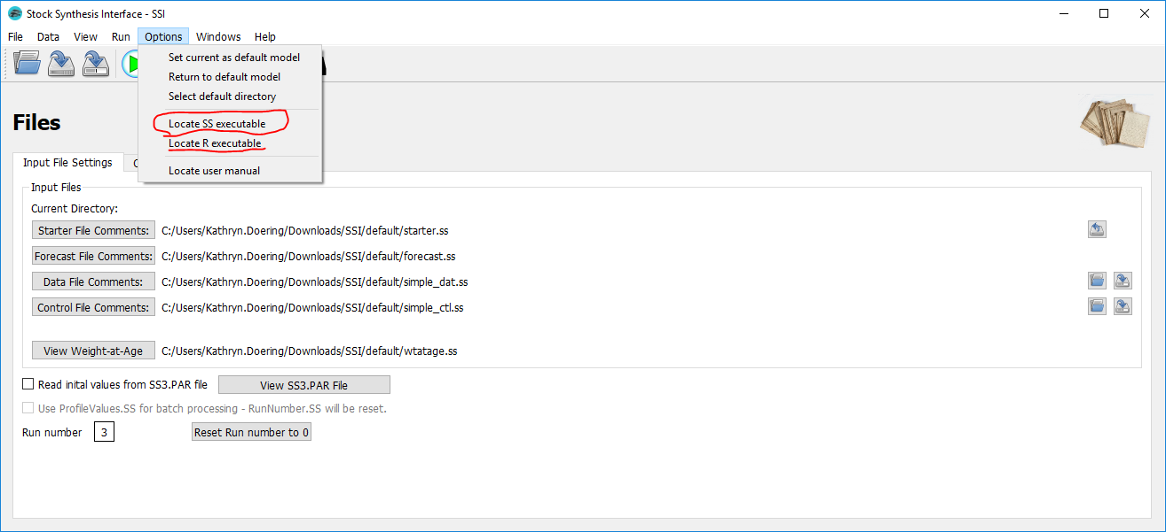
2. To run the model, click on the green "play" button (pointed to with a red arrow in the below screenshot) to open the “Running Stock Synthesis” dialog box. Check that the executable path and the model directory in the dialog box are correct. Add any ADMB model option in the box beside “With these options:” (a commonly used option is -nohess to avoid finding the hessian and inverting it to estimate error). When ready, click on the “run” button in the dialog box (circled in red in the below screenshot) to run the SS model. 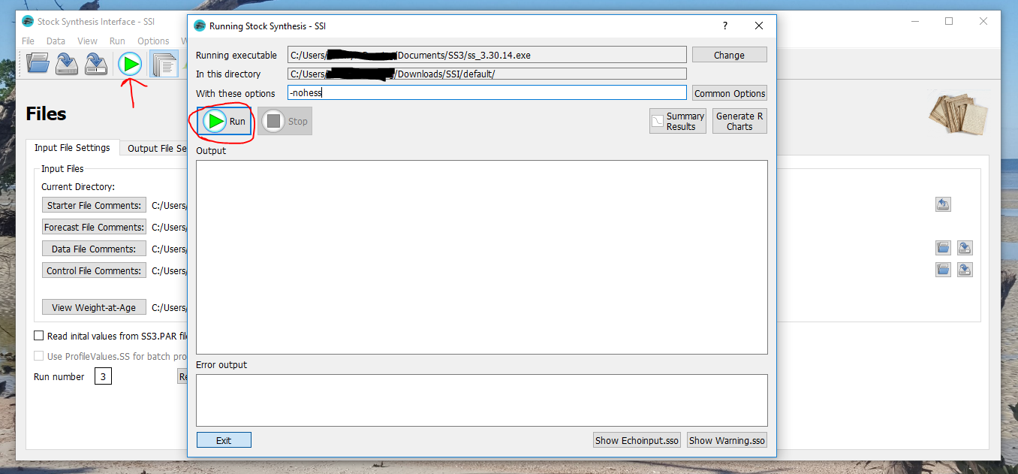
3. You should see output and error output, while the model is running, and will see “!! Run is completed !!” in the output when the model has finished running (shown circled in red in the screenshot below. 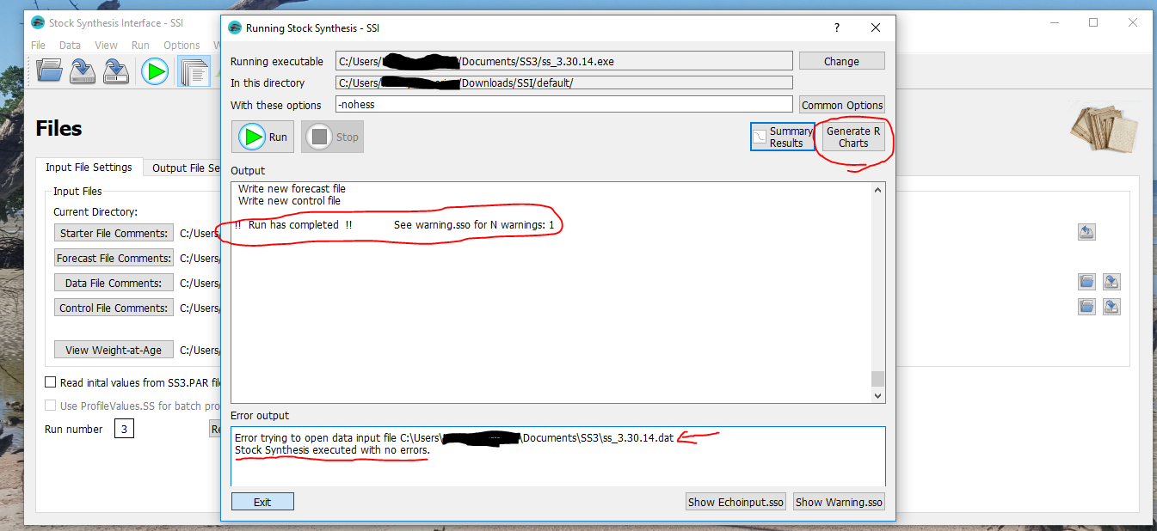
4. Plots of model quantities using r4ss plots can be made after a model run if you 1) have R already installed, 2) have installed the r4ss package, and 3) told the GUI where the R executable can be found.
5. R can be downloaded from <https://cran.r-project.org/>; once R is downloaded, r4ss can be installed; follow instructions on the README.md at <https://github.com/r4ss/r4ss> to download r4ss.
6. Tell SSI where to find R (once it has been downloaded) by navigating to options > locate R executable in SSI (underlined in red in the below screenshot). Where the R executable exists depends on where it was installed, but one place to check is

Program Files/R/R-"version"/bin, where "version" is the number of the R version (e.g., 3.6.1). In the “bin” folder, there will be several R executables, some of which are there for historical reasons. Select either R.exe or Rscript.exe to use with the SSI. (Rscript.exe can be used for batch scripts, while R.exe is the default executable to use, but in this case, either can be used).



1. You can now make figures from r4ss by clicking the “Generate R Charts” button in the “Running Stock Synthesis” dialog box after a model has been run. You should see output from running the r4ss functions (the central one used is SS_plots()) in the output and any warnings or errors in error output.The SSI main window is shown behind the SSI Running Stock Synthesis dialog box. On the right hand side is a button that says "Generate R Charts". Within this dialog box is a text box with the header "Output" which contains text from ruining the R charts (done by pressing the "Generate R Charts" button after runing the model). The last text in this box is "Opening HTML file in your default web-browser". 

   There is also an error output box, which includes some text of warnings and error messages from using the "Generate R Charts" button.
2. If the functions run successfully, an html page will open in your browser, showing you all the output produced. You can view different plots by clicking the headers (shown circled in red in the screenshot below). You can also browse figures individually in a “plots” subfolder of the model directory.

