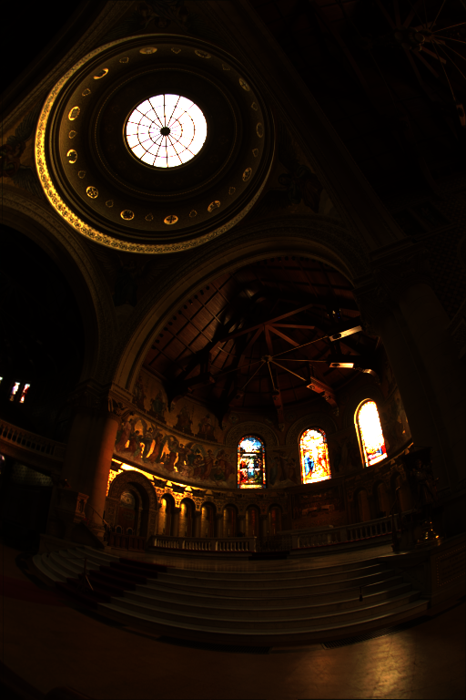
memorial.exr without any edits.
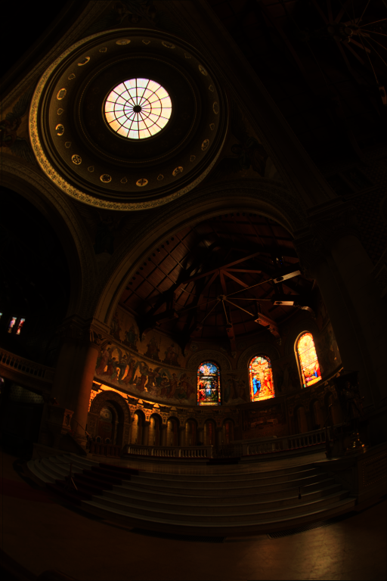
memorial.exr with baseline tone mapping
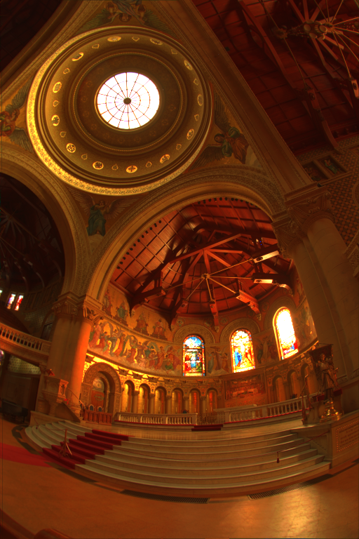
memorial.exr with gamma compression (ɣ = 1 / 2.2)

The baseline tone mapping does very little. It seems to only reduce the brighter parts of the
image to be within the desired color space. The clearest changes are in the stained glass windows and the glass dome, as well as the ornate ring at its base. The gamma compression reveals much more detail in the darker parts of the image, but gives the image an orange hue. It makes it look like the image was taken at sunset/sunrise, but to me this is worth it to see all the detail of the paintings on the ceiling.
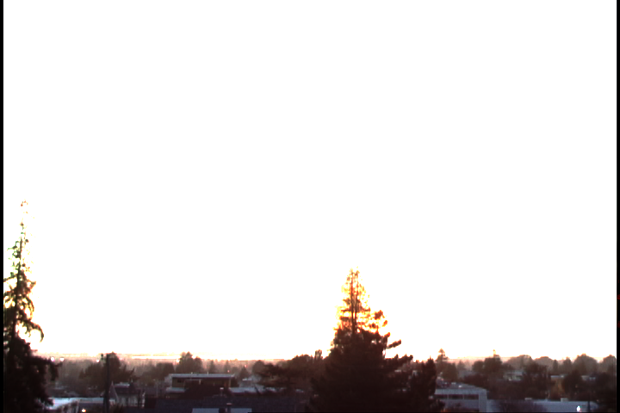
vinesunset.hdr unedited

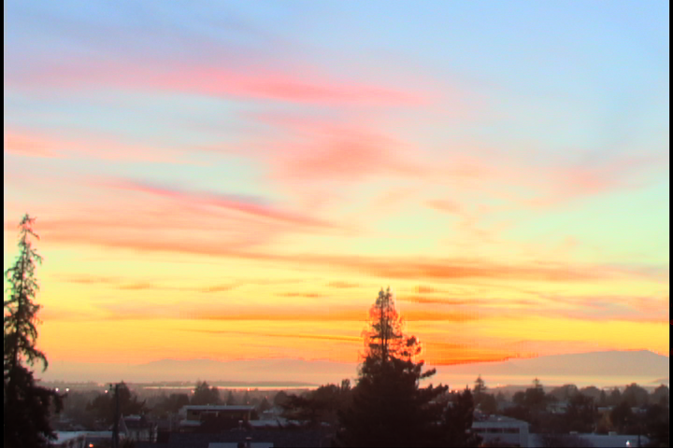
vinesunet.hdr with baseline tone mapping
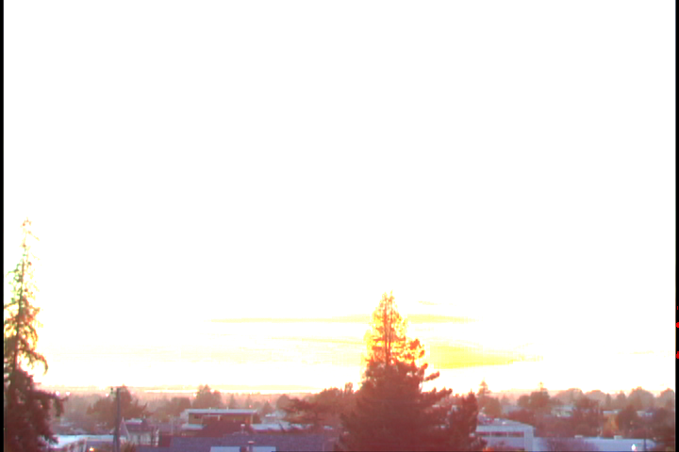
vinesunset.hfr with gamma compression (ɣ = 1 / 2.2)

With this image baseline tone mapping does much better as most of the image is too bright for the display. There’s minor loss of detail in the bottom part of the image, but the sky looks much better. Gamma compression struggled a lot with this image. Most of the sky is still way too bright, but the town at the bottom of the image gains a lot of detail. A gamma value of around 0.35 yields slightly more detail in the sky, but the town begins to lose detail. Any values lower yields colors that are far from the original. (see below)
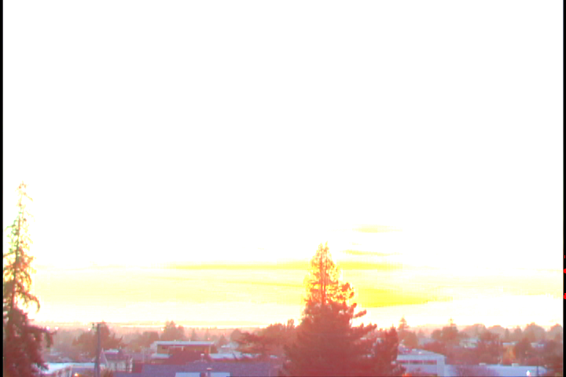
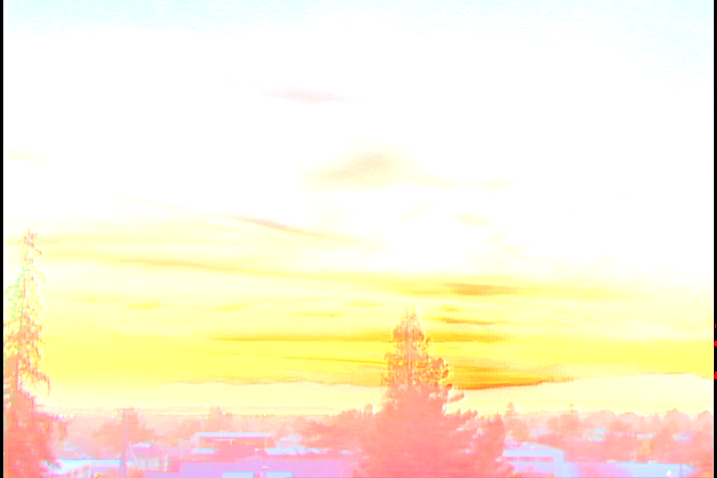
vinesunset.hdr with gamma compression (ɣ = 0.35)

vinesunset.hdr with gamma compression (ɣ = 0.1)

