# SUPPLEMENTARY MATERIAL:

# *Engineering E. coli for Large-Scale Production – Strategies Considering ATP Expenses and Transcriptional Responses*

# 

# Author names and affiliations:

Michael Löfflera,1, Joana Danica Simena,1, Günter Jägerb,Karin Schäferhoffb, Andreas Freunda, Ralf Takorsa,*

a University of Stuttgart, Institute of Biochemical Engineering, Allmandring 31, 70569 Stuttgart, Germany

b University of Tübingen, Institute of Medical Genetics, Calwerstr. 7, 72076 Tübingen, Germany

* Corresponding author.

*E-mail address*: takors@ibvt.uni-stuttgart.de

1 These authors contributed equally to this work.

# Supplementary Tables

Supplementary Table S1. ATP requirements for *de novo* production of nucleotide triphosphates (NTPs) from precursors, assuming a P/O ratio of 1.49. The number of moles of compounds required to produce one mole of each NTP is indicated. Negative numbers indicate production. The overall ATP requirement (ATP req.) is stated in the last column.

|  |  |  |  |  |  |  |  |  |  |
| --- | --- | --- | --- | --- | --- | --- | --- | --- | --- |
| **NTP** | **Precursors** | | | **Energy** | | | **Others** | | **ATP req.** |
| **R5P** | **PG** | **OAA** | **ATP** | **NADH** | **NADPH** | **Am** | **Mlthf** |
| ATP | 1 | 1 | 0 | 11 | -3 | 1 | 5 | -1 | *6.53* |
| GTP | 1 | 1 | 0 | 13 | -3 | 0 | 5 | -1 | *8.53* |
| CTP | 1 | 0 | 1 | 9 | 0 | 1 | 3 | 0 | *9* |
| UTP | 1 | 0 | 1 | 7 | 0 | 1 | 2 | 0 | *7* |

Supplementary Table S2. ATP requirements for the production of amino acids starting from precursors were adopted from Kaleta et al. (2013), assuming a P/O ratio of 1.49. The number of moles of compounds required to produce one mole of each amino acid (AA) is indicated. Negative numbers indicate production. The overall ATP requirement (ATP req.) is stated in the last column.

|  |  |  |  |  |  |  |  |  |  |  |  |  |  |  |  |
| --- | --- | --- | --- | --- | --- | --- | --- | --- | --- | --- | --- | --- | --- | --- | --- |
| **AA** | **Precursors** | | | | | | | | **Energy** | | | **Others** | | | **ATP req.** |
| **Ru5P** | **E4P** | **PEP** | **PG** | **Pyr** | **AcCoA** | **AKG** | **OAA** | **ATP** | **NADH** | **NADPH** | **NH3** | **Mlthf** | **CO2** |
| Ala | 0 | 0 | 0 | 0 | 1 | 0 | 0 | 0 | 0 | 0 | 1 | 1 | 0 | 0 | *1.49* |
| Arg | 0 | 0 | 0 | 0 | 0 | 0 | 1 | 0 | 5 | -1 | 3 | 4 | 0 | 1 | *7.98* |
| Asn | 0 | 0 | 0 | 0 | 0 | 0 | 0 | 1 | 2 | 0 | 1 | 2 | 0 | 0 | *3.49* |
| Asp | 0 | 0 | 0 | 0 | 0 | 0 | 0 | 1 | 0 | 0 | 1 | 1 | 0 | 0 | *1.49* |
| Cys | 0 | 0 | 0 | 1 | 0 | 0 | 0 | 0 | 6 | -1 | 3 | 1 | 0 | 0 | *8.98* |
| Glu | 0 | 0 | 0 | 0 | 0 | 0 | 1 | 0 | 0 | 0 | 1 | 1 | 0 | 0 | *1.49* |
| Gln | 0 | 0 | 0 | 0 | 0 | 0 | 1 | 0 | 1 | 0 | 1 | 2 | 0 | 0 | *2.49* |
| Gly | 0 | 0 | 0 | 1 | 0 | 0 | 0 | 0 | 0 | -1 | 1 | 1 | -1 | 0 | *0* |
| His | 1 | 0 | 0 | 0 | 0 | 0 | 0 | 0 | 6 | -2 | 2 | 3 | 1 | 0 | *6* |
| Ile | 0 | 0 | 0 | 0 | 1 | 0 | 0 | 1 | 2 | 0 | 5 | 1 | 0 | -1 | *9.45* |
| Leu | 0 | 0 | 0 | 0 | 2 | 1 | 0 | 0 | 0 | -1 | 2 | 1 | 0 | -2 | *1.49* |
| Lys | 0 | 0 | 0 | 0 | 1 | 0 | 0 | 1 | 2 | 0 | 4 | 2 | 0 | -1 | *7.96* |
| Met | 0 | 0 | 0 | 0 | 0 | 0 | 0 | 1 | 10 | -1 | 6 | 1 | 1 | 0 | *17.45* |
| Phe | 0 | 1 | 2 | 0 | 0 | 0 | 0 | 0 | 1 | 0 | 2 | 1 | 0 | -1 | *3.98* |
| Pro | 0 | 0 | 0 | 0 | 0 | 0 | 1 | 0 | 1 | 0 | 3 | 1 | 0 | 0 | *5.47* |
| Ser | 0 | 0 | 0 | 1 | 0 | 0 | 0 | 0 | 0 | -1 | 1 | 1 | 0 | 0 | *0* |
| Thr | 0 | 1 | 0 | 0 | 0 | 0 | 0 | 1 | 2 | 0 | 3 | 1 | 0 | 0 | *6.47* |
| Trp | 1 | 1 | 1 | 0 | 0 | 0 | 0 | 0 | 5 | -1 | 1 | 2 | 0 | -1 | *5* |
| Tyr | 0 | 0 | 2 | 0 | 0 | 0 | 0 | 0 | 1 | -1 | 2 | 1 | 0 | -1 | *2.49* |
| Val | 0 | 0 | 0 | 0 | 2 | 0 | 0 | 0 | 0 | 0 | 2 | 1 | 0 | -1 | *2.98* |

Supplementary Table S3. Moles of ATP produced until removal of the amino acid or nucleotide precursor from catabolism (adopted from Kaleta et al. (2013)), assuming a P/O ratio of 1.49. Moles of glucose and energy metabolites needed for the production of one mole precursor are also indicated.

|  |  |  |  |  |  |  |
| --- | --- | --- | --- | --- | --- | --- |
| **Precursor** | **Energy** | | | **Other** | | **ATP prod.** |
| **ATP** | **NADH** | **NADPH** | **Glc** | **CO2** |
| R(u)5P | -1 | 0 | 2 | -1 | 1 | *1.98* |
| E4P | -1 | 0 | 4 | -0.75 | 2 | *4.96* |
| PEP | 0 | 1 | 0 | -0.5 | 0 | *1.49* |
| PG | 0 | 1 | 0 | -0.5 | 0 | *1.49* |
| Pyr | 1 | 1 | 0 | -0.5 | 0 | *2.49* |
| AcCoA | 1 | 2 | 0 | -0.5 | 1 | *3.98* |
| AKG | 1 | 4 | 0 | -1 | 1 | *6.96* |
| OAA | 0 | 1 | 0 | -0.5 | -1 | *1.49* |

Supplementary Table S4. Total ATP requirements for nucleotide and amino acid building blocks (BB), estimated for a P/O ratio of 1.49. The total ATP costs for each building block were calculated from the ATP produced (Table S3) and consumed (Table S1, Table S2).

|  |  |  |  |
| --- | --- | --- | --- |
| **BB** | **ATP prod.** | **ATP req.** | **total ATP cost** |
| Ala | 2.49 | 1.49 | -1 |
| Arg | 6.96 | 7.98 | 1.02 |
| Asn | 1.49 | 3.49 | 2 |
| Asp | 1.49 | 1.49 | 0 |
| Cys | 1.49 | 8.98 | 7.49 |
| Glu | 6.96 | 1.49 | -5.47 |
| Gln | 6.96 | 2.49 | -4.47 |
| Gly | 1.49 | 0 | -1.49 |
| His | 1.98 | 6 | 4.02 |
| Ile | 3.98 | 9.45 | 5.47 |
| Leu | 8.96 | 1.49 | -7.47 |
| Lys | 3.98 | 7.96 | 3.98 |
| Met | 1.49 | 17.45 | 15.96 |
| Phe | 7.94 | 3.98 | -3.96 |
| Pro | 6.96 | 5.47 | -1.49 |
| Ser | 1.49 | 0 | -1.49 |
| Thr | 6.45 | 6.47 | 0.02 |
| Trp | 8.43 | 5 | -3.43 |
| Tyr | 2.98 | 2.49 | -0.49 |
| Val | 4.98 | 2.98 | -2 |
| ATP | 3.47 | 8.02 | 4.55 |
| GTP | 3.47 | 8.53 | 5.06 |
| CTP | 3.47 | 10.49 | 7.02 |
| UTP | 3.47 | 8.49 | 5.02 |

**Supplementary Table S5.** Parameters derived from plug flow reactor characterization.

|  |  |  |
| --- | --- | --- |
| **Sample port** | **Residence time $τ$** | |
|  | **Mean/ s** | **Variance/ s2** |
| P1 | 31.3 | 37.0 |
| P2 | 49.5 | 69.5 |
| P3 | 69.6 | 107.0 |
| P4 | 89.8 | 141.8 |
| P5 | 109.6 | 196.2 |
| PFRoutlet | 125.3 | 380.1 |

Mean and variance of the residence time $τ$ were determined from tracer curves.

**Supplementary Table S6.** Specific glucose and ammonia uptake rates.

|  |  |  |
| --- | --- | --- |
| **Time/ h** | ***qglc*/g g (DW)-1 h-1** | ***qNH4*/ g g (DW)-1 h-1** |
| -18.0 | 0.531±0.018 | 0.040±0.003 |
| -16.5 | 0.533±0.016 | 0.039±0.002 |
| -2.0 | 0.528±0.019 | 0.036±0.004 |
| 2.5 | 0.521±0.016 | 0.040±0.002 |
| 3.5 | 0.512±0.016 | - |
| 5.5 | 0.510±0.015 | - |
| 25.0 | 0.493±0.021 | 0.033±0.003 |
| 26.5 | 0.490±0.020 | 0.034±0.002 |
| 28.5 | 0.490±0.018 | 0.035±0.003 |

Specific uptake rates were calculated at different time points using the total STR-PFR volume (1.5 L). Values represent the arithmetic mean of three biologically independent replicates ± s.d. (standard deviation).

**Supplementary Table S7.** Additional ATP costs estimated per COG during periodic stimulation. Minimum (recycling, Rec.) and maximum (*de novo* synthesis) energy demands for mRNA synthesis and translation (11 Trans. per mRNA) were calculated as a percentage of the growth independent maintenance for COG functional categories.

|  |  |  |  |  |  |
| --- | --- | --- | --- | --- | --- |
| **COG** | **Add-on to maintenancea, %** | | | | **b*#* Genes** |
|  | **mRNA synthesis** | | **Trans.** | ***∑*** |  |
| **Rec.** | ***De novo*** |  |  |
| Cell motility (N) | 0.77 | 3.39 | 5.49 | 6.26/8.88 | 7 |
| Energy production and conversion (C) | 0.31 | 1.38 | 2.23 | 2.55/3.62 | 18 |
| not annotated in COG | 0.31 | 1.35 | 2.12 | 2.43/3.47 | 82 |
| Amino acid transport and metabolism (E) | 0.29 | 1.27 | 2.06 | 2.35/3.33 | 25 |
| Transcription (K) | 0.22 | 0.98 | 1.59 | 1.81/2.57 | 32 |
| Posttranslational modification, protein turnover, chaperones (O) | 0.22 | 0.97 | 1.56 | 1.78/2.53 | 24 |
| Signal transduction mechanisms (T) | 0.12 | 0.54 | 0.88 | 1.00/1.42 | 11 |
| General function unknown or prediction only (R+S) | 0.12 | 0.54 | 0.83 | 0.95/1.36 | 54 |
| Carbohydrate transport and metabolism (G) | 0.11 | 0.48 | 0.76 | 0.87/1.23 | 31 |
| Translation, ribosomal structure and biogenesis (J) | 0.08 | 0.34 | 0.56 | 0.64/0.90 | 5 |
| Inorganic ion transport and metabolism (P) | 0.06 | 0.27 | 0.44 | 0.50/0.70 | 14 |
| Lipid transport and metabolism (I) | 0.06 | 0.27 | 0.43 | 0.49/0.69 | 8 |
| Replication, recombination and repair (L) | 0.02 | 0.11 | 0.17 | 0.19/0.55 | 6 |
| Cell wall/membrane/envelope biogenesis (M) | 0.02 | 0.10 | 0.16 | 0.18/0.28 | 14 |
| Othersc | 0.01 | 0.07 | 0.1 | 0.11/0.16 | 9 |
| Coenzyme transport and metabolism (H) | 0.01 | 0.04 | 0.06 | 0.07/0.10 | 4 |

a Growth-independent maintenance taken from Taymaz-Nikerel et al. (2010)

b Genes which expression was always significantly changed between STR and PFR P5 (FDR < 0.01) were selected for the calculations (core genes).

c Others: Defense mechanisms (V), cell cycle control, cell division, chromosome partitioning (D), nucleotide transport and metabolism (F), secondary metabolites biosynthesis, transport and catabolism (Q) and RNA processing and modification (A).

Supplementary Table S8**.** Logarithmic expression ratio of genes involved in glycogen metabolism and regulation between sample port PFR P5 and STR S.

|  |  |  |  |  |
| --- | --- | --- | --- | --- |
| ***gene*** | **Logarithmic ratioa (P5/S) at:** | | | **Function of the gene product** |
| **25min** | **120min** | **28h** |
| *glgC* | 0.43 | 0.48 | 0.33 | Glucose 1P adenylyltransferase |
| *glgA* | 0.17 | 0.30 | 0.10 | Glycogen synthase |
| *glgP* | 0.13 | 0.23 | 0.22 | Glycogen phosphorylase |
| *glgB* | 0.19 | 0.28 | 0.23 | 1,4-α-glucan branching enzyme |
| *glgX* | 0.15 | 0.31 | 0.21 | Limit dextrin α-1,6-glucohydrolase/ glycogen debranching enzyme |
| *glgS* | 1.05 | 0.98 | 0.68 | Surface composition regulator |
| *csrA* | 0.20 | 0.23 | 0.35 | CsrA dimer (carbon storage regulator) |
| *csrB* | 0.53 | 0.63 | 0.53 | CsrB regulatory RNA (369 bp) inhibitor of CsrA |
| *csrC* | 0.36 | 0.30 | 0.10 | CsrC regulatory RNA (245 bp) inhibitor of CsrA |

a Underlining indicates significantly differential expression.

Supplementary Table S9. Logarithmic expression ratio of genes from 13 well-characterized toxin-antitoxin systems identified in *E. coli* K12 (Yamaguchi and Inouye, 2011). In case of the *chpSB* and *relEB* toxin-antitoxin systems both components were equally induced so that potential actions of the toxin may be neutralized by the antitoxin.

|  |  |  |  |  |
| --- | --- | --- | --- | --- |
| ***gene*** | **Logarithmic ratioa (P5/S) at:** | | | **Function of the gene product** |
| **25min** | **120min** | **28h** |
| *chpA* | -0.34 | -0.24 | -0.08 | MazF toxin of the MazF-MazE toxin-antitoxin system |
| *chpR* | -0.01 | 0.09 | 0.24 | MazE antitoxin of the MazF-MazE toxin-antitoxin system |
| *chpB* | 0.77 | 0.57 | 0.19 | ChpB toxin of the ChpB-ChpS toxin-antitoxin system |
| *chpS* | 0.93 | 0.62 | 0.30 | ChpS antitoxin of the ChpB-ChpS toxin-antitoxin system |
| *hokB* | 0.09 | -0.06 | 0.10 | HokB toxin of the HokB-SokB type I toxin-antitoxin system |
| *sokB* | 0.15 | -0.08 | 0.21 | Antisense RNA of the HokB-SokB type I toxin-antitoxin system |
| *yafQ* | -0.60 | -0.42 | -0.32 | Toxin of the YafQ-DinJ toxin-antitoxin system |
| *dinJ* | 0.26 | 0.46 | 0.21 | DinJ antitoxin of the YafQ-DinJ toxin-antitoxin system |
| *yoeB* | 0.23 | 0.22 | -0.08 | Toxin of the YoeB-YefM toxin-antitoxin pair |
| *yefM* | 0.10 | -0.11 | -0.06 | YefM-antitoxin of the YoeB-YefM toxin-antitoxin pair |
| *hipA* | -0.14 | -0.04 | 0.04 | Ser/thr kinase HipA toxin of the HipA-HipB toxin-antitoxin system |
| *hipB* | -0.08 | -0.16 | 0.02 | HipB antitoxin of the HipA-HipB toxin-antitoxin system |
| *yncN* | -0.53 | -0.37 | -0.01 | HicA toxin of the HicA-HicB toxin-antitoxin system |
| *ydcQ* | -0.76 | -0.44 | -0.36 | HicB antitoxin of the HicA-HicB toxin-antitoxin system |
| *ygiU* | 0.20 | 0.40 | 0.26 | mRNA interferase, toxin of the MqsR-MqsA toxin-antitoxin system |
| *ygiT* | 0.34 | 0.23 | 0.45 | MqsA antitoxin of the MqsRA toxin-antitoxin system |
| *yfjN* | -0.39 | -0.36 | -0.14 | RnlA RNase LS, toxin of the RnlAB toxin-antitoxin system |
| *yfjO* | -0.33 | -0.12 | -0.04 | RnlB antitoxin of the RnlA-RnlB toxin-antitoxin system |
| *ygjM* | -0.08 | 0.06 | -0.05 | HigA antitoxin of the HigB-HigA toxin-antitoxin system |
| *ygjN* | -0.49 | -0.49 | -0.40 | HigA toxin of the HigB-HigA toxin-antitoxin system/ mRNA interferase |
| *yafN* | 0.10 | -0.11 | 0.09 | Antitoxin of the YafO-YafN toxin-antitoxin system |
| *yafO* | -0.29 | -0.60 | 0.12 | mRNA interferase, toxin of the YafO-YafN toxin-antitoxin system |
| *yhaV* | -0.02 | 0.02 | 0.05 | YhaV toxic ribonuclease of the YhaV-PrlF toxin-antitoxin system |
| *sohA* | 0.18 | 0.33 | 0.12 | PrlF antitoxin of the YhaV-PrlF toxin-antitoxin system |
| *relB* | 0.28 | 0.29 | 0.51 | RelB-antitoxin of the RelE-RelB toxin-antitoxin system |
| *relE* | 0.28 | 0.26 | 0.54 | Qin prophage; toxin of the RelE-RelB toxin-antitoxin system |

a Underlining indicates significantly differential expression.

# Supplementary Figures

|  |
| --- |
|  |
| Supplementary Figure S1**.** Time profiles of (A) adenylate energy charge (AEC) and (B) intracellular ppGpp concentrations in µmol g (DW)-1 over residence time $τ$ in the PFR sampled at 25 min, 120 min and 28 h after PFR addition. Data represent mean ± s.d. from three independent biological replicates. |

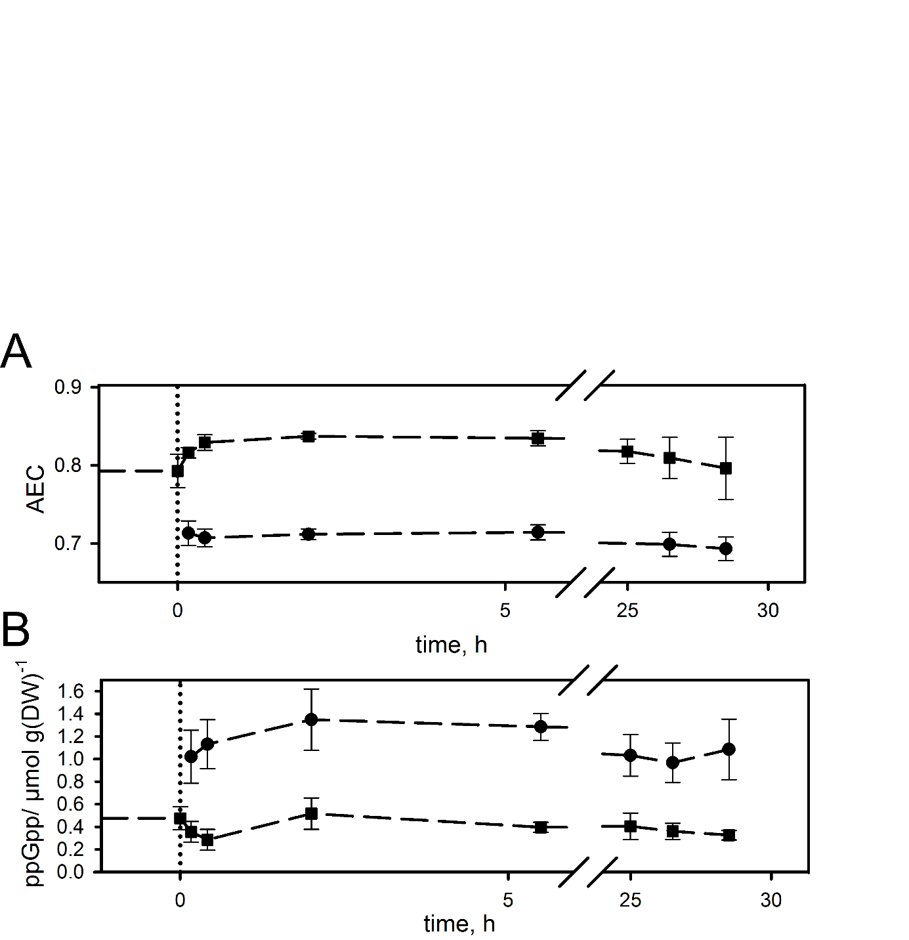

|  |
| --- |
|  |
| Supplementary Figure S2**.** Time profiles of (A) AEC and the (B) intracellular ppGpp concentration over process time sampled at STR (squares) and PFR P5 (circles). Start of PFR connection is indicated by the dotted line. Data represent mean ± s.d. from three independent biological replicates. |

|  |
| --- |
|  |
| Supplementary Figure S3**.** Proportion of upregulated differentially expressed genes (DEGs) with fold change ≥ 1.5 clustered by their sigma factor interaction (Salgado et al., 2013). Areas for each sigma factor regulated gene set are shown over samples taken at different process time points in the STR. |

|  |
| --- |
|  |
| Supplementary Figure S4**.** Proportion of differentially expressed genes (DEGs) with fold change ≥ 1.5 assigned to stringent and stress related regulons derived from Traxler et al. (2011) referenced to the total number of upregulated DEGs. Areas for each regulon are shown over samples taken at different process time points in the STR. |

|  |
| --- |
|  |
| Supplementary Figure S5**.** Boxplots of log2 fold changes shown for each sample port P1-P5 along the PFR. Upper panel: ppGpp-regulated gene set; lower panel: ppGpp and σS-regulated gene set**.** Distributions which significantly (FDR < 0.05) deviate from zero as tested by GAGE (Luo et al., 2009) are indicated with an asterisk. |

# Supplementary Sections

## Supplementary Section S1. Determination of the power input, Kolmogorov length and batch control experiment

In all experiments, we used a Rushton Turbine with six flat blades mounted vertically on a disc. The Reynolds number indicates turbulent mixing in the STR, which means that the Power number $(N_{P})$ is independent from the Reynolds number $(Re)$. We received a Power number of five from the Power number-Reynolds number correlation (Bates et al., 1963). We calculated a stirrer power input $(Po)$ of 5 W using equation 2. The calculated power input we found is in accordance with literature (Takors, 2014).

Power input stirrer:

|  |  |
| --- | --- |
| $$n=900 rpm=15 s^{-1}$$ |  |
| $$d=0.05 m$$ |  |
| $$ρ=900 kg∙m^{-3}$$ |  |
| $$η=0.72 mPa∙s$$ |  |
| $$Re=n∙d^{2}∙\frac{ρ}{η}$$ | (1) |
| $$Re=4.68∙{10}^{4}$$ |  |
| $$Po=N_{P}∙{ρ∙d}^{5}∙n^{3}$$ | (2) |
| $$Po=5 W$$ |  |

We also calculated a Kolmogorov length of 18 µm for the STR (equation 4). Because the Kolmogorov length is larger than the average cell size of *E. coli* (3 µm) we can assume that the eddies do not have negative effects on the cells (Murhammer and Goochee, 1990; Reshes et al., 2008).

Kolmogorov length STR:

|  |  |
| --- | --- |
| $$λ=Kolmogorov length$$ |  |
| $$ν=kinematic viscosity=8 ∙{10}^{-7} m^{2}s^{-1}$$ |  |
| $$ε_{STR}=mass specific power input$$ |  |
| $$P_{STR}= power input = 5 kg m^{2} s^{-3}$$ |  |
| $$ρ=900 kg∙m^{-3}$$ |  |
| $$V_{STR}=1.12 ∙{10}^{-3}m^{3}$$ |  |
| $$ε_{STR}=\frac{P}{ρ∙V_{STR}}=4.96 m^{2} s^{-3}$$ | (3) |
| $$λ_{STR}={\left(\frac{ν^{3}}{ε_{STR}}\right)}^{\frac{1}{4}}=18 µm$$ | (4) |

It is difficult to determine the mass specific power input for the PFR recycle pump. Therefore, we assume a pressure difference of 0.6 bar along the PFR, which is in accordance to other publications (Dittler et al., 2015; Fries et al., 2015). With this value we calculated a mass specific power input of 0.53 W kg-1 (equation 5). For hot spot analysis, we assumed 10 fold increased local energy dissipation which lead to local maximum mass specific power input ( $ε_{maxPFR})$ of 5.3 W kg-1. The maximum specific power input was used to determine a Kolmogorov length of 18 µm in the PFR (equation 6), which is again far larger than the average *E. coli* cell size.

Kolmogorov length PFR:

|  |  |
| --- | --- |
| $$Q=pump flow rate=3.04∙{10}^{-6}m^{3}s^{-1}$$ |  |
| $$ν=kinematic viscosity=8 ∙{10}^{-7} m^{2}s^{-1}$$ |  |
| $$∆p=pressure difference=0.6 bar (assumption)$$ |  |
| $$ρ=900 kg∙m^{-3}$$ |  |
| $$V_{PFR}=0.38 ∙{10}^{-3}m^{3}$$ |  |
| $$ε_{PFR}=\frac{∆p∙Q }{ρ∙V_{PFR}}$$ | (5) |
| $$ε_{PFR}=0.53 m^{2} s^{-3}$$ |  |
| $$ε_{maxPFR}=5.3 m^{2} s^{-3}$$ |  |
| $$λ_{PFR}={\left(\frac{ν^{3}}{ε_{maxPFR}}\right)}^{\frac{1}{4}}=18 µm$$ | (6) |

Additional experiments:

We additionally performed control experiments, to exclude cell lysis due to the PFR. Therefore, the STR-PFR system was used without inducing starvation along the PFR. In this case there must be an excess of all substrates, so it is necessary to operate the system as batch cultivation. We performed batch cultivations in the STR-PFR system (biological triplicates) and observed the biomass increase. The STR-PFR system was operated with the same volume ratio, aeration (in STR and PFR), stirrer speed and residence times like the STR-PFR cultivations with the carbon starvation zone. Supposed that PFR induces cell lysis, the biomass increase in the STR-PFR system should be reduced compared to the biomass increase in a batch cultivation done in a standard STR. However, significant differences between the batches were not detected (Supplementary Figure S6). Accordingly, cell lysis due to the technical setup of the PFR can be neglected.

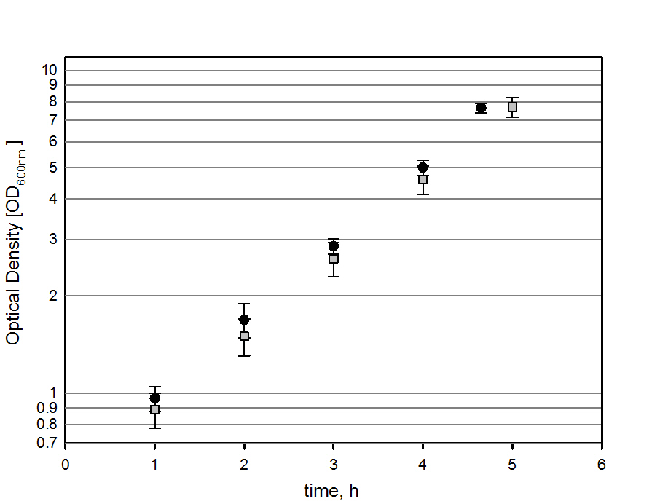

Supplementary Figure S6. Biomass concentration of batch cultivations performed in the STR-PFR two-compartment system (circle) and STR (square) over process time.

## Supplementary Section S2. Oxygen saturation in the PFR and off gas analysis

The oxygen saturation was measured at sample port P1 (prior to addition of supplementary air to the PFR) to exclude oxygen limitation between the outlet of the STR and the air sparger in the PFR. The oxygen saturation at P1 and P5 was above 30% and 50%, respectively (Supplementary Figure S7). Therefore, it can be expected that the cells will enter and reenter the STR without getting oxygen limited.

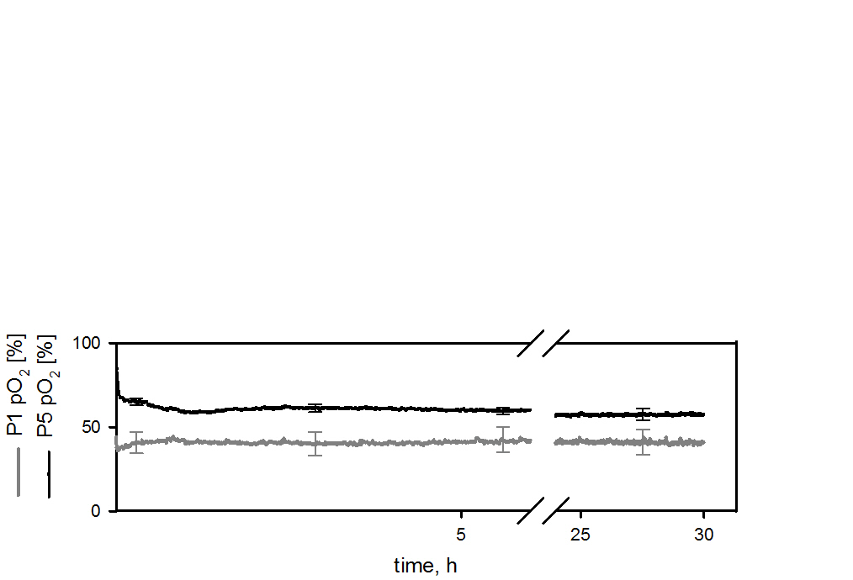

Supplementary Figure S7. Oxygen saturation in the PFR at sample ports P1 and P5.

The carbon dioxide/oxygen transfer rates remained constant over the entire cultivation time (Supplementary Figure S8). The slightly increasing values at 0 h result from the additional gas sparger in the PFR, which was turned on before the PFR was connected.

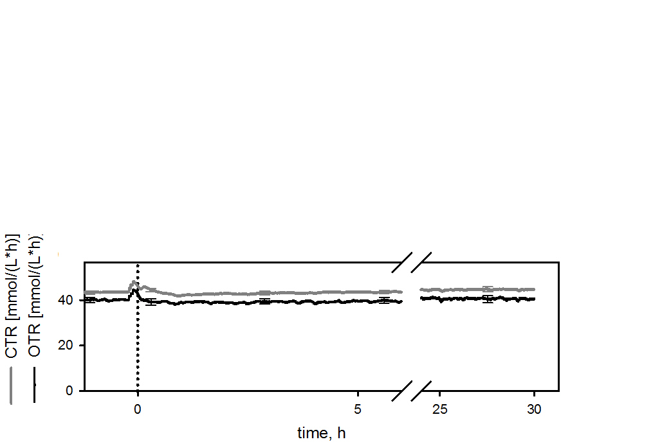 Supplementary Figure S8. Carbon dioxide/oxygen transfer rate plotted over the process time. The dotted line symbolizes the time of PFR connection.

The increase of the energy demand cannot be seen in the specific oxygen consumption rate, because the estimated increase in the oxygen consumption rate would be within the range of standard deviations of the specific respiratory rates (Supplementary Figure S9). The off gas analysis did not measure the compartments separately. For this reason, the calculated specific rates (Supplementary Figure S9) represent a mixture of STR and PFR effects. The metabolic variation due to the circulation between PFR and STR seems to be more dominant and decrease the specific respiratory rates slightly.

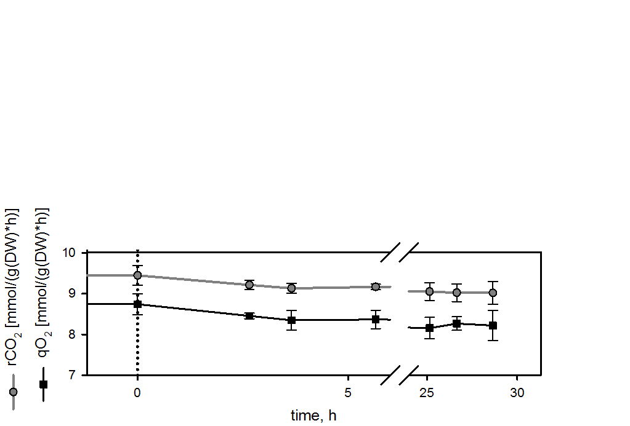Supplementary Figure S9. Specific carbon dioxide production (rCO2) and oxygen uptake (qO2) rate. The increasing biomass after connecting the PFR (dotted line) leads to reduced specific rates.

## Supplementary Section S3: Additional cultivations details

The connection of the PFR reduced the STR volume from 1.5 L to 1.12 L, while the feed rate was kept constant. The assumption that carbon starvation begins during the first seconds after entering the PFR accompanied by a sharp decrease of growth leads to a growth rate split in the system. The total growth rate of 0.2 h-1 for the STR-PFR system can be distributed in a faster growing STR (0.27 h-1) and a non-growing PFR (0 h-1) section due to the absence of an electron donor in the PFR. A typical phenomenon in chemostat cultivations is the increasing biomass concentration after raising the growth rate, especially when the cellular maintenance is high. For *E. coli* W3110 a biomass increase of about 6 % was observed by Abdel-Hamid et al. (2001) after changing the dilution rate from 0.2 h-1 to 0.25 h-1 . Therefore, we assume that the increase in biomass concentration observed after PFR connection only results from the growth rate increase in the STR.

Because separate calculation, especially of the off gas analysis, is not possible, the yields, specific rates and the carbon balance were calculated for both compartments using the overall growth rate of 0.2 h-1(Supplementary Table S10). The apparent YX/C yield is in accordance with other publications (Emmerling et al., 2002; Folsom and Carlson, 2015; Ihssen and Egli, 2004). The increase of the apparent YX/C after connection of the PFR also results from the faster growth rate in the STR as was shown by Pirt (1965).

To ensure that the cells residing in the STR do not produce side products that can be used as alternative carbon source under glucose starvation in the PFR, we measured typical *E.coli* side products including succinic acid, lactic acid, formic acid, acetic acid and ethanol in the STR using HPLC. However, all of them were below the detection limit of 0.2 mmol L-1. Only carbon dioxide and biomass was built from glucose (Supplementary Table S10). The residual glucose concentration in the bioreactor was also below the detection limit (<0.022 mmol L-1).

Supplementary Table S10. Steady state parameters before PFR connection (STR S0) and 28 h after connection (STR-PFR S1).

|  |  |  |  |  |  |  |  |
| --- | --- | --- | --- | --- | --- | --- | --- |
|  |  |  |  | Specific Carbon uptake/formation rate  [mmol of carbon g-1 h-1] | | |  |
|  | Dilution rate  [h-1] | YX/C  [g mol-1] | Residual Glucose [mmol L-1] | From glucose | To CO2 | To other side products | Carbon recovery [%] |
|  |  |  |  |  |  |  |  |
| STR (S0) | 0.2 | 67.81 ± 1.15 | < 0.022a | 17.70 ± 0.52 | 9.45 ± 0.25 | -b | 94 ± 4c |
| STR-PFR (S1) | 0.27/0 | 73.35 ± 1.73 | < 0.022a | 16.36 ± 0.58 | 9.03 ± 0.21 | -b | 99 ± 4c |

a Below the detection limit of 0.022 mmol L-1.

b Succinic acid, lactic acid, formic acid, acetic acid and ethanol were below the detection limit of 0.2 mmol L-1 as described in the organic HPLC protocol by Vallon et al. (2015)

c Biomass content was taken from Taymaz-Nikerel et al. (2010) for a carbon limited *E. coli* chemostat cultivation with a growth rate of 0.3 h-1.

## Supplementary Section S4: Nucleotide analysis

We measured the nucleotides ATP, ADP, AMP, GTP, GDP and the alarmones cAMP and ppGpp. Unlike e.g. ppGpp, cAMP is exported very quickly to reset cellular regulation (Matin and Matin, 1982). Correction of the total concentration is very difficult because of the high filtrate levels (~99% of the total concentration (Matin and Matin, 1982)) compared to the intracellular concentration. Consequently, intracellular cAMP levels were not yet measured directly in *E. coli* (to the best of our knowledge) but estimated instead. Like in Hardiman et al. (2007) who found equal concentration profiles of total and extracellular cAMP. Recently, intracellular cAMP levels were measured in *Vibrio fischeri* by Colton et al. (2015).

Anions like adenosine/guanosine nucleotides and ppGpp are likely to stay inside the cells. Consequently, degrading or modifying reactions are well known in *E. coli*. Accordingly, studies of Traxler et al. (2011), Wang et al. (2007) and Cserjan-Puschmann et al. (1999) only considered intracellular measurements for ppGpp and nucleotides, respectively. Mempin et al. (2013) examined extracellular ATP levels. They detected 1000 fold lower extracellular than intracellular ATP concentrations. Therefore we concluded that extracellular nucleotide (AXP, GXP) levels could be neglected. Nevertheless, we have performed preliminary ppGpp measurements in the supernatant finding that ppGpp levels were below the detection limit of around 0.5 µM.

**References**

Abdel-Hamid, A. M., Attwood, M. M., Guest, J. R., 2001. Pyruvate oxidase contributes to the aerobic growth efficiency of *Escherichia coli*. Microbiology. 147**,** 1483-1498.

Bates, R. L., Fondy, P. L., Corpstei.Rr, 1963. An Examination of Some Geometric Parameters of Impeller Power. Industrial & Engineering Chemistry Process Design and Development. 2**,** 310-314.

Colton, D. M., Stoudenmire, J. L., Stabb, E. V., 2015. Growth on glucose decreases cAMP-CRP activity while paradoxically increasing intracellular cAMP in the light-organ symbiont *Vibrio fischeri*. Molecular Microbiology. 97**,** 1114-1127.

Cserjan-Puschmann, M., Kramer, W., Duerrschmid, E., Striedner, G., Bayer, K., 1999. Metabolic approaches for the optimisation of recombinant fermentation processes. Applied Microbiology and Biotechnology. 53**,** 43-50.

Dittler, I., Dornfeld, W., Schob, R., Cocke, J., Rojahn, J., Kraume, M., Eibl, D., 2015. A Cost-effective and Reliable Method to Predict Mechanical Stress in Single-use and Standard Pumps. Engineering in Life Science. 311-317.

Emmerling, M., Dauner, M., Ponti, A., Fiaux, J., Hochuli, M., Szyperski, T., Wüthrich, K., Bailey, J., Sauer, U., 2002. Metabolic flux responses to pyruvate kinase knockout in *Escherichia coli*. Journal of Bacteriology. 184**,** 152-164.

Folsom, J. P., Carlson, R. P., 2015. Physiological, biomass elemental composition and proteomic analyses of *Escherichia coli* ammonium-limited chemostat growth, and comparison with iron-and glucose-limited chemostat growth. Microbiology. 161**,** 1659-1670.

Fries, T., Dittler, I., Blaschczok, K., Löffelholz, C., Dornfeld, W., Schöb, R., Drews, A., Eibl, D., 2015. Quantifizierung der hydromechanischen Beanspruchung von Pumpen auf tierische Zellen mittels des nicht‐biologischen Modellsystems Emulsion. Chemie Ingenieur Technik. 88**,** 177-182.

Hardiman, T., Lemuth, K., Keller, M. A., Reuss, M., Siemann-Herzberg, M., 2007. Topology of the global regulatory network of carbon limitation in *Escherichia coli*. Journal of Biotechnology. 132**,** 359-374.

Ihssen, J., Egli, T., 2004. Specific growth rate and not cell density controls the general stress response in *Escherichia coli*. Microbiology. 150**,** 1637-1648.

Kaleta, C., Schaeuble, S., Rinas, U., Schuster, S., 2013. Metabolic costs of amino acid and protein production in *Escherichia coli*. Biotechnology Journal. 8**,** 1105-1114.

Luo, W., Friedman, M. S., Shedden, K., Hankenson, K. D., Woolf, P. J., 2009. GAGE: generally applicable gene set enrichment for pathway analysis. BMC Bioinformatics. 10**,** 1.

Matin, A., Matin, M., 1982. Cellular levels, excretion, and synthesis rates of cyclic AMP in *Escherichia coli* grown in continuous culture. Journal of Bacteriology. 149**,** 801-807.

Mempin, R., Tran, H., Chen, C., Gong, H., Ho, K. K., Lu, S., 2013. Release of extracellular ATP by bacteria during growth. BMC Microbiology. 13.

Murhammer, D. W., Goochee, C. F., 1990. Sparged animal cell bioreactors: mechanism of cell damage and Pluronic F-68 protection. Biotechnology Progress. 6**,** 391-397.

Pirt, S., 1965. The maintenance energy of bacteria in growing cultures. Proceedings of the Royal Society of London B: Biological Sciences. 163**,** 224-231.

Reshes, G., Vanounou, S., Fishov, I., Feingold, M., 2008. Cell shape dynamics in *Escherichia coli*. Biophysical Journal. 94**,** 251-264.

Salgado, H., Peralta-Gil, M., Gama-Castro, S., Santos-Zavaleta, A., Muñiz-Rascado, L., García-Sotelo, J. S., Weiss, V., Solano-Lira, H., Martínez-Flores, I., Medina-Rivera, A., 2013. RegulonDB v8. 0: omics data sets, evolutionary conservation, regulatory phrases, cross-validated gold standards and more. Nucleic Acids Research. 41**,** D203-D213.

Takors, R., 2014. Kommentierte Formelsammlung Bioverfahrenstechnik. Springer-Verlag.

Taymaz-Nikerel, H., Borujeni, A. E., Verheijen, P. J., Heijnen, J. J., van Gulik, W. M., 2010. Genome-derived minimal metabolic models for *Escherichia coli* MG1655 with estimated in vivo respiratory ATP stoichiometry. Biotechnology and Bioengineering. 107**,** 369-381.

Traxler, M. F., Zacharia, V. M., Marquardt, S., Summers, S. M., Nguyen, H. T., Stark, S. E., Conway, T., 2011. Discretely calibrated regulatory loops controlled by ppGpp partition gene induction across the 'feast to famine' gradient in *Escherichia coli*. Molecular Microbiology. 79**,** 830-845.

Vallon, T., Simon, O., Rendgen‐Heugle, B., Frana, S., Mückschel, B., Broicher, A., Siemann‐Herzberg, M., Pfannenstiel, J., Hauer, B., Huber, A., 2015. Applying systems biology tools to study n‐butanol degradation in *Pseudomonas putida* KT2440. Engineering in Life Sciences. 15**,** 760-771.

Wang, J. D., Sanders, G. M., Grossman, A. D., 2007. Nutritional control of elongation of DNA replication by (p) ppGpp. Cell. 128**,** 865-875.

Yamaguchi, Y., Inouye, M., 2011. Regulation of growth and death in *Escherichia coli* by toxin–antitoxin systems. Nature Reviews Microbiology. 9**,** 779-790.