Project Outline

Overview Try to use Kemmeren data in which a kinase or phosphatase is knocked out to identify the TF targets of that kinase or phosphatase in the relevant growth conditions. Use existing HT interaction data to validate. Try to determine whether the guesses are better than random, with respect to the interaction data (or other, more focused literature specifying targets).

Steps
- Read some basic TFA inference papers

Liao, J.C. et al. Network component analysis: reconstruction of regulatory signals in biological systems. Proc Natl Acad Sci U S A 100, 15522-7 (2003).

Pemberton-Ross, P.J., Pachkov, M. & van Nimwegen, E. ARMADA: Using motif activity dynamics to infer gene regulatory networks from gene expression data. Methods 85, 62-74 (2015).

Balwierz, P.J. et al. ISMARA: automated modeling of genomic signals as a democracy of regulatory motifs. Genome Res 24, 869-84 (2014).

- Read papers on HT interaction data in yeast, including:

Breitkreutz, A, Choi, H, Sharom, JR, Boucher, L, Neduva, V, Larsen, B, Lin, ZY, Breitkreutz, BJ, Stark, C, Liu, G, Ahn, J, Dewar-Darch, D, Reguly, T, Tang, X, Almeida, R, Qin, ZS, Pawson, T, Gingras, AC, Nesvizhskii, AI, & Tyers, M. (2010). A global protein kinase and phosphatase interaction network in yeast. Science, 328(5981), 1043-1046.

Fasolo, J, Sboner, A, Sun, MG, Yu, H, Chen, R, Sharon, D, Kim, PM, Gerstein, M, & Snyder, M. (2011). Diverse protein kinase interactions identified by protein microarrays reveal novel connections between cellular processes. Genes Dev, 25(7), 767-778. doi: 10.1101/gad.1998811

as well as any more recent, relevant papers that site them (check citing papers using Google Scholar).

Also learn about general yeast protein-protein interaction networks (e.g. BioGrid, Marcotte stuff).

- Learn from Cynthia how to train run TFA inference on ZEV expression data and test on Kemmeren data. "Ma, Cynthia" <czma@wustl.edu>

  - Also learn the current perturbed-TF “guessing” algorithm and evaluation code.

  - Think about any whether there might be other logical guessing algorithms besides largest fold-change relative to WT. Maybe some normalization scheme?

- Identify the kinase or phosphatase knockout samples from the overall Kemmeren data.

- Run the code on the relevant samples and compare results to data sets on kinase-target and phosphatase-target interactions. Also try with randomized activity level predictions. Do the actual activity level predictions do better than chance?

9/10/18
Set up desktop, changed home/mblab/.gitconfig (file is commented)
Downloaded and set up repo
Thoughts of TF inference papers
- NCA
  - Good idea however issues with contraints pose a trade off between mathematical certainty (existence and uniqueness) and biological relevance. For the interaction matrix it may not be accurate to have full row rank.
  - [E] = [A][P]
    - [E] is the output
    - [A] is the interaction matrix with the strength of connections (full column rank)
    - [P] is the regulatory signals inferred
- MARA
  - Bayesian/Ensemble technique
  - Built in normalization of expression data
  - From that fit a bayesian model activity given binding sites
  - ARMARA
      - uses an autoregressive first order model
        - assumes that activity is only dependent on prior activities
        - This eliminates external stimuli
        - With timecourse however it is able to determine how activities are changing overtime
        - Allows for weighted interactions distributions to be estimated for different transcriptional regulators. The interaction between regulators

9/11/18
HT Interaction Papers
- Pawson Yeast Kinase Interaction Networks
  - Significance Analysis of Interactome (SAINT) used to eliminate non-specific interactions
  - Found the Kamerren papers and the earlier kinase specific microarray study

Lab Meeting Notes:
Handling kinase knockout in inactive form, check that significant change occurs between perturbed and WT. Look at distribution of changes and pick threshold. This will be key start point

General TF phopho notes:
phosphorylation generally occurs in cytoplasm to allow for nucelorization of TF
Many loops occur

Looking at GEO database for the accessions:

Accession Numbers

The ArrayExpress accession number for responsive mutants is E-MTAB-1383. The GEO accession number for responsive mutants is GSE42527. (>4 significant altered mRNA transcript numbers)
The ArrayExpress accession number for nonresponsive mutants is E-MTAB-1384. The GEO accession number for nonresponsive mutants is GSE42526.
The ArrayExpress accession numbers for the WT data sets are E-TABM-773, E-TABM-984, E-TABM-1351, and E-TABM-1352. The GEO accession numbers for the WT data sets are GSE42215, GSE42217, GSE42241, and GSE42240.

YeastKinome.org is from Pawson. The kinase phospho network in yeast paper
list 126 kinases. Would be good to cross check
->
A Global Protein Kinase and Phosphatase Interaction Network in
Yeast, this has numerous predictions of interactions. List of interactions are also available on YeastKinome.org This might be good for rapid validation of predictions

Nim1-like kinases Gin4, Hsl1, and Kcc4,
which are functionally redundant in the cell cycle check-
point that responds to defects in the peripheral cytoskel-
eton

-Thought: With redundent proteins the expression change may actually change in area. Crutial to examine complete netwtork
---
Diverse Protein Kinase Interactions Paper
Kinase1 or Kinase2 or … or KinaseN → TF1 → Gene Expression
However, postulate the KinaseJ → TFN → Gene expression should still change, look for cofactors if very closely related.
Yeast has a number of protein kinases that are closely
related by sequence and/or function to one another.
This may be a cause for error in single deletions.

9/12/18
YeastKID is manually literature curated yeast kinase interactions
PhosphoGrid also contains many yeast kinase/protein interactions (HT, but older 2010)
127 Yeast Kinases ~30 are essential
Functional Analysis of KIN and TF In S.C. Paper provides genetic interactions, but seem to report mostly lethality and mutation results that might not be helpful. This paper also did not report any other new sources of information and it was written in 2017
Kammeren Data Papers
Significantly changed gene = Genes were considered significantly changed when the fold-change (FC) was > 1.7 and the p value < 0.05
From YeastKinome.com, a list of 250 kinases/phosphotases is formed. Seems up to date, but I am not sure

9/13/18
Working with first QC measured kamerron data (the 700 samples passing the DGE test)

Q1: How many of the 250 kinases represented in these 700 samples?
A: 81 Kinases/Proteoases (31%)
Q2: Of those 81 tested, was the knockdown successful?
A: In most cases yes, after knocking down the gene almost all of the 81 have a significant reduction in their expression
Significant in this case is using the same definition for significantly changed genes as the original authors for selecting the genes. This ends up being 75 phosphatase/kinases with differential expression
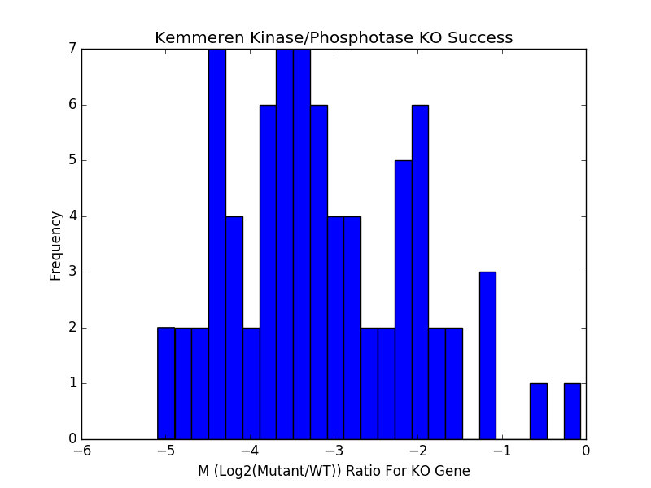

Q3: In the successful knockdowns, what percentage of the genes are differentially expressed when compared to the wildtype using the same metric
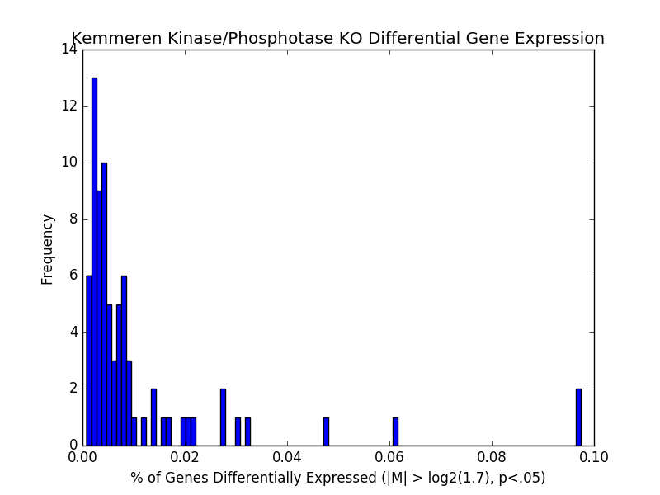

Q4: What is the distribution of kinases/phosphotases within the 75 sampless
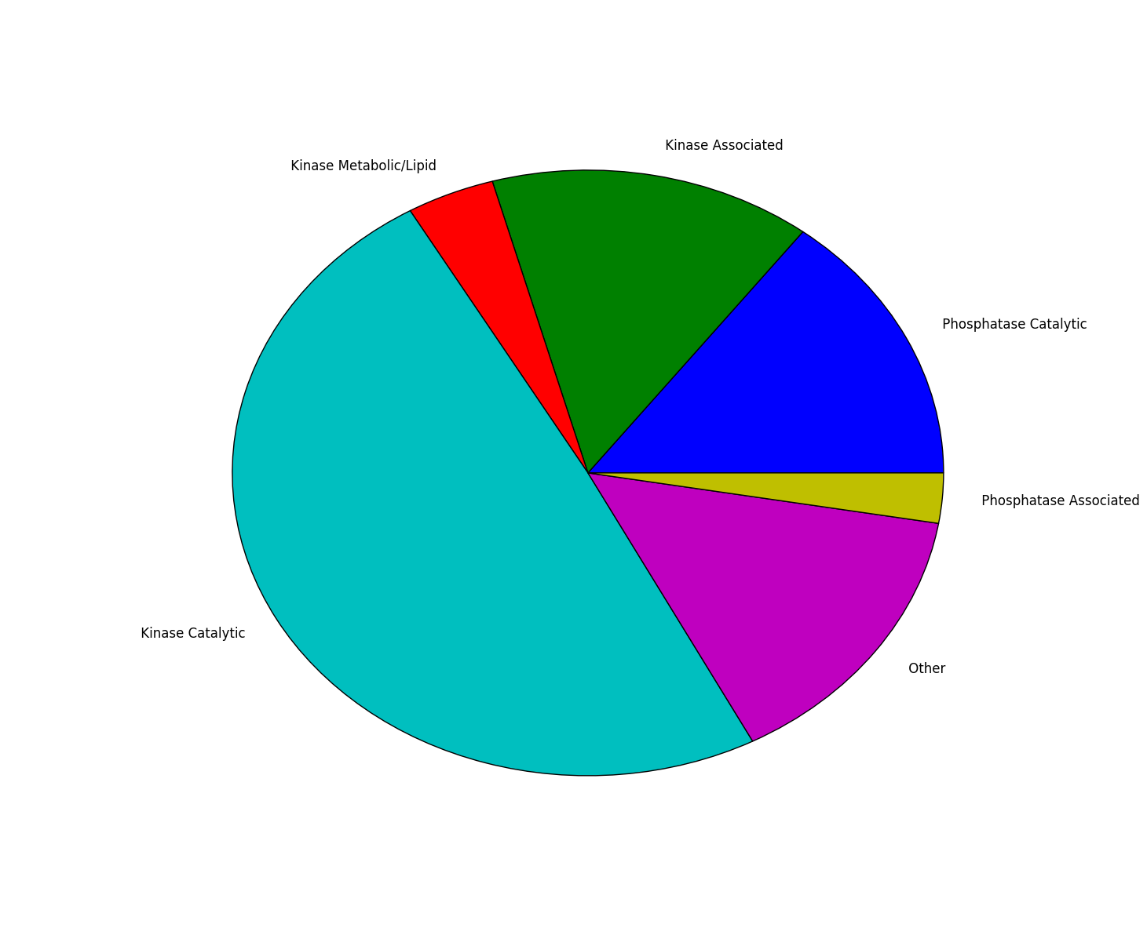
A: A large percentage of the 75 are kinase catalytic Almost ¾ are kinases

9/14-9/16
Using method adapted from FVA to quantify total solution space of TFA.
FVA (flux variability analysis) (Mahadevan et al, 2003) is a method derived for flux balance analysis that is employed in genome scale metabolic modeling. In genome scale metabolic modeling, a S matrix consisting of the reaction stoichiometry for all metabolic reactions in a given system is multiplied by a flux vector, v. The premise is that at steady state Sv =0, as there is no net accumulation of macromolecules. This system is often severely underdetermined, and, as such, an objective function is chosen by assembling a growth forming reaction and maximizing the flux through this reaction, f^{T}v. This sets up the following linear program. Max[f^{T}v], s.t. Sv =0. Unfortunate, with most objective functions this still does not define a unique solution. Thus, to capture the true solution space 2|v| more linear programs are solved: Max[v_{i}] st. Z_{obj} = f^{T}v, Sv=0 and Min[v_{i}] st. Z_{obj} = f^{T}v, Sv=0, for all v_{i} in V. This then defines a polytope in |v| dimensional space where the total solution space is guaranteed to exist, and the range of each element of v is identified.
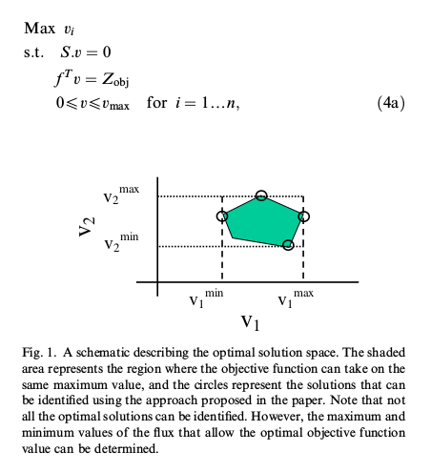

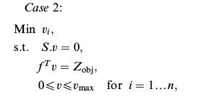
In the case of TFA inference where [GE] = [CS][TFA]. GE is factored iteratively yielding single [TFA] and [CS] matrices. This approach could then be used after [CS] is identified to calculate the range of possible [TFA] matrices. [GE] = [CS][TFA] can be split into a single column vector of a single sample’s gene expression and inferring the activity of the transcription factors for that sample, [ge] = [CS][tfa]. Suppose the initial optimization problem is solved: Min[([GE] – [CS][TFA])²] = є. Then the following optimization process can be formed as above, except now maximizing and minimizing the activity of each TF in [tfa]: Max[tfa_{i}] st. ([ge] - [CS][tfa])² = є, [tfa]>0 and Min[tfa_{i}] st. ([ge] - [CS][tfa])² = є, [tfa]>0, for all tfa_{i} in [tfa]. Repeating this procedure for each sample will result in the complete solution space for all solutions who equal factor [GE] = [CS][TFA] given the [CS] matrix found from the first solution. This would allow for a more accurate ranking of transcription factor activities within a solution.
This method would considerably increase the computational expense of calculating TFA and still does not consider all possible refinements of [CS]. One thought to increase the number of iterations required to find the maxima and minima of the TFA’s is to use the initial solution of the factorization as the starting point of the algorithm. A simple implementation of this approach is included in testFVAAdaptation.nb.

Curating Kemmeren Samples Cont.
~20% of kinase/posphotase samples passed QC standards described above where catagorized as “other” from YeastKinome.org (pawson paper). When examining these proteins individually, they often did not have any kinase/phosphotase domains or interactions when looking at the uniprot entry (with one exception), they were often transcription factors. These should then be excluded.
Kinase Associated: much of the same, many are kinase binding proteins but do not contain a kinase domain
Kinase Catalytic and Metabolic seem to be true kinases
Phosphtase Catalytic and Metabolic seem to be true
Phosphotrase Associated: All but 1 bad
From these results, due to only a few appearing exceptions. Only kinase/phosphatase catalytic and metabolic/lipid will be considered
This now gives 51 samples with high QC
Next Step is to compile a list of possible TF targets
Need to know which Tfs are considered in algorithm (set list or just visible in dataset)
YeastKID allows all kinases (with the exception of 3) to download all interactions with liklehood score. This could be useful in determining confidence of interaction, phosphotase interactions aren’t given
BioGRID (phosphogrid has same info) has flat file, this could be used to grab all interactions

