**Findings**

**F1: The navigation bar is unclear**

**Severity:** High

**Affected:** Task 1

“Another common performance metric is task success rate, sometimes referred to as accuracy. This metric simply records whether participants successfully complete a task and can help identify barriers that prevent task completion.” (Albert & Tullis, 2013, p. 153)

**Summary :** Participants were unable to discern the meaning represented by each section of the navigation bar, and the navigation bar's configuration deviated from commonly accepted conventions.

**Quantitative :** In the first step of the first task, only 40% of participants identified the correct section. (Please check appendix Image1)

|  |  |  |
| --- | --- | --- |
| **Step** | **Avg Time** | **Success Rate** |
| Step 1 | 21s | 40% |
| Step 2 | 45s | 100% |
| Step 3 | 35s | 100% |
| Step 4 | 4s | 100% |

* 40% of participants successfully identified the correct section of the navigation bar.
* Average completion time for this step was **21 seconds**, suggesting that participants spent considerable time scanning and interpreting the navigation before proceeding.

**Qual**：Many participants spent a long time stuck on the section about where to start creating posts and couldn't grasp what the “Community” section in the navigation bar represented.(Efficient to use (Preece et al., 2019) and Discoverability (Norman, 2013)“What is Community?”(Signifiers (Norman, 2013) and Discoverability (Norman, 2013)). However, participants also found the web design to be relatively straightforward.

**Impacts:** Users frequently make erroneous clicks and waste considerable time whilst navigating websites due to their inability to comprehend the precise functions of various buttons.

**F2: The method of inserting images differs from common perception.**

**Severity:** High

**Affected :** Task 1

**Summary :** To insert images on this website, copy the image URL into the comment section using a specific format, rather than opening it directly from your local folder.

“Counting errors—such as incorrect selections, mis-clicks, or wrong answers—is another useful performance metric. Errors provide insight into where users struggle and can help pinpoint aspects of the interface that need improvement.” (Albert & Tullis, 2013, p. 155)

**Quantitative :** None of the participants fully understood and utilized the method for inserting images set up on this website.

|  |  |  |  |
| --- | --- | --- | --- |
| **Step** |  | **Avg Time** | **Success Rate** |
| Step 1 |  | 27s | 40% |

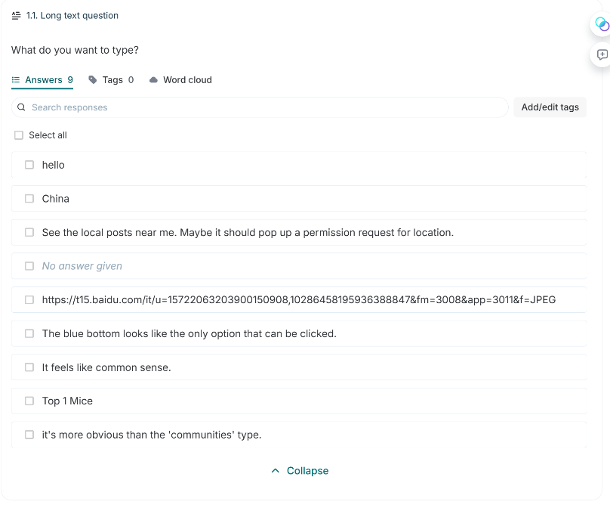

**Qual:** Some participants, even after receiving prompts, failed to understand the website's instructions for adding images and responded according to their usual habits. (Easy to learn (Preece et al., 2019) and Conceptual model (Norman, 2013))

**Impacts:** Users struggle to grasp the method of adding images by inputting URLs, which differs from the standard image upload process. This discrepancy causes frustration during usage and may ultimately prevent them from utilising the image functionality properly.

**F3: The share button's placement makes it hard to find.**

**Severity:** High

**Affected:** Task 5

**Summary :** The website placed the button in an unconventional location, and most participants failed to locate the accurate share button.

“Another common performance metric is task success rate, sometimes referred to as accuracy. This metric simply records whether participants successfully complete a task and can help identify barriers that prevent task completion.” (Albert & Tullis, 2013, p. 153)

**Quantitative :** Only 20 percent of participants found the correct location. (Please check appendix Image2)

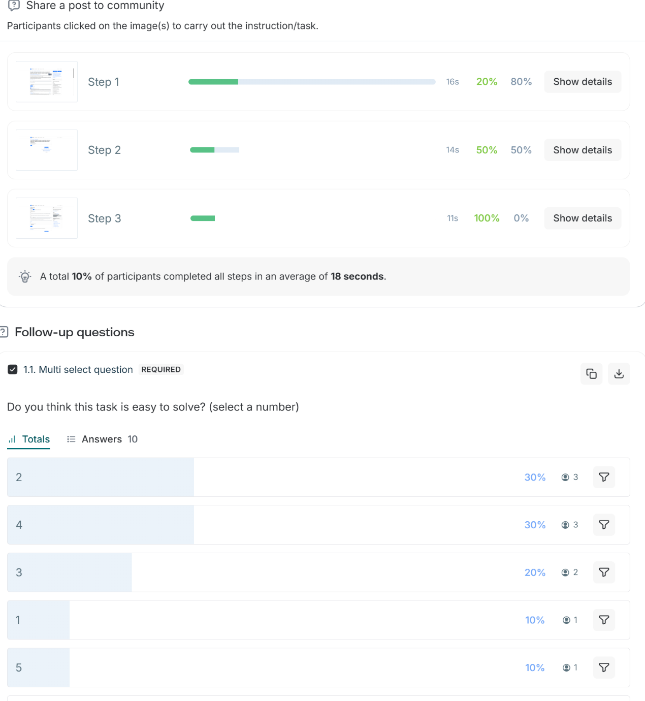

* Only 20% of participants successfully completed, this implies that most people's default way of thinking is inconsistent with web design principles.

**Qual:** Participants didn't linger long on this section, selecting answers based on their first instincts—but most of them were incorrect. (Effective to use (Preece et al., 2019) and Feedback (Norman, 2013))

**Impacts:** The position of the share button exceeded most users' expectations, resulting in the majority of participants either failing to notice it during their first interaction or spending additional time searching for it. Consequently, the task flow was disrupted, with some users experiencing noticeable hesitation, potentially leading to a portion abandoning the sharing functionality altogether.

**F4: The search button is not sufficiently clear.**

**Severity:** Mid

**Affected:** Task 2

**Summary :** The search button is relatively small and positioned in a rather out-of-the-way location.

“The most commonly collected performance metric is task completion time—how long it takes a participant to complete a task. Task times are a fundamental measure of efficiency and are particularly useful when comparing different designs or versions of a product.” (Albert & Tullis, 2013, p. 152)

**Quantitative :** Approximately 40 per cent of participants selected the correct button. (Please check appendix Image3)

|  |  |  |
| --- | --- | --- |
| **Step** | **Avg Time** | **Success Rate** |
| Step 1 | 27s | 40% |

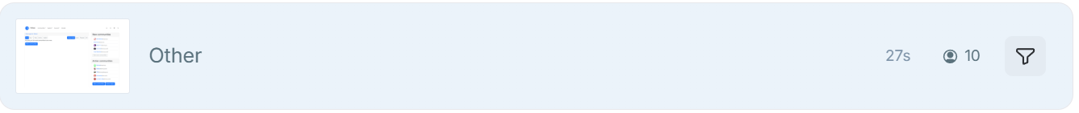

* Only 40% of participants successfully completed Step 1 of Task 2. the target button or feature is not easily noticeable or does not match users’ expectations.

**Qual:** Participants spent a considerable amount of time on this step and, upon failing to locate the correct button immediately, opted for more complex methods. (Efficient to use (Preece et al., 2019) and Discoverability (Norman, 2013)) “Where is search button?” (Signifiers (Norman, 2013) and Discoverability (Norman, 2013))

**Impacts:** The search button is excessively small and positioned in a manner inconsistent with user expectations, resulting in a significant negative impact on task completion efficiency. Many users spend considerable time scanning the interface or clicking erroneous areas before locating this functionality. This not only increases the time users expend but also disrupts the overall rhythm of usage.

**F5 – Slow response and lack of click feedback**

**Severity**: Medium  
**Affected Task:** General interaction and page navigation

Qualitative:

“Click a button without getting a reaction for a few seconds.” (Feedback (Norman, 2013) and Efficiency (Preece et al., 2019))

“Click a button once and get me to a new page immediately.” (Efficiency **(Preece et al., 2019)**)

**F6 – Unclear account creation process**

**Severity:** Medium  
**Affected Task:** Account registration

**Qualitative:**

“Didn’t delete the account and password when I try to create a new account.” (Constraints (Norman, 2013) and Safety (Preece et al., 2019)

**F7 – Lack of engaging content and low willingness to use**

**Severity:** High  
**Affected Task:** Long-term engagement and return usage

**Qualitative:**

“Limited content. Too much U.S. politics.” (Have good utility (Preece et al., 2019) and Effective to use (Preece et al., 2019)

“If all my friends use this forum, then I would try it.” Have good utility (Preece et al., 2019)

**F8 – Mixed first impressions of the interface**

**Severity:** Low  
**Affected Task:** Initial user experience

**Qualitative:**

“Many words.” Effective to use (Preece et al., 2019)

“Very clean and lots of information.” Effective to use (Preece et al., 2019)

Appendix

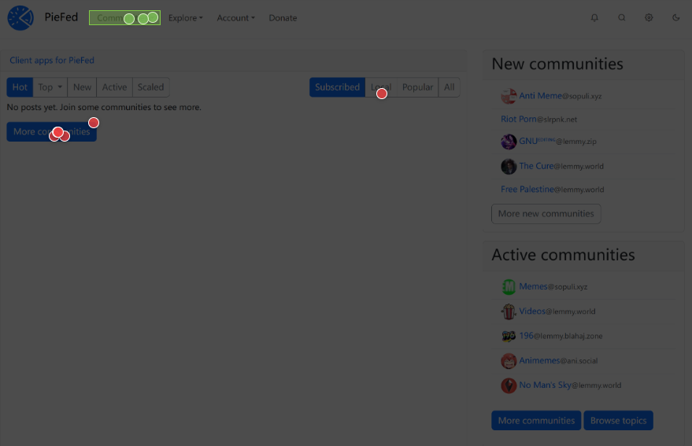

Image 1

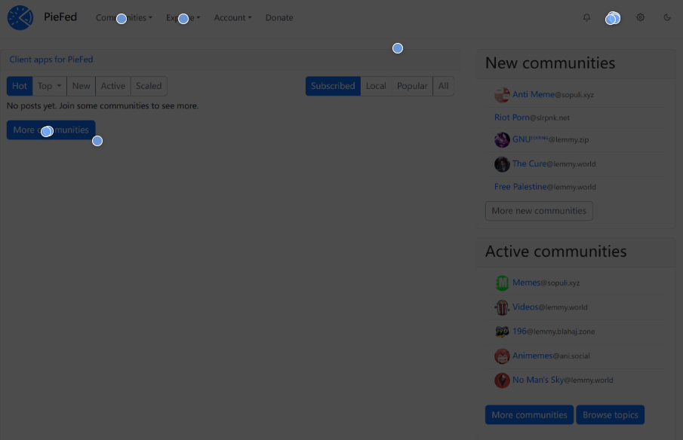

Image 2

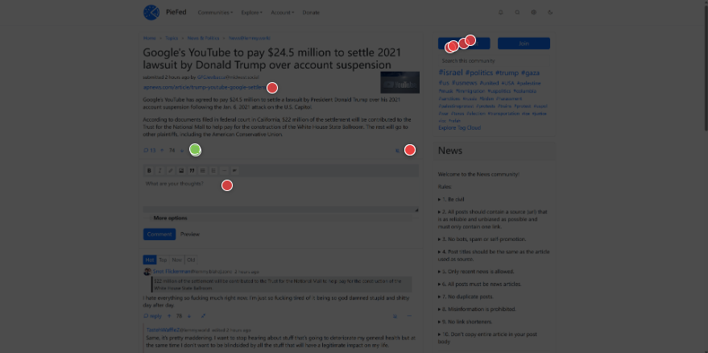

Image 3