Software Testing project : a mastermind game in Java.

The team :

- Ivanne Sanchez
- Maywadee Soytong

Description of the project :

The idea is to implement an interface to play mastermind.
Mastermind is a puzzle game, in which one player tries to guess the code his opponent comes up with.
Mastermind is the game you can test here : http://www.web-games-online.com/mastermind/index.php

How to play mastermind :

The computer has a secret combination of colors (usually randomly chosen) and the player has to guess it.
For that the player proposes a combination of colors and the computers tells him how many colors are correct (right color on the right place) and how many are just misplaced (right color but in the wrong place).
Usually, there is a maximum number of proposals possible for the player, 10 in the example from the link (which has a combination of 4 colors).

The goal of our mastermind :

The idea is to implement a program that choose a color combination randomly and then, for each proposal of the player, gives the number of well-placed colors and the number of right colors, but misplaced.

Components we have to implement (picture on next page) :

- Game Controller :
- random : returns a random combination (the one the player has to guess)
- checkWellPlaced : argument : color combination given by the player. Returns the number of well-placed colors.
- checkCorrectColor : argument : color combination given by the player. Returns the number of colors that are correct, but misplaced.
- ScoreFileManagement : we keep the track of the player's names and best scores in a file
- Graphical Interface : where the player will be able to make his proposals and see the results given by the program (well-placed or missplaced colors). At the end should also appear the correct solution (important if the player did not manage to find it) and a window for the player to enter his name if he wants his score to be kept in the database.

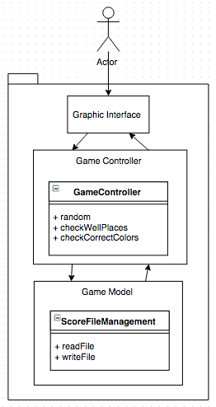

Technologies we want to use :

Java, Junit, Git deposit (github) and of course SpinRoot !

