**PANDAS**

CVS file

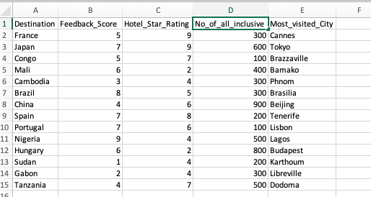

1. How many rows and columns are there in your file?

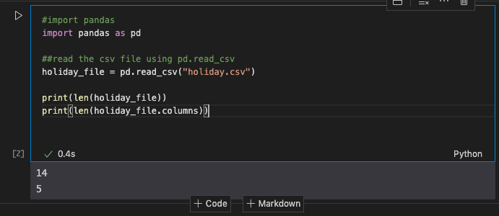

1. Print row 3-8 ( using iloc/loc).



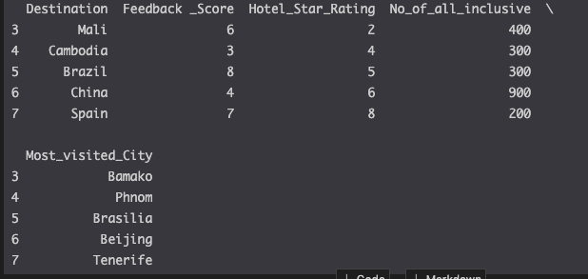

1. Find the mean number of all-inclusive hotels across all destinations.

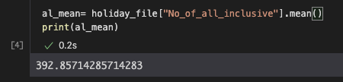

1. Find the lowest scoring destination.

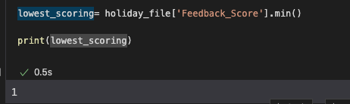

1. Find the highest scoring destination.

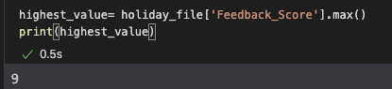

1. Find all the destinations where there are more than 9 all-inclusive hotels.
2. Filter the data by score above 8.

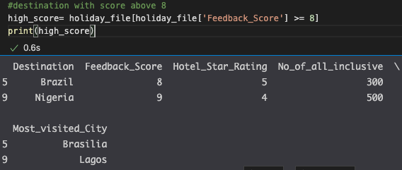

1. Filter the data score below 2 ( I need to know if these destinations should be removed or there is a problem)

