Emily Wojan

CSD 310

6.2 Assignment

4/18/2023

Movies: Setup

Screenshot of the output from running the .sql file and of the show tables command:

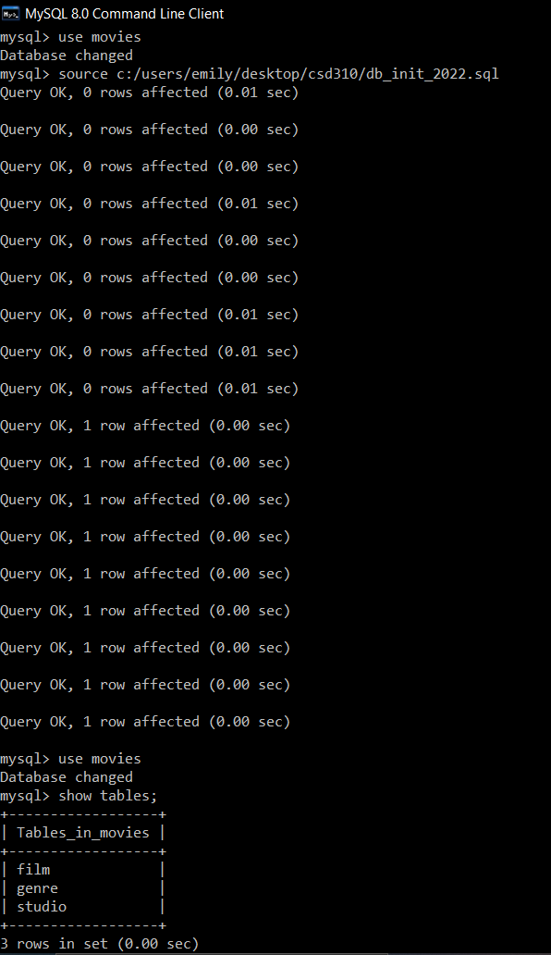

Screenshot of the output from running the connect program:

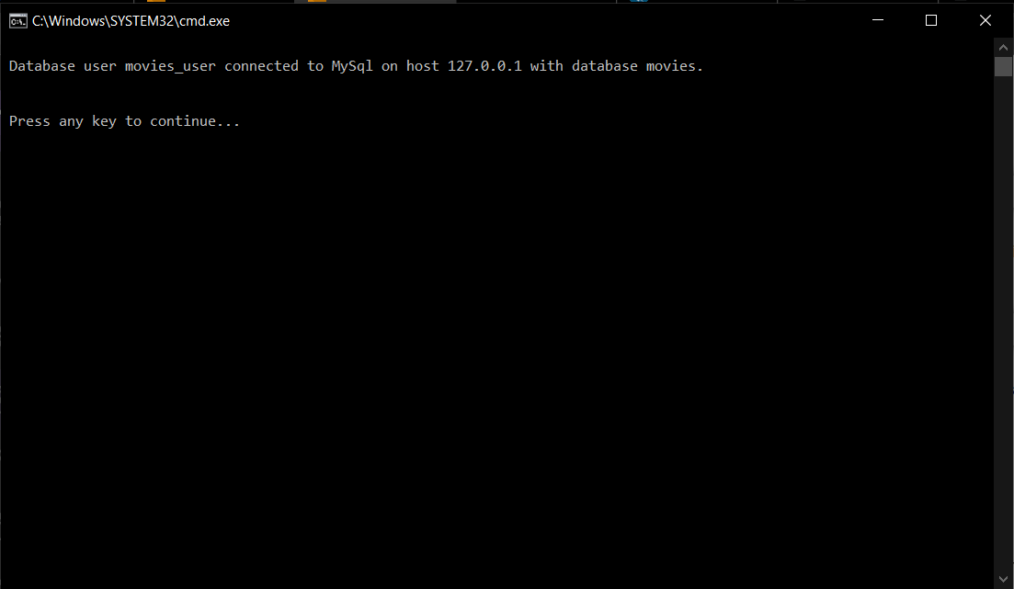

Link to the GitHub repository: [csd-310 Repository](https://github.com/e-wojan/csd-310.git)