Emily Wojan

CSD 310

7.2 Assignment

4/25/2023

Movies: Table Queries

Screenshot of the output from running the Python Script:

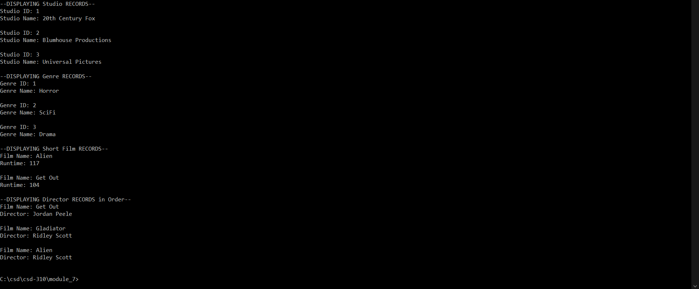

Link to the GitHub repository: [csd-310 Repository](https://github.com/e-wojan/csd-310.git)