Emily Wojan

CSD 310

8.2 Assignment

4/25/2023

Movies: Update & Deletes

Screenshots of the output from running the Python Script:

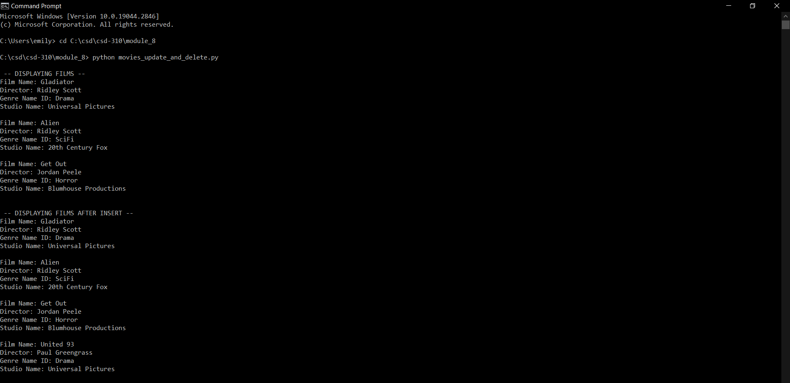

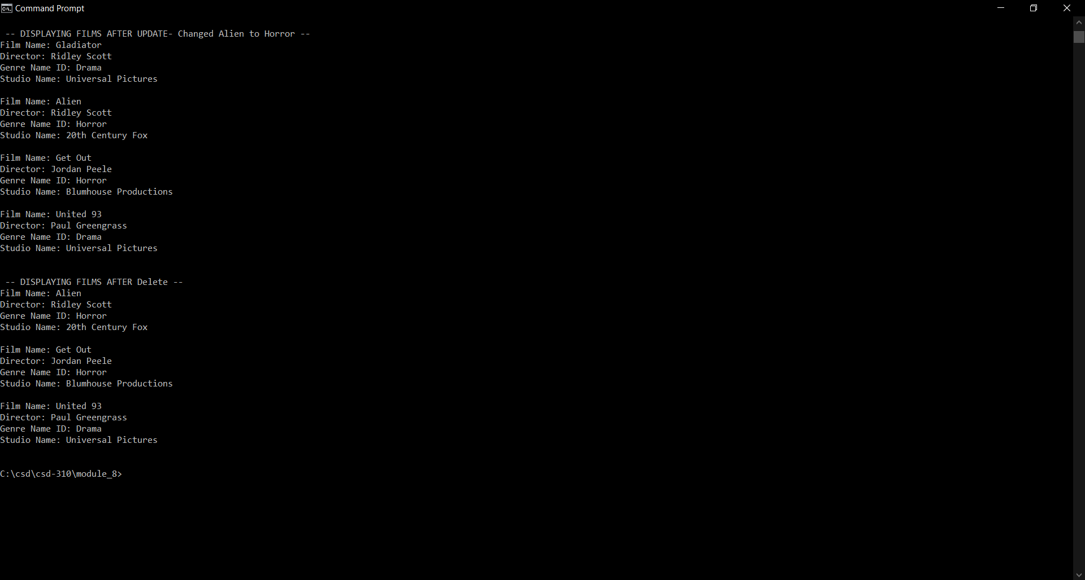

Link to the GitHub repository: [csd-310 Repository](https://github.com/e-wojan/csd-310.git)