- Write a C program to create a structure called student. Get details such as student id, name, age, department, year of study, address, mobile number, marks in three different subjects such as science, maths and English and print the details.
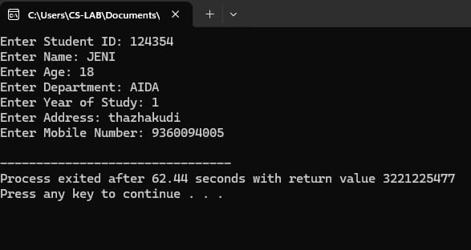

- Write a C program to create the above student structure and get details of 10 students and print them.

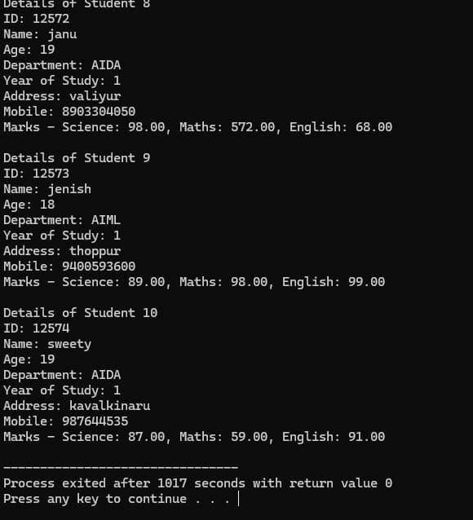

- Write a C program to get details of 10 students and find the average and maximum marks and print the student with maximum marks using structures.

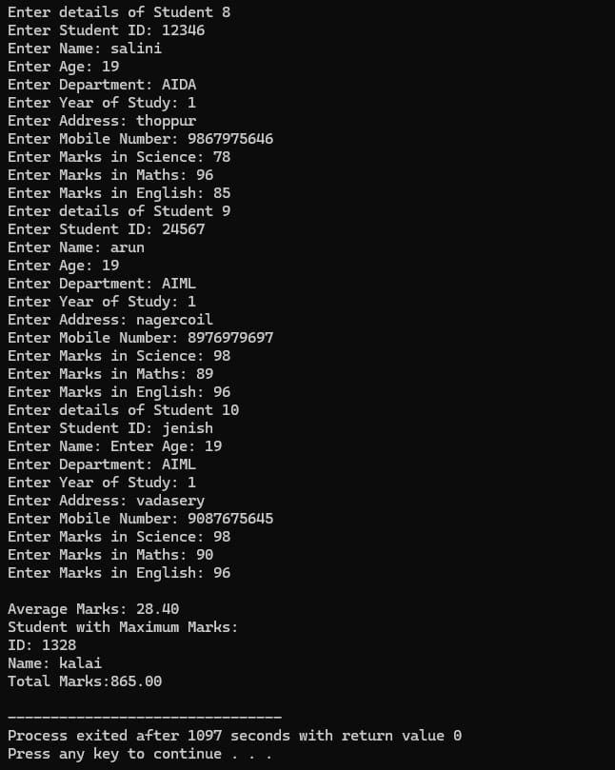

- Write a C program to create nested structure for students.

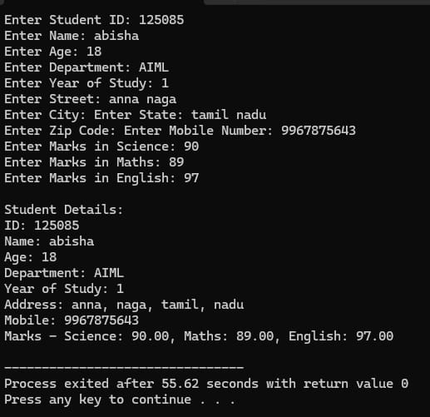

- Write a C program to perform employee payroll processing using structures.
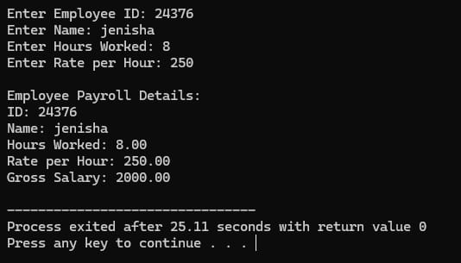
- Write a C program using a structure to store and display student details. Define a structure named Student with the following members: ● rollNo (integer) ● marks (float) ● grade (character) The program should: 1. Read the student’s roll number and marks from the user. 2. Assign a grade based on marks as follows: ○ Marks ≥ 90 → Grade A ○ Marks ≥ 75 → Grade B ○ Marks ≥ 50 → Grade C ○ Marks < 50 → Grade D 3. Display the student’s details including the calculated grade.

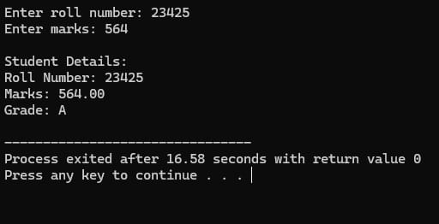

- Write a C program using a structure to store and display employee details. Define a structure named Employee with the following members: empId (integer) salary (float) grade (char) The program should: Read the employee details from the user. Assign a grade based on the salary range as follows: Salary ≥ 90000 → Grade A Salary ≥ 75000 → Grade B Salary ≥ 50000 → Grade C Salary < 50000 → Grade D Display the employee’s details including the calculated grade. give different values

