#include<stdio.h>
int main () {
float p1,p2,p3; //price
int a,b,c; // quantity
float t1,t2,t3,total; // totalbill
printf("\n what's the price of a:");
scanf("%f",&p1);
printf("\n what's the price of b:");
scanf("%f",&p2);
printf("\n what's the price of c:");
scanf("%f",&p3);
printf("\n what's the quantity of a:");
scanf("%d",&a);
printf("\n what's the quantity of b:");
scanf("%d",&b);
printf("\n what's the quantity of c:");
scanf("%d",&c);
t1=p1*a;
t2=p2*b;
t3=p3*c;
total=t1+t2+t3;
printf("\n the bill for item a is:%2f",t1);
printf("\n the bill for item b is:%2f",t2);
printf("\n the bill for item c is:%2f",t3);
printf("\n the totsl bill for all item is:%2f",total);
return 0;
}
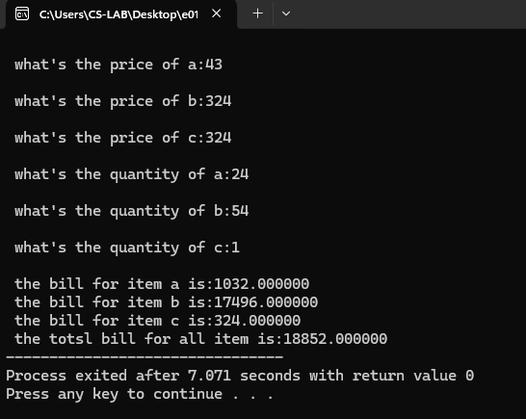
#include<stdio.h>
int main ()
{float ab,wm,nb; //account balnce,withdral money,new balance
printf("\nenter the money that should be withdrawn from your savings:");
scanf("%f",&wm);
printf("\nenter your account balance:");
scanf("%f",&ab);
nb=ab-wm;
if(wm<=ab) {printf("\nthe amount %2f will be withdrawn",wm);
printf("\nthe remaining balance is:%2f",nb);}
else {printf("insufficiant funds");}
return 0;
}
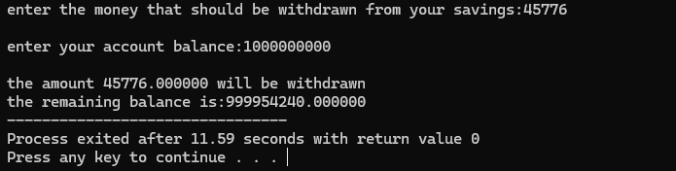
#include<stdio.h>
int main ()
{int y;
printf("Enter a the year: ");
scanf("%d", &y);
if((y%4==0 && y%100!= 0)||(y%400==0)){printf("%d is a leap year.\n",y);}
else {printf("%d is not a leap year.\n",y);}
return 0;
}
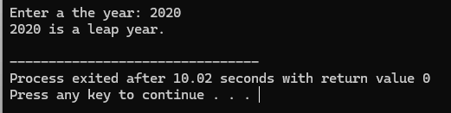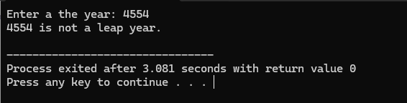
#include<stdio.h>
int main (){
char c;
printf("\nenter the character:");
scanf("%c",&c);
if (c=='a'||c=='e'||c=='i'||c=='o'||c=='u'||c=='A'||c=='E'||c=='I'||c=='O'||c=='U')
{printf("%c is the vowel",c);}
else {printf("%c is the constant",c);}
return 0;
}
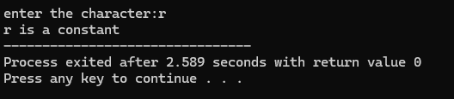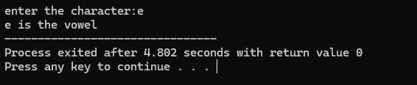
#include<stdio.h>
#include<math.h>
int main () {
int n;
float root;
printf("Enter the number to find the square root of it: ");
scanf("%d",&n);
root=sqrt(n);
printf("Square root of the %d=%2f",n,root);
return 0;
}
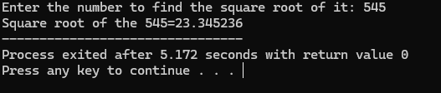
#include<stdio.h>
int main ()
{int n;
printf("enter the value of n:");
scanf("%d",&n);
(n%2==0)?printf("it is Even Number"):printf("it is Odd Number");
return 0;
}
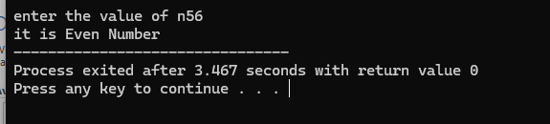
#include<stdio.h>
int main ()
{ float op,d,t,fp; //original price,discount,tax,fixed price
printf("Enter the original price of the item: ");
scanf("%f",&op);
printf("Enter the discount of the item: ");
scanf("%f",&d);
printf("Enter the sales tax on the item: ");
scanf("%f",&t);
fp=op-(op*(d/100));
fp=fp*(1+(t/100));
printf("The final price is: $%.2f\n",fp);
return 0;
}
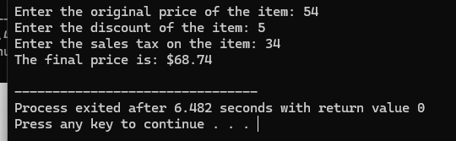
#include <stdio.h>
int main() {
int a,b,result;
printf("enter the value of a and b");
scanf("%d%d",&a,&b);
result = ++a + b++ + a++;
printf("Result = %d\n",result);
printf("a=%d, b=%d\n",a,b);
return 0;
}
