- Write a C program to store 5 elements in an array and print them.
#include<stdio.h>
int main (){
int i,n;
int a[88];
printf("enter the number of elements \n");
scanf("%d",&n);
printf("enter the elements:\n");
for(i=0;i<n;i++){
scanf("%d",&a[i]);}
for(i=0;i<n;i++){
printf("%d",a[i]);
}
return 0;}
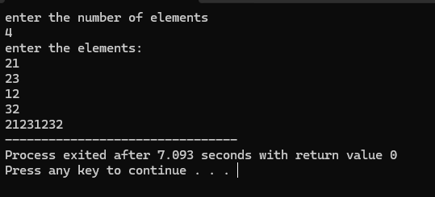

- Write a C program to find the Sum of n Integers using 1 Dimensional Array
#include<stdio.h>
int main (){
int i,n,a[88],sum=0;
printf("enter the number of elements \n");
scanf("%d",&n);
printf("enter the elements:\n");
for(i=0;i<n;i++){
scanf("%d",&a[i]);}
for(i=0;i<n;i++)
{sum += a[i];
}
printf("the sum is %d",sum);
return 0;}
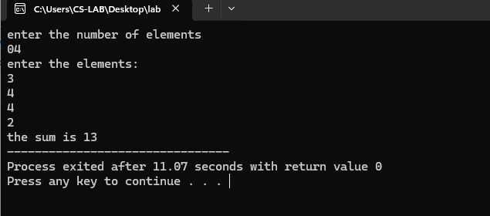
- Write a C program to search for an element from the array.
#include<stdio.h>
int main ()
{ int i,n,search,found=0,a[99];
printf("enter the number of elements \n");
scanf("%d",&n);
printf("enter the element to search");
scanf("%d",&search);
printf("enter the elements:\n");
for(i=0;i<n;i++){
scanf("%d",&a[i]);}
for(i=0;i<n;i++){
if (a[i]==search)
{found=1;
printf("element %d is found at %d",search,i);
}}
if (found==0)
{printf("element is not found");
}
return 0;}
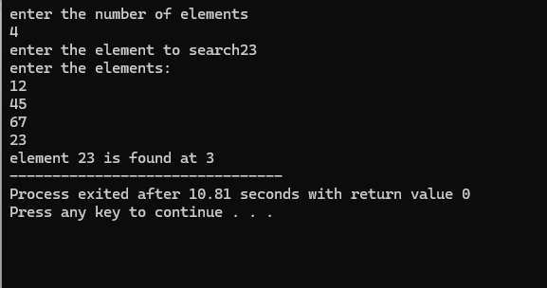

- Write a C program to find the largest and smallest element from the array.
#include<stdio.h>
int main()
{int smallest,largest,a[99],n,i;
printf("enter the number of elements \n");
scanf("%d",&n);
printf("enter the elements:\n");
for(i=0;i<n;i++){
scanf("%d",&a[i]);}
smallest=a[0];
largest=a[0];
for(i=0;i<n;i++){
if(smallest>a[i]){
smallest=a[i];
}
if(largest<a[i])
{largest =a[i];}
}

printf("the largest is %d",largest);
printf("the smallest is %d",smallest);

return 0; }
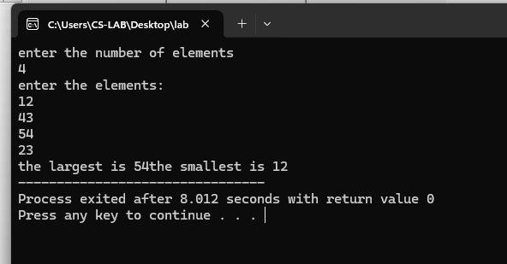

- Write a C program to sort the array
#include<stdio.h>
int main (){
int i,j,n,a[88],temp;
printf("enter the number of elements \n");
scanf("%d",&n);
printf("enter the elements:\n");
for(i=0;i<n;i++){
scanf("%d",&a[i]);}
for(i=0;i<n-1;i++){
for(j=0;j<n-i-1;j++){
if (a[j]>a[j+1]){
temp=a[j];
a[j]=a[j+1];
a[j+1]=temp;
}
}

}
printf("After sorting: ");
for (int i = 0; i < n; i++) {
printf("%d ", a[i]);}

return 0;
}
