1. Write a C program to count the vowels in a string.
#include<stdio.h>
int main (){
int i,count=0;
char str[98];
printf("enter the string");
scanf("%s",&str);
for(i=0;str[i]!='\0';i++) {if (str[i] == 'a' || str[i] == 'e' || str[i] == 'i' || str[i] == 'o' || str[i] == 'u' || str[i] == 'A' || str[i] == 'E' ||
str[i] == 'I' || str[i] == 'O' || str[i] == 'U'){count++;
}

}
printf("Number of vowels: %d\n", count);
return 0;
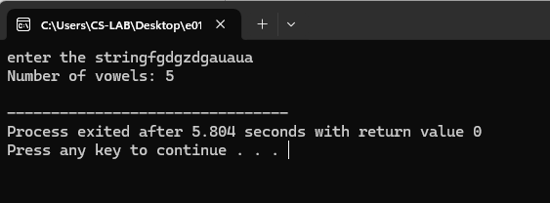
}
2 . Write a C program to check if a string is a palindrome or not.
#include <stdio.h>
#include <string.h>
int main() {
char six[67];
int i,ln,flag = 1;
printf("Enter the string:");
scanf("%s",&six);
ln=strlen(six);
for (i=0;i<ln/2;i++) {
if(six[i]!=six[ln-i-1]) {
flag =0;
break;}}
if (flag==1) {
printf("The string is a palindrome\n");
} else {
printf("The string is not a palindrome\n");
}
return 0;
}
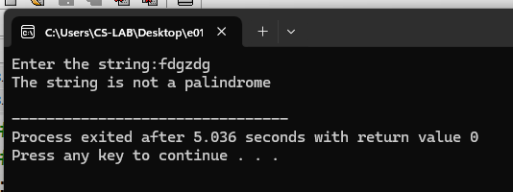
3. Write a C program for Finding the Frequency of a Character in a String
#include <stdio.h>
int main() {
char seven[100], ch;
int i, count = 0;
printf("Enter a string: ");
scanf("%s", &seven);
printf("Enter the character to find frequency: ");
scanf(" %c", &ch);
for (i = 0; seven[i] != '\0'; i++) {
if (seven[i] == ch) {
count++;
}
}
printf("Frequency of '%c': %d\n", ch, count);
return 0;
} 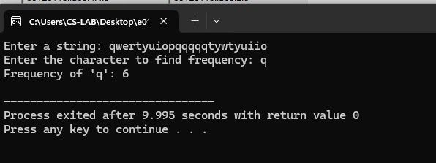
4. Write a C program to perform String operations using Pre-defined functions
4.1 (i) strlen
#include<stdio.h>
#include<string.h>
int main (){
char str[56]="gjykgyg yguygu";
int lt=strlen(str);
printf("the lenght of the string is %d:",lt);
return 0;
}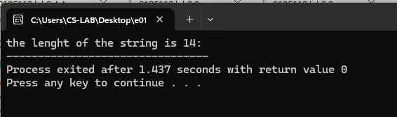
4.2 (ii) strcpy
#include<stdio.h>
#include<string.h>
int main (){
char ghjghj[] = "six seven";
char copy[50];
strcpy(copy, ghjghj);
printf("Copied string: %s\n", copy);
return 0;
}
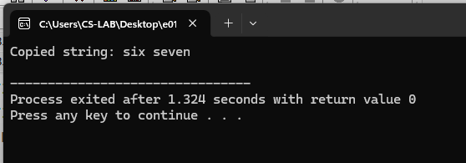

4.3 (iii) strcat #include<stdio.h>
#include<string.h>
int main(){
char six[] = "six";
char seven[] = "seven!";
strcat(six,seven);
printf("Concatenated string: %s\n",six);
return 0;
}
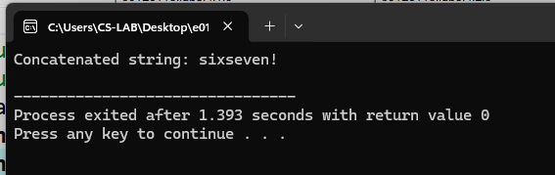

4.4 (iv) strcmp
#include <stdio.h>
#include <string.h>
int main() {
char six[100], seven[100];
printf("Enter the first string: ");
scanf("%s",&six);
printf("Enter the second string: ");
scanf("%s",&seven);
int result = strcmp(six,seven);
if (result == 0)
{
printf("The strings are equal.\n");
}
else if (result < 0)
{
printf("The first string is less than the second string.\n");
}
else {
printf("The first string is greater than the second string.\n");
}
return 0;
}
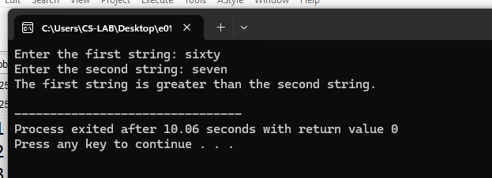

5. Write a C program to perform String operations without using Pre-defined functions
5.1(i) strlen
#include <stdio.h>
int main() {
char qwe[] = "six sevennn!";
int ln = 0;
while (qwe[ln] != '\0') {
ln++;
}
printf("The length of the string \"%s\" is: %d\n", qwe, ln);
return 0;}
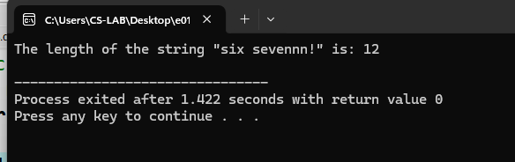
5.2(ii) strcpy
#include <stdio.h>
int main() {
char six[] = "sixty sevenn!";
char seven[50];
int i = 0;
while (six[i] != '\0') {
seven[i] = six[i];
i++;
}
seven[i] = '\0';
printf("Copied string: %s\n", seven);
return 0;
}
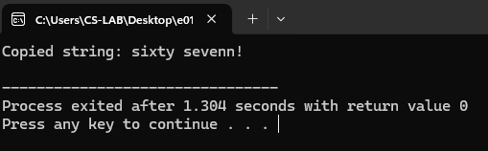
5.3(iii) strcat
#include <stdio.h>
#include <string.h>
int main() {
char six[] = "forty eight";
printf("Original string: %s\n", six);
int n = strlen(six);
for (int i = 0; i < n / 2; i++) {
char temp = six[i];
six[i] = six[n - i - 1];
six[n - i - 1] = temp;
}
printf("Reversed string: %s\n", six);
return 0;
}
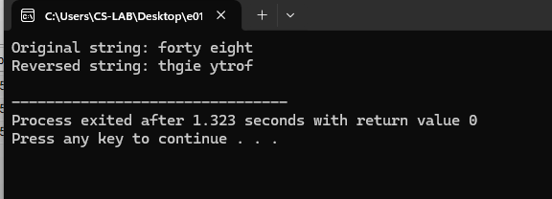
5.4(iv) strcmp
#include <stdio.h>
int main() {
char six[100],seven[100];
printf("Enter the first string: ");
scanf("%s",six);
printf("Enter the second string: ");
scanf("%s",seven);
int i = 0;
while (six[i]!='\0'&&seven[i]!='\0') {
if (six[i]!=seven[i]) {
break;
}
i++;
}

if (six[i] == seven[i]) {
printf("The strings are equal.\n");
} else if (six[i] < seven[i]) {
printf("The first string is less than the second string.\n"); }
else {
printf("The first string is greater than the second string.\n"); }
return 0;
}
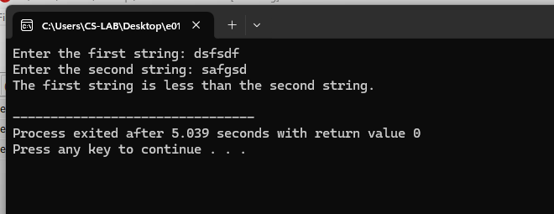

5.5(v) strlwr

#include <stdio.h>
int main() {
char str[100];
printf("Enter a string: ");
scanf("%s",&str);
for (int i = 0; str[i] != '\0'; i++) {
if (str[i] >= 'A' && str[i] <= 'Z') {
str[i] = str[i] + 32;
}}
printf("Lowercase string: %s\n", str);
return 0;} 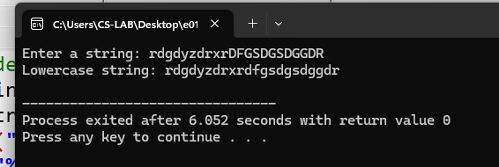

5.6 (vi) strupr
#include <stdio.h>
int main() {
char str[100];
printf("Enter a string: ");
scanf("%s", &str);
for (int i = 0; str[i] != '\0'; i++) {
if (str[i] >= 'a' && str[i] <= 'z') {
str[i] = str[i] - 32;}
}
printf("Uppercase string: %s\n", str);
return 0;}
