**E0324020**

**PYTHON**

**Analysis of Student Academic Performance in a Class**

**Dataset:**

|  |  |  |  |  |  |
| --- | --- | --- | --- | --- | --- |
| Student ID | Marks in Math | Marks in Science | Marks in English | Hours Studied/Week | Attendance % |
| S001 | 85 | 78 | 92 | 15 | 95 |
| S002 | 92 | 88 | 85 | 20 | 98 |
| S003 | 78 | 82 | 79 | 12 | 87 |
| S004 | 65 | 70 | 68 | 8 | 75 |
| S005 | 88 | 95 | 90 | 18 | 96 |
| S006 | 72 | 75 | 80 | 10 | 82 |
| S007 | 95 | 92 | 88 | 22 | 99 |
| S008 | 81 | 79 | 84 | 14 | 90 |
| S009 | 70 | 68 | 72 | 9 | 78 |
| S010 | 89 | 85 | 91 | 17 | 94 |

**Why use Bar Graph:**  
A bar graph is ideal for **comparing discrete categories** (individual students) side-by-side. It clearly shows which students performed better or worse in Mathematics, making it easy to identify high achievers and those who may need help.

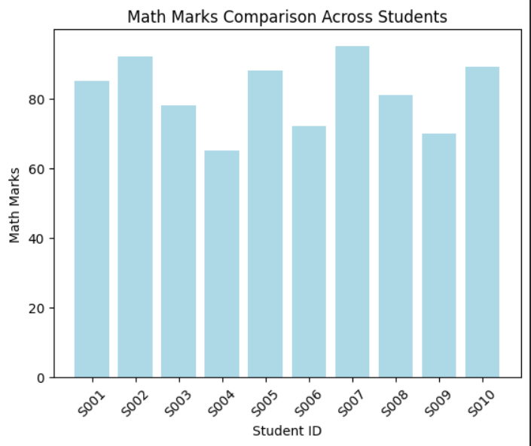

**Why use Pie Chart:**  
A pie chart is perfect for showing the **proportional contribution** of each subject to a student's total marks. It helps visualize if a student is balanced across subjects or has strong/weak areas.

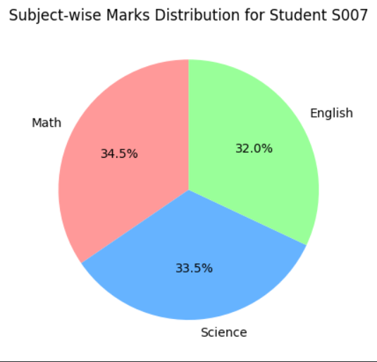

**Why use Histogram:**  
A histogram helps analyze the **distribution of continuous data** (attendance percentages). It shows how many students fall into different attendance ranges (e.g., 70-80%, 80-90%, etc.), revealing the overall attendance pattern of the class.

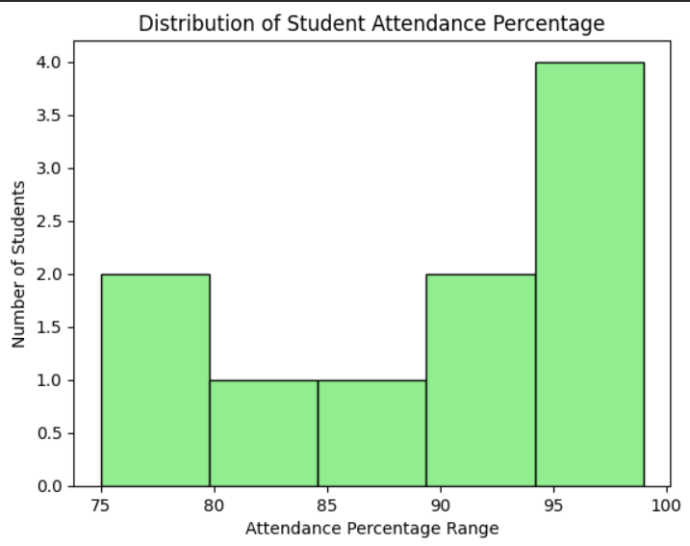

**Why use Line Plot:**  
A line plot effectively shows **trends across categories**. Here, it helps visualize which subject has the highest average performance and how the averages compare across the three main subjects.

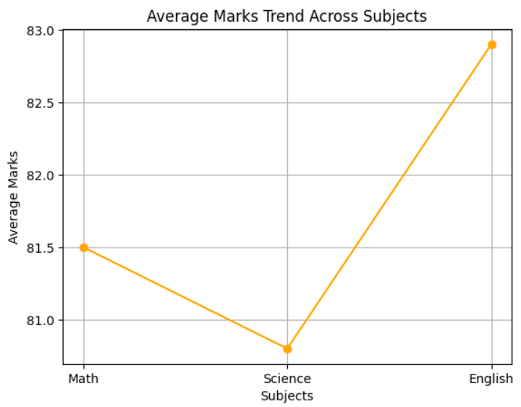

**Why use Scatter Plot:**  
Scatter plots are best for studying **correlation** between two numerical variables. This plot helps answer whether there's a relationship between the amount of time students spend studying and their resulting math scores.

