WS con los métodos actualizados

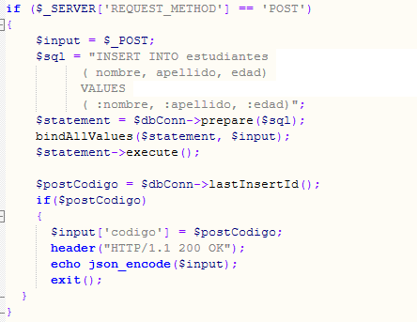

Consumo del métod GET

Se actualiza la información del registro con código “5”

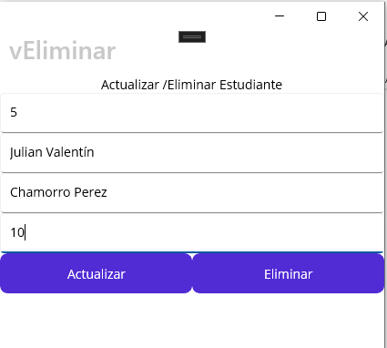

Registro Actualizado

Método PUT agregar nuevo estudiante.

Registro insertado

Eliminación de un registro con código “4”, Método DELETE

Validación que el registro fue eliminado satisfactoriamente:

