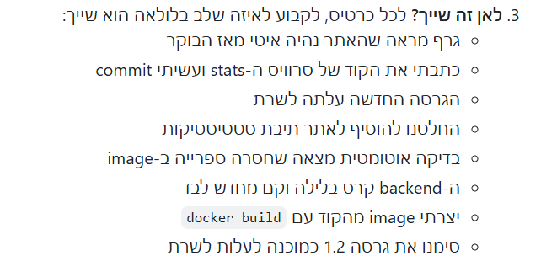

Monitor
Code
Deploy
Plan
Test
Operate
Build
release

