# Question 1

For the following DAG, assume M is the source vertex and the adjacency list is in alphabetical order. Show each vertices discover & finish time by a DFS on the graph

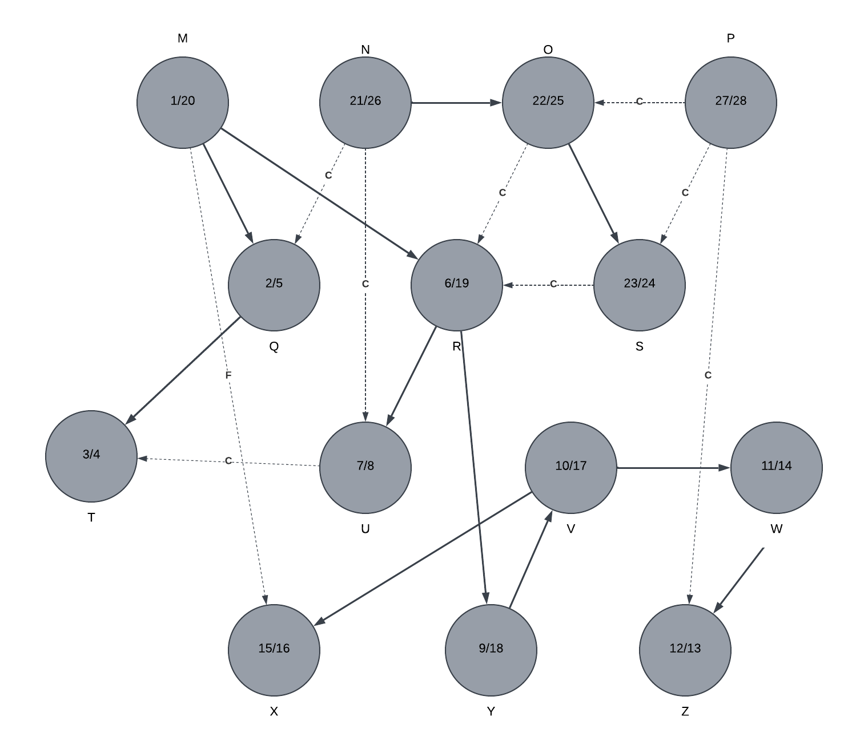

# Question 2

Show the ordering of vertices produced by TOPOLOGICAL-SORT when it is run on above DAG. (see Fig. 22.7 on pp.613 as one example)

