Question 1

[4 pts] Demonstrate what happened when we insert the keys 6, 29, 20, 16, 21, 34, 13, 18, 11 into a hash table with collisions resolved by chaining. Let the table have 9 slots and let the hash function be h(k) = k mod 9. Draw the resulting hash table.

|  |  |  |  |  |  |  |  |  |  |  |  |  |  |
| --- | --- | --- | --- | --- | --- | --- | --- | --- | --- | --- | --- | --- | --- |
| 1 | | 2 | | 3 | | 4 | | 5 | | 6 | | 7 | |
| Slot | keys | Slot | keys | Slot | keys | Slot | keys | Slot | keys | Slot | keys | Slot | keys |
| 0 |  | 0 |  | 0 |  | 0 |  | 0 |  | 0 |  | 0 |  |
| 1 |  | 1 |  | 1 |  | 1 |  | 1 |  | 1 |  | 1 |  |
| 2 |  | 2 | 29 | 2 | 20,29 | 2 | 20,29 | 2 | 20,29 | 2 | 20,29 | 2 | 20,29 |
| 3 |  | 3 |  | 3 |  | 3 |  | 3 | 21 | 3 | 21 | 3 | 21 |
| 4 |  | 4 |  | 4 |  | 4 |  | 4 |  | 4 |  | 4 | 13 |
| 5 |  | 5 |  | 5 |  | 5 |  | 5 |  | 5 |  | 5 |  |
| 6 | 6 | 6 | 6 | 6 | 6 | 6 | 6 | 6 | 6 | 6 | 6 | 6 | 6 |
| 7 |  | 7 |  | 7 |  | 7 | 16 | 7 | 16 | 7 | 34,16 | 7 | 34,16 |
| 8 |  | 8 |  | 8 |  | 8 |  | 8 |  | 8 |  | 8 |  |

|  |  |  |  |
| --- | --- | --- | --- |
| 8 | | 9 | |
| Slot | keys | Slot | keys |
| 0 | 18 | 0 | 18 |
| 1 |  | 1 |  |
| 2 | 20,29 | 2 | 11,20,29 |
| 3 | 21 | 3 | 21 |
| 4 | 13 | 4 | 13 |
| 5 |  | 5 |  |
| 6 | 6 | 6 | 6 |
| 7 | 34,16 | 7 | 34,16 |
| 8 |  | 8 |  |

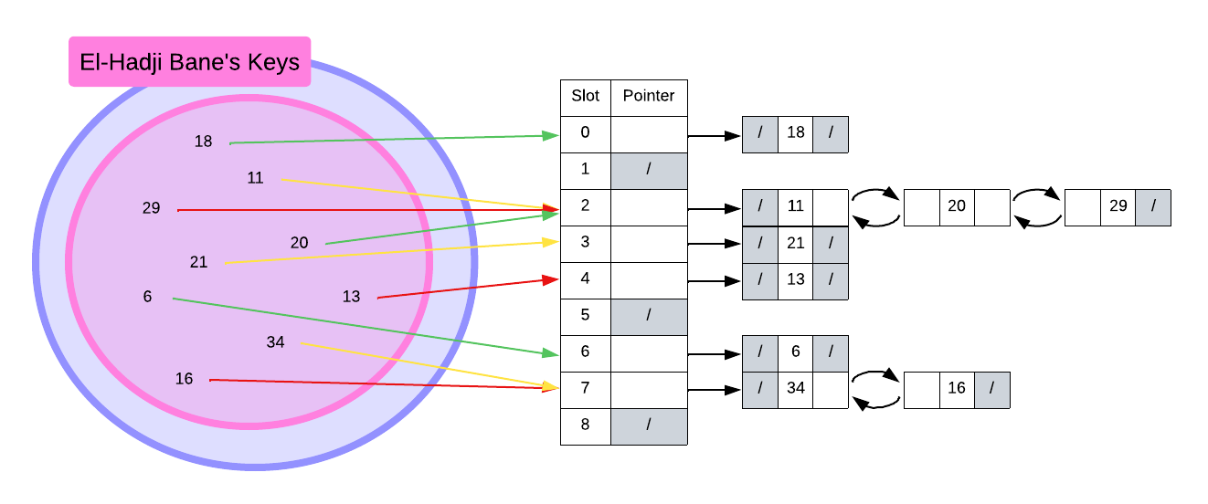

Question 2

Suppose you are given a universe of elements U = {85, 46, 65, 34, 39, 98, 17} to be inserted into a hash table and number of slots in the table is 5.

1. [2 pt] What is the load factor?
$$load factor=\frac{7}{5}$$

2. [4 pts] To resolve collision using chaining method draw the final content of the hash table with hash function h(k) = k mod 5. How many computations at the most do you think you’re required to search for any element in the final hash table.

Search computation factors

1. To access the correct slot, the hash value is computed.
2. Traversing up a list takes time.
3. The longest linked-list in the table has 2 nodes.

Conclusion: it takes 2 computations to perform a search at most.