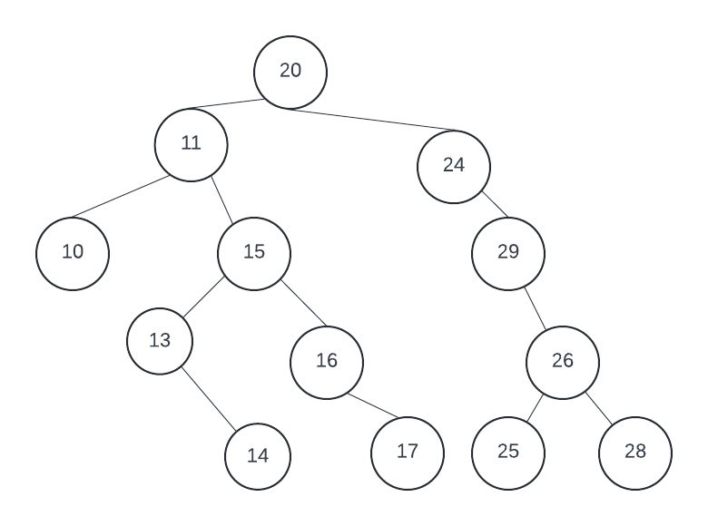1. For the following Binary Search Tree, answer questions. [1 pt each, total 4 pts

1.1) Draw the resulting BST if we insert a new node 12 inside above original tree.

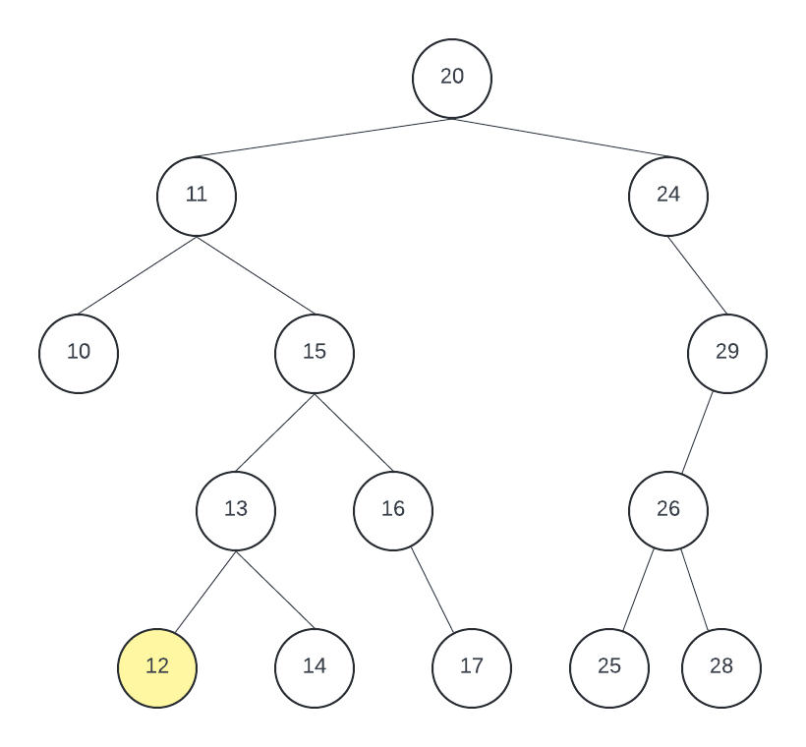

1.2) Draw the resulting BST if we delete node 11 from above original tree.

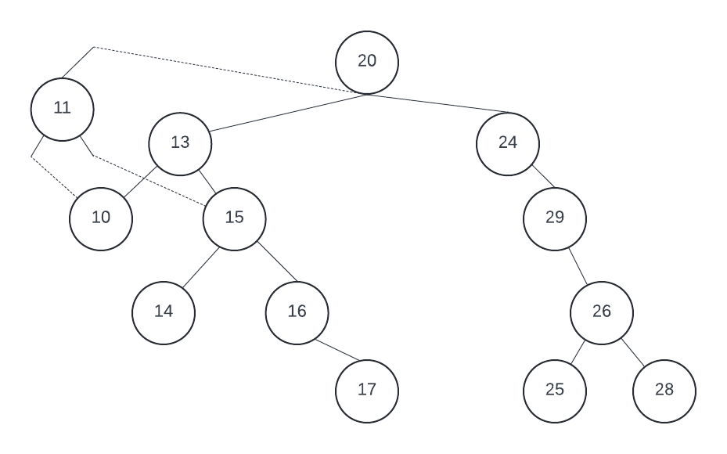

1.3) Draw the resulting BST if we delete node 20 from above original tree.

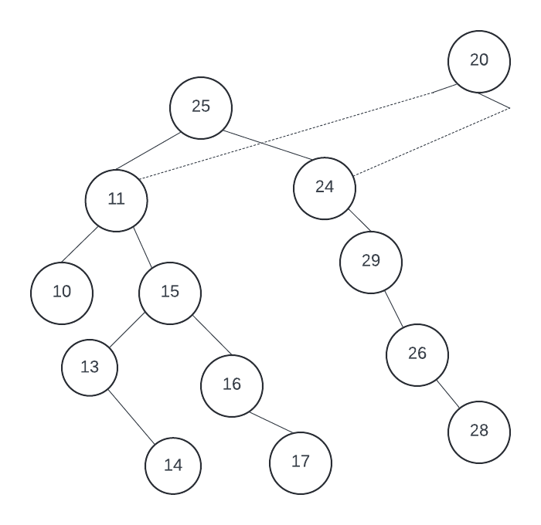

1.4) Draw the resulting BST if we delete node 24 from the original tree.

2. Given the following binary search tree T, answer questions.[total 6 pts] 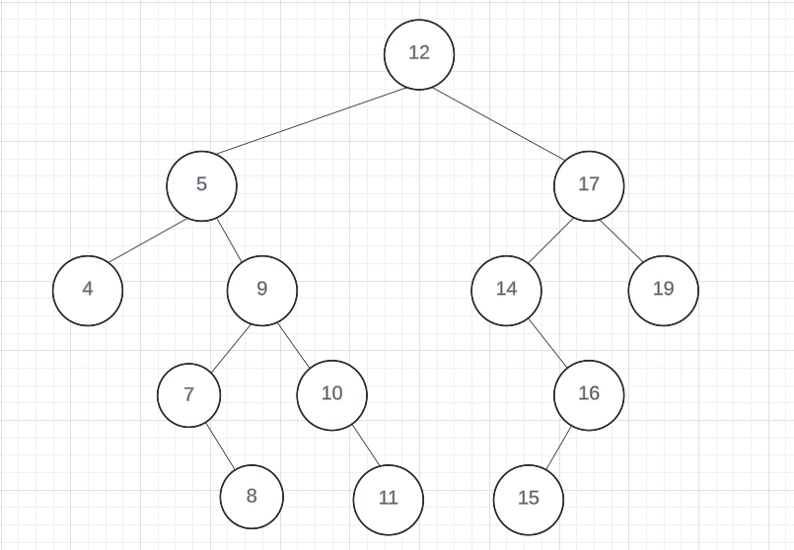

2.1) Draw the resulting BST if we perform LEFT-ROTATE(T, 5) on the original tree.

2.2) Draw the resulting BST if we perform LEFT-ROTATE(T, 12) on the original tree

2.4) Draw the resulting BST if we perform RIGHT-ROTATE(T, 17) on the original tree.