# Insertions

## INSERT 1

### Tree-Insert(1)

### Case 0: insert is root

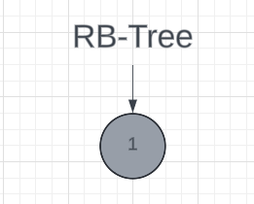

## INSERT 2

Tree-Insert(2)

## INSERT 5

Tree-Insert(5)

### Case 3: 5’s uncle is black, 5 is a left child, and 2 is a left child

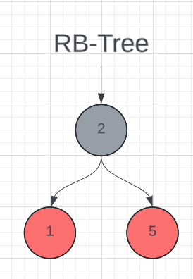

## INSERT 15

### Tree-Insert(15)

### Case 1: uncle is red

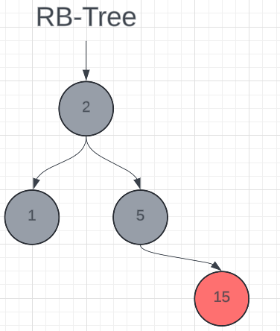

## INSERT 4

### Tree-Insert(4)

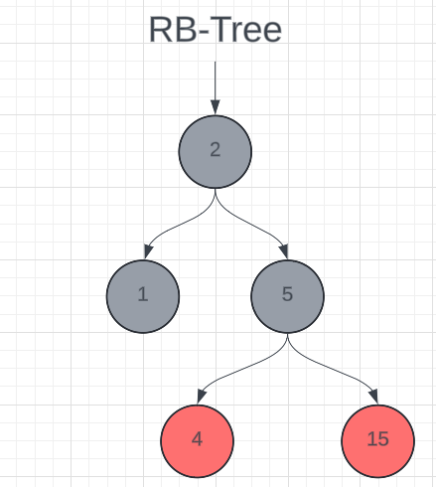

## INSERT 7

### Tree-Insert(7)

### Case 1: 4 is red

## INSERT 8

Tree-Insert(8)

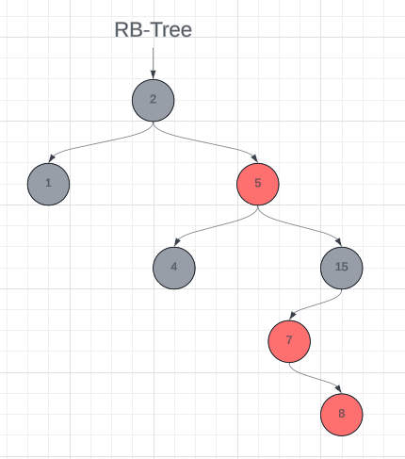

### Case 2: 8’s uncle is black, 8 is right child, and 7 is left child

Case 3: 7’s uncle is black, 7 is left child, and 8 is left child

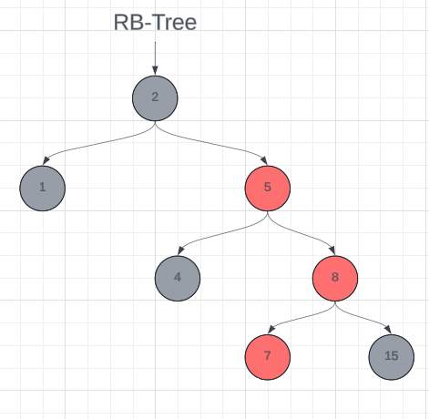

## INSERT 14

### Tree-Insert(14)

### Case 1: 7 is red

### Case 3: 1 is black, 8 and 5 are left children

## INSERT 11

### Tree-Insert(11)

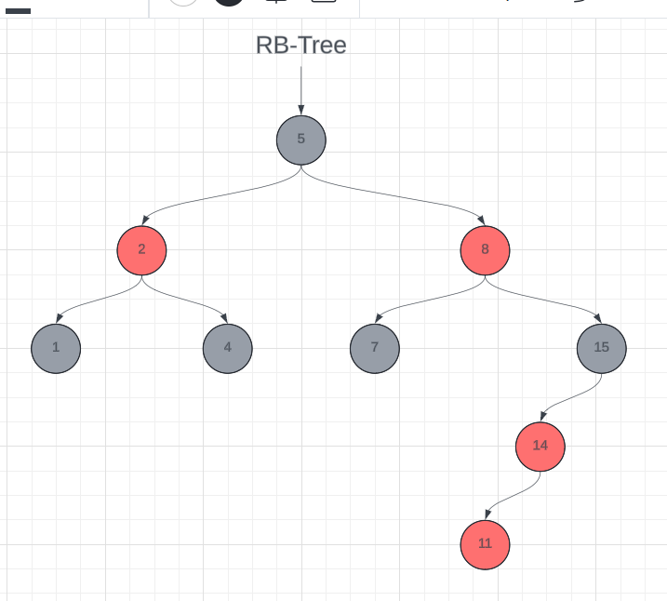

Case 3: 11’s uncle is black and both 11 and 14 are left children

# Deletion

## DELETE 2

### Tree-Delete(2)

## DELETE 7

### Tree-Delete(7)

### Case 2: 25 and its children are black.

## DELETE 13

### Tree-Delete(13)

### Case 2: 35 and its children are black

## DELETE 32

### Tree-Delete(32)

### Case 2: 25 and its children are black

## DELETE 35

### Tree-Delete(35)

