1. [8 pts] Show how Dijkstra’s algorithm works on the following undirected graph step-by-step. Assume A is the source vertex and adjacency list are in alphabetical order. Fill in the relevant table to show, at each step, a vertex’s attributes, d and π accordingly. Use shaded or highlighted edges to indicate the path picked at each step, write (S) next to the vertex inside the table to indicate that the vertices are in the set S. Also write S contents (Note: add extra table whenever necessary)

2. [2 pts] Write the shortest path from source A to all other vertices B, C…, I respectively.

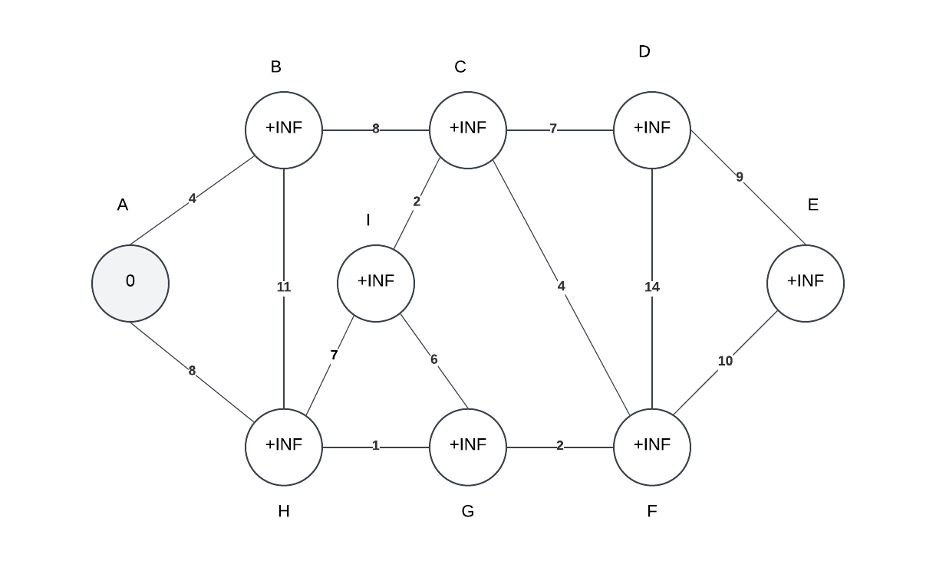

|  |  |  |
| --- | --- | --- |
|  | d | π |
| A | 0 | NIL |
| B | +∞ | NIL |
| C | +∞ | NIL |
| D | +∞ | NIL |
| E | +∞ | NIL |
| F | +∞ | NIL |
| G | +∞ | NIL |
| H | +∞ | NIL |
| I | +∞ | NIL |

|  |  |  |
| --- | --- | --- |
|  | d | π |
| A | 0 | NIL |
| B | 4 | A |
| C | +∞ | NIL |
| D | +∞ | NIL |
| E | +∞ | NIL |
| F | +∞ | NIL |
| G | +∞ | NIL |
| H | 8 | A |
| I | +∞ | NIL |

|  |  |  |
| --- | --- | --- |
|  | d | π |
| A | 0 | NIL |
| B | 4 | A |
| C | 12 | B |
| D | +∞ | NIL |
| E | +∞ | NIL |
| F | +∞ | NIL |
| G | +∞ | NIL |
| H | 8 | A |
| I | +∞ | NIL |

|  |  |  |
| --- | --- | --- |
|  | d | π |
| A | 0 | NIL |
| B | 4 | A |
| C | 12 | B |
| D | +∞ | NIL |
| E | +∞ | NIL |
| F | 11 | G |
| G | 9 | H |
| H | 8 | A |
| I | 13 | H |

|  |  |  |
| --- | --- | --- |
|  | d | π |
| A | 0 | NIL |
| B | 4 | A |
| C | 12 | B |
| D | 25 | F |
| E | 22 | F |
| F | 11 | G |
| G | 9 | H |
| H | 8 | A |
| I | 13 | H |

|  |  |  |
| --- | --- | --- |
|  | d | π |
| A | 0 | NIL |
| B | 4 | A |
| C | 12 | B |
| D | 19 | C |
| E | 22 | F |
| F | 11 | G |
| G | 9 | H |
| H | 8 | A |
| I | 13 | H |

|  |  |  |
| --- | --- | --- |
|  | d | π |
| A | 0 | NIL |
| B | 4 | A |
| C | 12 | B |
| D | 19 | C |
| E | 22 | F |
| F | 11 | G |
| G | 9 | H |
| H | 8 | A |
| I | 13 | H |

|  |  |  |
| --- | --- | --- |
|  | d | π |
| A | 0 | NIL |
| B | 4 | A |
| C | 12 | B |
| D | 19 | C |
| E | 22 | F |
| F | 11 | G |
| G | 9 | H |
| H | 8 | A |
| I | 13 | H |

|  |  |  |
| --- | --- | --- |
|  | d | π |
| A | 0 | NIL |
| B | 4 | A |
| C | 12 | B |
| D | 19 | C |
| E | 22 | F |
| F | 11 | G |
| G | 9 | H |
| H | 8 | A |
| I | 13 | H |

|  |  |  |
| --- | --- | --- |
|  | d | π |
| A | 0 | NIL |
| B | 4 | A |
| C | 12 | B |
| D | 19 | C |
| E | 22 | F |
| F | 11 | G |
| G | 9 | H |
| H | 8 | A |
| I | 13 | H |