Matthew Nguyen

Ethan Nguyen

ECE 152A

**Lab 3**

**Part 1**

As seen below, we have implemented a counter that counts from 0-7 in binary. In the waveform simulation below, we see that the counter is able to wrap around 7 and 0 to allow a counting loop from 0 to 7.

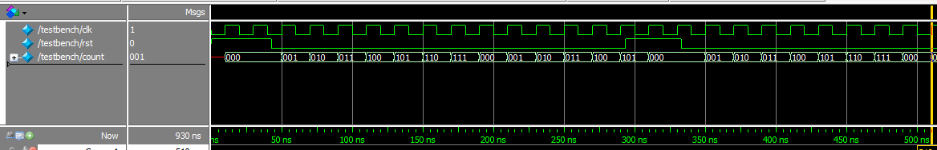

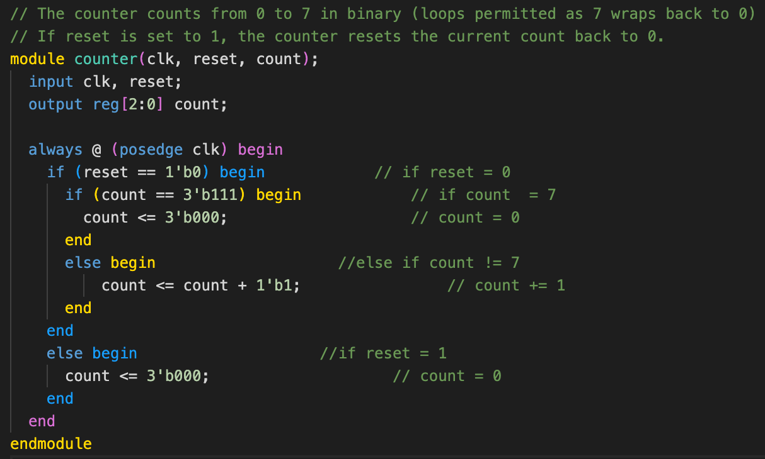

**Part 2 - Adding Additional Features and Simulation**

1. **Adding enable switch**

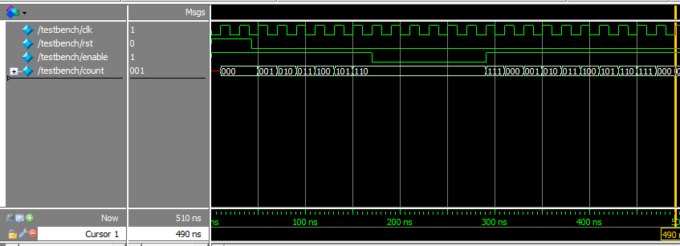

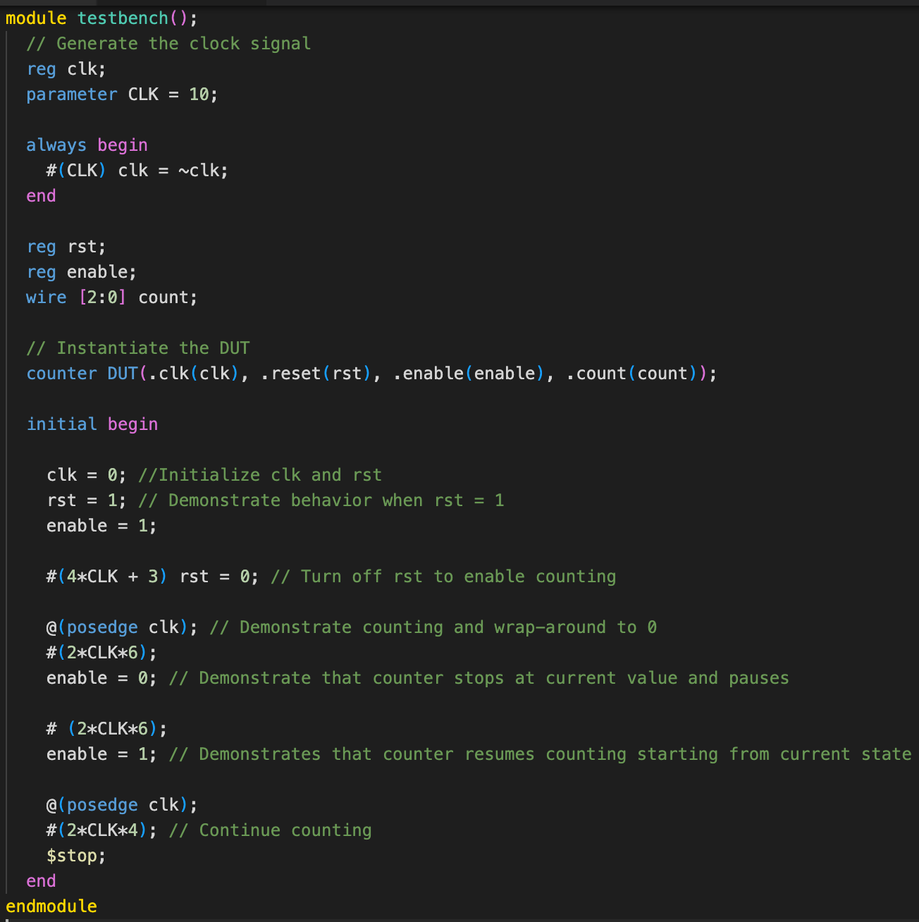

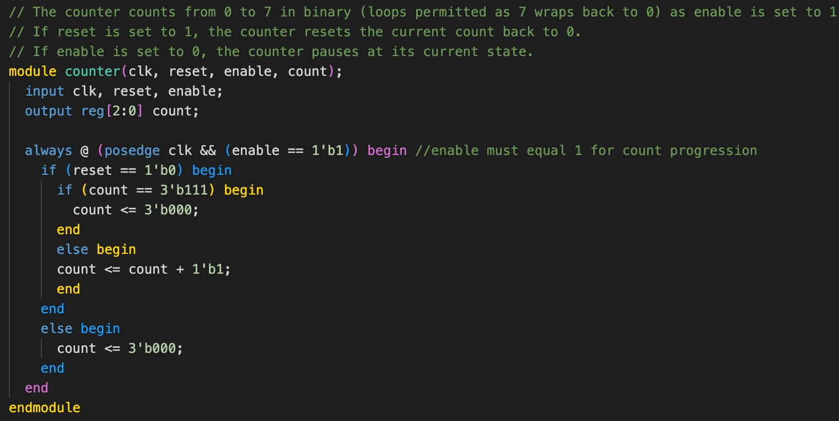

The enable switch of our counter was implemented into our test bench by replacing the use of the reset input. Instead there was an initial moment where enable == 1, and the count began, and then as it reached 110, enable was set to 0, this stopped the count for 120ns. After enable was set back to 1 and the count resumed, reaching 111 and going back to 000 resuming its normal pattern.

1. **Adding direction bit**

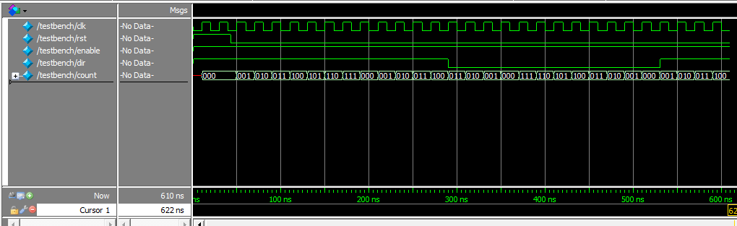

The direction bit allows the counter to either count down or count up. Our waveform shows our simulated testbench to test the direction switch. We initiated the counter with the direction bit set to 1 which allows the counter to count up. We observe that after the reset bit gets set to 0 at around 45ns, the counter begins counting up. However, we observe that when the directional bit gets set to 0 at 290ns, the counter begins counting down, wrapping around from 7 to 0. Furthermore, we see the direction bit back to 1 at 530 ns where the counter began counting up from the current state.

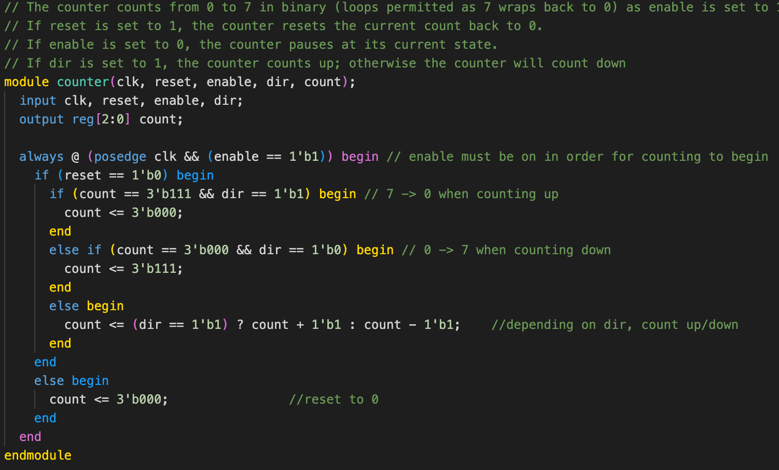

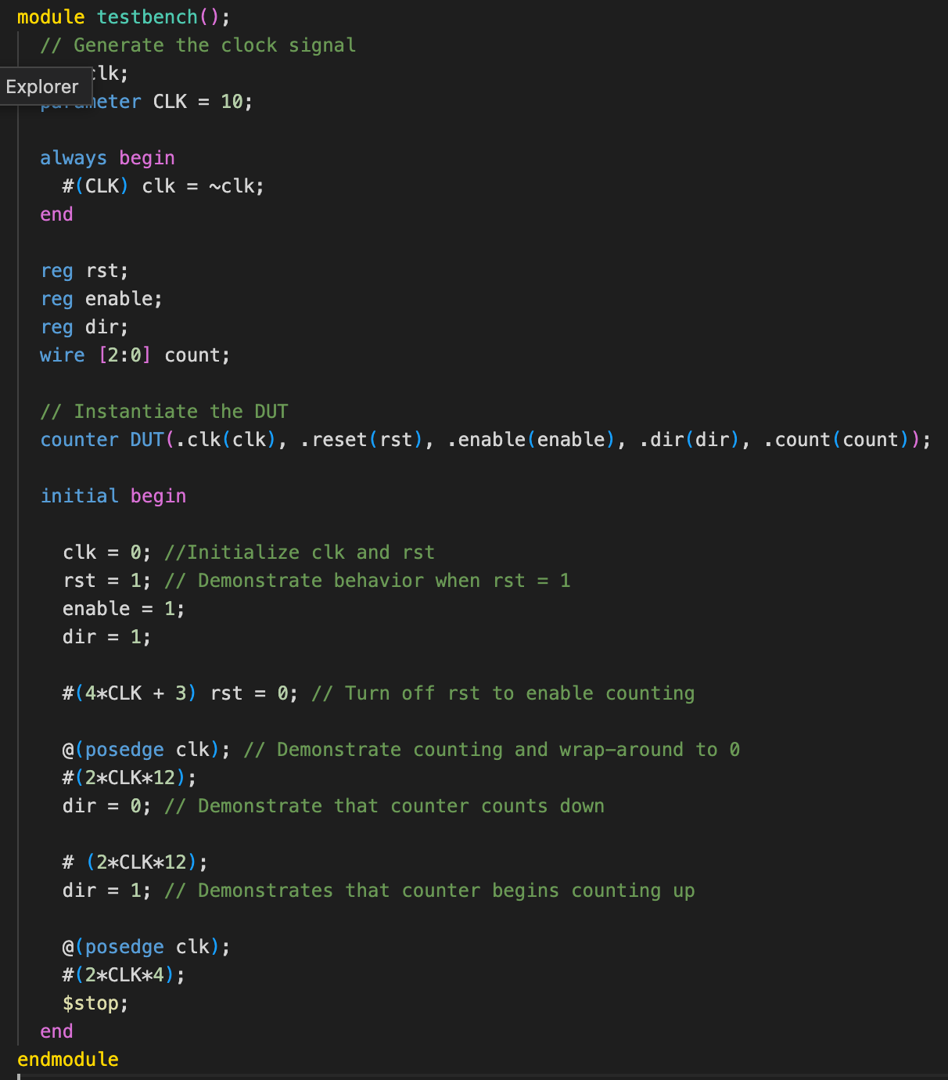

1. **Implementing 7-Segment LED display decoder for counter**

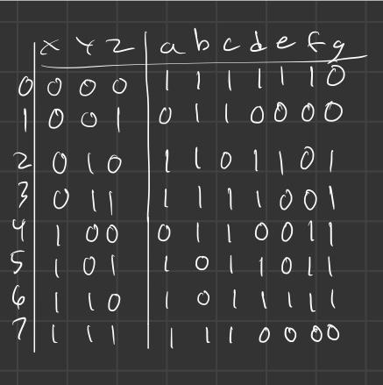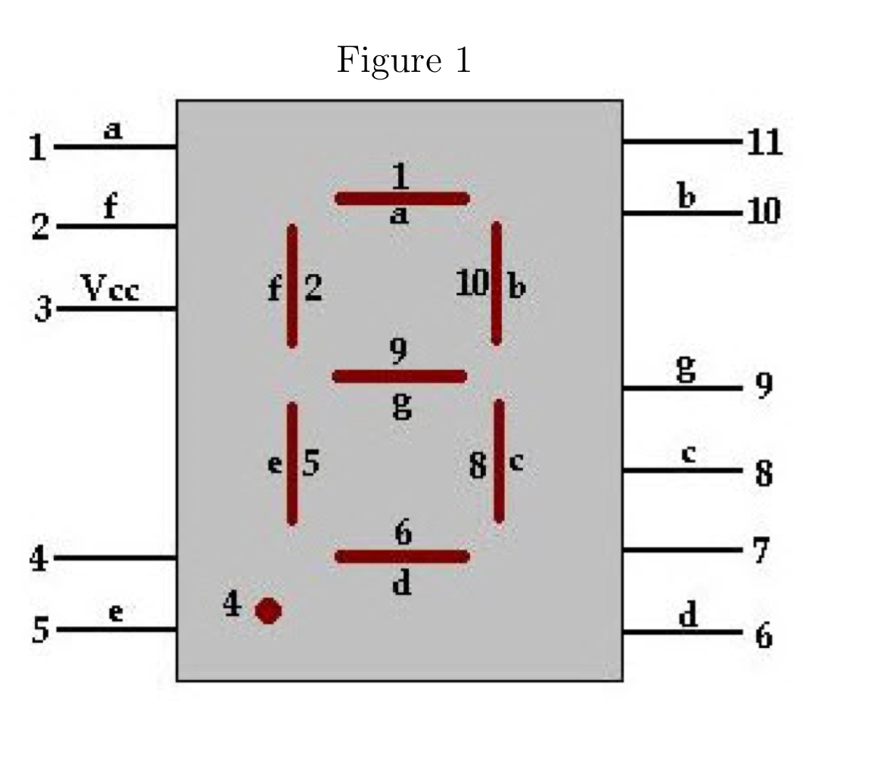

We will now create a display module that decodes the counter and allows for the corresponding output to be displayed onto a 7-segment LED display. Above shows the truth table implementation corresponding to the pin diagrams of the display.

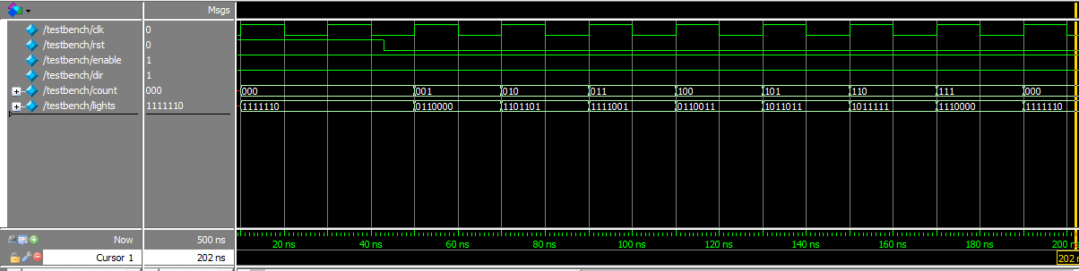

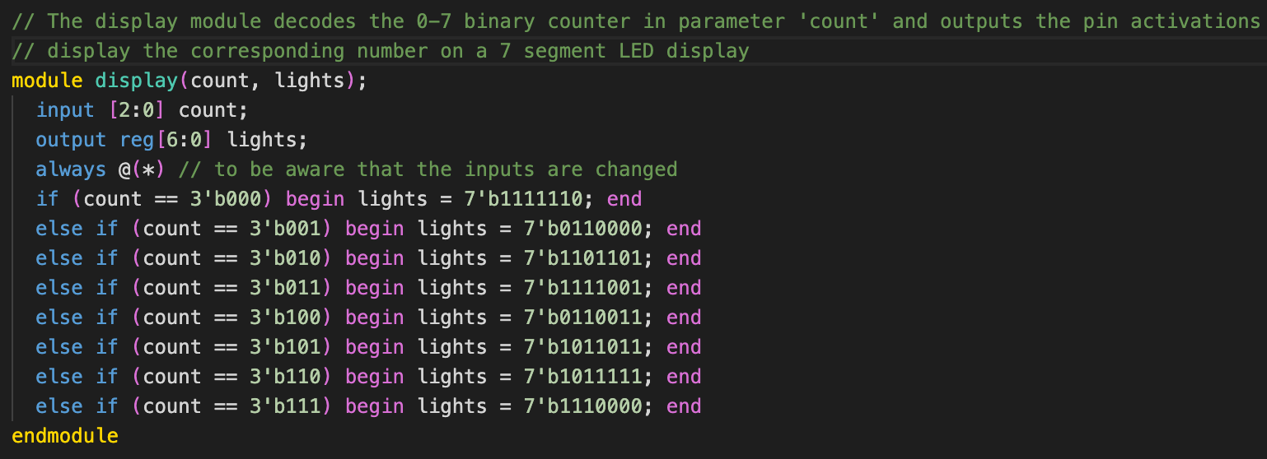

After mapping out the truth table values, a new module was created called display that would handle the 7-segment LED display from the FPGA. Based on the count from the counter module, the display has 7-bits outputs, with each of the 7 different inputs mapped out to display their respective numbers. Our test bench observes the correct behavior by letting the counter go through multiple cycles from 0-7 and revealing that the ‘lights’ display shows the correct signal to output the correct output on the display.