Predicting Road Traffic Accident Severity: An Analysis of Environmental Factors and Spurious Correlations
Kiassa Samy (0000-0003-2580-979X)
Adigun Oladapo Oludele (0009-0001-7256-5903)
Katoch Nea (0009-0009-4474-1576)
Muskan Sodhi (0009-0004-8744-9106)

22.06.2026
- Group 02 -
Final Report

Inhalt
Abstract 3
DBRepo Schema 4
ER Diagram 4
Ontology and unit mapping table 4
standards application and overlap analysis 5
DMP Comparison 5
OSTrails test results table 5
individual contribution and sign-off tables 6

Abstract
This project investigates the prediction of road traffic accident severity using machine learning methods and structured accident-related data. The experiment focuses on environmental, contextual, and accident-specific attributes to analyse which factors contribute to casualty severity and whether some observed correlations may be spurious or misleading.

The project is developed as part of the FAIR Data Science / Data Stewardship exercise at TU Wien. It follows FAIR-oriented documentation and publication practices by combining a public GitHub repository, DBRepo-based data access, machine-readable metadata, licence documentation, and persistent identifiers for deposited artefacts.

The final experiment retrieves all input data from DBRepo through the REST API instead of reading local CSV files. The repository includes documentation for the database schema, SQL views, API-based loading workflow, RO-Crate metadata, Croissant metadata, software and data licences, and generated outputs.

DBRepo Schema
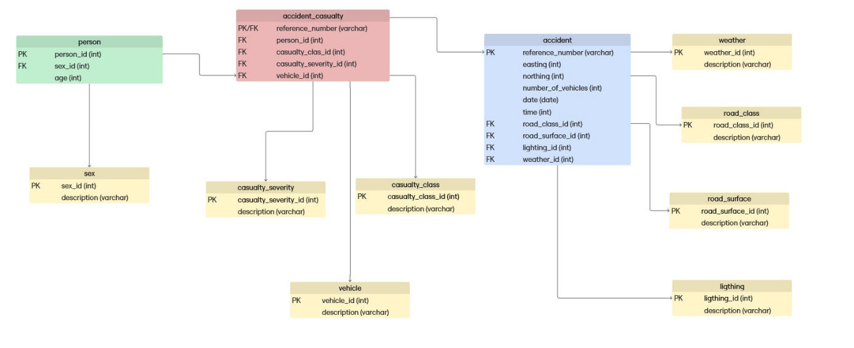
Figure 1: DBRepo Schema (22.06.2026)

ER Diagram

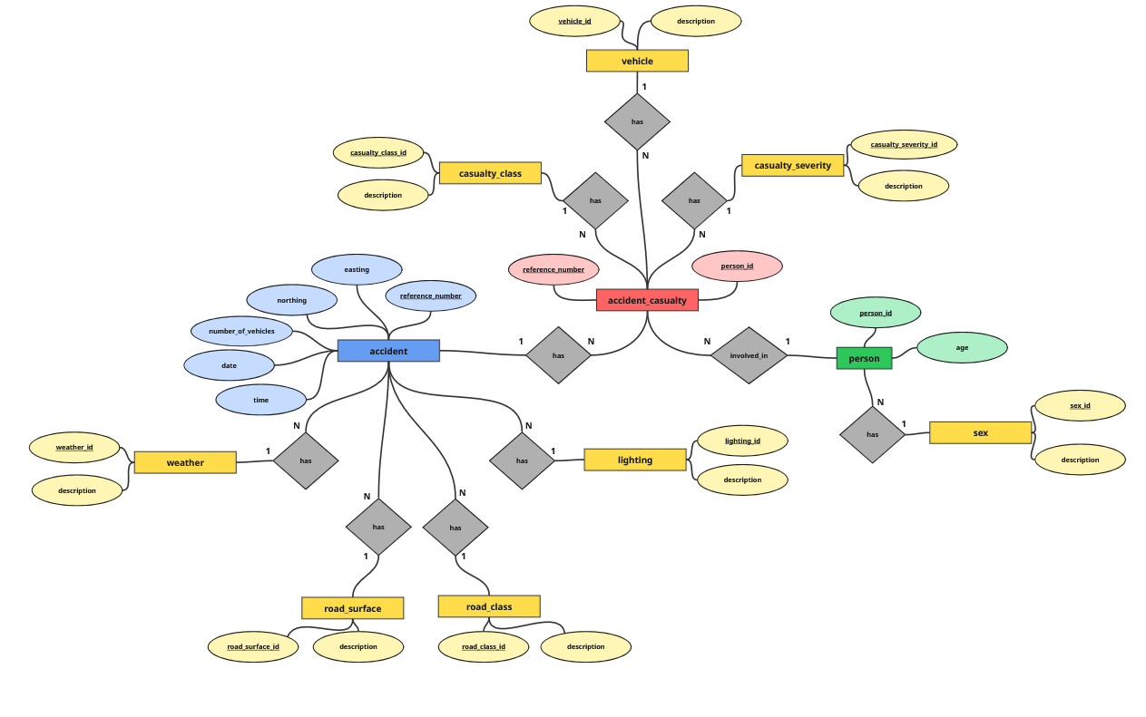
Figure 2: Entity Relationship model (13.05.2026)

Ontology and unit mapping table

standards application and overlap analysis

DMP Comparison

OSTrails test results table

Metric id | Category | Outcome | Message
1
2
3 | F | indeterminate | No reused datasets found
16
22 | F / A | fail | Not all reused dmp.dataset have an PID defined
26
32
37
58
65
69
83
90 | A | pass | At least one URL is valid and resolves: https://github.com/e12436439/Data-Stewardship-UE-2026S/tree/main

individual contribution and sign-off tables

Student A – Nea Katoch – Matriculation No.: 52308278
task | What i did | Link/DOI/Commit | DONE | CHECKED | CONFIRMED BY
T1.1 | Together as a team we assigned the roles. I diced to be owner A. | https://github.com/e12436439/Data-Stewardship-UE-2026S/releases/tag/Part3 | 
T1.2 | Together as a team we decided on the road traffic accident use case. | https://github.com/e12436439/Data-Stewardship-UE-2026S/releases/tag/Part3 | 
T1.3 | I created the naming convention. | https://github.com/e12436439/Data-Stewardship-UE-2026S/commit/edba0369cf0305d14cc5a447a8a7a2b6f2e927d6 | 
T2.1 | I created a relational DB schema, tested it in SQL, created an ER diagram in miro. Afterwards I created the DB in DBRepo added the tables and the metadata. | DOI (DBRepo): https://github.com/e12436439/Data-Stewardship-UE-2026S/commit/96597c5dd26227ff39327a8c87b045f65bfde4cd | 
T3.1 | I created the ro-crate file and validated it with the help of a ro-crate validator. | https://github.com/e12436439/Data-Stewardship-UE-2026S/commit/13b15e129b65438545cc67b5c7224c5f8dddffed | 
T3.5 | I added metrics evaluation to the model and created a model card. | https://github.com/e12436439/Data-Stewardship-UE-2026S/commit/a662b387cfafe7787795ba308171d64a4a96ffbc | 
T3.9 | I made the TUWRD model deposit. | https://test.researchdata.tuwien.ac.at/records/thw4c-36p53 | 
T4.4 | I made the final DMP TUWRD deposit. | https://test.researchdata.tuwien.ac.at/records/4an2r-4m095 | 
T5.1 | I forked the repo and created a new branch. | https://gitlab.tuwien.ac.at/e52308278/dast-2026-ue/-/tree/group-02/groups/group-02?ref_type=heads | 
T5.2 | I implemented and tested the following tests: 3, 22, 90 | https://gitlab.tuwien.ac.at/e52308278/dast-2026-ue/-/commit/d4a3853a9aacddca20e17218f983bcdeff227e64 | 
T6.1 | I reviewed the github repo and the DBRepo entry. | https://github.com/e12436439/Data-Stewardship-UE-2026S/commit/5a4091f7590fcd802d9ac3117f29ddafb793c768 | 
T6.2 | I reviewed point a and created the review file. | https://github.com/e12436439/Data-Stewardship-UE-2026S/commit/5a4091f7590fcd802d9ac3117f29ddafb793c768 | 
T7.1 | I created the final report file. Added the overall structure, title, authors, abstract, DBRepo schema, ER diagram, OST Trails test results (3, 22, 90) and signoff table for user A. |  | 

