1. **Initialising Git Repo and Creating a new python file (save with “:wq!” command)** 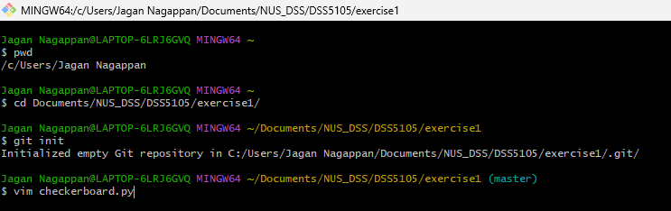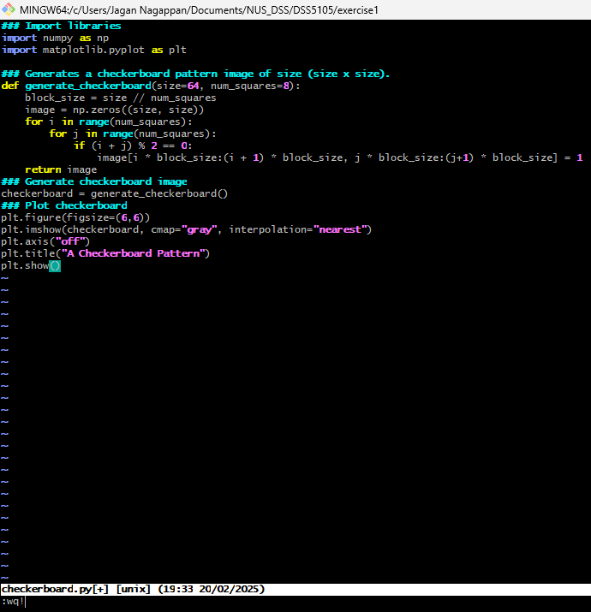
2. **Add file to git and commit changes  
   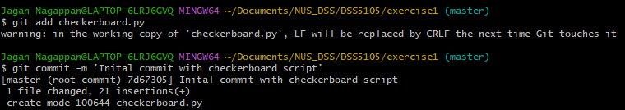**
3. **Create remote repository on github, connect your local repository to github and push local commits to the repository  
   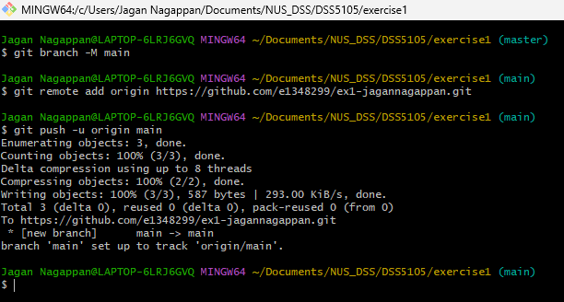**

1. **Change colormap to green in script and check in code into new branch named “change-colormap”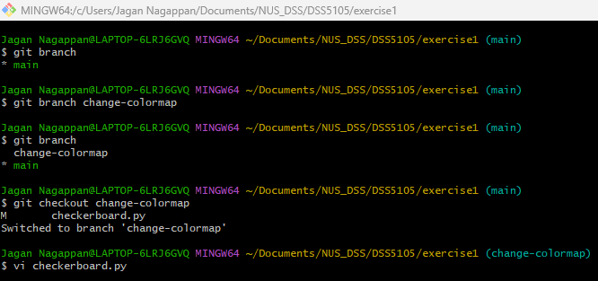  
   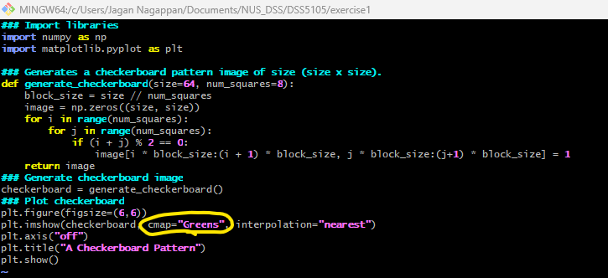**

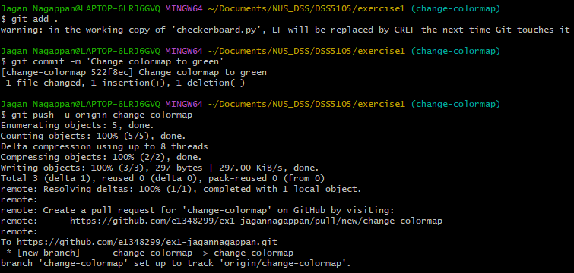

1. **Open a pull request on github, verify the difference and merge into main branch**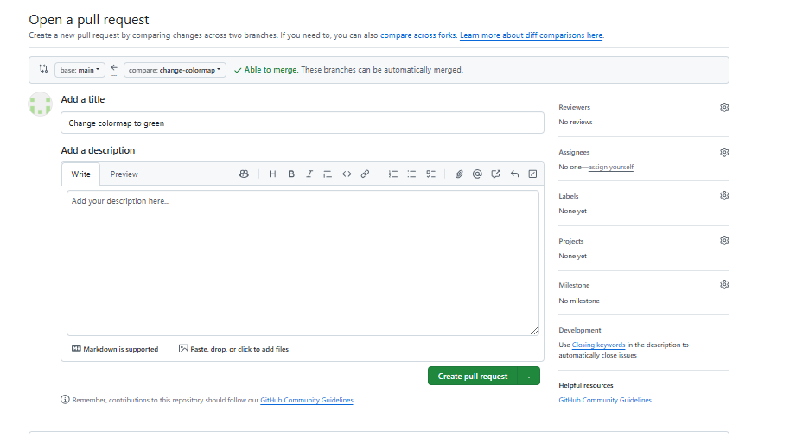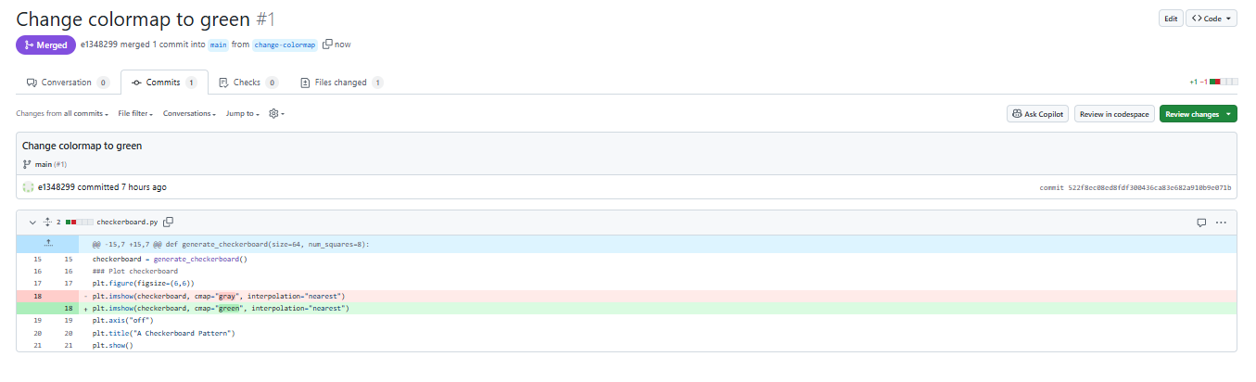
2. **Run python script on git bash as follows:  
   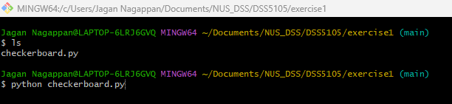**
3. **New output with green checkerboard**

