Dynamics of Machinery
Dynamic Analysis of the Ram Drive with a Spring and a Damper
HW #3 (16 %) Due to Nov. 29, 2017
If the mechanism is driven by a motor via the indirect drive as shown below, where 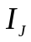 = 0.9 Kg-m², 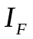 = 0.0 Kg-m², the gear ratio g = 2.27, and the speed ratio of the jackshaft to the motor-shaft is 1/1.71. The T-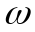 relation of the motor is: T = a(27000 - 7ω), when 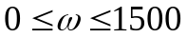; and T = a[16500 - 55(ω - 1500)], when 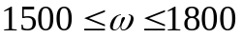, where the dimensions of T and are N*m and rpm, respectively; and the motors with a being 0.0027 and 0.0054, respectively, are under consideration. The mechanism is started from rest, then it is speed-up to reach its 1st steady state for about 1 second without process load; then the process load 89000 N is applied until the mechanism reaches the 2nd steady state for about 1 second. Please develop PC programs and also use the software to analyze, with choosing each a, the following cases, (a) without both of the spring and damper, (b) with the spring only, (c) with the damper only, (d) with both of the spring and damper. For each case of choosing each a, the following results should be given:
- the equivalent moment of inertia with respect to the crank shaft;
- the time history of the crank angular velocity;
- angular displacement, velocity and acceleration of the crank, and coefficient of velocity fluctuation for a cycle during the 1st & 2nd steady states, respectively;
- the displacements, velocities, and accelerations of other moving links and mass centers for a cycle during the 1st & 2nd steady states, respectively;
- the input torque, bearing loads, shaking force and shaking moment with respect to the LDCP for a cycle during the 1st & 2nd steady states, respectively.
- compare the relevant results, especially, the results of average speeds with those of the steady states.
The results of choosing different a should also be compared. Appropriate discussions should be given.
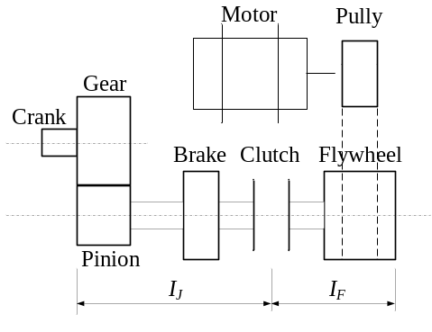
項目 | 配分 | 得分
結果與討論 | 70%
結論與建議 | 10%
報告寫作 | 10%
報告美觀 | 10%
總得分 | 100%

