Dynamics of Machinery
Kinematic Analysis of the Ram Drive with a Spring and a Damper
Homework #1 (10 %) Due to Oct. 11, 2017
Please develop programs on a PC and use the package for the kinematic analysis of the ram drive with a spring and a damper, whose skeleton is as shown in Fig. 1 and the dimensions are given in Table 1. Additionally, 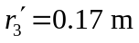, 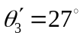, θ₁ = -107.47º and 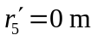. Between links 2 and 7, there are a pair of gears, both have 22 teeth with 15 mm module and their pressure angles are 20º, to keep ω₂ : ω₇ = 1:-1. When θ₂ = 0º, θ₇ = 287.45º for the assembly position of the gears. Regarding the locations for the fixed pivots of the spring and damper are X_{s} = 0 m, Y_{s} = -0.75 m, and X_{d} =0.22 m, Y_{d} = 0.44 m, respectively. Please use the analytical method for the displacement analysis. The drive is operated with constant speeds of 10, 60, and 120 rad/sec, respectively. The results, with 1º interval, of displacement, velocity and acceleration of each moving link and its mass center are required, furthermore the spring length and the rate of change of the damper length are also needed. Please check the results, by choosing 2 (not particular) positions, with graphical methods. Please investigate the relations between the input velocity and the maximum magnitudes of the velocity and acceleration, respectively, of the ram. (Hints: The derivation and programs should be able to analyze the cases with non-zero input acceleration, and kinematic coefficients should be gotten before the velocity and acceleration analysis.)

項目 | 配分 | 得分
結果與討論 | 70%
結論與建議 | 10%
報告寫作 | 10%
報告美觀 | 10%
總得分 | 100%

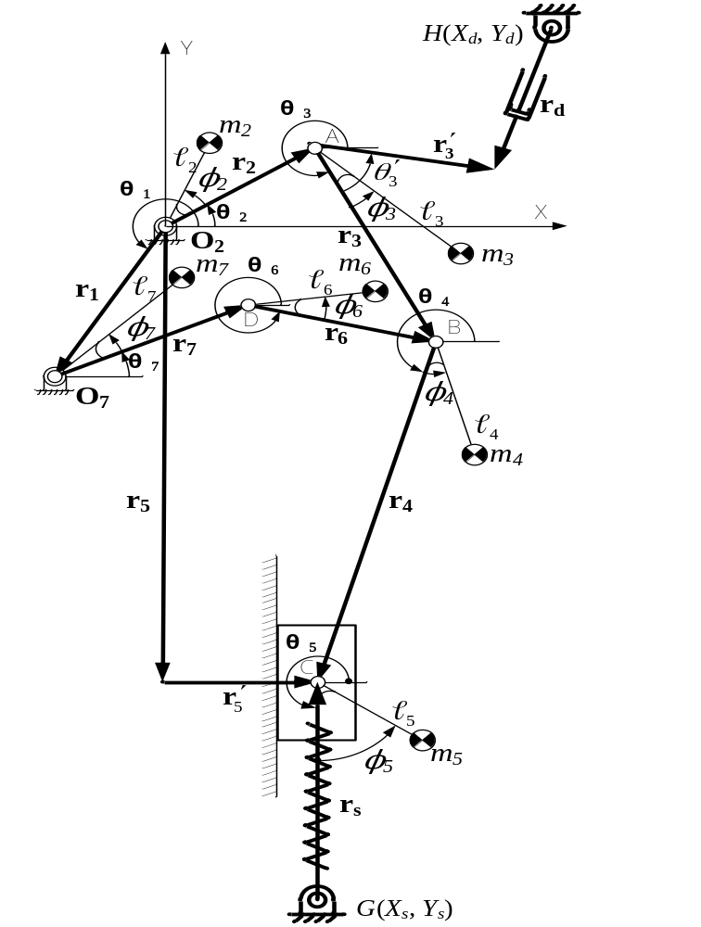

表1複合驅動伺服沖床之機構尺寸及幾何慣性尺寸
i | (m) | 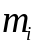 (kg) | 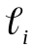 (m) | 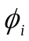 (deg) | (kg×m²)
1 | 0.330 | --- | --- | --- | ---
2 | 0.055 | 53.00 | 0.0247 | 0 | 0.651
3 | 0.283 | 7.10 | 0.1287 | 13 | 0.047
4 | 0.322 | 10.59 | 0.1467 | 0 | 0.887
5 | --- | 47.93 | 0.0000 | 0 | ---
6 | 0.165 | 50.03 | 0.0749 | 0 | 0.313
7 | 0.061 | 60.07 | 0.0277 | 0 | 0.955

