Dynamics of Machinery
Flywheel Inertia and Brake Torque
HW #4 (14 %) Due to Dec. 20, 2017
If the drive arrangement of the ram drive is as given in HW #3, please determine the moment of inertia I_{F} and the brake torque T_{B} when the operating speeds of the mechanism are 10, 60, and 120 rad/sec and the average velocity of the 2nd steady state (of HW#3 with the spring and damper), respectively. The flywheel is a timing-belt pulley driven by a motor. The coefficient of fluctuation should be less than 3% for all the above cases, or half of that of the 2nd steady state (of HW#3 with the spring and damper) if it would be less than 3 %. The brake is first applied when the ram is at the lower dead center position, and the mechanism is required to be stopped before the downward ram arriving 6 mm above the LDCP.
With the flywheel and brake designed for the 2nd steady state (with the spring and damper), please develop your programs and also use the software, respectively, to analyze the time responses of the mechanism (with each of a) under the following operation sequence: (1) started from rest, then it is speed-up to reach its steady state for 1 second without process load; (2) the process load is applied then the mechanism reaches the second steady state for 1 second; (3) during a cycle of the 2nd steady state the clutch is dis-engaged and the brake is applied, when the ram is at the LDCP, until the mechanism is stopped. Please illustrate those results required in HW#3 during the 2nd steady-state.
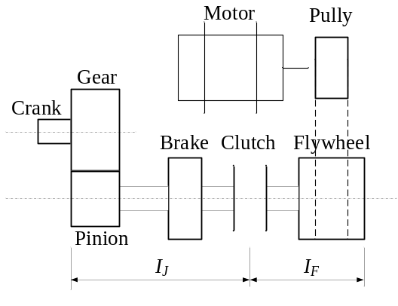
項目 | 配分 | 得分
結果與討論 | 70%
結論與建議 | 10%
報告寫作 | 10%
報告美觀 | 10%
總得分 | 100%

