Dynamics of Machinery
Kinetostatic Analysis of the Ram Drive with a Spring and a Damper
Homework #2 (16 %) Due to Nov. 8, 2017
Please develop programs on a PC and use the package for the kinetostatic analysis of the ram drive of mechanical presses, when the operating speeds are 10, 60, and 120 rad/sec, respectively. The free-body diagrams of moving links are shown in Fig. 1, and in Fig. 1(e), t = -57 mm, t’ = 13 mm, and 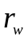 = 0. The process force F_{w} = 89000 N, and it is applied during the ram moves from 5 mm above the lower dead center position to LDCP. Regarding the spring, its stiffness K = 37 N/mm, and initial length L₀ = 270 mm. The damping coefficient, d_{c}, of the damper is 11 N.s/mm. If (I) there is no spring and damper, (II) the spring and damper are exist, please consider the following situations respectively, (a) only the inertial effects are considered; (b) only the gravity forces are neglected; (c) only the inertial effects are neglected; (d) all are considered. In each situation, the required results should at least include:
(1) bearing force (Cartesian components, resultant, and direction) on each joint, and driving torque (should be checked with the energy method);
(2) peak, and rms values, and fluctuation of each bearing force, and the peak, mean, and fluctuation of the driving torque. (You may investigate the relations between these amounts with respect to the operating speeds);
With or without the spring and damper, please (1) based on the results of situation (a) above, investigate the relations between the peak input torque and the input speed; (2) based on the results of (b) & (d), discuss the differences of input torques and force peaks by neglecting the gravity forces with different operating speeds; (3) based on the results of (c) & (d), discuss the differences of input torques and force peaks by neglecting the inertial effects with different operating speeds. Also, compare the results of those with and without the sprin and damper.

項目 | 配分 | 得分
結果與討論 | 40%
結論與建議 | 10%
報告寫作 | 40%
報告美觀 | 10%
總得分 | 100%
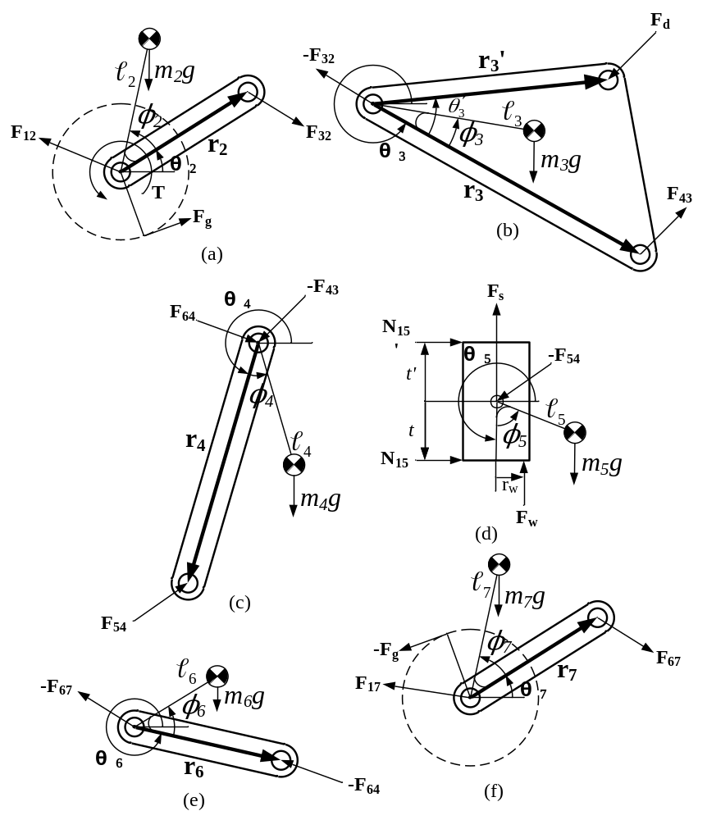
Fig. 1 Free-body diagrams of moving links

