EE387 – LAB 1

E/19/166

JAYATHUNGA W.W.K.

SEMESTER 06

23/04/2024

PART 1: Basic Signal Representation in MATLAB

1. **Part1_1.m**

% Clear all variables

clear all;

% Define the sample period and time vectorize

Ts = 0.01;

t = -5:Ts:5;

% Define the ramp function

function y = ramp(t, m, ad)

y = max(0, t + ad) * m;

endfunction

% Define the unit step function

function y = ustep(t, ad)

y = (t+ad) >= 0;

endfunction

% Generate the signal

y1 = ramp(t, 3, 3);

y2 = ramp(t, -6, 1);

y3 = ramp(t, 3, 0);

y4 = ustep(t, -3);

y = y1 - 2 * y2 + 3 * y3 - y4;

% Plot the signal

plot(t, y, 'k');

axis([-5 5 -2 7]);

grid on;

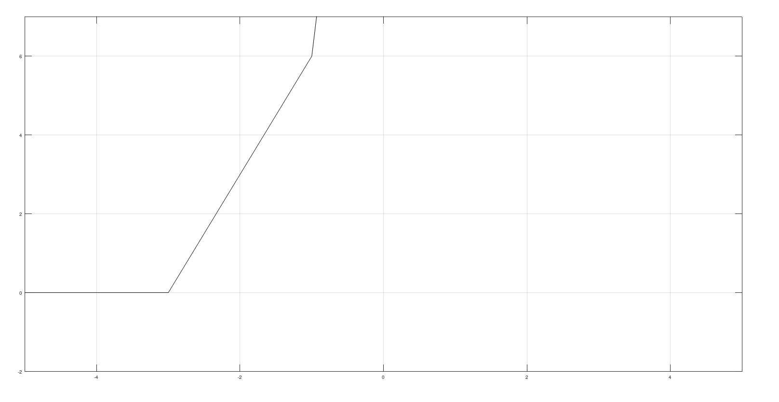

1. **Part1_2.m**

clear all;

close all;

clc;

Ts=0.01; %Sampling time

t=-5:Ts:5; %Time vector

x= 3 * exp(-1*t) .* cos(4*pi*t);

envelope= 3 * exp(-1*t);

figure;

hold on;

plot(t,x);

plot(t, envelope);

plot(t, -1*envelope);

title('A damped signal');

xlabel('t');

ylabel('x(t)');

grid

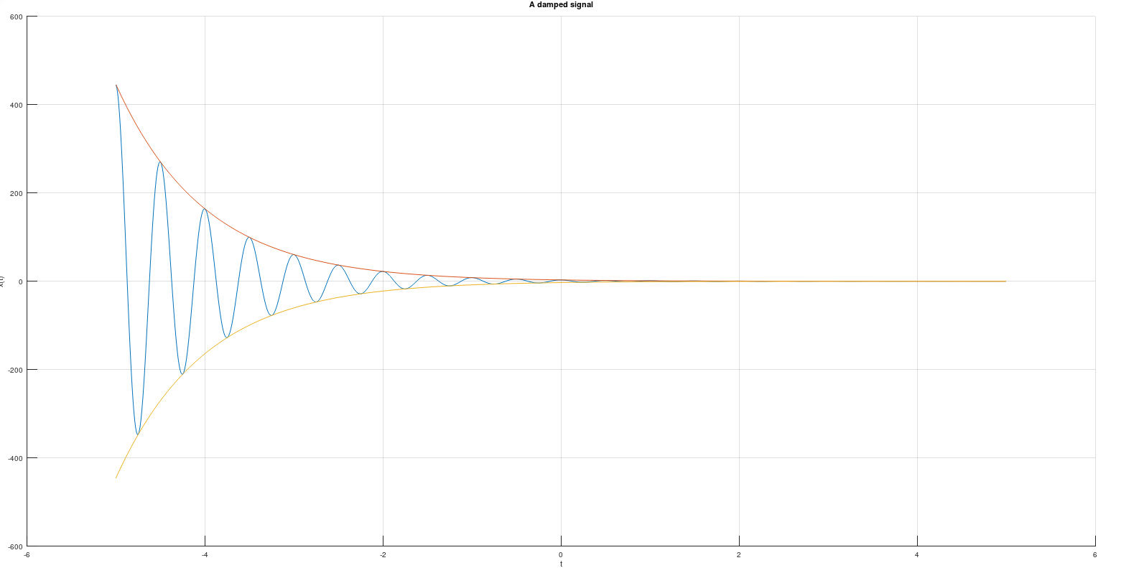

PART2: Time-Domain Convolution and Elementary Signal Operations

Q: Are there any disadvantages if a high sampling frequency is used?

Yes.

1. Increased Computational Demand: The process will require more computational power for effective processing.
2. High-Frequency Hardware Requirements: Utilizing higher sampling frequencies will necessitate hardware components, such as sensors and ADC (Analog-to-Digital Converter) units, that can operate at higher clock speeds. These components are generally more expensive.

**Part2.m**

clear all;

close all;

clc;

Ts=0.01; %Sampling time

t=-5:Ts:5; %Time vector

% Define the rectangular pulse function

function x = rect(t)

x = (t >= -0.5 & t < 0.5);

endfunction

x1=rect(t);

x2 = rect(t-1);

x3 = rect(t/2);

x4 = rect(t) + (1/2)*rect(t-1);

x5 = rect(-t) + (1/2)*rect(-t-1);

x6 = rect(1-t)+ (1/2)*rect(-t);

subplot(3,2,1);

plot(t,x1) ;

axis( [-2 2 -1 2]);

xlabel( 'time (sec)' );

ylabel('x_1(t) = rect(t)');

subplot(3,2,2);

plot(t,x2);

axis( [-2 2 -1 2]);

xlabel( 'time (sec)' );

ylabel('x_2(t) = x_1(t-1)');

subplot(3,2,3);

plot(t,x3);

axis( [-2 2 -1 2]);

xlabel( 'time (sec)' );

ylabel('x_3(t) = x_1(t/2)');

subplot(3,2,4);

plot(t,x4);

axis( [-2 2 -1 2]);

xlabel( 'time (sec)' );

ylabel('x_4(t) = x_1(t) + 0.5*x_1(t-1) ');

subplot(3,2,5);

plot(t,x5);

axis( [-2 2 -1 2]);

xlabel( 'time (sec)' );

ylabel('x_5(t) = x_4(-t)');

subplot(3,2,6);

plot(t,x6);

axis( [-2 2 -1 2]);

xlabel( 'time (sec)' );

ylabel('x_5(t) = x_4(-t)');

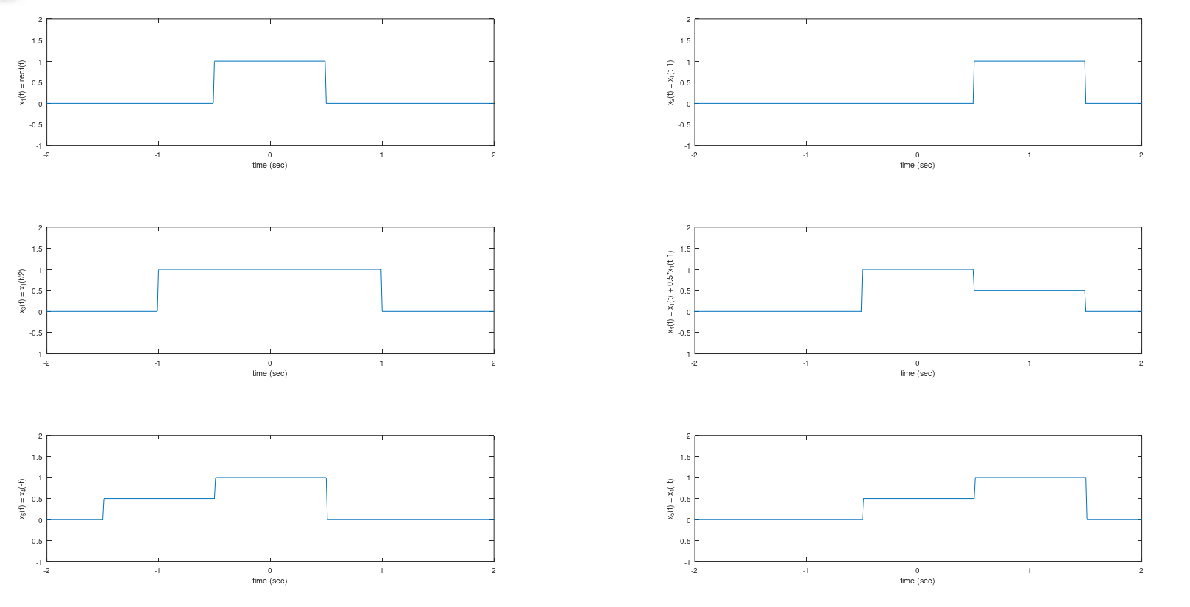

Convolution

**Convolution.m**

clear all;

Ts=0.01; %Sampling time

t=-5:Ts:5; %Time vector

% Define the rectangular pulse function

function x = rect(t)

x = (t >= -0.5 & t < 0.5);

endfunction

x1=rect(t);

y=conv(x1,x1);

try

plot(t,y)

catch

disp('The dimensions do not match for t and y');

end

t_y=-10:Ts:10;

%plot(t_y,y);

y1 = Ts* conv(x1,x1);

plot(t_y, y1);

axis( [-2 2 -1 2] ) ;

xlabel( 'time (sec)');

ylabel('y_1(t)');

title('Figure : y_1(t) = x_1(t)*x_1(t)');

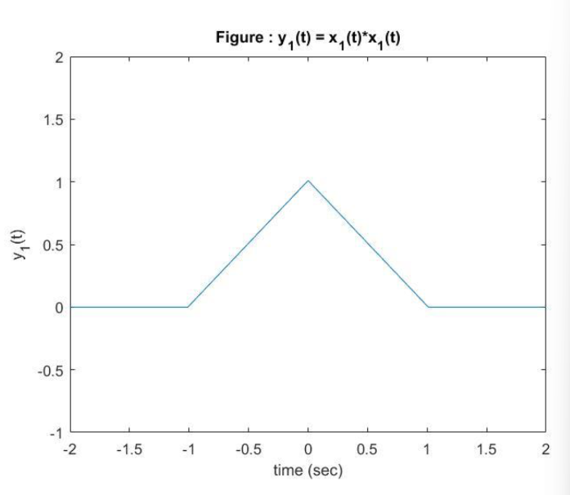

Exercise

**Ex1.m**

clear all;

close all;

clc;

x1 = [1, 2, 4];

h1 = [1, 1, 1, 1, 1];

y1 = conv(x1,h1);

x2 = 1:5;

h2 = 1;

y2 = conv(x2, h2);

x3 = [1, 2, 0, 2, 1];

h3 = x3;

y3 = conv(x3, h3);

% Plot the graphs for (1)

subplot(3, 3, 1)

stem(x1);

title('x_1(n)');

grid

subplot(3, 3, 4);

stem(h1);

title('h_1(n)');

grid

subplot(3, 3, 7);

stem(y1);

title('y_1(n) = x_1(n)*h_1(n)');

grid

% Plot the graphs for (2)

subplot(3, 3, 2)

stem(x2);

title('x_2(n)');

grid

subplot(3, 3, 5);

stem(h2);

title('h_2(n)');

grid

subplot(3, 3, 8);

stem(y2);

title('y_2(n) = x_2n)*h_2(n)');

grid

% Plot the graphs for (3)

subplot(3, 3, 3)

stem(x3);

title('x_3(n)');

grid

subplot(3, 3, 6);

stem(h3);

title('h_3(n)');

grid

subplot(3, 3, 9);

stem(y3);

title('y_3(n) = x_3n)*h_3(n)');

grid

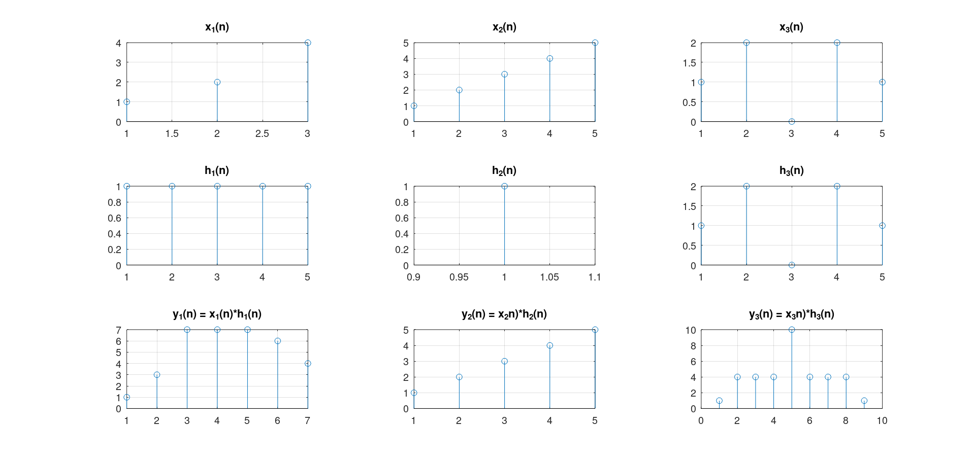

**Ex2.m**

clear all;

close all;

clc;

%[Q, R] = deconv(B, A)

% B = conv(A, Q) + R.

n = 0:3;

h = 0.5.^n;

y = [1, 2, 2.5, 3, 3, 3, 2, 1,0, 0, 0, 0, 0, 0, 0, 0];

[x, R] = deconv(y, h);

figure

subplot(3, 1, 1);

stem(h);

title('Impulse Response');

xlabel('n');

ylabel('h(n)');

subplot(3, 1, 2);

stem(y);

title('Output');

xlabel('n');

ylabel('y(n)');

subplot(3, 1, 3);

stem(x);

title('Input');

xlabel('n');

ylabel('x(n)');

