# CO544

# Lab 02

## E/19/166

## Jayathunga W.W.K.

**Implementation**

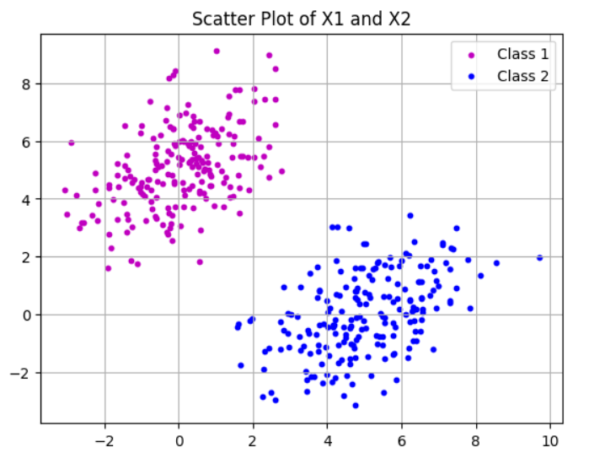

**4.** 

**6.** 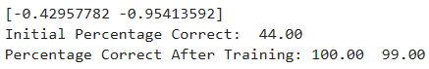

**7.** 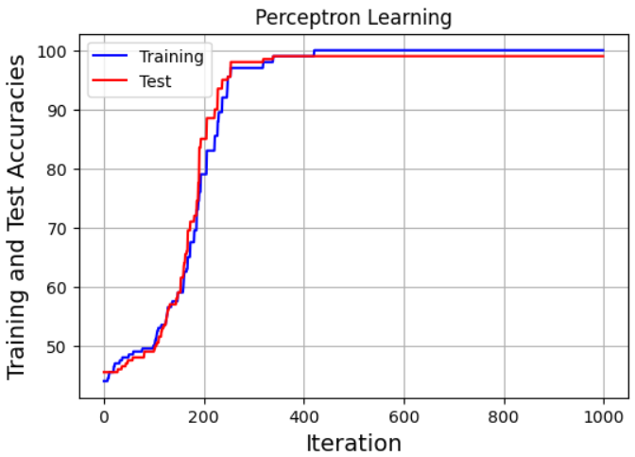

**8.** 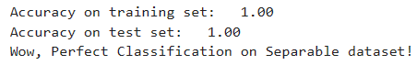

**9.** The perceptron algorithm, can solve this problem under certain conditions. The perceptron is a linear classifier, and it can perfectly classify data if the two classes can be separated by a hyperplane in the feature space.   
In this case, the decision boundary between the two classes will be a straight line, which is a hyperplane in 2D. So, a bias term to the data can be added. This is a common technique in Machine Learning to allow the decision boundary to not pass through the origin.   
By appending a column of ones to the data matrix X, we’re effectively adding a bias term to the model. The weight w associated with this term is learned along with the other weights, and it allows the model to fit the data better. This modification can help the perceptron to solve problems where the optimal decision boundary does not pass through the origin. However, it still doesn’t guarantee that the perceptron can solve the problem if the data is not linearly separable.  
The actual performance would depend on the specific data and problem at hand.

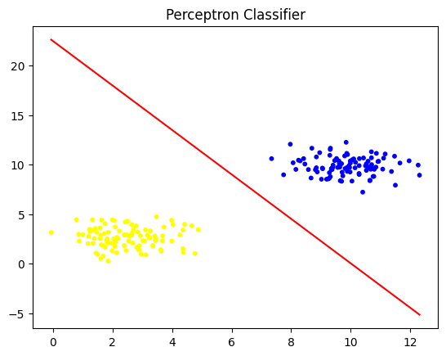

**10**. Model Training: <https://colab.research.google.com/drive/1DkDK6CRk2Nc4JirzaZ7_qmmPnuYAQm_d?usp=sharing>

