課題2-1

定義図

1

8

5

2

8

4

9

1

9

7

3

5

6

4

2

定式化

min 2x13+4x12+6x25+3x34+7x45+5x36+x47+9x58+9x67+2x79+8x710+x108+4x811+5x910+8x1011

st

node1) x13+x12 =10

node2) x25-x12 =-1

node3) x36+x34-x13 =-1

node4) x47+x45-x34 =-1

node5) x58-x45-x25 =-1

node6) x67-x36 =-1

node7) x79+x710-x67-x47 =-1

node8) x811-x108-x58 =-1

node9) x910-x79 =-1

node10) x1011+x108-x710-x910 =-1

node11) -x1011-x811 =-1

end

出力結果

Global optimal solution found.

Objective value: 87.00000

Infeasibilities: 0.000000

Total solver iterations: 0

Variable Value Reduced Cost

X13 8.000000 0.000000

X12 2.000000 0.000000

X25 1.000000 0.000000

X34 6.000000 0.000000

X45 0.000000 2.000000

X36 1.000000 0.000000

X47 5.000000 0.000000

X58 0.000000 5.000000

X67 0.000000 10.00000

X79 4.000000 0.000000

X710 0.000000 1.000000

X108 2.000000 0.000000

X811 1.000000 0.000000

X910 3.000000 0.000000

X1011 0.000000 3.000000

Row Slack or Surplus Dual Price

1 87.00000 -1.000000

NODE1 0.000000 -14.00000

NODE2 0.000000 -10.00000

NODE3 0.000000 -12.00000

NODE4 0.000000 -9.000000

NODE5 0.000000 -4.000000

NODE6 0.000000 -7.000000

NODE7 0.000000 -8.000000

NODE8 0.000000 0.000000

NODE9 0.000000 -6.000000

NODE10 0.000000 -1.000000

NODE11 0.000000 4.000000

最短経路図

1

5

2

4

1

3

5

6

4

2

課題2-2

6

3

7

1

4

2

8

6

4

5

5

9

3

2

1

定義図

定式化

max v

st

x12+x13+x14-v=0

x25+x23-x12=0

x36+x34-x23-x13=0

x47-x14-x34-x64=0

x56+x58-x25=0

x68+x64-x36-x56-x76=0

x76+x79-x47=0

x89-x58-x68=0

x12<=1

x13<=2

x14<=3

x23<=9

x34<=5

x25<=5

x36<=6

x64<=6

x47<=8

x56<=4

x76<=2

x58<=4

x68<=1

x79<=3

x89<=7

end

最大フロー図

3

2

1

1

1

4

1

2

2

2

1

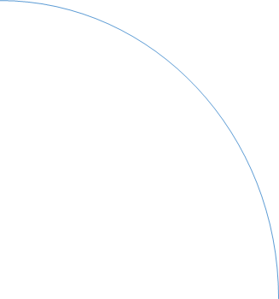

最小カット

1

1

2

2

3

3

4

4

7

3

10

2

14

1

15

4