Q2: GenAI Analysis of Customer Reviews

1. Methodology
In this section, we applied Generative AI techniques to analyze the 582 customer reviews for the VICTGOAL Bike Helmet. The workflow involved:
- Generating sentence embeddings for all reviews using the 'all-MiniLM-L6-v2' model.
- Performing K-means clustering to identify distinct review topics.
- Using FAISS (Facebook AI Similarity Search) to retrieve semantically relevant reviews.
- Leveraging Large Language Models (LLM) to extract detailed visual and functional features.
- Generating a product visualization based on the extracted insights.

2. Topic Clustering Analysis
We identified 8 distinct clusters of reviews, representing different topics and sentiments. The distribution of reviews across these clusters is shown below:
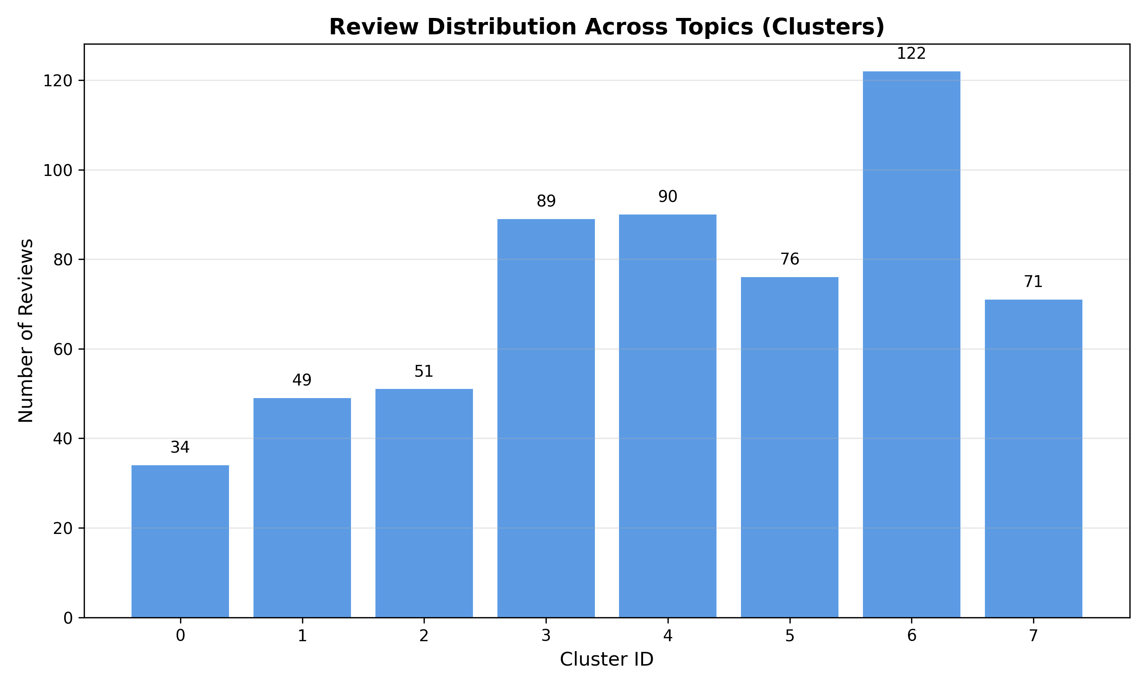

Cluster Insights:
Cluster ID | Dominant Theme
0 | General neutral/short feedback.
1 | Positive feedback on fit and delivery speed.
2 | Focus on the rear LED light and safety features.
3 | Mixed reviews regarding visor assembly and fitment.
4 | High praise for value for money and comfort.
5 | Specific complaints about assembly difficulties.
6 | Detailed praise for style, goggles, and versatility.
7 | General enthusiasm and recommendations.

3. GenAI Feature Extraction
Using an LLM to analyze the most relevant reviews, we extracted the following key product attributes:

Design & Aesthetics
Style: Modern, sporty, and aerodynamic cycling helmet with a 'Robocop-like' futuristic aesthetic.
Shape: Streamlined and compact with a slightly extended rear coverage for safety. Features multiple ventilation vents.

Key Features
Magnetic Goggles: Magnetic detachable goggles/eye shield. Strong magnets hold it securely. Fits over most prescription glasses. Tinted (grey) included.
Rear Light: Built-in USB rechargeable LED rear light with 3 modes (steady, flashing, slow flash). Located at the back of the helmet.
Ventilation: Excellent airflow with multiple large vents to keep the head cool.

Materials & Build
Shell/Foam: Durable PC (Polycarbonate) shell. / High-density EPS foam for impact absorption.
Padding: Soft, removable, and washable inner padding with insect net.

4. AI-Generated Product Visualization
Based on the extracted features, the following image prompt was generated and used to create a visualization:
Prompt: A high-quality, professional product shot of a modern cycling helmet in matte black with electric blue accents. The helmet features a futuristic design with a magnetic dark-tinted eye shield (goggles) attached to the front. On the back, there is a glowing red LED safety light. The helmet has a streamlined shape with multiple ventilation holes for airflow. It sits on a clean, neutral studio background with soft lighting to highlight the sleek texture and the reflection on the magnetic goggles.
[Note: Image generation was attempted using DALL-E 3. Please insert the generated image here if available, or use the prompt above to generate one.]

