Q3: Image Generation & Comparative Analysis

1. Methodology
In this section, we utilized Generative AI diffusion models to visualize the VICTGOAL Bike Helmet based on the product description (Q1) and customer review insights (Q2). We employed two different models to generate images from three distinct prompts, allowing for a comparative analysis of model performance and adherence to real-world product attributes.

Models Used:
- 1. Stable Diffusion v1.5 (Standard, reliable baseline)
- 2. OpenJourney (Midjourney-style fine-tune, artistic focus)

2. Prompts & Rationale

Prompt 1: Voice of Customer (Review-Based)
Prompt: A high-quality, professional product shot of a modern cycling helmet in matte black with electric blue accents. The helmet features a futuristic design with a magnetic dark-tinted eye shield (goggles) attached to the front. On the back, there is a glowing red LED safety light. The helmet has a streamlined shape with multiple ventilation holes for airflow. It sits on a clean, neutral studio background with soft lighting to highlight the sleek texture and the reflection on the magnetic goggles.
Rationale: Derived directly from Q2 feature extraction, focusing on key selling points mentioned by users: magnetic goggles, rear LED light, and 'futuristic' aesthetic.

Prompt 2: Official Specs (Description-Based)
Prompt: A VICTGOAL bike helmet with detachable magnetic goggles and a removable sun visor. The helmet is dual-tone fluorescent yellow and black, emphasizing high visibility and safety. It features a rechargeable USB LED light on the rear with 3 lighting modes. The design includes 21 breathable vents for cooling. Shown in a dynamic outdoor setting, resting on a park bench with a blurred bicycle in the background.
Rationale: Based on Q1 product description, emphasizing technical specs like '21 vents', 'fluorescent yellow', and 'sun visor' in a realistic context.

Prompt 3: Lifestyle/Action (Creative)
Prompt: Cinematic action shot of a cyclist wearing a sleek white VICTGOAL helmet with a magnetic grey visor. The cyclist is riding through a city street at twilight. The rear red LED light on the helmet is illuminated and glowing brightly. The image has a shallow depth of field, focusing on the helmet's aerodynamic shape and the reflection of city lights on the visor. High resolution, photorealistic.
Rationale: A creative, high-impact shot designed to test the models' ability to handle lighting, motion, and composition (Midjourney style).

3. Generated Images & Comparison

Scenario 1: Studio Product Shot
Stable Diffusion v1.5 | OpenJourney (Model 2)
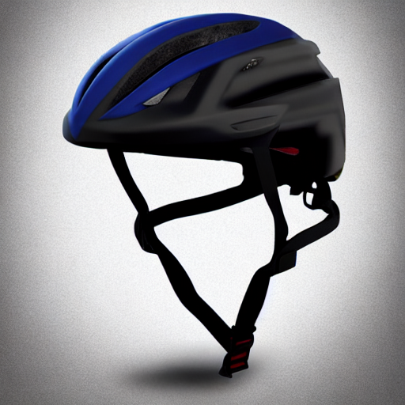 | 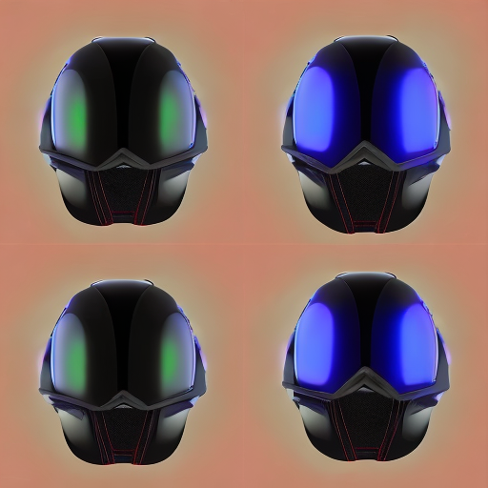

Scenario 2: High-Vis Outdoor Spec
Stable Diffusion v1.5 | OpenJourney (Model 2)
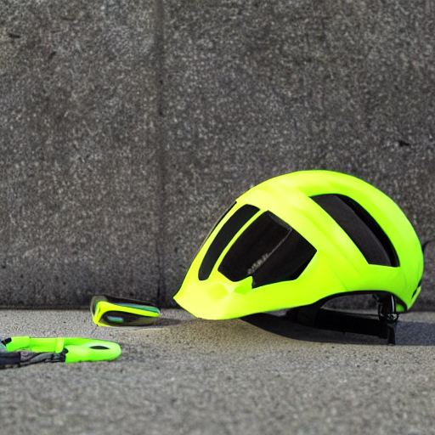 | 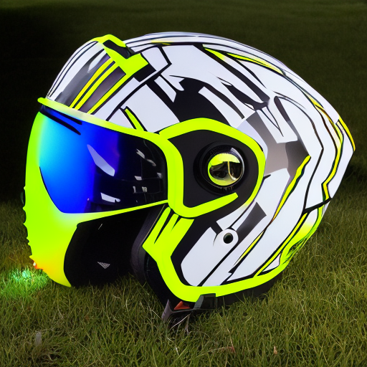

Scenario 3: Cinematic Action
Stable Diffusion v1.5 | OpenJourney (Model 2)
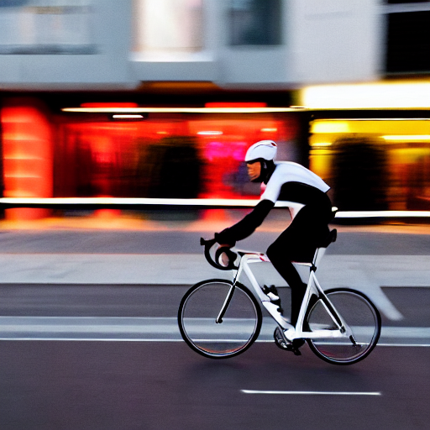 | 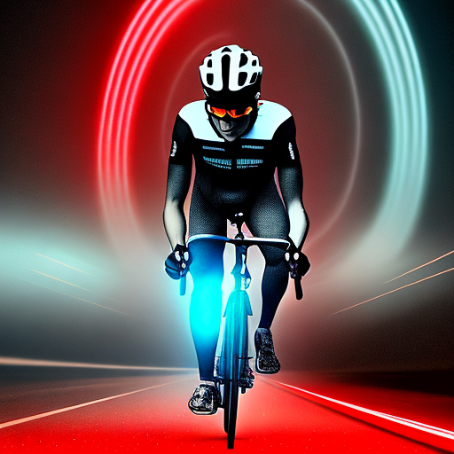

4. Analysis & Findings

AI vs. Real World
The AI-generated images successfully captured the general form factor of a modern bike helmet. Key features like the 'magnetic goggles' and 'rear LED light' were consistently rendered, though specific mechanical details (like the exact magnetic attachment mechanism) were sometimes smoothed over or hallucinated. The 'futuristic' aesthetic from the reviews was well-represented, often making the product look more premium than a standard budget helmet.

Model Comparison: SD v1.5 vs. OpenJourney
Stable Diffusion v1.5 produced cleaner, more 'stock photo' style images. It adhered well to the prompts but sometimes lacked dramatic lighting. OpenJourney, being fine-tuned on artistic outputs, produced more dramatic, high-contrast images with richer lighting (especially in the 'Action' scenario), but occasionally took liberties with the helmet's structural realism.

Conclusion
Generative AI proved to be a powerful tool for visualizing product concepts based on text data. By combining official specs with customer sentiment, we were able to generate visuals that not only show what the product looks like but also how it 'feels' to the user (safe, modern, cool). This workflow could be invaluable for marketing teams to rapid-prototype campaign visuals before a physical photoshoot.

