INDICES
A. Plaque Indices:
- Silness and Loe Plaque Index – PI
- Interdental Hygiene Index – HYG
- O’Leary and Lindhe Hygiene Index – HI
B. Gingival Indices:
- Loe and Silness Gingival Index – GI
- Papillary Bleeding Index Saxer and Muhlemann – PBI
- Simplified Gingival Index – GI-S (corresponds to the Gingival Bleeding Index – GBI)
C. Periodontal Indices:
- Periodontal Screening Index – PSR
- Periodontal Disease Index – PDI
- Treatment Needs Index – CPITN

Silness and Loe Plaque Index (PI)  • Measures the thickness of bacterial plaque along the gingival margin.  • For visualizing plaque, teeth are dried with air, and the plaque is not stained.  • Time-consuming.  • Recommended for epidemiological studies alongside the Gingival Index (GI). | 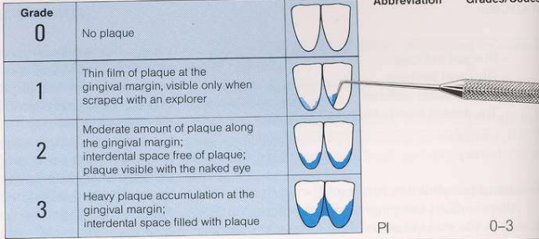
Interdental Hygiene Index (HYG)  • Records plaque-free surfaces as a percentage. Similar to the Approximal Plaque Index (API).  • After disclosing plaque, surfaces are assessed for the presence (+) or absence (−) of stained plaque on proximal surfaces.  • Recording occurs on specific faces in each quadrant (e.g., quadrants 1 and 3 on the oral side, quadrants 2 and 4 on the buccal side).  Number of plaque-free surfaces  HYG = ------------------------------------------  Number of surfaces examined  It is a sensitive index as it considers even small amounts of interdental plaque. | 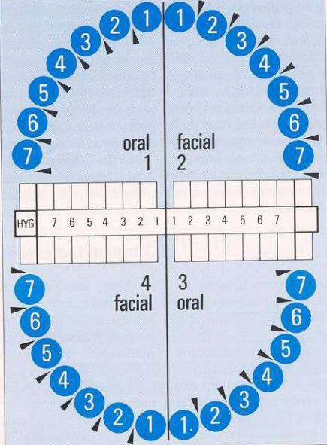
Oral Hygiene Index (HI)  - Records plaque accumulation on all dental surfaces, making it highly precise.  - Plaque is visualized using a disclosing agent.  - The presence (+) or absence (−) of plaque is recorded for each tooth surface (mesial, distal, buccal, and lingual).  - Results are documented in a chart, with a percentage of clean surfaces calculated.  - It is used only for individual cases  . | 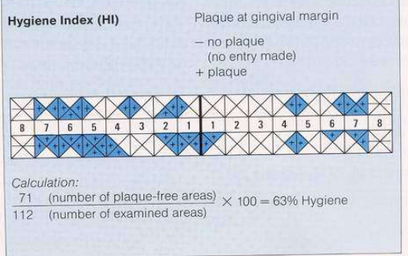 HI + or -
Indice gingival GI – Loe si Silness  Gingival Index (GI) by Loe and Silness  - Measures gingival inflammation on a scale of 0–3 for the vestibular, mesial, and lingual surfaces of all teeth.  - A bleeding symptom contributes to a score of 2.  - Often used in epidemiological studies. | 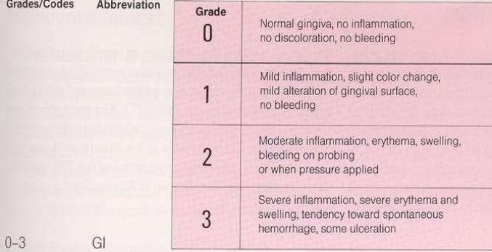
Papillary Bleeding Index (PBI)  The Papillary Bleeding Index (PBI) distinguishes four different grades of bleeding after careful probing of the gingival sulcus in the papillary region.  - Probing Procedure:  - Conducted in all four quadrants:  - Quadrants 1 and 3 on the oral side.  - Quadrants 2 and 4 on the buccal side.  - The bleeding index is recorded on the same surfaces as the Interdental Hygiene Index (HYG).  - Practical Use:  - Multiple forms can be utilized to track the progression of bleeding over time. | 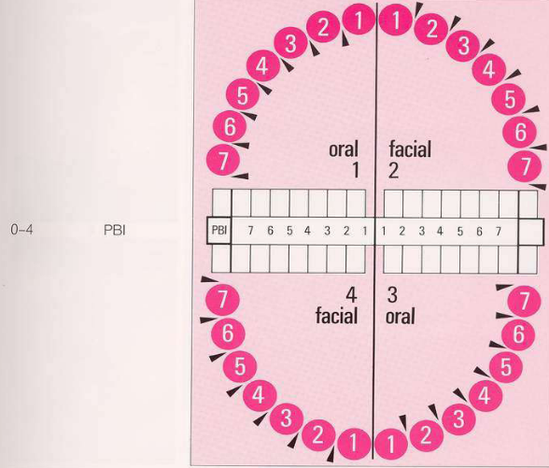
Simplified Gingival Index (GI-S)  Gingival Bleeding Index (GBI)  - Description:  Similar to the Hygiene Index (HI), these indices record the presence (+) or absence (−) of bleeding during probing on all four surfaces of each tooth (mesial, distal, buccal, and lingual).  - Calculation:  The incidence of gingivitis is calculated as the percentage of affected (bleeding) units  Recommended for individual use. | 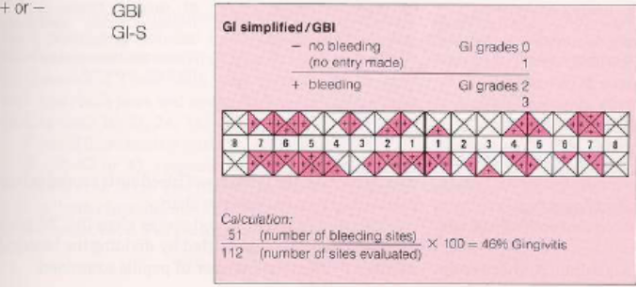

Papillary Bleeding Index (PBI)
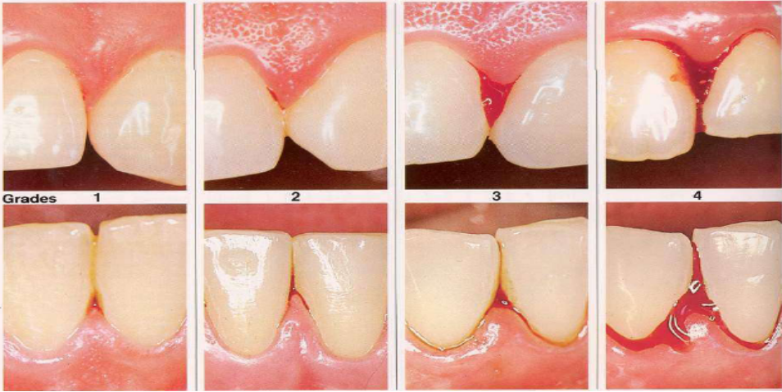
- Grade 1 - Point:
A single point of bleeding appears 20–30 seconds after probing the mesial and distal sulcus with a periodontal probe.
- Grade 2 - Line/Points:
A thin blood line or several points of bleeding become visible along the gingival margin.
- Grade 3 - Triangle:
The interdental triangle fills partially or completely with blood.
- Grade 4 - Drop:
Diffuse bleeding occurs. Immediately after probing, blood flows into the interdental area, covering portions of the tooth and gingiva.

PBI Recording Procedure
- Bleeding Provocation:
Bleeding is induced by gently passing (stroking) a periodontal probe along the sulcus, applying light pressure from the base of the papilla toward the tip, on both the mesial and distal aspects of the tooth.
- Timing and Recording:
After probing an entire quadrant, wait 20–30 seconds before recording the intensity of bleeding.
Each site is graded according to the four levels described above.
- Calculating the Total Bleeding Score:
  - The total of the recorded scores provides the "bleeding number."
Bleeding number
PBI = -----------------------------------
Total number of examined papillae

Periodontal Screening and Recording (PSR)
Purpose:
The PSR is used to classify patients into one of two categories:
- Those with periodontal health or gingivitis.
- Those with periodontitis.

Procedure:
- Recording: Only the highest score for each sextant is recorded.
- Table Format: Scores are documented in a special table for all six sextants:
Sextant 1 Sextant 2 Sextant 3
Sextant 6 Sextant 5 Sextant 4
- Special Cases: Sextants with fewer than two teeth are marked with an X and are excluded from the overall evaluation.
- Asterisks: An asterisk (*) is added for sextants with anomalies, such as:
  - Furcation involvement.
  - Tooth mobility.
  - Mucogingival issues.
  - Significant gingival recession extending into the colored band of the probe (≥3.5 mm).

PSR Codes:
- Code 0:
  - The reference mark (colored band) is completely visible in the deepest sulcus or pocket of the sextant.
  - No calculus or defective restoration margins.
  - No bleeding on gentle probing.
  - Healthy gingival tissues.
- Code 1:
  - The reference mark is completely visible.
  - No calculus or defective restoration margins.
  - Bleeding on probing is present.
- Code 2:
  - The reference mark is completely visible.
  - Supra- or subgingival calculus or defective restoration margins are present.
- Code 3:
  - The reference mark is partially visible in the deepest sulcus or pocket.
  - Indicates probing depths of 3.5–5.5 mm.
- Code 4:
  - The reference mark is not visible in the deepest sulcus or pocket.
  - Indicates probing depths greater than 5.5 mm.
- **Code ***:
  - Applied to sextants with:
    - Furcation involvement.
    - Tooth mobility.
    - Mucogingival problems.
    - Recessions extending into the colored band of the probe.

Periodontal Damage Index – PDI

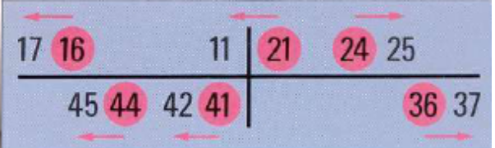  Scores:  0 - No inflammation or alterations in the gingiva.  Gingiva  1 - Mild to moderate gingivitis in localized areas of the marginal gingiva.  2 - Mild to moderate gingivitis affecting the entire marginal gingiva surrounding the teeth  3 - Advanced gingivitis with severe erythema, bleeding, and ulceration.  Periodontium  4 - Attachment loss up to 3 mm, measured from the cemento-enamel junction (CEJ).  5 - Attachment loss between 3–6 mm.  6 - Attachment loss greater than 6 mm. | Ramfjord teeth are representative of the entire dentition in epidemiological studies (16; 21; 24; 36; 41; 44). The teeth colored in red are Ramfjord teeth, and the non-colored teeth are their substitutes when they are missing. PDI includes a gingivitis index with scores 1, 2, and 3, and a measurement of attachment loss independent of gingivitis, with scores 4, 5, and 6 (measures attachment loss, not pocket depth). PDI is recommended for epidemiological studies. Wisdom teeth are excluded. Grades 1-3 and 4-6 are evaluated separately. (e.g., a score of 2.8 does not mean there is only gingivitis)."

CPITN (Community Periodontal Index of Treatment Needs)
For epidemiological studies:
- Determines the severity of gingivitis.
- Determines the severity of periodontitis.
- Provides data regarding the need for treatment.
Examination is done using a special probe (WHO probe) that differentiates between normal and affected areas but does not provide precise measurements. The evaluation is done by sextants. Disadvantage: It does not detect attachment loss due to recession. The highest score of the sextant is recorded. For children up to 19 years old and in epidemiological studies, one anterior tooth in the maxilla and one in the mandible, along with the first permanent molars, are examined.
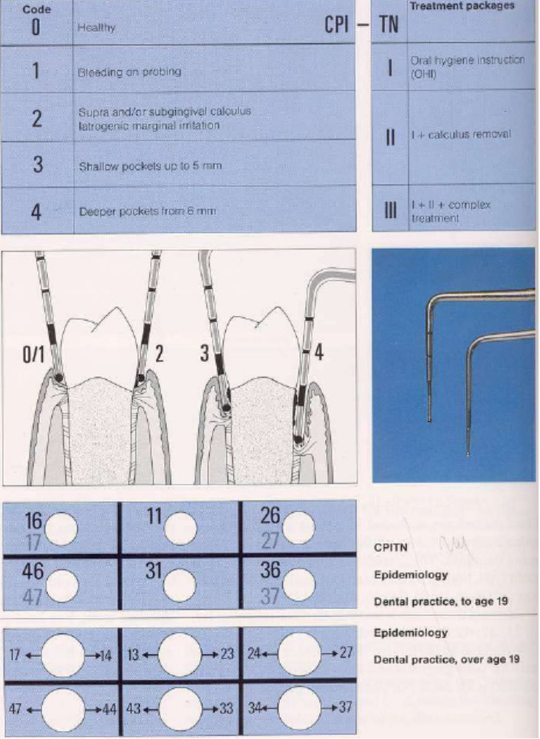
Index for Evaluating Gingival Overgrowth – Rossmann, Ingles, and Caffesse
Grade 0
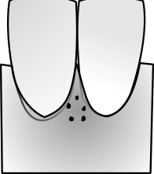

• Firm adaptation of the attached gingiva to the underlying alveolar bone, with no volume changes.
• Slight granular appearance.
• Normal papillary margin appearance.
• Papilla with normal size and density.
Grade I
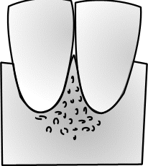

• Slight growth characterized by increased gingival density, marked granular appearance.
• Rounded papillary tip.
• Probing depth ≤ 3 mm.
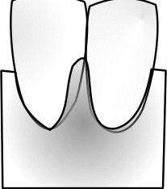Grade II

• Moderate overgrowth manifested by an increase in the size of the papilla and/or rolled gingival margins.
• The contour of the gingival margin is still concave or straight.
• Gingival enlargement in the buccolingual direction (V-O) up to 2 mm, measured from the tip of the papilla outward.
• Probing depth ≤ 6 mm.
• The papilla is somewhat detachable.
Grade III

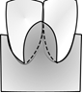
• Marked overgrowth represented by the migration of the gingiva onto the clinical crown.
• The contour of the gingival margin is convex.
• Gingival enlargement has a dimension ≥3 mm, measured from the tip of the papilla outward.
• Probing depth > 6 mm.
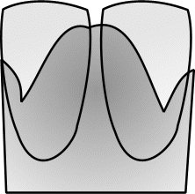Grade IV

• Severe overgrowth, characterized by extreme thickening of the gingiva.
• The clinical crown is largely covered.
• Gingival enlargement has a dimension ≥3 mm, measured from the tip of the papilla outward.
• Probing depth > 6 mm.
• The papilla is clearly detachable.

Dental Mobility Indices
These are used during the clinical examination both before treatment and subsequently during treatment phases to assess the response to treatment. The mobility index is an important criteria that helps in determining the clinical progression of periodontal health after treatment, allowing the evaluation of improvement, worsening, or stabilization/healing of the clinical condition.
Tooth mobility can be determined by using the twizzers, a probe on the oclusal surface of the posterior teeth, or the blunt end of two instruments. Another more efficient way to determine mobility is by using precise electronic devices.
- 0 = Physiological mobility (fremitus)
- 1 = Mobility perceptible with the finger (0.2–1 mm in the horizontal direction)
- 2 = Mobility greater than 1 mm in any direction, in the horizontal plane
- 3 = Mobility greater than 1 mm in any horizontal direction, plus movements of intrusion/rotation
Based on the recorded values, the clinical index of pathological mobility degree is calculated as follows:
- m1 is the pathological mobility recorded by summing the mobility value of all the teeth examined before treatment.
- m2 is the mobility of the teeth after treatment.
The mobility index (Im) is calculated using the formula:
m = | m₁-m₂ | x 100
m = | m₁ | x 100

Recession Classes (MILLER)

