Report: IMPLEMENTING JDBC

1. Overview of the Selected Table
For this assignment, I chose the Participants table from my "Meeting Calendar" project database.
Relevance to my project. In a meeting calendar application, managing participants is a core functionality. The table stores essential information about users, such as their names and email addresses. This data is required to link individuals to specific meetings (Many-to-Many relationship) and to send notifications or invites.
Table Structure id, name, e-mail

2. CRUD Operations Implementation
public void queryParticipants() throws SQLException {
String sql = "SELECT * FROM Participants";
ResultSet rs = connection.createStatement().executeQuery(sql);

System.out.println("\n--- PARTICIPANTS ---");
while(rs.next()) {
System.out.println(rs.getInt("id") + " " + rs.getString("name") + " (" + rs.getString("email") + ")");
}
}

public void insertParticipant(String name, String email) throws SQLException {
String sql = String.format("INSERT INTO Participants (name, email) VALUES ('%s', '%s')", name, email);
connection.createStatement().executeUpdate(sql);
System.out.println("Added to DB: " + name);
}

public void updateParticipant(int id, String newName) throws SQLException {
String sql = String.format("UPDATE Participants SET name='%s' WHERE id=%d", newName, id);
connection.createStatement().executeUpdate(sql);
System.out.println("Updated ID: " + id);
}

public void deleteParticipant(int id) throws SQLException {
String sql = String.format("DELETE FROM Participants WHERE id=%d", id);
connection.createStatement().executeUpdate(sql);
System.out.println("Deleted ID: " + id);
}

3. Screenshots

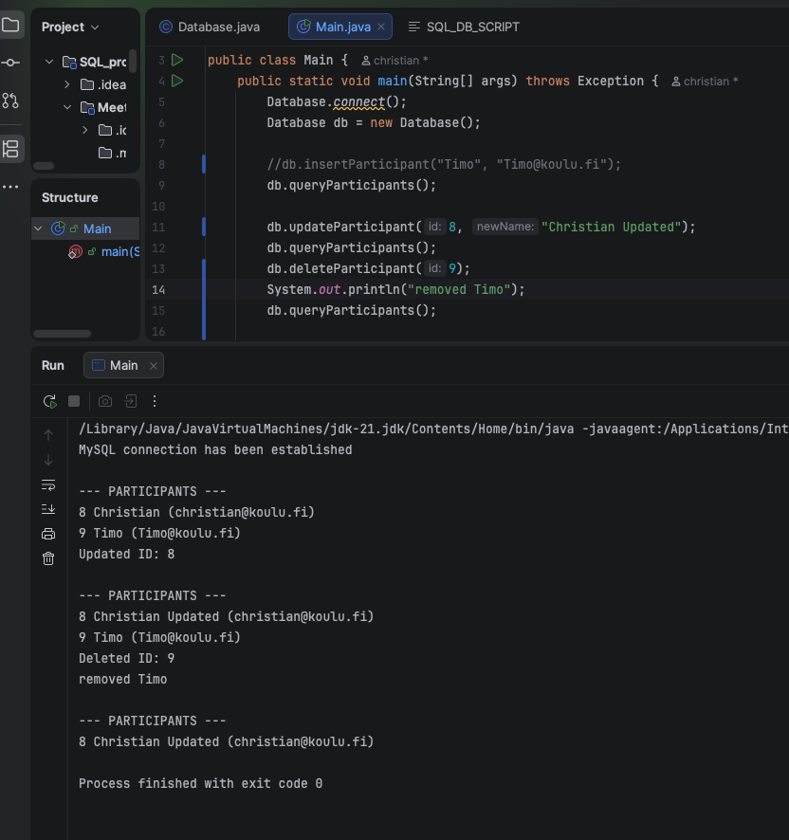

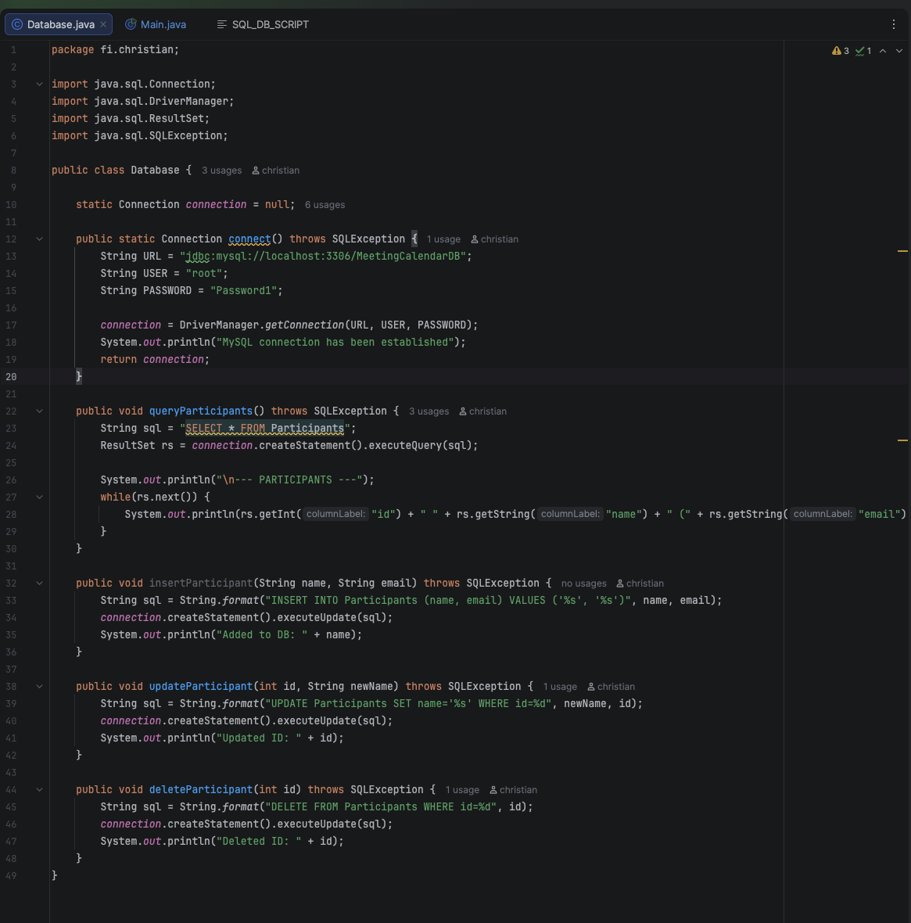

4. Challenges Faced and Solutions
No code releted problems but. Git Configuration Submodules: When pushing to GitHub, the Maven project folder appeared as an empty/unclickable "submodule" (Git Error 160000).
I had to remove the nested .git folder from the project subfolder and use git rm --cached to reset the tracking. After this, I performed a forced push to clean the repository.

