Formula 1 racing website designing
-R.Shajini,E/24/365
MY BASIC IDEA
Tab title | Main idea | Additional info
Home | Hero with the car on one side and a short intro on the other, then three link cards: University, Team, Car | University- Engineering faculty, basic info, brief history  Team – take to team information page.  Car- car as a 3D model, our sponsors, specialty of the car, and all the photos of its making to its success
Team information | Team photo with the car, basic info, hierarchy, then member profiles (photo, role, short bio, university email, LinkedIn) | Team photo with car as the main face  scroll down for the team details and the hierarchy  basic history  main team members and guidance  Then a link to visit the remaining team members  Add all the team members engineering email, a short bio and linked in
Competitions | Countdown to the next event, a live link button, past results with photos | Past competition- results, awards, a video of the car on the track, pictures of the car and racer  Live link button- to visit the competition live video during competition season.  Countdown – needed nearing a competition like day and hourly count down
Contact information | A contact form (name, email, message | The team email and university address  Social media icons (Instagram, Facebook, YouTube, LinkedIn).  Become a sponsor.
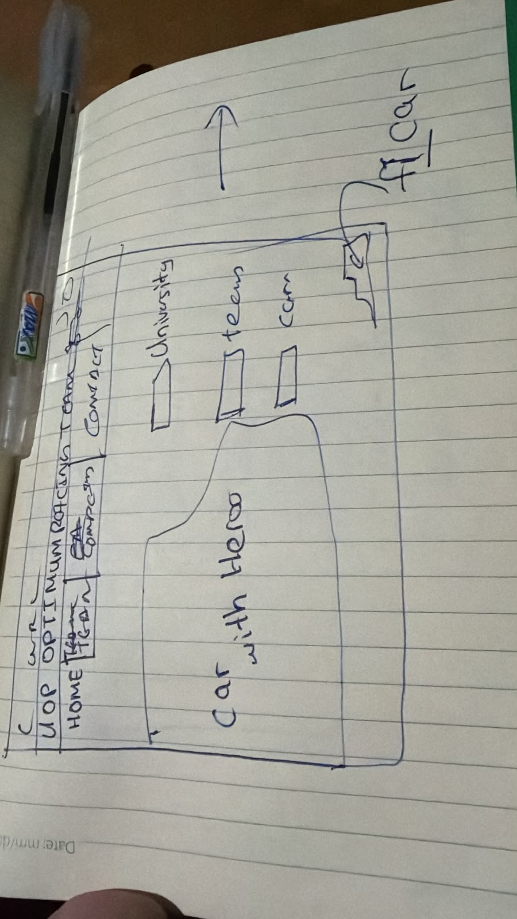
Home page hand drawing

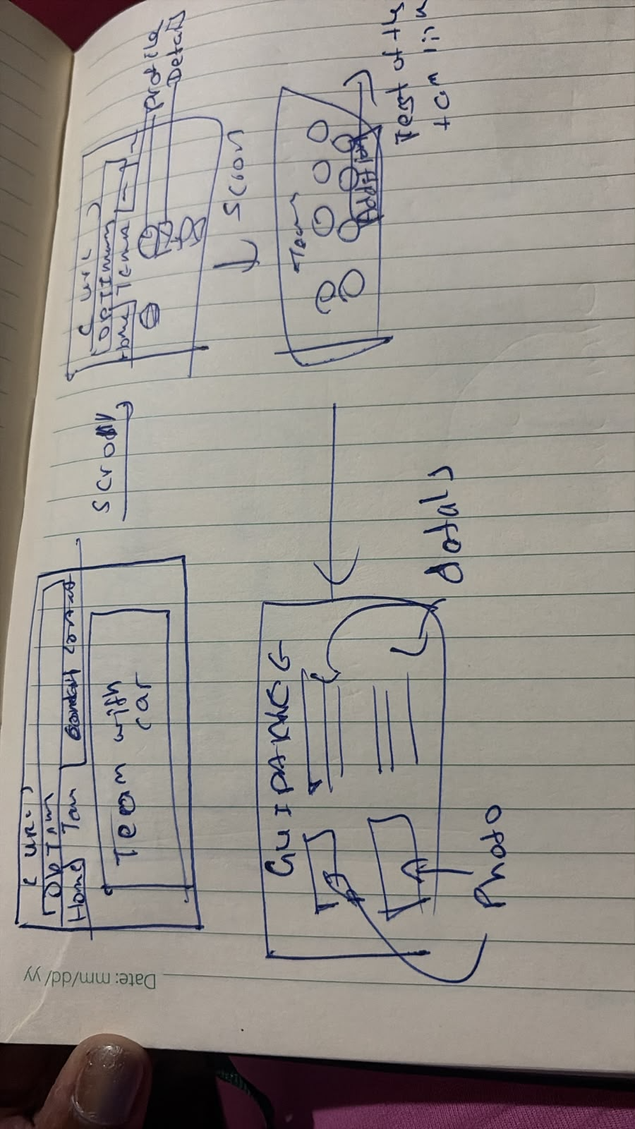
Team page hand drawing

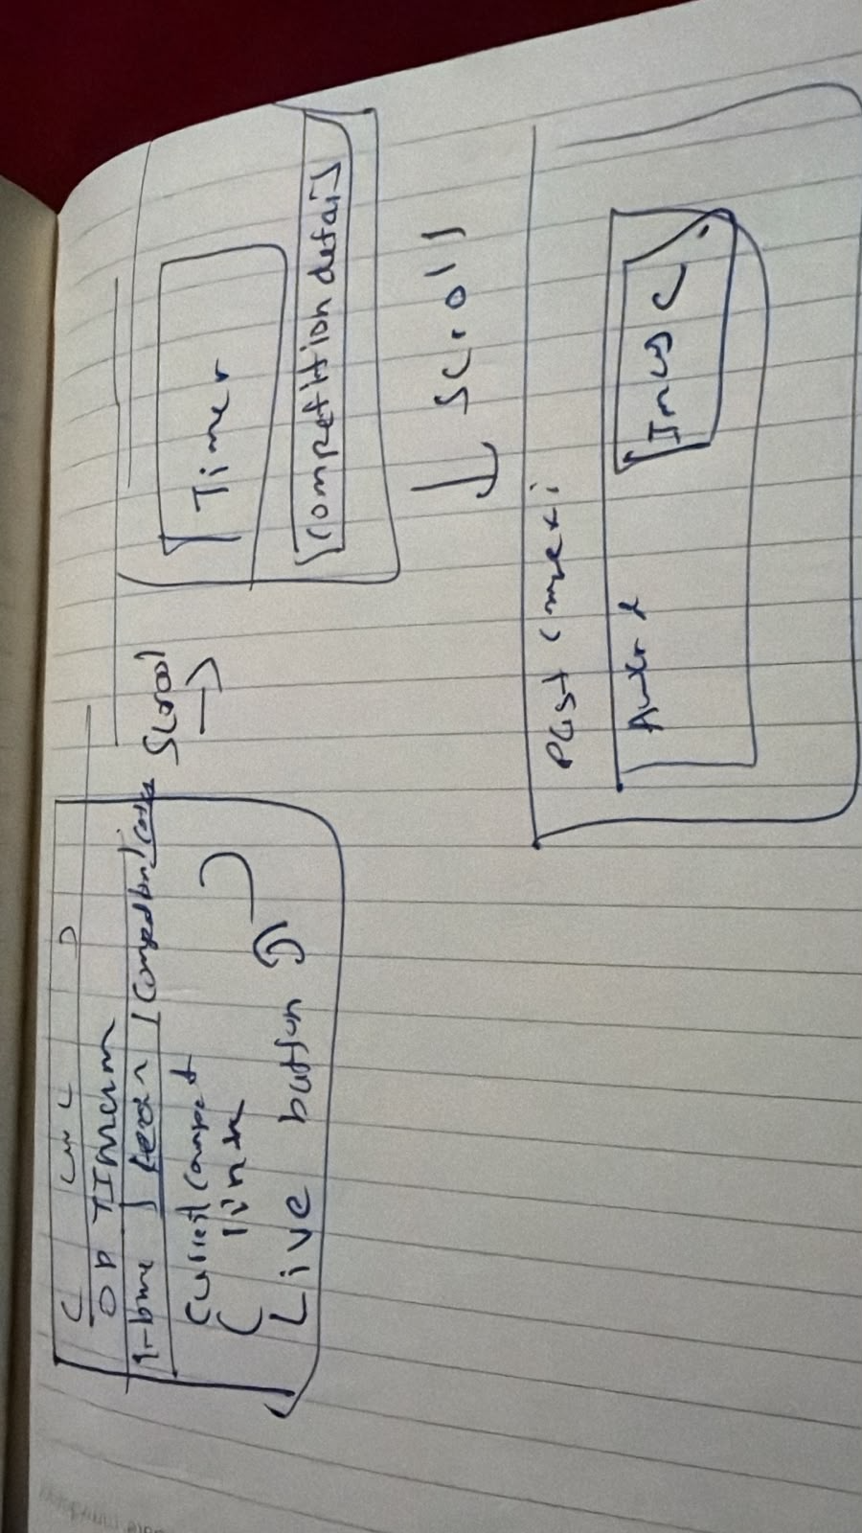
Competition page hand drawn.
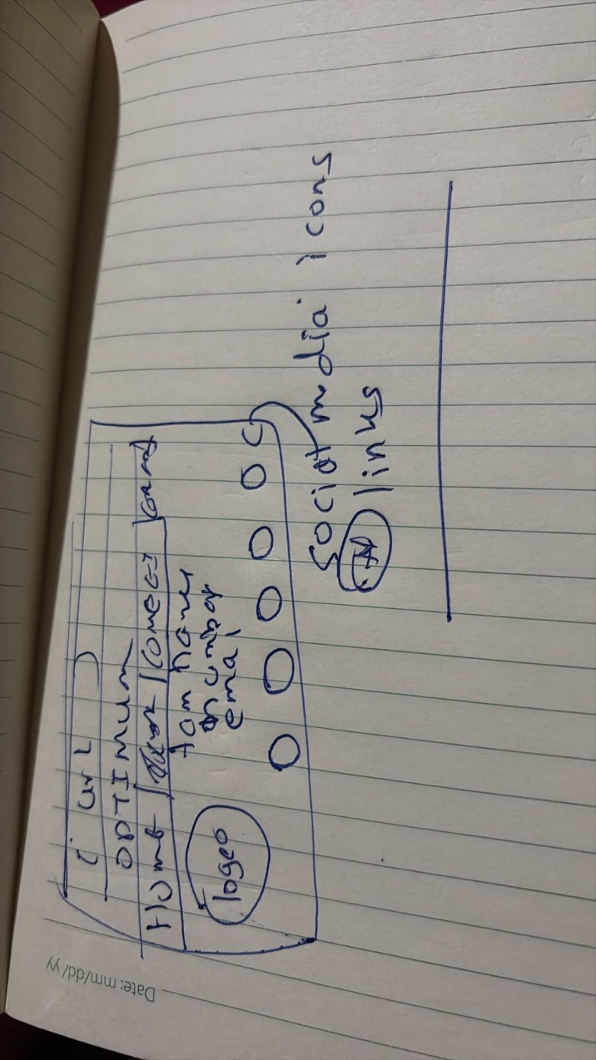contact information page hand drawn.

Website plan – dark black background

