The Code Has been Written By Katalon Studio Tool -Open Source Tool – Selenium

Below is Manual View.

I have not parametried the script , its just an harcoded script .Based on the Requiremnet it can be hardcoded .

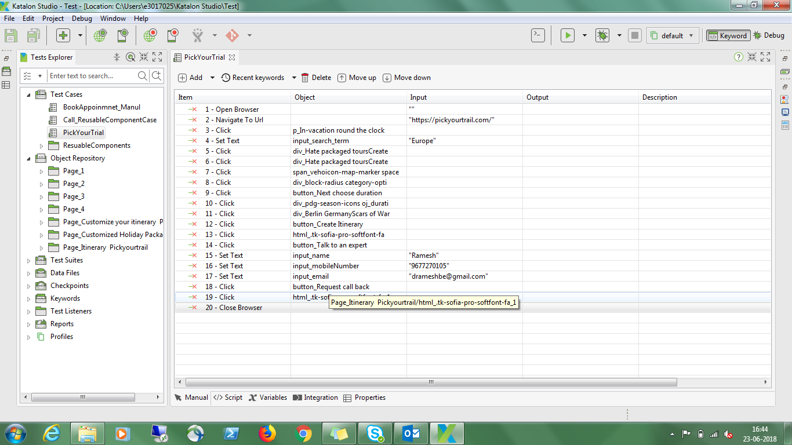

Please see below for script view .

